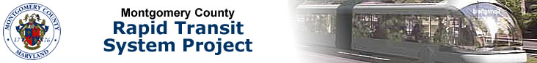

Transit Signal Priority Working Group Meeting
7/16/13 Agenda
Casey Anderson, Chair

- Welcome/Working Group Meeting Purpose

- Introductions

- Presentation – Transit Signal Prioritization (TSP) and RTS Paul Silberman, Sabra, Wang & Associates, Inc.

- Next Steps: Transit Signal Priority Subtask Scope Deliverables

- Technical Memorandum on Needs Assessment and Goals/Objectives for TSP System Operations

- Technical Memorandum on Existing Conditions of Signal Systems and Traffic/Transit Operations on Corridors Planned for TSP Implementation

- RTS Transit Signal Priority Planning Technical Memorandum

