Technical Memorandum 1:

Goals, Objectives, and Needs Assessment for Rapid Transit System (RTS) Transit Signal Priority

For:

Montgomery County   
Department of Transportation

SWA side logo blue

19 September 2013

Version History

|  |
| --- |
| Version 1: August 29, 2013  Prepared by: James A. Bunch, Sabra, Wang, & Associates, Inc.  Checked by: Paul Silberman, Sabra, Wang, & Associates, Inc.  Initial version  Version 2 (r3): September 10, 2013  Prepared by: James A. Bunch, Sabra, Wang, & Associates, Inc.  Checked by: Montgomery County Department of Transportation  Paul Silberman, Sabra, Wang, & Associates, Inc.  Version 3 (r4): September 10, 2013  Prepared by: James A. Bunch, Sabra, Wang, & Associates, Inc.  Checked by: Paul Silberman, Sabra, Wang, & Associates, Inc. |

Table of Contents

I. Introduction 1

I.1 Background 1

I.2 Montgomery County and the State of Maryland System Responsibilities 5

I.3 Organization 5

II. Overview of Transit Signal Priority 5

III. The Potential Role of Transit Signal Priority Within RTS 9

III.1 Purpose of TSP within the RTS System 9

III.2 Goals, Objectives, and Evaluation Measures 10

III.3 TSP in Past & Parallel Montgomery County Priority Transit Studies/Projects 12

III.4 Differences to consider between Countywide and RTS TSP 14

IV. Stakeholders and Their Needs 15

V. Policy Issues & Challenges 17

VI. Next Steps 18

Technical Memorandum 1:

Goals, Objectives, and Needs Assessment   
for Rapid Transit System (RTS) Transit Signal Priority

Sabra, Wang & Associates, Inc.

For:   
Montgomery County  
Department of Transportation

19 September 2013

# Introduction

The Rapid Transit System (RTS) Transit Signal Priority (TSP) Concept Study was commissioned by the Montgomery County Department of Transportation (MCDOT) in March 2013 in order to assist in determining how TSP and its operations may be integrated and operate within the overall RTS system. One of the study’s primary goals is to “define the appropriate metrics for the implementation of TSP systems on each RTS corridor, building on what was developed for TSP for local bus operations”. The purpose of the study is to:

* Define:
  + Current state of traffic signal control & TSP systems used in Montgomery County.
  + Key measures of effectiveness and range of functional attributes for TSP within RTS Corridors
  + Qualitative impacts associated with TSP system operations within RTS Corridors
  + Systems Engineering Approach to TSP planning, design, and implementation within RTS Corridors
* Recommend:
  + Approach to coordinate implementation of planned countywide and RTS TSP
* Establish:
  + Guidelines for TSP systems on RTS study corridors and the degree/need for consistency with TSP systems used on other county and state highways in Montgomery County.
  + Proposed guidelines for agency coordination regarding implementation of TSP on RTS corridors.

This technical memorandum is the first of three deliverables associated with the RTS TSP Concept Study. It provides the foundational concepts needed to understand what TSP is and what it can offer specific to the context of an RTS framework including service levels and guideway infrastructure. It then describes the goals, objectives, measures and needs for TSP within RTS in Montgomery County. Last it discusses Policy Issues and Challenges to resolve when considering TSP for RTS and Next Steps.

## Background

Since Councilmember Elrich first proposed a comprehensive countywide Bus Rapid Transit (BRT recast as a Rapid Transit System or RTS) system as a new direction in the County’s transportation system the proposed RTS system has evolved and been refined through several high level conceptual and planning efforts. The initial exploratory Countywide Bus Rapid Transit Study (Parson’s Brinkerhoff, July 2011) examined 23 potential corridors consisting of 198 miles of right of way and recommended 148 miles of right of way (ROW) within 16 corridors. The Montgomery County Transit Task Force then further described the RTS at a conceptual level on what a premium service RTS 162.5 mile 19 corridor network could offer and explored funding /financing options. Last, the Countywide Transit Corridors Functional Master Plan was approved by the Maryland National Capitol Park and Planning Commission (MNCPPC) Planning Board in July 2013, and is now being considered by the Montgomery County Council. As shown in Figure 1 it consists of 80.7 miles of Right of Way (ROW) within 10 corridors. Table 1, shows the types of ROW treatment it assumes determined based upon ROW constraints, potential ridership, and other factors.

Table 1 MNCPPC Functional Master Plan   
Priority ROW Treatments

|  |  |
| --- | --- |
| **Type of Priority ROW** | **Miles** |
| Bi-directional 1 lane median | 6.2 |
| Curb lanes | 4.0 |
| Managed Lanes | 0.9 |
| Mixed Traffic | 23.9 |
| Reversible One-Lane Median | 16.6 |
| Two-Lane Median | 28.1 |
| Two-Lane Side Running | 0.9 |
| Total | 80.7 |

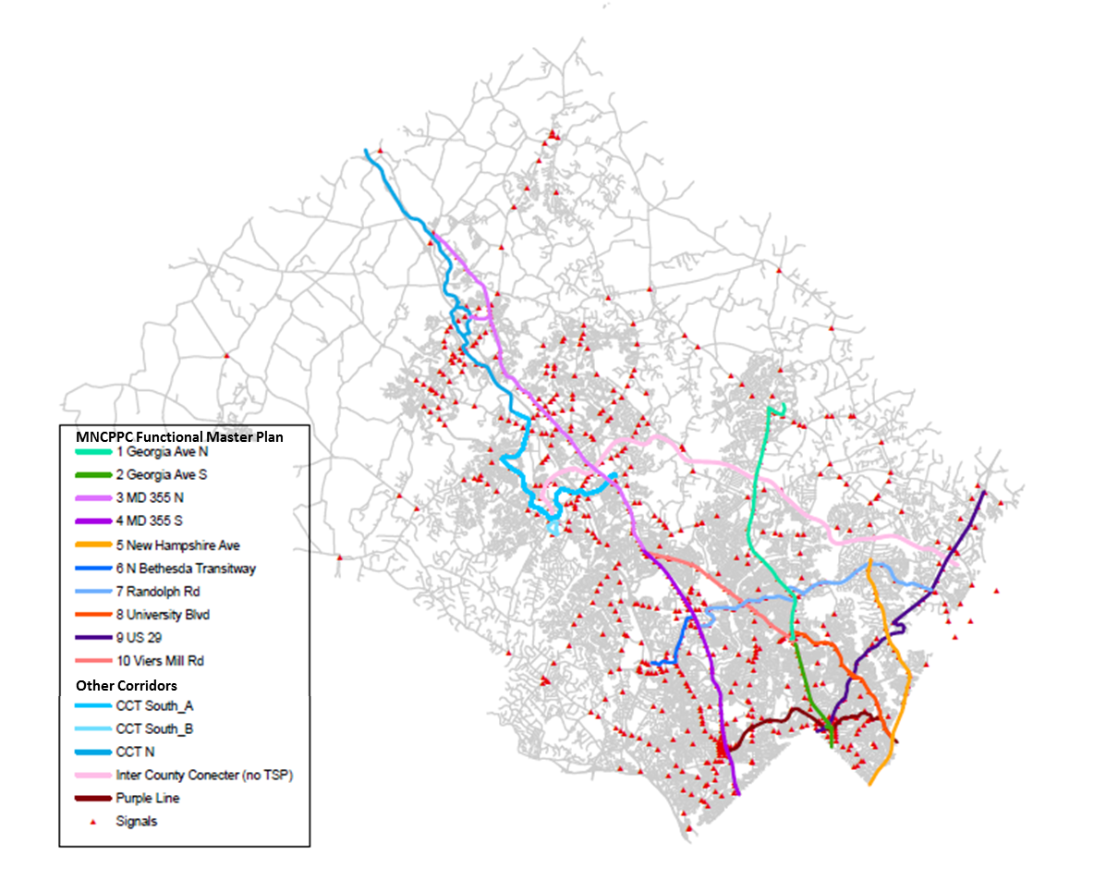

Figure 1 Priority Transit Corridors and Montgomery County Signals

All of these conceptual efforts assumed that TSP aimed at reducing delay and unreliability due to traffic signals is a key component of a successful RTS system. However, the type of TSP that can be implemented in a particular corridor or intersection and the benefits it generates depend on the type of Priority ROW Treatment, parallel and crossing roadway and intersection traffic operations (level of service), RTS and non-RTS transit service characteristics (the frequency and ridership of the transit service), the vehicle and roadway TSP technologies and other factors that were not examined in these conceptual analyses. This study provides the initial assessment of how to integrate TSP within the RTS given more detailed system, operational, and ROW factors.

During the same time that the plans for the Montgomery County RTS were in development, Montgomery County DOT and the Maryland State Highway Administration (MSHA) have been working on a plan and implementation policy for TSP within the existing local transit environment and exploring transit signal priority systems on several highway corridors in the county in support of Ride On, WMATA, and MTA bus systems. The Countywide TSP study has:

* Carried out a state of the practice/lessons learned assessment on TSP across the country and past operational tests within the region
* Carried out a technology assessment and selection of recommended equipment for Montgomery County
* Developed a Concept of Operations for TSP implementation and operations
* Identified and ranked 18 potential corridors within the county for TSP implementation in the current system based upon inputs from WMATA, RIDE ON, the MTA, and transit and roadway operating characteristics.

The potential corridors are shown in Figure 2. Note that many, but not all, of the corridors overlap with the MNCPPC Transit Functional Master Plan.

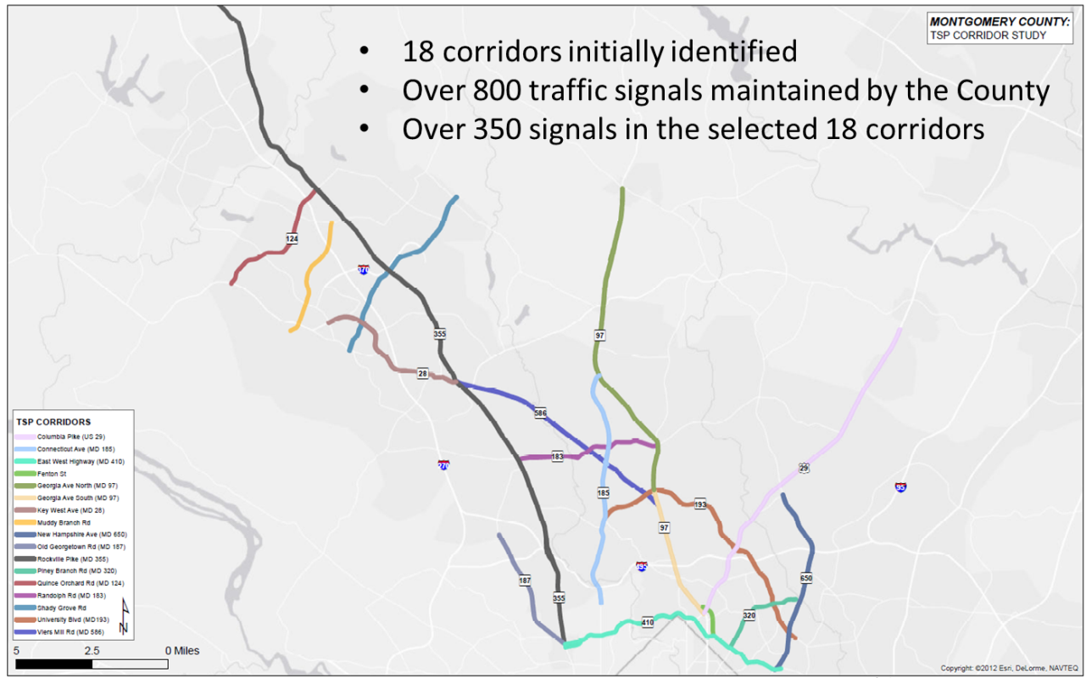

Figure 2 Montgomery Countywide TSP Potential Corridors

The Countywide TSP effort is in the process of identifying the intersections within each of the corridors shown in Figure 2. Intersections where TSP is feasible (Volume/Capacity < 1 and available slack time where minimum walk and turning green times are met) are being identified first. The feasible TSP intersections are then being ranked by the potential effectiveness of TSP based upon:

* Their overall corridor ranking
* The general traffic congestion (V/C > 0.6)
* The cross street facility type
* If other priority treatment exists
* Bus Delay on Approach (Bus Speed)
* Bus passengers, and
* Bus frequency.

Preliminary analysis indicates that approximately 200 signalized intersections along these corridors will meet the criteria for TSP implementation.

The Countywide TSP Concept of Operations assumes that (see section II for an explanation of TSP concepts) (Sabra, Wang & Associates Inc. July 2013):

* TSP will be requested only when the buses are running more than 5 minutes behind schedule.
* A TSP request will be granted on a first come first served basis (no special consideration to direction, corridor, operator, or type of service).
* A TSP request will be granted only when it can be accommodated safely within the traffic signal controller phases at the intersection.
* TSP signal options include only green extension and red truncation.
* Once priority is granted at an intersection the signal cannot grant another request (i.e. the lockout period) until the system recovers coordination (currently assumed to be three cycles).

WMATA is also pursuing a program to make WMATA buses compatible with TSP system capabilities. It is desirable to coordinate the future TSP systems on the RTS corridors with the current TSP initiative for local bus operations on state and county highways. Therefore important questions to address as part of this RTS and TSP effort include:

* How should potential signal operations change when combined with other priority treatments options (queue jumps, exclusive guideway, etc.)?
* What types of transit service will be eligible for signal priority (RTS, Express, Local) and in which directions (peak, off-peak, cross)?
* How often should priority be granted when requested?
* What weights should be given to transit ridership versus general traffic vehicle and person movements when granting conditional TSP requests?
* Should the RTS transit operations center be integrated or separate with respect to TSP?

## Montgomery County and the State of Maryland System Responsibilities

It is important to point out at the start of the TSP discussion that implementing and operating TSP within a system by its very nature requires agreements and coordination between operating agencies and across modes. Different agencies/entities own operate and maintain the roadways, traffic signals, and their control/communications systems versus those that may own operate and maintain the RTS and other transit services. As a framework/policy approach for TSP within the RTS system and how it might be implemented is examined we must keep in mind that the agencies/entities that own operate and maintain the signal systems in Montgomery County have the ultimate decision authority over these systems and must agree with what is being proposed. Of the over 800 signalized intersections in the county, approximately 64% (~ 500) are owned by the Maryland State Highway Administration, with the remainder owned by the county. The MDSHA and County signals are operated by the County. SHA will have to approve the TSP implementation and strategies along state roads, which make up the vast majority of the RTS corridors.

Note, that the incorporated cities and towns along RTS corridors also have important roles and responsibilities for their road system performance and operation. The City of Rockville has about 35 signals that they operate in their own closed loop system. Gaithersburg, Takoma Park, and Chevy Chase do not operate or maintain signals but have a vested interest in the performance of their road/traffic system. It will also be important to coordinate with them as we move forward with RTS and TSP.

## Organization

Five sections follow. First, an overview of TSP concepts, operations, and potential impacts is given. Second, it focuses on the potential role of TSP within the overall RTS system including the purpose, goals and objectives and key measures of effectiveness of TSP within RTS. Third, TSP and RTS stakeholders and their needs/concerns are summarized. Forth, potential policy issues and challenges regarding TSP and RTS are discussed. Last, the next steps, are laid out.

# Overview of Transit Signal Priority

There is often some confusion over what TSP is, how modern TSP systems operate, and what benefits potential TSP options may offer within the future RTS system. Consequently, this section provides an overview of transit signal priority basic concepts and principles as a foundation for the remainder of the study and discussions within the RTS Steering Committee.

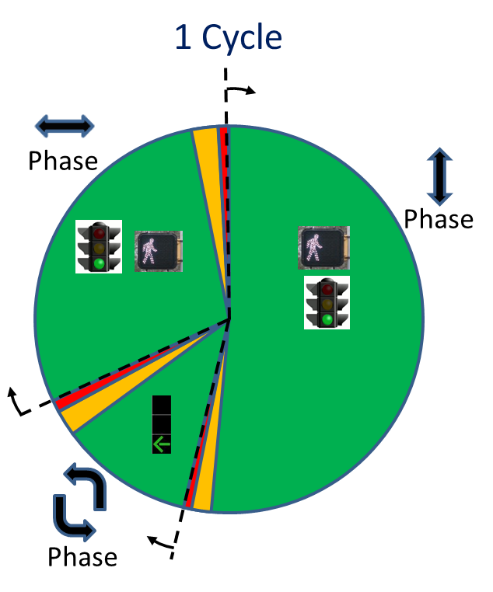

Figure 3 Traffic Signal Cycles and Phases

In order to better understand what TSP is and how it works one must first understand some basic features of traffic signals themselves. As shown in Figure 3 traffic signals typically operate on fixed cycles which repeat over time. A Cycle consists of multiple phases (Figure 3 has 3: North South through, North South left turns, and East West all movements). Phases allocate time to movements competing for shared right-of-way. The length of each phase (green, yellow, and red time) is a function of geometry, and vehicle and pedestrian volumes (demand). Cycle length is sensitive to many factors including coordination with adjacent signals; time of day; volume demand, and vehicle detection (e.g. loops). In Montgomery County cycle lengths typically range from 120 to 180 seconds in the peak period. Providing for vehicle progression along a corridor adjusts the starting time (offsets) of the cycles for signals so that the signals are green as the vehicles move along the corridor in the desired direction of travel. Overall signal coordination and timing optimization efforts aim to adjust the cycle lengths and offsets and phases in order to minimize overall stopped delay due to traffic signals for all traffic throughout the system.

Given the above, the Transit Signal Priority (TSP): a Planning and Implementation Handbook defines TSP as:

TSP is an operational strategy that facilitates the movement of transit vehicles (usually those in service), either buses or streetcars (*including BRT and LRT*), through traffic-signal controlled intersections (USDOT, FTA, 2005, Page 4).

Typical objectives of TSP include improved schedule adherence and improved transit travel time efficiency while minimizing impact to normal traffic operations (USDOT, FTA, 2005, Page 4). It is important to point out that while they use many of the same systems and components TSP is NOT signal Preemption. TSP modifies normal signal operations to conditionally accommodate requests for priority from transit vehicles. Preemption disrupts signal operations to ensure a green light for emergency and other vehicles that warrant it from safety and other perspectives.

The effectiveness and potential benefits of TSP depends greatly on the causes of delay in a particular corridor or situation. TSP focuses on reducing traffic signal delay which on average represents about 15% of a vehicle’s trip time in mixed flow conditions (ITSA, 2004). Causes of signal delay include may include: Accommodating side-street traffic, Special phases (e.g. left-turns only), Pedestrians Crossing, and Volume-related delay (queues). Other causes of delay include dwell time (passenger boardings/alightings, fare collection, and acceleration/deceleration) and traffic delay (congestion and general friction) (Walker, 2011 Chapter 8). Note, that as rapid transit reduces the other causes of delay by providing exclusive guideways, off board fare collection, and quick boarding (low floors, multiple doors), the percentage of delay due to signals increases.

Overall TSP can either be Passive or Active:

**Passive Priority** adjusts the signal system to favor transit speeds and patterns. An example is designing the signal progression along a corridor based upon the running speed of exclusive guideway rapid transit vehicles between stations (this is likely to be different from the general traffic in adjacent lanes). Passive priority reduces the likelihood of a transit vehicle stopping at a traffic signal when travel times are predictable, and does not require additional technology or equipment on the vehicle or roadside. Passive priority provided travel time savings from 5 to 20% depending on time of day and direction for the Baltimore Howard Street Light Rail Line as well as providing more consistent operations (Kittelson & Associates, 2008).

**Active Priority** provides priority treatment to a specific transit vehicle following detection and subsequent priority request activation. Figure 4 provides the conceptual elements for implementing Active Priority[1]. These are:

1. Vehicle Tracking and Detection. Determines where a vehicles is and when it likely to cross the signalized intersection. Some systems also include capturing when the vehicle has passed through the intersection and no longer needs priority.
2. Priority Request Generator (PRG). As a transit vehicle approaches an intersection the PRG determines if it should request priority or not. Systems with **unconditional active priority** will send a priority request every time an eligible (equipped) vehicle approaches. Systems with **conditional active priority** will base the request on set criteria such as schedule adherence (is the vehicle late, passenger loading, the direction of travel, type of service (express versus local), or are the doors open/closed. If the vehicle meets the thresholds a priority request is generated and sent.
3. Priority Request Server (PRS). Determines which vehicle will be granted its priority request when multiple requests have been received. It then determines the signal priority strategy (see below) to send to the traffic signal controller for implementation. Note, that if minimum walk times cannot be met, or if there is no available “slack” time within the cycle from other phases then a priority request may not be granted by the PRS.
4. Signal Controller. Implements the signal priority strategy it receives from the PRS by adjusting the available phases within the signal cycle.

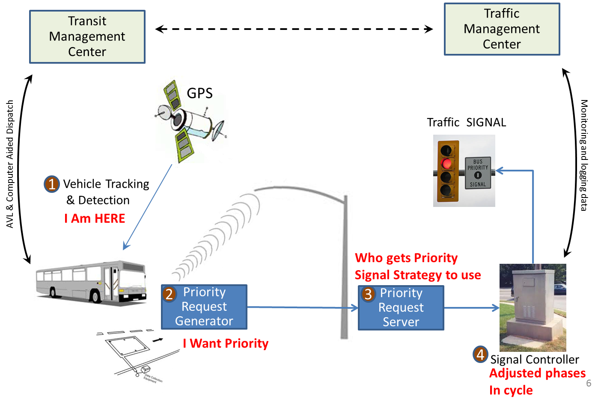

Figure 4 Conceptual Elements of Active Transit Signal Priority

Note, that logging of priority requests and whether they were granted may also be sent back to the Traffic Management Center. Similarly, the Automatic Vehicle Location and Computer Aided Dispatch systems may be sharing information between the vehicle and the Transit Management Center on current location, schedule adherence, passenger loadings, other transit vehicles etc. Even when the transit and traffic management are collocated at the same center the transit and traffic data often are on separate and disparate systems potentially creating an integration need when TSP performance. This raises an important point, that where and how these functions are implemented depends on the system architecture and the information needed to implement tradeoffs and operational policies of concern to those running the system. Systems can be totally distributed with the PRG and schedule information on the Transit Vehicle and the PRS and decisions to grant priority residing in the field within the signal cabinet. Making tradeoffs between transit vehicles and/or types of transit service or how full the vehicles are may require additional information to be sent to each transit vehicle, or for some decisions to be made at their respective operations centers. Understanding and determining the needs and resultant system architecture and interfaces to implement them is one of the main purposes of the Systems Engineering process.

As stated, once it receives a priority request the PRS selects which signal priority strategy to implement based upon where the signal is within its cycle and when the transit vehicle is expected to arrive at the intersection. Signal Priority Strategies include:

* Green Extension: As a transit vehicle approaches near the end of the green time in its direction of travel, the green time for that phase is extended to allow it to pass.
* Red Truncation: As a transit vehicle approaches a red light in its direction of travel, phases are adjusted for other movements to reduce the time that the transit vehicle sits at the intersection.
* Phase suppression/rotation: As the transit vehicle approaches or is stopped at a signal a cross-street phase may be suppressed or shifted to reduce delay to the transit vehicle. For example, in Figure 3 the North South left turn phase may be skipped or moved to the end of the cycle and the green extended for an approaching North South transit vehicle.
* Transit Only Phase: A transit only phase (all other movements red) may be inserted into the cycle to allow transit vehicles to cross an intersection diagonally, or to allow for a transit only movement. In queue jump lanes a leading green is often given to the transit vehicle to allow them to clear the intersection and merge back into the traffic flow lanes prior to general traffic in the same direction.

The simplest active signal priority system issues and grants a priority request every time an eligible vehicle is detected. Early TSP systems were often of this type and while they provided benefits to the transit system also caused delays to cross traffic with mixed overall benefits. Most modern TSP systems are based on conditional priority using schedule adherence and other criteria. As more factors are desired for conditional strategies (such as passenger loadings) the information and interface needs/requirements and architecture to support them become more complex. Also, different signal controllers vary as to which of the signal priority strategies and/or conditional tradeoffs they can implement. The remaining tasks in this project are concerned with what these needs/requirements are and their implications in implementing TSP within the RTS system.

# The Potential Role of Transit Signal Priority Within RTS

This section describes the potential role of Transit Signal Priority with the RTS system. This includes the purpose of implementing TSP within RTS, proposed goals, objectives, and evaluation measures , the differences between the Countywide TSP and RTS, and a brief summary of how TSP has been considered in the previous conceptual RTS Planning efforts and ongoing BRT corridor studies/projects for Montgomery County.

## Purpose of TSP within the RTS System

As stated in the Rapid Transit System (RTS) Transit Signal Priority Study Scope (Montgomery County DOT, February 2013) “A key component of a successful Rapid Transit System (RTS) will be the provision and operation of a transit signal priority (TSP) system to reduce delay for rapid transit vehicles along the operating corridors”. It then states:

*The purpose of the TSP system is typically to reduce overall delay and improve schedule adherence along transit routes.*

There are several factors within the RTS system that provide nuance to this general statement of the Purpose of TSP. First, the frequency of service within the RTS system corridors increase the importance of reducing travel time variability in the system to ensure that vehicles run on consistent headways and minimize the opportunity for vehicle bunching along the corridors and at stations. This is especially important for the bi-directional exclusive guideway proposed along Viers Mill Rd. Maintaining a constant flow of RTS vehicles with adequate spacing between them is again highlighted as frequency increases and the ability to grant priority to all vehicles making a priority request diminishes. It therefore becomes important for the TSP system to not only reduce overall delay but reduce the likelihood that a TSP request will be needed.

Second, several of the major causes of transit delay (e.g. traffic congestion and friction, boarding/alighting times, etc.) are reduced or eliminated with RTS especially where there are exclusive guideways proposed. Yet, signal delay and the additional time lost due to acceleration and deceleration remains. Reducing not only the delay at each signal but also the frequency that the buses stop/slow for signals in total is therefore also an important consideration.

Third, there may be other transit service within the RTS Corridors that may or may not be eligible to use the RTS guideway or request TSP at intersections.

Consequently the revised purpose and goal for TSP within the RTS system is proposed as:

***Purpose: Help maintain consistent transit vehicle flows and travel times for RTS Service while reducing delays due to stops at traffic signals.***

## Goals, Objectives, and Evaluation Measures[2]

Given the above purpose statement the Goal of TSP within RTS can be stated as:

***Goal: Improve expected Transit Travel Times for travelers using the RTS system through improving reliability and reducing delays without undo negative impacts to the overall transportation system performance or other travelers.***

Objectives should be defined to capture measureable attributes of an overall goal and also reflect tradeoffs and constraints within the various dimensions of the overall goals. Objectives need to be defined at both the corridor and system wide levels.

**Corridor Level Objectives:** At the corridor level, the TSP within the RTS system needs to balance the positive RTS travel time and improved reliability impacts with the potential disruptions and additional delays that may result to other transit services in the corridor, crossing traffic and transit service, and pedestrians or bicycle traffic. In all cases operational safety must be maintained by requiring that once a signal phase is initiated that minimum times for pedestrian walk, turning movements, and other safety factors be observed. At the corridor/intersection level the proposed objectives and measures are:

* **Increase RTS travel speeds by reducing delay at traffic signals:**
  + Predicted signal delay (using simulation tools such as VISSIM) for TSP enabled RTS vehicles at intersections and along corridor
* **Increase RTS on‐time performance by reducing travel time variability:**
  + Predicted run times (using simulation tools such as VISSIM) for TSP enabled RTS vehicles by type of right-of-way segment along corridor
* **Avoid undo impacts to non-RTS transit performance:**
  + Predicted signal delay (using simulation tools such as VISSIM) for thru and crossing non-TSP enabled transit service at intersections and along corridor.
  + Predicted run times (using simulation tools such as VISSIM) for thru and crossing non-TSP enabled transit service by type of right-of-way segment along corridor.
* **Avoid undo impacts to the overall transportation system and other travelers:**
  + Intersection Highway Capacity Manual volume to capacity ratio must be less than 1.
  + Available slack time (time remaining after minimum safe green times and pedestrian crossings are met within each phase) at each intersection must be greater than five (5) seconds.
* **Provide an increase in overall person throughput and level of service:**
  + Predicted person delay (using simulation tools such as VISSIM) for all travelers at intersections and along corridor (should not increase).
  + Predicted person throughput (using simulation tools such as VISSIM) for all travelers at intersections and along corridor (should increase).

**System Wide Objectives:** Other important considerations include the overall cost to implement, operate, and maintain the TSP system and components, compatibility with existing and planned technologies and equipment used within Montgomery County, functionality (the ability to implement conditional TSP algorithms that capture agreed upon preferences), the ability to monitor and produce reports on the overall performance of the TSP operations and impact, and technical feasibility/reliability (proven systems). Some of the system wide factors are that the system should be:

* **Cost Effective:**
  + Benefit Cost Ratio greater than 1.
* **Compatible and Interoperable:**
  + Selected on board communications and other technologies that are compatible with existing and planned systems within Montgomery County (Traffic Operations, Ride On, WMATA, The Purple Line, etc.)
  + Selected roadside communications and other technologies that are compatible with transit vehicles that may operate within the RTS corridors (Ride On, WMATA, The Purple Line, MTA Express Service, etc.)
  + Selected network and software systems that interface with existing and planned systems within Montgomery County.
  + Utilize applicable ITS Standards and non-proprietary data formats for all interfaces, dialogs, and data archives.
* **Functional:**
  + Meet all needs and functional requirements defined in the Concept of Operations (under development).
  + Include system and subsystem component and software verification and validation tests defined in the Systems Engineering Analysis (and pass these tests during implementation and testing).
  + Include an acceptance validation and refinement period during operations (1 year) to modify parameters and ensure that they system is performing properly prior to final acceptance.
* **Technically feasible and reliable:**
  + All technologies, communications, and software systems have been successfully deployed and accepted in North America.
  + Positive reports on reliability and system performance from other locations where the technologies and systems have been deployed.
* **Able to provide performance measures and reports:** 
  + Produce measures of TSP effectiveness for TSP enabled RTS vehicles including the vehicle, location, and time of all signal delays, priority requests, and whether the request was granted.
  + Performance measures of TSP impacts for all non-RTS transit service travelling through TSP intersections including stops and delay at the intersection.
  + Performance measures of TSP impacts on the signal system including when TSP is requested, which requests are granted, the type of TSP treatment, and recovery time.
  + Ability to monitor and provide reports (real time, daily, weekly) to the traffic operations center and the transit management center upon request.

Both the corridor level and system wide objectives and resultant requirements will be further refined during the development of the TSP Concept of Operations.

## TSP in Past & Parallel Montgomery County Priority Transit Studies/Projects

As stated, the previous RTS conceptual planning and refinement efforts provide key inputs to this study on potential intersections and utilizing signal operations for line haul TSP, to support queue jumps, or specialized turning signals in/out of facilities. The first initial exploration was the Countywide Bus Rapid Transit Study (Parson’s Brinkerhoff, July 2011) which performed an overview assessment of TSP applicability at the signalized intersections along each RTS route. The PB study limited its evaluation of TSP to green extension and/or red truncation for RTS vehicles operating straight through at intersections and relied on intersection level-of-service as the measure to determine potential TSP applicability. Intersection LOS data was confined to existing conditions data from Maryland SHA and M-NCPPC resources for approximately 70 percent of the RTS network. Intersections with weekday peak period LOS “C” or “D” were assumed to be candidates for TSP. The study also identified queue jump locations where vehicles use an auxiliary lane at a signalized intersection to bypass the adjacent general traffic queue and then have and advance green signal (activated through the TSP system PRG and PRS) to move through the intersection unimpeded ahead of the general traffic. Last, where For locations where BRT left or right turning movements would be made from one major road to another, revised or new left turn or right turn phasing was assumed to be possible if the overall Intersection LOS was “C” or” D.” The number of signalized intersections assumed within each corridor for TSP, Queue Jumps and Special Turn Signals is provided in Table 2. These were used as inputs to calculate speeds (travel times) and ridership within each corridor for the initial PB study and reviewed as part of the Transit Functional Plan development. They will also be assessed in the remainder of this effort.

Table 2 Recommended Signal Priority Treatments from Initial Concept Study   
(Parsons Brinkerhoff, July 2011)



Second, The Traffic Group’s Rapid Transit Montgomery County Maryland Concept Plans and Cost Estimates for the Envisioned System (The Traffic Group, January 2011) was commissioned by the County Executive’s Transit Task Force to develop conceptual designs for an RTS system. It focused on the feasibility constructing of a high level BRT system with no ROW expansion for the transitways themselves and developed and conceptual designs and costs utilizing median based guideways wherever practical (feasible). Where median guideways were impractical curbside Business Access and Transit (BAT) lanes were assumed followed by mixed traffic operations. Only RTS vehicles were assumed to operate within the median guideways and BAT lanes. The Traffic Group effort provided an upper bound on what could be done if an aggressive approach that put the RTS system and service first without regard to impacts to the other modes was taken. It did not address ridership, system operations or other tradeoffs. In order to assume the highest level of service possible within the conceptual designs it assumed that TSP would be implemented at every signal along each proposed corridor. The corridors, their length, and the number of TSP signalized intersections within them are provided in Table 3. As shown, the conceptual designs assumed 330 TSP enabled signalized intersections within 102.5 miles of right of way in 17 corridors.

Table 3 Corridors and TSP from the Traffic Group Concept Analysis  
(The Traffic Group, January 2011)



A number of planning, design, and implementation projects for priority transit that incorporate TSP in their future operations are also ongoing. These include:

* The Purple Line
* The Corridor Cities Transitway
* The MD 586 (Veirs Mill Road) Bus Rapid Transit (BRT) Study from Rockville Metrorail Station to Wheaton Metrorail Station
* MD 97 (Georgia Avenue) Bus Rapid Transit (BRT) Study from the Glenmont Metrorail Station to Montgomery General Hospital

Each of these will be developing detailed design and operating plans for how TSP will be implemented and operated within their chosen alternative and systems including: the equipment used, communications and interface requirements, and the strategies for requesting and granting signal priority in their operations. Consequently, coordination is needed between each of these efforts to insure that their operations are consistent and compatible with what is being planned for both the Countywide TSP and RTS systems. More details on these corridors and plans will be included in the Technical Memorandum 2 on existing conditions of signal systems and traffic/transit operations on corridors planned for TSP implementation (See Section VI).

## Differences to consider between Countywide and RTS TSP

It is important to point out that while it must be coordinated and build upon the Countywide TSP program implementing TSP within the RTS system both is more complex with many more issues and tradeoffs, and due to its additional Priority ROW treatments provides the opportunity to implement additional TSP signal strategies and potentially greater TSP benefits. Some of the differences between the two are highlighted in Table 3.

Table 4 Countywide versus RTS TSP Considerations

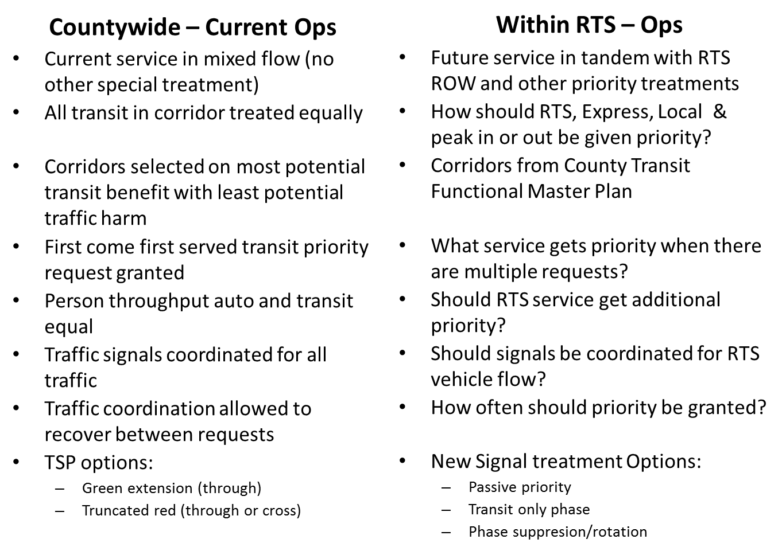

# Stakeholders and Their Needs

Identifying the stakeholders that use the RTS system and/or are impacted by its implementation and operation and understanding their needs and how to respond to them is a key element in considering TSP within the RTS system. It is a central aspect in developing a Concept of Operations and the overall Systems Engineering Process. Different groups of stakeholders include: System Users, Traffic System Owner/Operators, Transit System Owner/Operators, Planning Organizations, Funding Bodies, and Neighboring Jurisdictions. Each has its own concerns and perspective which are summarized in Table 5.

Note, that advocacy groups, consultants, and technology/system providers are not listed as stakeholders. While they speak out, hold strong positions, or may have a financial stake in the TSP and RTS system decisions they are secondary stakeholders, either advocating for the stakeholder group they purport to represent, or are part of the solution. Land owners, developers, and neighborhoods are also not included since while they may be important stakeholders for the overall system it is unlikely that TSP will be a major concern or impact them significantly.

Table 5 Needs Concerns by Stakeholder



# Policy Issues & Challenges

As discussed above there are many questions and issues that must be resolved concerning TSP within the RTS system as the process moves forward from concept to design and implementation. Some, such as issues of equipment compatibility determining operational parameters are technical and can be addressed during the systems engineering and design process. However, others dealing with service tradeoffs and agency coordination/collaboration are more public policy and goal related. These act as inputs into the systems engineering process setting the constraints and technical/operational environment that TSP will operate in and may bound what can be done and what potential benefits due to TSP may result.

This section highlights these Policy Issues and Challenges so that they can be brought to the attention of the Steering Committee and appropriate decision makers.

**Traveler Preferences and Weights.** First, is the issue how to weight the travel of different stakeholders along the RTS corridors and within each type of ROW priority treatment. A general preference to person versus vehicle trips is recommended, however, a more detailed discussion is warranted. This includes tradeoffs between:

* Transit services:
  + RTS passengers and other transit services (local bus, non-RTS express service)
  + Peak direction and off peak direction
  + RTS corridor and crossing transit service (or crossing RTS corridors)
* Traffic system versus Transit operations
  + General traffic level of service and delay versus RTS level of service and delay
  + Truck and other vehicle travel versus RTS service
* Pedestrian and bicycle traffic within intersections

The general policy on which types of travelers are to be given preference sets the context for policy decisions on:

* What transit service will be allowed to share the RTS priority ROW
* What transit service will be allowed to generate requests for signal priority (by direction and time of day)
* Which intersections along RTS corridors are to be enabled for TSP operations (All intersections versus those that meet operational criteria)
* How often will the requests for Signal Priority be granted at each intersection (i.e. will there be a lockout after a request is granted and for how long)
* What real time monitoring of different transit services and communication between vehicles/operational centers is needed. For example, if all service types can make a request for priority but they have different preferences, the system will need to know the status of all transit vehicles in the vicinity to determine whether to grant priority to a particular vehicle or not (note, this can reside on the vehicle in the request generator or at the roadside at the request server).

**Equipment Compatibility and Functionality.** Second, the agency stakeholders responsible for operating the traffic signal systems and transit services within Montgomery County (Montgomery County Traffic, Maryland SHA, Ride On, WMATA, MTA, The Purple Line, the Corridor Cities Transitway, etc.) need clearly specified agreements on on-board and wayside equipment functionality and communications standards and protocols. This is a necessity to ensure that wayside traffic signals and controllers can serve all the transit systems within a corridor (e.g. the Purple Line and University Boulevard RTS) with one system, and also that duplicate equipment is not needed on individual transit vehicles.

**Independent or Integrated Operations.** Last, is whether the RTS system will be operated as an independent system with its own operations center, communications, control system and other components, or whether it will be an integral part of the Montgomery County Traffic Operations and Ride On system. Whether it is independent or integrated may determine the communications architecture and interfaces needed and what real time communications or control is feasible at what cost. This decision may also influence.

* Real time wayside, on-board and system monitoring and reporting capabilities
* Feasible communications and interfaces
  + Bus to/from bus
  + Bus to/from operational center
  + Bus to/from wayside
  + Operational center to/from wayside

# Next Steps

Now that foundational knowledge and high level needs, goals, objectives and potential roles of TSP within RTS have been provided the next steps for this study are to document the existing conditions on signal systems, communications, and traffic & transit operations within the RTS corridors, and then carry out the high level RTS TSP planning and policy development. This includes:

* Ongoing interaction with the RTS TSP stakeholders (see Section IV) to refine operational needs and better understand their systems architecture, equipment, and current/future operations with respect to RTS.
* Ongoing collaboration with the Service Planning and Integration Work Group and consultant team to incorporate their service recommendations and system design into the TSP recommendations.
* Develop a recommended Systems Engineering Approach to TSP implementation on the RTS study corridors, including integration with existing TSP programs in Montgomery County.
* Perform a review of performance characteristics along the recommended RTS corridors. Review RTS service and operations plan for potential conflicts and qualitative impacts associated with TSP system operations
* Establish policy recommendations regarding TSP implementation both for the overall systems and along RTS corridors by type of ROW priority treatment. Include best-practice parameters and minimum criteria for system architecture and performance to support the Montgomery County RTS
* Develop recommended guidelines for implementing TSP on RTS corridors to the extent possible at this stage of the RTS system planning, addressing some or all of the following areas of interest:
  + Recommended technology and equipment specifications
  + Typical schedule for TSP implementation relative to RTS construction
  + Recommended signal timing and operational guidelines
  + Installation and maintenance guidelines for RTS corridors
* Develop recommendations for inter-agency partnership and coordination with regard to TSP operation and signal coordination.
* Identify traffic signal equipment modifications or upgrades necessary on a corridor level to support TSP systems on the RTS study corridors
* Prepare and deliver remaining deliverables.

Two additional deliverables remain for this study.

Technical Memorandum 2 will describe existing conditions of signal systems and traffic/transit operations on corridors planned for TSP implementation. Completion of a draft version for review and comment is expected in Mid-October to include documentation of:

* Overall Transportation System Operations
  + Montgomery County and SHA signal system characteristics
  + Transit Operational technologies & systems (RIDE ON, WMATA, MTA)
* Within each corridor:
  + Characteristics (length, number of signals, HCM LOS, volumes, signal coordination, etc. )
  + Existing and proposed ROW and other priority treatments
  + Existing and proposed transit service
  + Potential for TSP

A final Technical Memorandum 3: Transit Signal Priority Planning will document the overall planning study. Completion of the draft version for review and comment is expected in Mid - November to document findings and recommendations on:

* Existing conditions, constraints and assumptions
* TSP Policy and Corridors
  + Recommended Montgomery County RTS-related TSP policies and procedures
  + Preferred minimum criteria and Measures of Effectiveness (MOE) for selection and evaluation of TSP locations
  + Preliminary operational review of RTS study corridors
* TSP and Traffic Operations
  + System wide TSP strategies and operational parameters.
  + Corridor ROW priority treatment strategies and operational parameters
* Concept of Operations and System Control
  + High-level Concept of Operations for TSP integration with the RTS system
  + Integration of TSP with other transit ITS, traffic engineering, and EMS pre-emption systems
  + Recommended system control architecture

References

1. Intelligent Transportation Society of America (ITSA),”Overview of Transit Signal Priority”, Washington DC, 2004.
2. Kittelson & Associates, “Howard Street Light Rail Transit Signal Priority Implementation” Report for Maryland Transit Administration Project 7202.02, Baltimore Maryland, May, 2008.
3. Montgomery County DOT, “Rapid Transit System (RTS) Transit Signal Priority Concept Study : Transit Signal Priority Subtask Scope” Montgomery County Rapid Transit System Project Steering Committee, Rockville Maryland, February 2013 : <http://www.montgomerycountymd.gov/RTS/Resources/Files/Transit_Signal_Priority_Subtask_Scope.docx>
4. Montgomery County Executive’s Transit Task Force, “Report and Recommendations of the County Executive’s Transit Task Force”, Montgomery County Executive’s Office, Rockville Maryland, May 2012.
5. Montgomery County Planning Department, “Countywide Transit Corridors Functional Master Plan”, Maryland National Capitol Park and Planning Commission (MNCPPC), Silver Spring Maryland, July 2013
6. Parsons Brinkerhoff, “Consultant’s Report for a Countywide Bus Rapid Transit Study “, Report for Montgomery County Department of Transportation, Rockville Maryland, July 2011.
7. Sabra, Wang, & Associates Inc. “Concept of Operations: Transit Signal Priority within Montgomery County Maryland”, Paper for the Maryland State Highway Administration and Montgomery County Maryland, Columbia Maryland, July 2013
8. The Traffic Group, “Rapid Transit Montgomery County Maryland: Concept Plans and Cost Estimates for the Envisions System”, for the Montgomery County Executive’s Task Force, Rockville Maryland, January 2011
9. United States Department of Transportation, Federal Transit Administration. “Transit Signal Priority: A Planning and Implementation Handbook.” 2005
10. Walker, Jarrett, “Human Transit: How Clearer Thinking about Public Transit Can Enrich Our Communities and Our Lives, Island Press Kindle Edition, 2011.

1. This discussion focuses on the conceptual elements and functions (logic) of Active TSP. How Active TSP is implemented varies based upon the communications, architecture, and technologies choses. For example, Montgomery County uses a fully distributed system with the PRG on each bus and the PRS located in the traffic control cabinet. The traffic and transit management centers are also co-located at one site. The specific design, architecture, technology and functions for Montgomery County’s system will be discussed in Technical Memorandum 2.
2. Note that while similar, the goals, objectives and especially the measures used for planning and designing a system prior to its implementation will be different from those used to monitor performance and goal attainment during either testing or ongoing operations. This section is concerned with those aimed at planning and design.