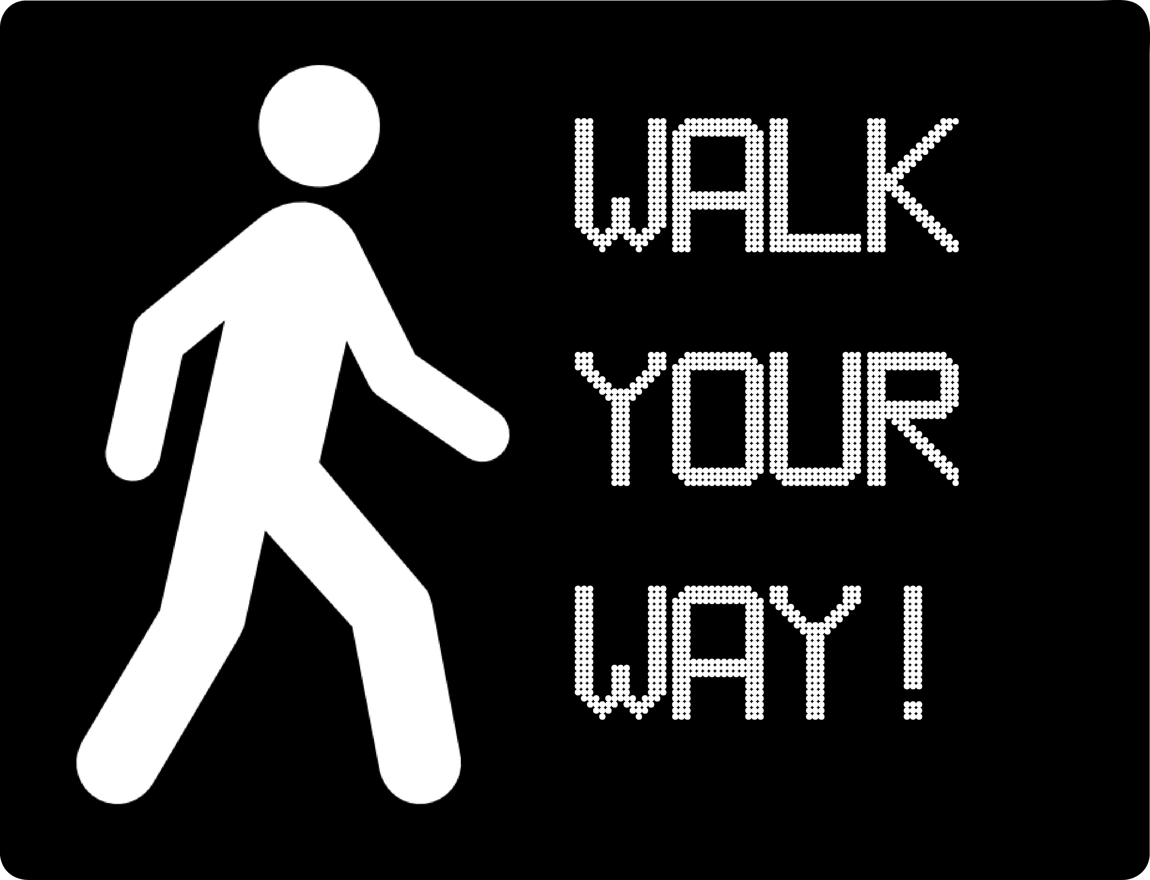
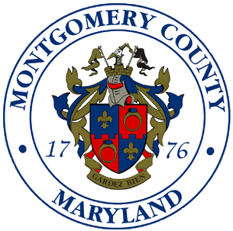
Walk Your Way Project Grant Application

Montgomery County Department of Transportation

Montgomery County Public Schools

Please attach a separate page for each application section (Project Group Information, Project Description, Project Implementation, and Project Logistics). All project groups must have a teacher or staff sponsor from the school.
Submissions can be emailed to WalkYourWay@montgomerycountymd.gov as a PDF document, or mailed/delivered to 101 Monroe Street, 10th Floor, Rockville, MD 20850. Applications will be evaluated based on the project’s originality and creativity, on the project’s potential effectiveness at educating classmates and creating a sustainable program in the future, and on the project’s use of the available budget and time. Applicants will be notified of the final decision regarding their application no later than two weeks after submission and will be accepted on a rolling basis.

Thank you for participating, and we look forward to reviewing your application. If you have any questions regarding your application, please contact Nadji Kirby at WalkYourWay@montgomerycountymd.gov.

Project Group Information:

High School:

Number of Students in Your Project Group:

Name, Email and Phone Number of Teacher/Staff Sponsor Supervisor:

Names, Class Years, Emails and Phone Numbers of Students*:

Project Description:

In 500 words or less, describe your pedestrian safety project idea and why you think your project will be successful at educating your fellow students about pedestrian safety.

Project Implementation:

In 300 words or less, describe how you plan to implement your pedestrian safety project idea at your school, and what you plan to do to continue the project at your school next year.

Project Logistics:

Please include the amount of money you are requesting to fund your project ($2,000 maximum), a budget, and a timeline. Grant money will be distributed in phases based off the timeline, and budget you provide. All projects must be completed by May 1, 2015.

