Title VI
2015 – 2017 Implementation Plan
Title VI of the Civil Rights Act of 1964

Montgomery County Department of Transportation
Division of Transit Services

Adopted date
April __, 2015

Table of Contents
I. INTRODUCTION 1
II. OVERVIEW OF SERVICES 2
III. POLICY STATEMENT AND AUTHORITIES 8
IV. NONDISCRIMINATION ASSURANCES TO MTA 9
V. PLAN APPROVAL DOCUMENT 9
VI. ORGANIZATION AND TITLE VI PROGRAM RESPONSIBILITIES 9
VII. GENERAL REPORTING REQUIREMENTS 12
VIII. REQUIREMENTS OF TRANSIT PROVIDERS 15
IX. Appendices 16
Appendix A – Title VI Assurances, Policy and Notice 16
Appendix B – Title VI Complaint Procedures and Form 19
Appendix C – Description of Title VI Investigations, Lawsuits and Complaints 24
Appendix D – Public Participation Plan 25
Appendix E – Language Assistance Plan 26
Appendix F – Minority Representation on Ride On Advisory Committees – December 2014 27
Appendix G – Title VI Policies 28
Appendix H – Title VI Policies Summary of Public Involvement Activities 31
Appendix I – Fare and Major Service Changes – 2012 to 2014 33
Appendix J – County Council Approval of the Montgomery County Title VI Implementation Plan 2015 to 2017 35

List of Tables
Table 1: Ride On Ridership Ethnic Background 6
Table 2: Ride On Ridership Household Income 6
Table 3: Montgomery County Investigations, Lawsuits and Complaints 2012 to 2014 13

List of Figures
Figure 1: Ride On Fixed Route Bus Unlinked Passenger Trips FY2000 to FY2014 2
Figure 2: Montgomery County Public Transportation Services 3
Figure 3: Minority Populations Greater than County Average 4
Figure 4: Percent of Households below the Poverty Level 5
Figure 5: Ride On On-board Survey - English 7

INTRODUCTION
Title VI of the Civil Rights Act of 1964 prohibits discrimination on the basis of race, color, or national origin in programs and activities receiving Federal financial assistance. Specifically, Title VI provides that "no person in the United States shall, on the ground of race, color, or national origin, be excluded from participation in, be denied the benefits of, or be subjected to discrimination under any program or activity receiving Federal financial assistance." (42 U.S.C. Section 2000d).
The Civil Rights Restoration Act of 1987 clarified the intent of Title VI to include all programs and activities of Federal-aid recipients, sub-recipients, and contractors whether those programs and activities are federally funded or not.
Recently, the Federal Transit Administration (FTA) has placed renewed emphasis on Title VI issues, including providing meaningful access to persons with Limited English Proficiency.
Recipients of public transportation funding from FTA and the Maryland Transit Administration (MTA) are required to develop policies, programs, and practices that ensure that federal and state transit dollars are used in a manner that is nondiscriminatory as required under Title VI.
This document details how Montgomery County Department of Transportation incorporates nondiscrimination policies and practices in providing services to the public.

OVERVIEW OF SERVICES
Montgomery County is located in Maryland northwest of the Washington, D.C. It is Maryland’s most populous county with a 2010 population of 971,777. Ride On is a local transit service owned and operated by Montgomery County. Since starting as a feeder bus service to Washington’s Metro, Ride On has grown to its current 281 peak vehicles on 78 different bus routes. On an average weekday, Ride On carries 88,370 riders and operates 2,591 revenue hours. Figure 1 shows Ride On unlinked passenger trips from fiscal year 2000 to fiscal year 2014.
Montgomery County is served by multiple transit agencies. The Washington Metropolitan Transit Authority (WMATA) provides rapid rail service with the Red Line and local bus services on 17 bus lines. Through MTA, the MARC provides commuter rail services. The MTA Commuter Bus program also provides commuter bus services and Ride On provides local and express bus services. Figure 2 on the following page illustrates the public transportation services in the County as of May 2014. This Title IV Implementation Plan applies to the Ride On services operated by the Montgomery County Department of Transportation.
Source: National Transit Database
Figure 1: Ride On Fixed Route Bus Unlinked Passenger Trips FY2000 to FY2014
Figure 2: Montgomery County Public Transportation Services
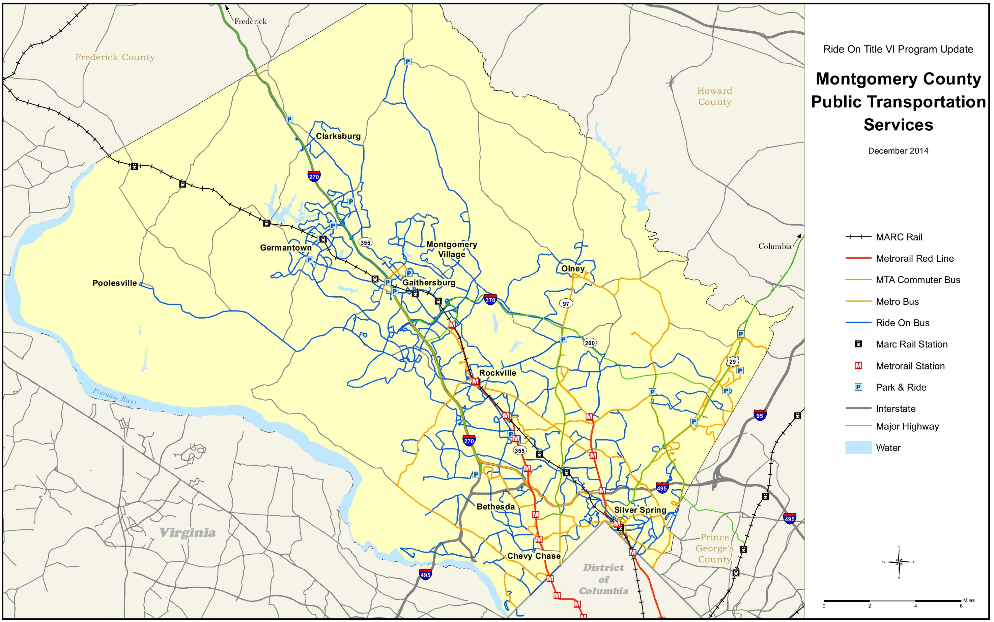

Figure 3 shows the distribution of minority populations within Montgomery County
Figure 3: Minority Populations Greater than County Average
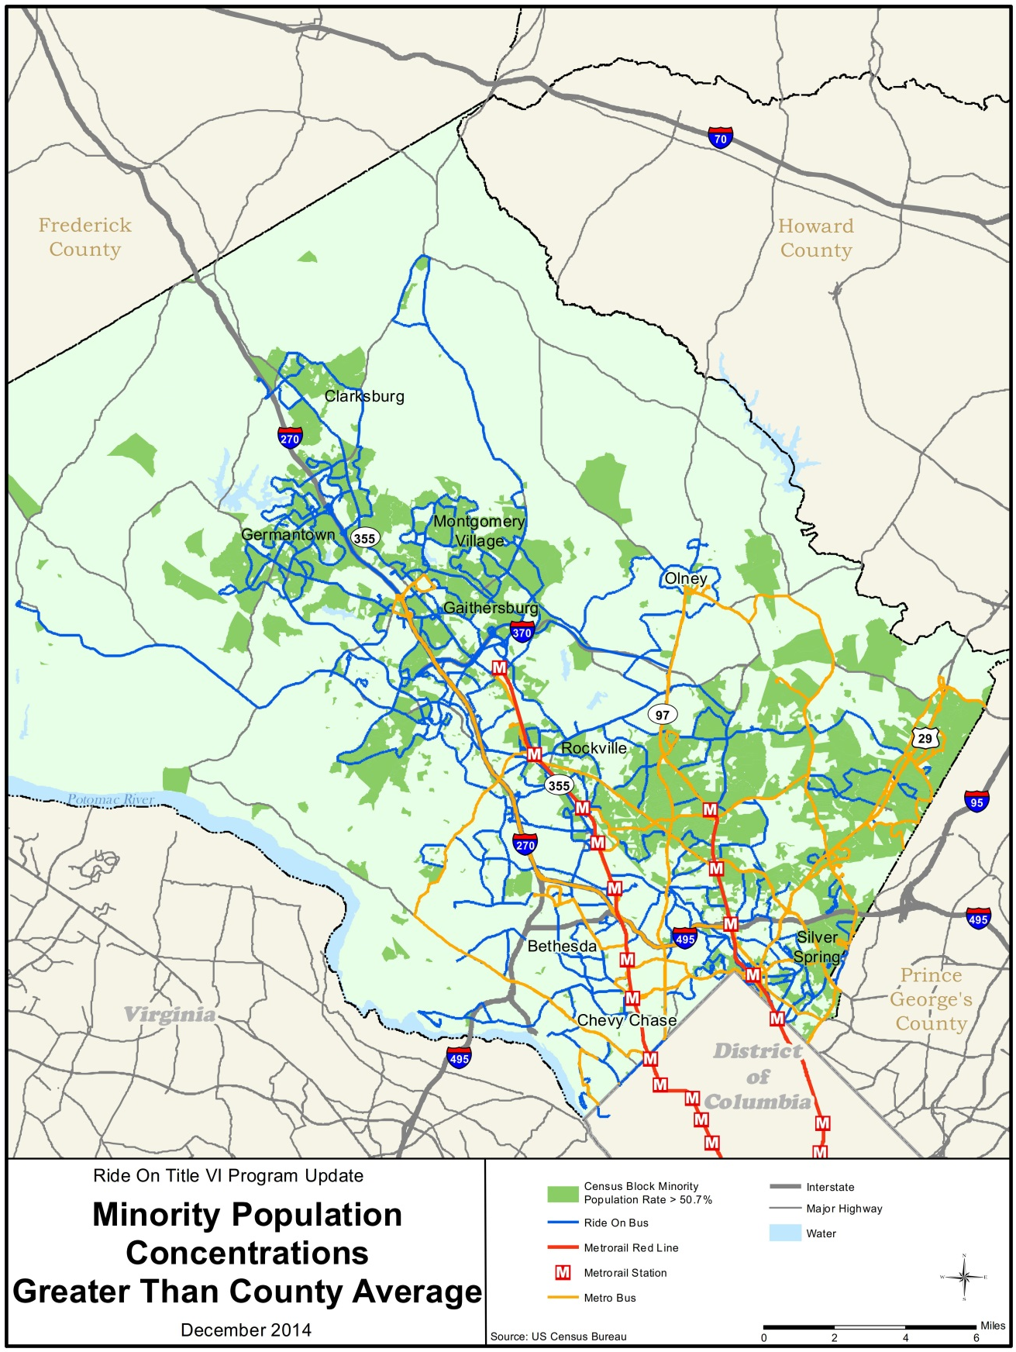

Figure 4 presents the number of households below the poverty level.
Figure 4: Percent of Households below the Poverty Level
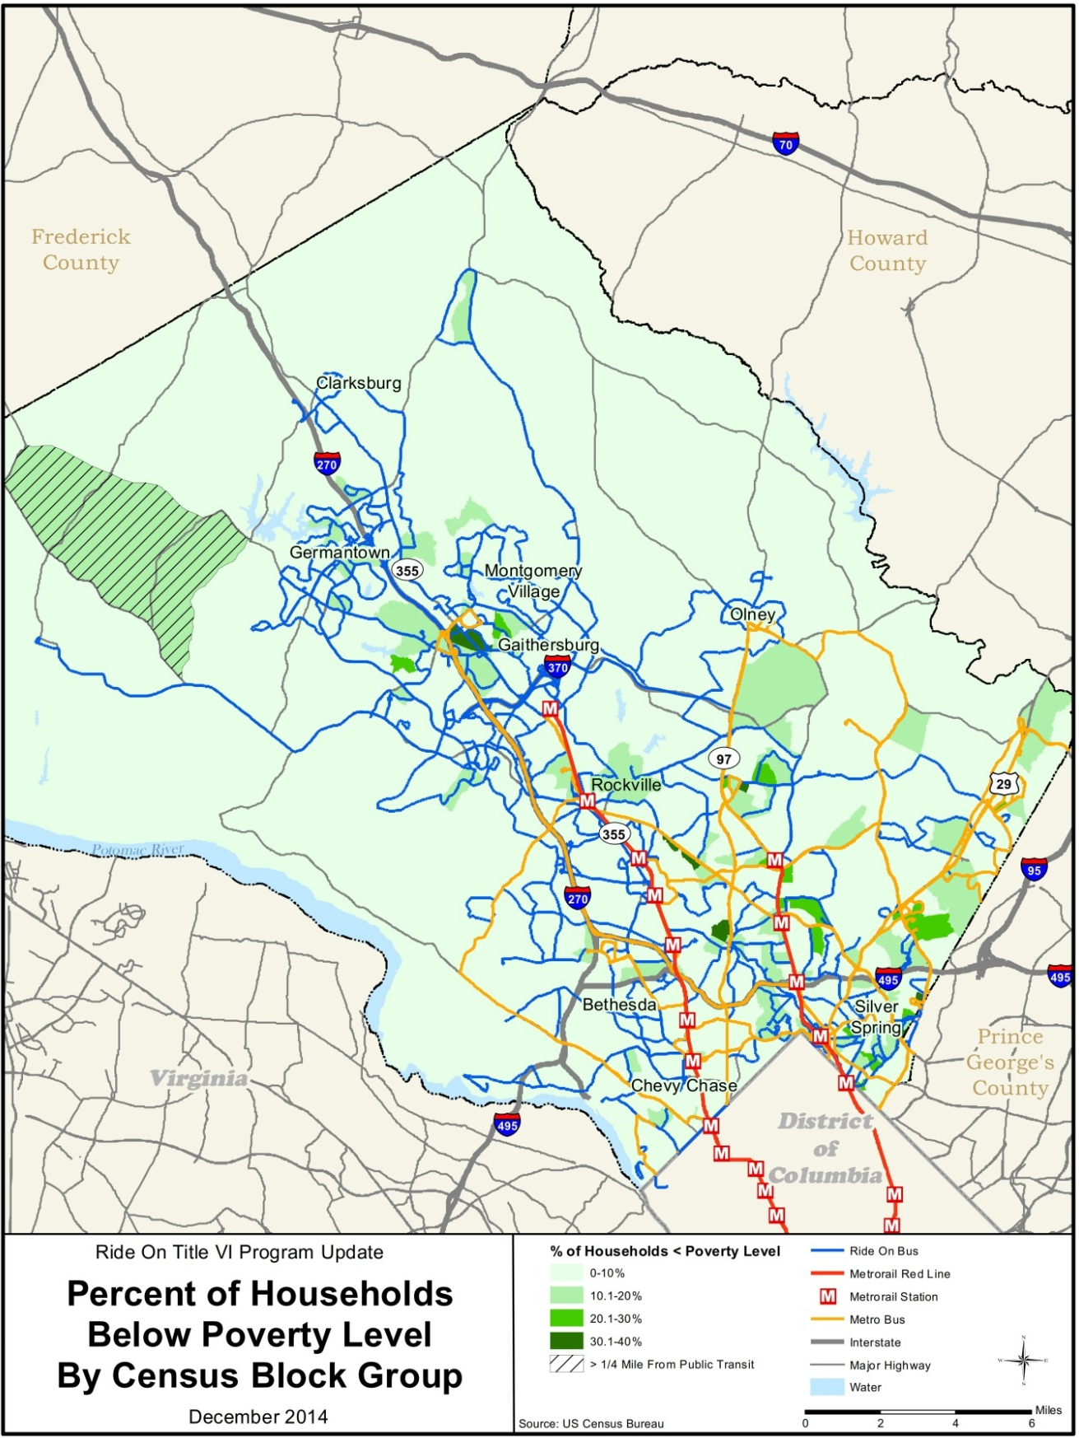
The Ride On on-board survey was conducted from July 28, 2014 to November 7, 2014. On-board surveys were available in the seven primary languages spoken in Montgomery County including English, Spanish, Chinese, Korean, Vietnamese, Amharic, and French. Figure 5 shows the English version of the survey.
Data collectors were instructed to ask customers to participate in the survey and hand each participating customer a small clipboard and survey so that the survey could be completed on-board the bus. 10,666 completed surveys were returned to the data collectors. Of the surveys returned, 9,500 were English, 1,130 were Spanish and 36 were in other languages. Not all respondents responded to each question so the number of responses by question varies. Table 1 tabulates the results by ethnic background.
Table 1: Ride On Ridership Ethnic Background
Ethnic Background | # of Responses | % of Responses
American Indian or Alaska Native | 116 | 1.14
Asian | 966 | 9.47
Black or African Descent | 4,305 | 42.19
European Descent | 1,687 | 16.53
Hawaiian of other Pacific Islander | 28 | 0.27
Hispanic | 2,226 | 21.82
Middle Eastern Descent | 147 | 1.44
Other and Two or More Races | 728 | 7.14
Total Responses | 10,203 | 100.00
Blank or no response | 463
Total Surveys Returned | 10,666
Source: Ride On On-board Survey – December 2014
Table 2 tabulates the results by household income.
Table 2: Ride On Ridership Household Income
Household Income | # of Responses | % of Responses
Less than $20,000 | 2,714 | 29.39
$20,000 to $29,999 | 2,395 | 25.93
$30,000 to $49,999 | 1,931 | 20.91
$50,000 to $74,999 | 825 | 8.93
$75,000 to $99,999 | 456 | 4.94
$100,000 to $149,999 | 474 | 5.13
$150,000 to $199,999 | 246 | 2.66
$200,000 or more | 194 | 2.10
Total Responses | 9,235 | 100.00
Blank or no response | 1,431
Total Surveys Returned | 10,666
Source: Ride On On-board Survey – December 2014

Figure 5: Ride On On-board Survey - English

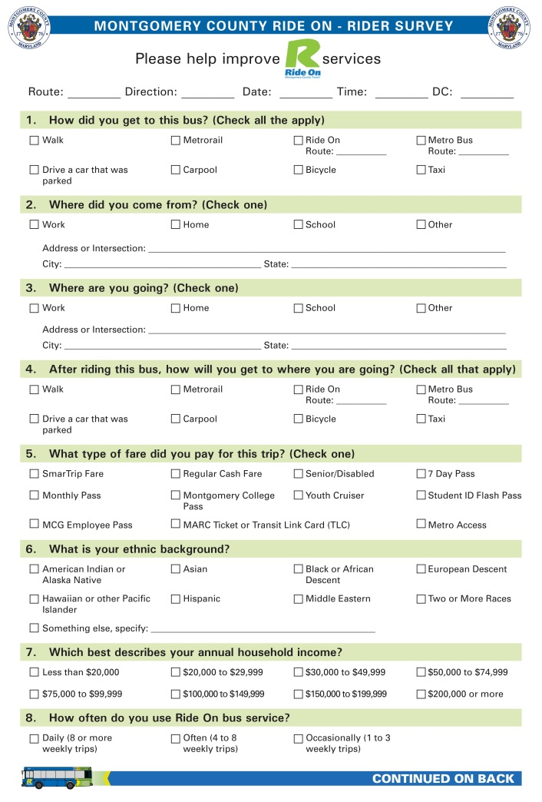
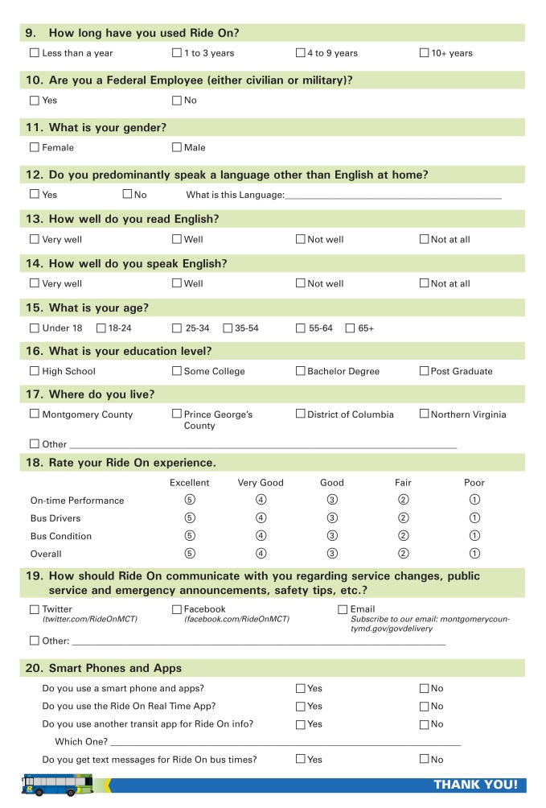

POLICY STATEMENT AND AUTHORITIES
Title VI Policy Statement
Montgomery County is committed to ensuring that no person shall, on the grounds of race, color, national origin, as provided by Title VI of the Civil Rights Act of 1964 and the Civil Rights Restoration Act of 1987 (PL 100.259), be excluded from participation in, be denied the benefits of, or be otherwise subjected to discrimination under any program or activity, whether those programs and activities are federally funded or not.
Montgomery County’s Title VI Manager is responsible for initiating and monitoring Title VI activities, preparing required reports, and other responsibilities as required by Title 23 Code of Federal Regulations (CFR) Part 200, and Title 49 CFR Part 21.

__________________________________ ________________________
Signature of Authorizing Official Date
Authorities
Title VI of the 1964 Civil Rights Act provides that no person in the United States shall, on the grounds of race, color, national origin, or sex, be excluded from participation in, be denied the benefits of, or be otherwise subjected to discrimination under any program or activity receiving federal financial assistance (refer to 49 CFR Part 21). The Civil Rights Restoration Act of 1987 broadened the scope of Title VI coverage by expanding the definition of the terms “programs or activities” to include all programs or activities of Federal Aid recipients, sub recipients, and contractors, whether such programs and activities are federally assisted or not.
Additional authorities and citations include: Title VI of the Civil Rights Act of 1964 (42 U.S.C. Section 2000d); Federal Transit Laws, as amended (49 U.S.C. Chapter 53 et seq.); Uniform Relocation Assistance and Real Property Acquisition Policies Act of 1970, as amended (42 U.S.C. 4601, et seq.); Department of Justice regulation, 28 CFR part 42, Subpart F, “Coordination of Enforcement of Nondiscrimination in Federally-Assisted Programs” (December 1, 1976, unless otherwise noted); U.S. DOT regulation, 49 CFR part 21, “Nondiscrimination in Federally-Assisted Programs of the Department of Transportation—Effectuation of Title VI of the Civil Rights Act of 1964” (June 18, 1970, unless otherwise noted); Joint FTA/Federal Highway Administration (FHWA) regulation, 23 CFR part 771, “Environmental Impact and Related Procedures” (August 28, 1987); Joint FTA/FHWA regulation, 23 CFR part 450 and 49 CFR part 613, “Planning Assistance and Standards,” (October 28, 1993, unless otherwise noted);
U.S. DOT Order 5610.2, “U.S. DOT Order on Environmental Justice to Address Environmental Justice in Minority Populations and Low-Income Populations,” (April 15, 1997); U.S. DOT Policy Guidance Concerning Recipients’ Responsibilities to Limited English Proficient Persons, (December 14, 2005), and Section 12 of FTA’s Master Agreement, FTA MA 13 (October 1, 2006).

NONDISCRIMINATION ASSURANCES TO MTA
In accordance with 49 CFR Section 21.7(a), every application for financial assistance from the Federal Transit Administration (FTA) must be accompanied by an assurance that the applicant will carry out the program in compliance with DOT’s Title VI regulations. This requirement is fulfilled when the Maryland Transit Administration (MTA) submits its annual certifications and assurances to FTA. The MTA shall collect Title VI assurances from sub recipients prior to passing through FTA funds.

As part of the Certifications and Assurances submitted to MTA at the time of grant application and award, Montgomery County submits a Nondiscrimination Assurance which addresses compliance with Title VI as well as nondiscrimination in hiring (EEO) and contracting (DBE), and nondiscrimination on the basis of disability (ADA).
In signing and submitting the assurance, Montgomery County confirms to MTA its commitment to nondiscrimination and compliance with federal and state requirements.

PLAN APPROVAL DOCUMENT
The acknowledgement of the County Council approval of the Montgomery County Title VI Plan is included in Appendix J.

ORGANIZATION AND TITLE VI PROGRAM RESPONSIBILITIES
Under the authority of Montgomery County, the Senior Planning Specialist will serve as the Title VI Manager and is responsible for ensuring implementation of the agency’s Title VI program. The Montgomery County Office of Human Rights is responsible for receiving, investigating and resolving Title VI complaints. The specific areas of responsibility are described below.
Overall Organization for Title VI
The Title VI Manager and staff are responsible for coordinating the overall administration of the Title VI program, plan, and assurances, including complaint recording, data collection and reporting, annual review and updates, and internal education. The Montgomery County Office of Human Rights is responsible for receiving, investigating and resolving Title VI complaints.
Title VI Manager Responsibilities
The Title VI Manager is charged with the responsibility for implementing, monitoring, and ensuring compliance with Title VI regulations. Title VI responsibilities are as follows:
1. Upon receipt, record Title VI complaints and forward them to the MTA and the Montgomery County Office of Human Rights for investigation.
2. Collect statistical data (race, color or national origin) of participants in and beneficiaries of agency programs, (e.g., affected citizens, and impacted communities).
3. Conduct annual Title VI reviews of agency to determine the effectiveness of program activities at all levels.
4. Conduct Title VI reviews of construction contractors, consultant contractors, suppliers, and other recipients of federal-aid fund contracts administered through the agency.
5. Conduct training programs on Title VI and other related statutes for agency employees.
6. Prepare a yearly report of Title VI accomplishments and goals, as required.
7. Develop Title VI information for dissemination to the general public and, where appropriate, in languages other than English.
8. Identify and eliminate discrimination.
9. Establish procedures for promptly resolving deficiency status and writing the remedial action necessary, all within a period not to exceed 90 days.
General Title VI responsibilities of the agency
The Title VI Manager is responsible for substantiating that these elements of the Plan are appropriately implemented and maintained, and for coordinating with those responsible for public outreach and involvement and service planning and delivery.
1. Data collection
To ensure that Title VI reporting requirements are met, Montgomery County will maintain:
- A database or log of Title VI complaints received. The investigation of and response to each complaint is tracked within the database or log.
- A log of the public outreach and involvement activities undertaken to ensure that minority and low-income people had a meaningful access to these activities.
2. Annual Report and Updates

As a sub-recipient of FTA funds, Montgomery County is required to submit a Quarterly Report Log to the MTA that documents any Title VI complaints received during the preceding quarter and for each year. Montgomery County will also maintain and provide to the MTA on an annual basis, the log of public outreach and involvement activities undertaken to ensure that minority and low-income people had a meaningful access to these activities.
Further, Montgomery County will submit to MTA updates to any of the following items since the previous submission, or a statement to the effect that these items have not been changed since the previous submission, indicating date:
- A copy of any compliance review report for reviews conducted in the last three years, along with the purpose or reason for the review, the name of the organization that performed the review, a summary of findings and recommendations, and a report on the status or disposition of the findings and recommendations
- Limited English Proficiency (LEP) plan
- Procedures for tracking and investigating Title VI complaints
- A list of Title VI investigations, complaints or lawsuits filed with the agency since the last submission
- A copy of the agency notice to the public that it complies with Title VI and instructions on how to file a discrimination complaint
3. Annual review of Title VI program
Each year, in preparing for the Annual Report and Updates, the Title VI Manager will review the agency’s Title VI program to assure implementation of the Title VI plan. In addition, they will review agency operational guidelines and publications, including those for contractors, to verify that Title VI language and provisions are incorporated, as appropriate.
4. Dissemination of information related to the Title VI program
Information on the Montgomery County Title VI program will be disseminated to agency employees, contractors, and beneficiaries, as well as to the public, as described in the “public outreach and involvement “section of this document, and in other languages when needed according to the LEP plan as well as federal and State laws/regulations.
5. Resolution of complaints
Any individual may exercise his or her right to file a complaint if that person believes that he, she or any other program beneficiaries have been subjected to unequal treatment or discrimination in the receipt of benefits/services or prohibited by non-discrimination requirements. Montgomery County will report the complaint to MTA within three business days (per MTA requirements), and make a concerted effort to resolve complaints locally, using the agency’s Title VI Complaint Procedures. All Title VI complaints and their resolution will be logged as described under Section 1. Data collection and reported annually (in addition to immediately) to MTA.
6. Written policies and procedures
Montgomery County Title VI policies and procedures are documented in this Plan and its appendices and attachments. This Plan will be updated periodically to incorporate changes and additional responsibilities that arise. During the course of the Annual Title VI Program Review (item 3 above), the Title VI Manager will determine whether or not an update is needed.
7. Internal education
Division of Transit Services employees will receive training on Title VI policies and procedures upon hiring and upon promotion. This training will include requirements of Title VI, our obligations under Title VI (LEP requirements included), required data that must be gathered and maintained. In addition, training will be provided when any Title VI-related policies or procedures change (agency-wide training), or when appropriate in resolving a complaint.
Title VI training is the responsibility of Safety and Training Manager.
8. Title VI clauses in contracts
In all federal procurements requiring a written contract or Purchase Order (PO), Montgomery County’s contract/PO will include appropriate non-discrimination clauses. The Title VI Manager will work with the Contracts Manager who is/are responsible for procurement contracts and PO’s to ensure appropriate non-discrimination clauses are included.

GENERAL REPORTING REQUIREMENTS
REQUIREMENT TO PROVIDE A TITLE VI PUBLIC NOTICE
Title 49 CFR Section 21.9(d) requires recipients to provide information to the public regarding the recipient’s obligations under DOT’s Title VI regulations and apprise members of the public of the protections against discrimination afforded to them by Title VI. The Division of Transit Services Standard Operating Procedure for Title VI Assurances, Policy and Notice is included as Appendix A including the list of posting locations.
TITLE VI COMPLAINT PROCEDURES
In order to comply with the reporting requirements established in 49 CFR Section 21.9(b), all recipients shall develop procedures for investigating and tracking Title VI complaints filed against them and make their procedures for filing a complaint available to members of the public. Recipients must also develop a Title VI complaint form. The form and procedure for filing a complaint shall be available on the recipient’s website and at their facilities. The Division of Transit Services Title VI Complaint Procedures and Form are included in Appendix B.
TITLE VI COMPLAINT FORM
The Division of Transit Services Title VI Complaint Procedures and Form are included in Appendix B.
TRANSPORTATION-RELATED TITLE VI INVESTIGATIONS, COMPLAINTS, AND LAWSUITS

Background
All recipients shall prepare and maintain a list of any of the following that allege discrimination
on the basis of race, color, or national origin:

  - Active investigations conducted by FTA and entities other than FTA;
  - Lawsuits; and
  - Complaints naming the recipient.

This list shall include the date that the transportation-related Title VI investigation, lawsuit, or complaint was filed; a summary of the allegation(s); the status of the investigation, lawsuit, or complaint; and actions taken by the recipient in response, or final findings related to the investigation, lawsuit, or complaint. This list shall be included in the Title VI Program submitted to MTA every three years and information shall be provided to MTA quarterly and annually.
Table 3: Montgomery County Investigations, Lawsuits and Complaints 2012 to 2014
 | Date  (Month, Day, Year) | Summary (include basis of complaint: race, color or national origin) | Status | Action(s) taken
Investigations | No investigations during the period January 1, 2012 to December 31, 2014
1.
Lawsuits | No lawsuits during the period January 1, 2012 to December 31, 2014
1.
Complaints | No complaints during the period January 1, 2012 to December 31, 2014
1.
Appendix C includes a summary description of the investigations, lawsuits and complaints.
PUBLIC OUTREACH AND INVOLVEMENT ACTIVITIES
The Public Participation Plan (PPP) is a guide for ongoing public participation endeavors. Its purpose is to ensure that Montgomery County utilizes effective means of providing information and receiving public input on transportation decisions from low income, minority and limited English proficient (LEP) populations, as required by Title VI of the Civil Rights Act of 1964 and its implementing regulations.

Under federal regulations, transit operators must take reasonable steps to ensure that Limited English Proficient (LEP) persons have meaningful access to their programs and activities. This means that public participation opportunities, normally provided in English, should be accessible to persons who have a limited ability to speak, read, write, or understand English.

In addition to language access measures, other major components of the PPP include: public participation design factors; a range of public participation methods to provide information, to invite participation and/or to seek input; examples to demonstrate how population-appropriate outreach methods can be and were identified and utilized; and performance measures and objectives to ensure accountability and a means for improving over time.

Montgomery County has established a public participation plan contained in Appendix D that describes how, when, and how often specific public participation activities should take place, and which specific measures are most appropriate.

Montgomery County will make these determinations based on a demographic analysis of the population(s) affected, the type of plan, program, and/or service under consideration, and the resources available. Efforts to involve minority and LEP populations in public participation activities may include both comprehensive measures, such as placing public notices at all transit stations, stops, and vehicles, as well as targeted measures to address linguistic, institutional, cultural, economic, historical, or other barriers that may prevent minority and LEP persons from effectively participating in our decision-making process.

Appendix D includes a list of the public outreach activities during the reporting period.
ACCESS FOR LIMITED ENGLISH PROFICIENT (LEP) PERSONS
LEP is a term that defines any individual not proficient in the use of the English language. The establishment and operation of an LEP program meets objectives set forth in Title VI of the Civil Rights Act and Executive Order 13116, Improving Access to Services for Persons with Limited English Proficiency (LEP). This Executive Order requires federal agencies receiving financial assistance to address the needs of non-English speaking persons. The Executive Order also establishes compliance standards to ensure that the programs and activities that are provided by a transportation provider in English are accessible to LEP communities. This includes providing meaningful access to individuals who are limited in their use of English. Montgomery County developed the Language Assistance Plan dated December 1, 2014 (Appendix E) using the FTA guidelines.
MINORITY REPRESENTATION ON PLANNING AND ADVISORY BODIES
Title 49 CFR Section 21.5(b)(1)(vii) states that a recipient may not, on the grounds of race, color, or national origin, “deny a person the opportunity to participate as a member of a planning,
advisory, or similar body which is an integral part of the program.”

The Division of Transit Services has transit-related, non-elected planning boards, advisory councils or committees, or similar committees, the membership of which it selects. Appendix F includes a racial breakdown of the membership of the Ride On Transit Advisory Committee.

REQUIREMENTS OF TRANSIT PROVIDERS
SERVICE STANDARDS AND POLICIES
Montgomery County is required to plan and deliver transportation services in an equitable manner. This means the distribution of service levels and quality is to be equitable between minority and low income populations and the overall population. Montgomery County has reviewed its services and policies to ensure that those services and benefits are provided in an equitable manner to all persons. The County Council has adopted the Montgomery County Title VI Policies on (insert date). These Title VI Policies are included in Appendix G. The Title VI Policies include:
- Definitions for Fare Change, Major Service Change, Disparate Impacts, Disproportionate Burdens and Minority Route;
- Service Standards for vehicle load, vehicle headway, on-time performance and service availability;
- Service Policies related to distribution of transit amenities and vehicle assignment; and,
- Approval procedures for Fare Changes and Major Service Changes
In developing the Title VI Policies, the Division of Transit Services completed public involvement activities to solicit the opinions of affected parties and the general public. A description of these activities is included in Appendix H
Every three years Montgomery County completes a Title VI Compliance Monitoring Report which must be reviewed and approved by the County Council. The Title VI Compliance Monitoring Report dated November 2014 was reviewed and approved by the County Council on (insert date).
FARE AND SERVICE CHANGES
Montgomery County follows its adopted written policy for the public comment process for major service reductions and fare increases. With each proposed service or fare change, Montgomery County considers the relative impacts on, and benefits to, minority and low income populations, including LEP populations. All planning efforts for changes to existing services or fares, as well as new services, have a goal of providing equitable service.
Appendix I includes a table listing fare and service changes during the three year period January 2012 to December 2014.

Appendices

Appendix A – Title VI Assurances, Policy and Notice
DIVISION OF TRANSIT SERVICES
STANDARD OPERATING PROCEDURE
Department of Transportation
Section:  Ride On | Title:  Title VI Assurances, Policy and Notice | Date:  December 1, 2014
Number: | Division Chief Signature: | Page:  1 of 2
Background:
As a condition of receiving federal transit grants, Montgomery County is required to comply with Title VI of the Civil Rights Act of 1964 and Federal Transit Administration Circular 4702.1B. These regulations require that Montgomery County provide Title VI Assurances, approve a Title VI Policy, develop a Title VI Program and update it every three years, and Notify Beneficiaries of Protection Under Title VI.
Title VI Assurances:
Montgomery County executes annually the Federal Transit Administration Certifications and Assurances which contain the current Title VI assurances.
Montgomery County Title VI Policy Statement
. Montgomery County does not discriminate on the basis of based on race, color, sex, marital status, religious creed, ancestry, national origin, disability, sexual ·orientation, or gender identity in places of public accommodation, which includes public transportation.
· ·Any person(s) who believe that have been subjected to unequal treatment because of race, color, sex, marital status, religious creed, ancestry, national origin, disability, sexual orientation or gender identify may file a formal complaint. Complaints may be filed within one hundred-eighty (180) days following the date of discriminatory action. Complaints may be filed with 'the Montgomery County Office of Human Rights.
Chapter 27 of the Montgomery County Code (2004), as amended, provides for investigations of complaints of discrimination or discriminatory practices by the Montgomery County Office of Human Rights and prosecution of cases found to have merit. A copy of Chapter 27 is available online at: http://www.amlegal.com/nxt/gateway.dll?f=templates&fn=default.htm&vid=amlegal:montgomeryco_md_mc.
Montgomery County Title VI Program
The Montgomery County Department of Transportation, Division of Transit Service (DTS) is responsible for management of the transit operation including transit grants and compliance. In completing its responsibilities, DTS maintains the Ride On Title VI Program which is updated every three years as required by FTA regulations.
Notice to Beneficiaries
Title 49 CFR Section 21.9(d) requires recipients to provide information to the public regarding the recipient’s obligations under DOT’s Title VI regulations and apprise members of the public of the protections against discrimination afforded to them by Title VI. At a minimum, recipients shall disseminate this information to the public by posting a Title VI notice on the agency’s website and in public areas of the agency’s office(s), including the reception desk, meeting rooms, etc. Recipients should also post Title VI notices at stations or stops, and/or on transit vehicles.
Montgomery County fulfills this requirement by:
- Posting the Montgomery County Title VI Policy Statement on its web site including:
- A statement that the agency operates programs without regard to race, color, or national origin.
- A description of the procedures that members of the public should follow in order to request additional information on the recipient’s Title VI obligations.
- A description of the procedures that members of the public shall follow in order to file a Title VI discrimination complaint against the recipient.
- Placing the poster below on all Ride On transit buses, at Ride On offices and operating facilities and at key transfer stations. A list of the posting locations is maintained by the Ride On Civil Rights Coordinator.
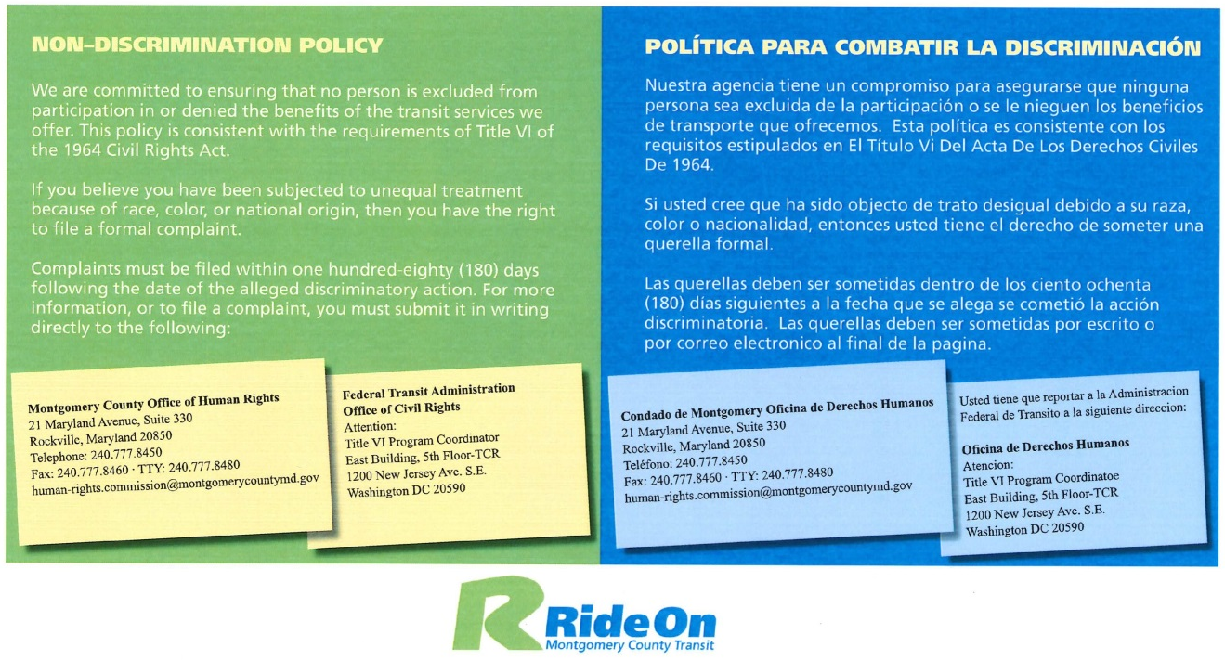

Appendix A – Title VI Notice Posting Locations

The Ride On Title VI notice has been posted at the following locations:

Montgomery County DOT, Division of Transit Services
101 Monroe Street, 5th floor
Rockville, Maryland 20850

Ride On Silver Spring Garage
8710 Brookville Road
Silver Spring, MD 20910

Ride On Nicholson Court Garage
4925 Nicholson Court
Kensington, MD 20895

David F. Bone Equipment Maintenance and Transit Operations Center (EMTOC)
16840 Crabbs Branch Way
Derwood, MD 20855

In addition to these posting locations, the notice has been placed on:
- 343 Ride On buses
- Montgomery County Department of Transportation web site at http://www.montgomerycountymd.gov/DOT-Transit/titlevi.html.
- Ride On Twitter account at: https://twitter.com/RideOnMCT.
- Ride On Facebook account at: https://www.facebook.com/RideOnMCT/info.
- Posted in 3 newspapers (English and Spanish)
- Email blast via GovDelivery system

Appendix B – Title VI Complaint Procedures and Form

DIVISION OF TRANSIT SERVICES
STANDARD OPERATING POLICY & PROCEDURE
Department of Transportation
Section:  Ride On | Title:  Title VI Complaint Procedures | Date:  December 1, 2014
Number: | Division Chief Signature: | Page:  1 of 3
BACKGROUND:
It is Montgomery County’s policy that any allegation of discrimination or unequal treatment on the basis of race, color or national origin should be thoroughly investigated as described in the procedure below.
As a federal requirement Montgomery County will comply with Title VI of the Civil Rights Act of 1964 and Federal Transit Administration Circular 4702.1B. These regulations require that Montgomery County have a process for receiving Title IV complaints that may allege discrimination or unequal treatment on the basis of race, color, or national origin.
PROCEDURE:
Complaints alleging discrimination or unequal treatment on the basis of race, color or national origin (referred to as “Complaint” in this procedure) must be received within 180 days of the alleged discrimination and may be received in four ways including 1) Written and delivered to Montgomery County offices, 2) Telephonically through MC311, 3) Electronically through email, Facebook or Twitter, and 4) In person at Montgomery County Offices or at public meetings sponsored by Montgomery County. The investigation procedure for each method of receiving a Title VI Complaint follows:
Written Complaints
- The written Complaint is forwarded to Office of Human Rights and the Division of Transit Services Title VI Coordinator.
- If a Title VI Complaint Form has not been completed, a copy of the form is mailed to the Complainant.
- The completed Title VI Complaint Form is mailed directory to the Office of Human Rights.
Telephone Complaints through MC311
- Telephone Complaints are recorded in the Customer Service database.
- The complainant is informed by the call taker that they may file a formal Title VI Complaint. If the complainant wants to file a formal Complaint they are referred to the website to download a Title VI Complaint Form or a Title VI Complaint Form is mailed to the complainant.
- The completed Title VI Complaint Form is mailed directly to the Office of Human Rights. A copy of the Complaint as recorded in the Customer Service database is forwarded to the Division of Transit Services Title VI Coordinator.
- If the caller does not wish to file a formal Title VI complaint, the Complaint is forwarded to Ride On Operations for normal processing. A copy of the Complaint as recoded in the Customer Service database is also forwarded to the Division of Transit Services Title VI Coordinator.
Electronic Complaints
- Electronic complaints received through email, Facebook or Twitter are forwarded to the Division of Transit Services Title VI Coordinator.
- The Division of Transit Services Civil Rights Coordinator replies to the electronic message and informs the complainant that they may file a formal Title VI Complaint as described at: http://www.montgomerycountymd.gov/DOT-Transit/titlevi.html.
- The completed Title VI Complaint Form is mailed directly to the Office of Human Rights.
In-person Complaints
- If a Complaint is made in person at a County office or at a public meeting, the County employee receiving the Complaint will record the contact information for the complainant and the nature of the Complaint. This information will be forwarded to the Division of Transit Services Title VI Rights Coordinator.
- The Division of Transit Services Title VI Coordinator replies to the complainant and informs them that that they may file a formal Title VI Complaint as described at: http://www.montgomerycountymd.gov/DOT-Transit/titlevi.html.
- The completed Title VI Complaint Form is mailed directly to the Office of Human Rights.
Record of Complaints
Upon receipt of a Title VI Complaint Form, the Division of Transit Services Title VI Coordinator transmits a copy of the complaint form to MTA within three business days of receiving the completed complaint form. The Division of Transit Services Title VI Coordinator is responsible for maintaining a list of Title VI Complaints. The list shall include:
- Date received
- Type of Complaint (formal or informal)
- Complainant Name
- Contact Information
- Nature of Complaint
- Date Title VI Complaint Form received by the Office of Human Rights
- Response Date by the Office of Human Rights
- Description of the Decision by the Office of Human Rights
- Date of Decision by the Office of Human Rights
Complaint Investigation - Office of Human Rights
Once a Title VI Complaint Form is received by the Office of Human Rights it is assigned to an investigator. The investigator will contact the complainant in writing and/or by telephone. Additional information or clarification may be requested by the investigator.
Based upon receipt of all the information required, the Office of Human Rights will investigate a Title VI complaint within 90 days of receipt. The Office of Human Rights will provide a final response to the complainant, including notifying the complainant of his/her right to file a Complaint externally.
The Office of Human Rights will use its best efforts to respond to a Title VI complaint within 90 calendar days of its receipt of such complaint. Receipt of additional relevant information and/or simultaneous filing of Complaint with Montgomery County and an external entity may expand the timing of the Complaint resolution. Failure of the complainant to provide the requested information by a certain date may result in the administrative closure of the Complaint or a delay in Complaint resolution.

Appendix C – Description of Title VI Investigations, Lawsuits and Complaints

During the period January 1, 2012 through December 31, 2014 there were no Title VI Investigations, Lawsuits or Complaints to report.

Appendix D – Public Participation Plan

Appendix E – Language Assistance Plan

Appendix F – Minority Representation on Ride On Advisory Committees – December 2014

Committee | Black or African American | White/  Caucasian | Latino/  Hispanic | American Indian or Alaska Native | Asian | Native Hawaiian or other Pacific Islander | Other  *Note | Totals
Transit Advisory Group (TAG) | 5 | 5 | 1 | 0 | 1 | 0 | 3 | 15
% of CAC Committee | 33% | 33% | 7% | 0% | 7% | 0% | 20% | 100%
*Note – Other races reported: African and Middle Eastern

Appendix G – Title VI Policies
Montgomery County
Title VI Policies
Federal Transit Administration (FTA) Circular 4702.1B requires grantees that operate more than 50 peak hour vehicles establish Title VI policies providing:
- Definitions for Fare Change, Major Service Change, Disparate Impacts, Disproportionate Burdens and Minority Route;
- Service Standards for vehicle load, vehicle headway, on-time performance and service availability;
- Service Policies related to distribution of transit amenities and vehicle assignment; and,
- Approval procedures for Fare Changes and Major Service Changes
These Definitions, Service Standards, Service Policies and Approval Procedures must be approved by the County Council.
DEFINITIONS
- Fare Change - A Fare Change is any change in fare or new fare product regardless of the amount of increase or decrease. Except for the circumstances listed below, a Fare Equity Analysis is required for any Fare Change to evaluate the effects of a Fare Change on low-income and Title VI-protected populations.
Exceptions.
    - “Give and Ride” and/or special events where Montgomery County has decided that all passengers ride free.
    - Temporary fare reductions that are mitigating measures for other actions such as free or reduced fare due to construction activities.
    - Promotional fare reductions that last less than six months.
- Major Service Change - A Major Service Change is any new route or a reduction or increase in a route’s revenue vehicle hours greater than 25% of the prior schedule’s revenue vehicle hours. A Service Change Equity Analysis is required for any Major Service Change to evaluate the effects of the proposed service change on low-income and Title VI-protected populations.
- Disparate Impact - For Major Service Changes, a disparate impact may exist when the minority population adversely affected by a Major Service Change is twenty percent (20%) more than non-minority population adversely affected by the Major Service Change. For a Fare Change, a disparate impact may exist if the difference between the average fare increase (represented as a % change) for minority populations and the average fare increase (represented as a % change) for non-minority populations is greater than 5% (percentage points). For example, if the average fare increase on minority riders was 10% and the average fare increase on non-minority riders was 4%, the difference is greater than 5% and would be considered disparate.
- Disproportionate Burden - For Major Service Changes, a disproportionate burden may exist when the low income population adversely affected by a Major Service Change is twenty percent (20%) more than non-low income population adversely affected by the Major Service Change. For a Fare Change, a disproportionate burden may exist if the difference between the average fare increase (represented as a % change) for low-income populations and the average fare increase (represented as a % change) for non-low income populations is greater than 5% (percentage points). For example, if the average fare increase on low income riders was 10% and the average fare increase on non-low income riders was 4%, the difference is greater than 5% and would be considered disproportionate.
- Minority Route - A Minority Route is a route that serves an area with a population with a higher percentage of minorities than the Montgomery County average as determined by the most recent and available US Census. Using Geographic Information Systems (GIS), the total population and minority population residing within ¼ of a mile of a bus route are tabulated except for express routes where the service area is 1 mile from the park and ride lot or transfer center.
SERVICE STANDARDS
Standard | Definition | Calculation
Vehicle Load | Average ratio of passengers per seat per bus during a service hour at the maximum load point | Peak period maximum load factor of 1.2 on regular routes and 1.0 on express routes. Off-peak service maximum load factors of 1.0 on all service types.
Headway | Maximum scheduled time interval between buses | Maximum 30 minutes peak headway during peak and off-peak periods.
Schedule Adherence | Percent adherence to scheduled service. | Goal 85 % on time performance for delivered trips, difference between scheduled time and actual time arriving at a time point based on a window of no more than 2 minutes early or 7 minutes late.
Service Coverage | Traffic Analysis Zones (TAZ) that have 3+ households per acre and/or 4+ jobs per acre are served by Ride On and / or Metro Bus routes. | Using the most recent data, TAZs meeting the threshold are analyzed for the presence of Ride On and / or Metro Bus service.

SERVICE POLICIES
Service Policy | Montgomery County Policy
Vehicle Assignment | Vehicles are assigned to routes based on ridership demands, road conditions, service type, and maintenance garage capacity and vehicle technologies (e.g., CNG fueling only provided at EMTOC).
Distribution of Transit Amenities | Ride On will equitably provide amenities such as shelters and kneewalls at bus stops where Ride On has decision-making authority.
APPROVAL PROCEDURES
- Fare Change - It is expected that fare changes will be proposed jointly with the Washington Metropolitan Area Transit Authority (WMATA). WMATA’s Fare Change Equity Analysis will be utilized by Montgomery County in determining potential impacts resulting from a proposed Fare Change. The required public involvement and community outreach will be conducted cooperatively with WMATA. In the event of a Fare Change that only affects Ride On bus services the Division of Transit Services Office of Service Planning will be responsible for completing the Fare Change Equity Analysis and the Division of Transit Services Marketing Office will be responsible for conducting and documenting the public involvement activities. Upon completion of the Fare Change Equity Analysis and the required public involvement, the Montgomery County Council will follow its procedures in reviewing and approving the Fare Change. Additional public meetings may be conducted by the Montgomery County Council.
- Major Service Change – The Division of Transit Services Office of Service Planning is responsible for developing service changes and will identify any service change that meets the definition of Major Service Change. For each Major Service Change, the Division of Transit Services Office of Service Planning will complete a Major Service Change Equity Analysis. The Division of Transit Services Marketing Office will conduct and document the public involvement required for Major Service Changes consistent with Ride On’s Public Participation Plan. Upon completion of the Major Service Change Equity Analysis and the required public involvement, the Montgomery County Council will follow its procedures in reviewing and approving the Major Service Change. Additional public meetings may be conducted by the Montgomery County Council.

Appendix H – Title VI Policies Summary of Public Involvement Activities
PUBLIC OUTREACH AND INVOLVEMENT ACTIVITIES
Incorporating Title VI Outreach Best Practices, Ride On offered several opportunities for the public, including minorities, Limited English Proficient (LEP) individuals, and people with low incomes to get involved in the development of the Title VI Policies. This approach also extends to the public’s ongoing involvement in the identification of potential impacts of all proposed Ride On Transit initiatives. Efforts to include minorities, LEP individuals and people with low incomes included comprehensive measures and outreach strategies that were targeted at overcoming barriers that have historically prevented these populations from effective participation in decision making.
In an effort to identify all of the key stakeholders who should be involved in the Title VI Update process Ride On staff sought input from the Montgomery County Office of Community Partnerships (OCP). OCP serves as a bridge between County government and community organizations by working across the barriers of race, ethnicity, income, and religion.
The public was also invited to provide comment on Ride On’s revised Title VI policies through a press release which stated that Montgomery County’s Ride On bus system was soliciting comments on its updated Title VI plan which describes how Ride On provides equitable and non-discriminatory service. This release also informed the public that under Federal Transit Administration regulations, transit systems such as Ride On must have a plan to ensure that service availability, routing, amenities, and the types of buses, etc. are provided equitably regardless of race, color or national origin.
The proposed Title VI definitions, service standards and policies were made available on Ride On’s website: http://www.montgomerycountymd.gov/DOT-Transit/titlevi.html
In conjunction with the Ride On Title VI Update the following Public Outreach Events were held:
August 28, 2014: Ride On Transit Advisory Group
The Ride On Transit Advisory Group (TAG) consists of 15 volunteers who serve for a period of two years. This diverse group of transit advocates is comprised of committed Ride On riders, bus operators and residents of Montgomery County. At this meeting Ride On staff provided information on; the intent of Title VI and the Plan update process. The group was given a detailed description of Title VI regulations and the requirements of transit agencies that receive federal funds. A PowerPoint® presentation was presented to explain Montgomery County Ride On's newly updated policies and standards. There was good discussion on service area data, demographics, and the protection provided to the riding public under Title VI. The goal of this meeting was to get TAG’s input on the modifications to the Title VI Plan.

September 8, 2014: Middle Eastern Advisory Board
The Ride On Title VI Update team participated in the Middle Eastern Community Advisory Committee’s meeting on September 8, 2014. The team took this opportunity to; provide information to the advisory committee on the intent of Title VI, explain the process for updating the Ride On Title VI Plan, gain input on the proposed modifications to the Plan, and the level and quality of Ride On Service in their communities. The Advisory Committee was informed of the date, time and locations of the public information sessions and they were encouraged to invite their constituents to attend. No comments were offered regarding the Title VI Plan Update. However, the committee provided comments and asked question regarding Ride On transit service.
September 16, 2014: Silver Spring- Public Meeting (Information Session/Open House) - Silver Spring Civic Center
September 17, 2014: Rockville- Public Meeting (Information Session/Open House) - Executive Office Building
Ride On conducted two formal Public Information sessions. The public was encouraged to attend these events in order to receive information on Ride On’s proposed Title VI definitions, service standards and policies. Individuals who could not attend either of the sessions were invited to review the draft Title VI polices, including the definitions of major service changes, disparate impact and disproportionate burden which were posted on Ride On’s web page at http://www.rideonbus.com. Measures taken to overcome linguistic, institutional, and cultural barriers that might prevent minority and low-income populations from participating in this event included: publishing the Public Information Meeting notices in English and Spanish in newspapers of general circulation. Spanish speaking staff was also available at the Title VI information sessions. Title VI comments were accepted through September 30, 2014.
At these two public involvement sessions, five citizens signed the sign in sheets and five comment cards were received. Related to the Title VI policies and service standards, one citizen requested that the minimum headway be shortened from 30 minutes to 25 minutes and two citizens commented that the bus fares should not be increased.
September 20, 2014: Silver Spring- Career Planning Fair (Latin Americans/ African Americans/ Middle Eastern/ Chinese) - East County Regional Services Center
In an effort to reach minority and LEP populations Ride On participated in the Silver Spring Career Planning Fair on September 20, 2014. For this event Ride On partnered with the Montgomery County Office of Community Partnerships, and Montgomery Community College. This well attended event provided an opportunity for Ride On staff to present information on the Title VI Update Plan. Attendees were given the comment cards used at the formal Public Information sessions in order to provide written input about Ride On service and the Title VI Plan.

Appendix I – Fare and Major Service Changes – 2012 to 2014

Service Change Date | Route | Description of Service Change | Revenue Hours before Change | Revenue Hours After Change | % Change | Major Service Change | Public Meeting(s) | Equity Analysis Completed
July 1, 2012 | All | Fare Change | Increase monthly pass / cash / SmartTrip, increase monthly pass and parking rates |  |  | Yes | Yes | Yes
September 9, 2012 | 10 | New trip times | 67.1 | 68.5 | 2% | No | No | No
 | 14 | Enhancement | 25.0 | 25.2 | 1% | No | No | No
 | 18 | Enhancement | 35.1 | 34.8 | -1% | No | No | No
 | 20 | Enhancement | 70.9 | 73.6 | 1% | No | No | No
 | 21 | Enhancement | 11.4 | 12.9 | 1% | No | No | No
 | 22 | Enhancement | 19.1 | 19.4 | 1% | No | No | No
 | 25 | Enhancement/ | 14.8 | 14.8 | 0% | No | No | No
 | 26 | Enhancement | 94.4 | 96.7 | 2% | No | No | No
 | 37 | Enhancement | 14.1 | 15.8 | 8% | No | No | No
 | 41 | New trip times | 16.9 | 16.9 | 0% | No | No | No
 | 45 | Enhancement | 40.9 | 45.7 | 11% | No | No | No
 | 47 | Enhancement | 48.2 | 51.3 | 6% | No | No | No
 | 58 | Modify schedule | 39.8 | 39.3 | 1% | No | No | No
 | 94 | New MARC schedule | 76.0 | 43.3 | -43.2% | Yes | Yes | No*
January 13, 2013 | 38 | Enhancement | 58.8 | 31.95 | -47% | Yes | Yes | Yes
 | 47 | New community | 51.33 | 54.23 | 6% | Yes | Yes | Yes
 | 52 | Restructured | 9 | 12.11 | 35% | Yes | Yes | Yes
 | 53 | Restructured | 21.57 | 28.68 | 33% | Yes | Yes | Yes
 | 58 | Enhancement | 39.27 | 44.84 | 14% | Yes | Yes | Yes
 | 98 | Enhancement | 16.08 | 43.27 | 169% | Yes | Yes | Yes
 | Z2 | Eliminate Saturday | 16.08 | 0 | 16% | Yes | Yes | Yes
May 5, 2013 | 42 | Modify schedule | 37.3 | 37.3 | 0% | No | No | No
 | 45 | Modify schedule | 45.8 | 45.8 | 0% | No | No | No
 | 53 | New timepoint | 28.7 | 28.7 | 0% | No | No | No
 | 94 | Modify schedule | 43.3 | 43.3 | 0% | No | No | No
October 20, 2013 | 1 | Enhancement | 33.2 | 34.7 | 4% | No | No | No
 | 2 | Reduce IOS (added) trips, adjust trip times | 20.3 | 18.8 | -7% | No | No | No
 | 3 | Schedule revision | 2.3 | 2.3 | 0% | No | No | No
 | 4 | Remove Fort Detrick | 15.0 | 15.0 | 0% | No | No | No
 | 5 | Modify schedule | 68.4 | 68.4 | 0% | No | No | No
 | 6 | Modify schedule | 18.1 | 18.1 | 0% | No | No | No
 | 8 | Modify schedule | 33.3 | 33.3 | 0% | No | No | No
 | 9 | Enhancement | 38.2 | 39.9 | 4% | No | No | No
 | 10 | Enhancement | 67.1 | 71.6 | 7% | No | No | No
 | 11 | Modify schedule | 14.8 | 14.6 | -1% | No | No | No
 | 12 | Modify schedule | 42.5 | 42.5 | 0% | No | No | No
 | 13 | Modify schedule | 9.1 | 9.1 | 0% | No | No | No
 | 14 | Modify schedule | 24.7 | 25.2 | -2% | No | No | No
 | 15 | Modify schedule | 50.5 | 50.5 | 0% | No | No | No
 | 16 | Modify schedule | 94.6 | 94.6 | 0% | No | No | No
 | 17 | Modify schedule | 32.1 | 34.0 | 5% | No | No | No
 | 18 | Modify schedule | 35.1 | 34.7 | -1% | No | No | No
 | 19 | Modify schedule | 6.3 | 6.3 | 0% | No | No | No
 | 20 | Modify schedule | 70.9 | 71.5 | 1% | No | No | No
 | 21 | Modify schedule | 11.4 | 12.9 | 12% | No | No | No
 | 22 | Modify schedule | 19.1 | 19.4 | 0% | No | No | No
 | 24 | Modify schedule | 6.4 | 6.4 | 0% | No | No | No
 | 28 | N/C | 28.3 | 28.4 | 0% | No | No | No
 | 38 | Modify route | 58.8 | 32.0 | -45.6% | Yes | Yes | Yes
 | 42 | Modify route | 38.0 | 38.0 | 0% | No | No | No
 | 43 | Modify schedule | 31.0 | 27.8 | -10% | No | No | No
 | 49 | Modify schedule | 44.8 | 44.0 | -2% | No | No | No
 | 55 | Enhancement | 146.5 | 157.3 | 7% | No | No | No
 | 59 | Enhancement | 84.0 | 86.2 | 3% | No | No | No
 | 61 | Modify schedule | 66.7 | 66.6 | -1% | No | No | No
 | 70 | Enhancement | 35.7 | 38.2 | 7% | No | No | No
 | 81 | Modify route | 12.5 | 12.5 | 0% | No | No | No
 | 90 | Modify schedule | 44.8 | 43.8 | -2% | No | No | No
 | 94 | Eliminate, redeploy Jan-14 | 76.0 |  | -100% | Yes | No* | No*
 | 96 | Modify schedule | 24.3 | 20.6 | -15% | No | No | No
 | 98 | Modify schedule | 43.3 | 40.9 | -5% | No | No | No
 | 100 | Modify schedule | 57.5 | 55.5 | -3% | No | No | No
July 1, 2014 | All | Fare Change | Reduce cash fare to $1.75; Increase express fare to $4.00; Increase transfer charges; extend kids ride free hours |  |  | Yes | Yes | Yes
September 7, 2014 | 83 | Enhancement | 33.4 | 38.2 | 14% | No | Yes | Yes
 | 94 | New coverage area | 76.0 |  |  |  | Yes | Yes

- Route 94 is an experimental service funded by MARC. On a daily basis, the Germantown Commuter Rail Station parking lot is full. In order to provide some additional parking spaces, MARC contracted with Ride On to provide shuttle service from the Kingsview park and ride lot. Because ridership was very low, MARC decided to suspend service and experiment with a new route from Clarksburg beginning in January 2014.

Appendix J – County Council Approval of the Montgomery County Title VI Implementation Plan 2015 to 2017

