Language Assistance Plan

December 2014

Title VI of the Civil Rights Act of 1964
(42 U.S.C. §§ 2000d, et seq.)
&
FTA Circular 4702.1B, dated October 1, 2012
TITLE VI REQUIREMENTS AND GUIDELINES FOR FEDERAL TRANSIT ADMINISTRATION RECIPIENTS

Montgomery County Department of Transportation
Division of Transit Services
Rockville, Maryland

Accessible Formats
This document will be made available in accessible formats upon request. Paper copies of this document as well as information regarding accessible formats may be obtained by contacting the Title VI Coordinator, Division of Transit Services.

This notice will be made available in other languages. English
Este aviso estará disponible en otros idiomas. Spanish
本通知将在其他语言中提供 Chinese
Cet avis seront disponible dans d'autres langues. French
이 통지는 다른 언어에서 사용할 수 있는 만들 것 이다. Korean
Thông báo này sẽ được thực hiện có sẵn trong các ngôn ngữ khác. Vietnamese

Montgomery County Department of Transportation
Division of Transit Services
101 Monroe Street, 5th Floor
Rockville, Maryland 20850
240-777-5800 * http://www.montgomerycountymd.gov/dot-transit/dartfirststate.com
Contents
I. Background 1
II. Identification of LEP Individuals Who Need Language Assistance 3
III. Frequency of Contact by LEP Persons with Ride On Services 9
a. Call Center – Requests for Interpretation 9
b. Website Data Translations 9
c. On-board Survey 9
d. Montgomery County Ride On Reported Data 9
IV. Nature and Importance of Transit 9
V. Available Resources & Costs of Providing Language Assistance Services 10
VI. Language Assistance Measures Employed by Montgomery County 10
VII. Planned Language Assistance Initiatives 12

Background

Title VI of the Civil Rights Act of 1964, 42 U.S.C. 2000d et seq., provides that no person in the United States shall, on the grounds of race, color, or national origin, be excluded from participation in, be denied the benefits of, or be otherwise subjected to discrimination under any program or activity that receives Federal financial assistance. The Supreme Court, in Lau v. Nichols, 414 U.S. 563 (1974), interpreted Title VI regulations promulgated by the former Department of Health, Education, and Welfare to hold that Title VI prohibits conduct that has a disproportionate effect on Limited English Proficient (LEP) persons because such conduct constitutes national origin discrimination.

Executive Order 13166, “Improving Access to Services for Persons with Limited English Proficiency,” reprinted at 65 FR 50121, August 16, 2000 directs each Federal agency to examine the services it provides and develop and implement a system by which LEP persons can meaningfully access those services. Federal agencies were instructed to publish guidance for their respective recipients in order to assist them with their obligations to LEP persons under Title VI. The Executive Order states that recipients must take reasonable steps to ensure meaningful access to their programs and activities by LEP persons.

President Bush affirmed his commitment to Executive Order 13166 through a memorandum issued on October 25, 2001 by Assistant Attorney General for Civil Rights, Ralph F. Boyd, Jr. Federal agencies were directed to provide guidance and technical assistance to recipients of Federal funds as to how they can provide meaningful access to Limited English Proficient users of Federal programs.

The U.S. DOT published revised guidance for its recipients on December 14, 2005. This document states that Title VI and its implementing regulations require that DOT recipients take responsible steps to ensure meaningful access to the benefits, services, information, and other important portions of their programs and activities for individuals who are Limited English Proficient (LEP) and that recipients should use the DOT LEP Guidance to determine how best to comply with statutory and regulatory obligations to provide meaningful access to the benefits, services, information, and other important portions of their programs and activities for individuals who are LEP.

The Federal Transit Administration (FTA) references the DOT LEP guidance in its Circular 4702.1B, “Title VI Requirements and Guidelines for Federal Transit Administration Recipients,” which was published on October 1, 2012. Chapter III, section 9 of this Circular reiterates the requirement to take responsible steps to ensure meaningful access to benefits, services, and information for LEP persons and requires that FTA recipients and sub-recipients develop a language implementation plan consistent with the provisions of the DOT LEP Guidance.

The DOT LEP Guidance recommends that all recipients, especially those that serve large LEP populations, should develop an implementation plan to address the needs of the LEP populations they serve. The DOT LEP Guidance notes that effective implementation plans typically include the following five elements: 1) identifying LEP individuals who need language assistance; 2) providing language assistance measures; 3) training staff; 4) providing notice to LEP persons; and 5) monitoring and updating the plan.

Individuals, who have a limited ability to read, write, speak, or understand English are Limited English Proficient, or ‘‘LEP.” Transit agencies that provide language assistance to persons with Limited English Proficiency in a competent and effective manner will help ensure that their services are safe, reliable, convenient, and accessible to those persons. These efforts may attract riders who would otherwise be excluded from participating in the service because of language barriers and, ideally, will encourage riders to continue using the system after they are proficient in English and/or have more transportation options. Catering to LEP persons may also help increase and retain ridership among the agency’s broader immigrant communities in two important ways: 1) agencies that reach out to recent immigrant populations in order to conduct a needs assessment and prepare a language implementation plan (pursuant to the DOT LEP Guidance) will send a positive message to these persons that their business is valued; and 2) community outreach designed to identify appropriate language assistance measures can also assist the agency in identifying the transportation needs of immigrant and linguistically isolated populations and ensuring that an agency’s transit routes, hours and days of service, and other service parameters are responsive to the needs of these populations. Additionally, transit agencies that conduct outreach to LEP persons can increase their potential for recruiting bilingual employees to better serve the needs of the community. In summary, serving the needs of LEP persons is not only a good business decision; it fulfills the mission of the transit agency to serve the public.

Montgomery County is a very diverse county with more than 39 different languages spoken. The Montgomery County Department of Transportation (MCDOT) supports the goals of the DOT LEP Guidance to provide meaningful access to its services by LEP persons. Montgomery County has devoted significant resources to provide oral and written language assistance services to LEP individuals.

This document provides Ride On’s 2014 Language Assistance Plan and includes:

- Identification of LEP Individuals in the Montgomery County Who Need Language Assistance
- The Nature and Importance of Transit to LEP Individuals
- Available Resources and Costs of Providing Language Assistance Services
- Language assistance measures employed by Montgomery County
- Planned language initiatives

Identification of LEP Individuals Who Need Language Assistance

The United States Census’ most recent American Community Survey (ACS) 5 year estimates (2008-2012) offer a current and reliable estimate of the number, proportion, and geographic distribution of LEP persons in the Ride On service area. This analysis of LEP individuals uses data estimates for the “county subdivision” census-defined areas (shown in Figure 1). The county subdivision geography was chosen because the estimates at this level provide the best balance between detail and statistical significance of the data.

According to the ACS (2008-2012), of the total Montgomery County population over the age of five (910,751):

- approximately 39% (352,000) speak a language other than English at home;
- approximately 15 % (139,000) speak English less than “very well”; and
- approximately 9 % (83,500) speak English “not well” or “not at all”.

Figure 1, shows that the highest concentrations of linguistically isolated households are located in and around the Germantown/Gaithersburg area in the center of the county and the Wheaton-Glenmont/College Park area just north of Washington, D.C.

Figure 1: Percent Linguistically Isolated Households, Montgomery County
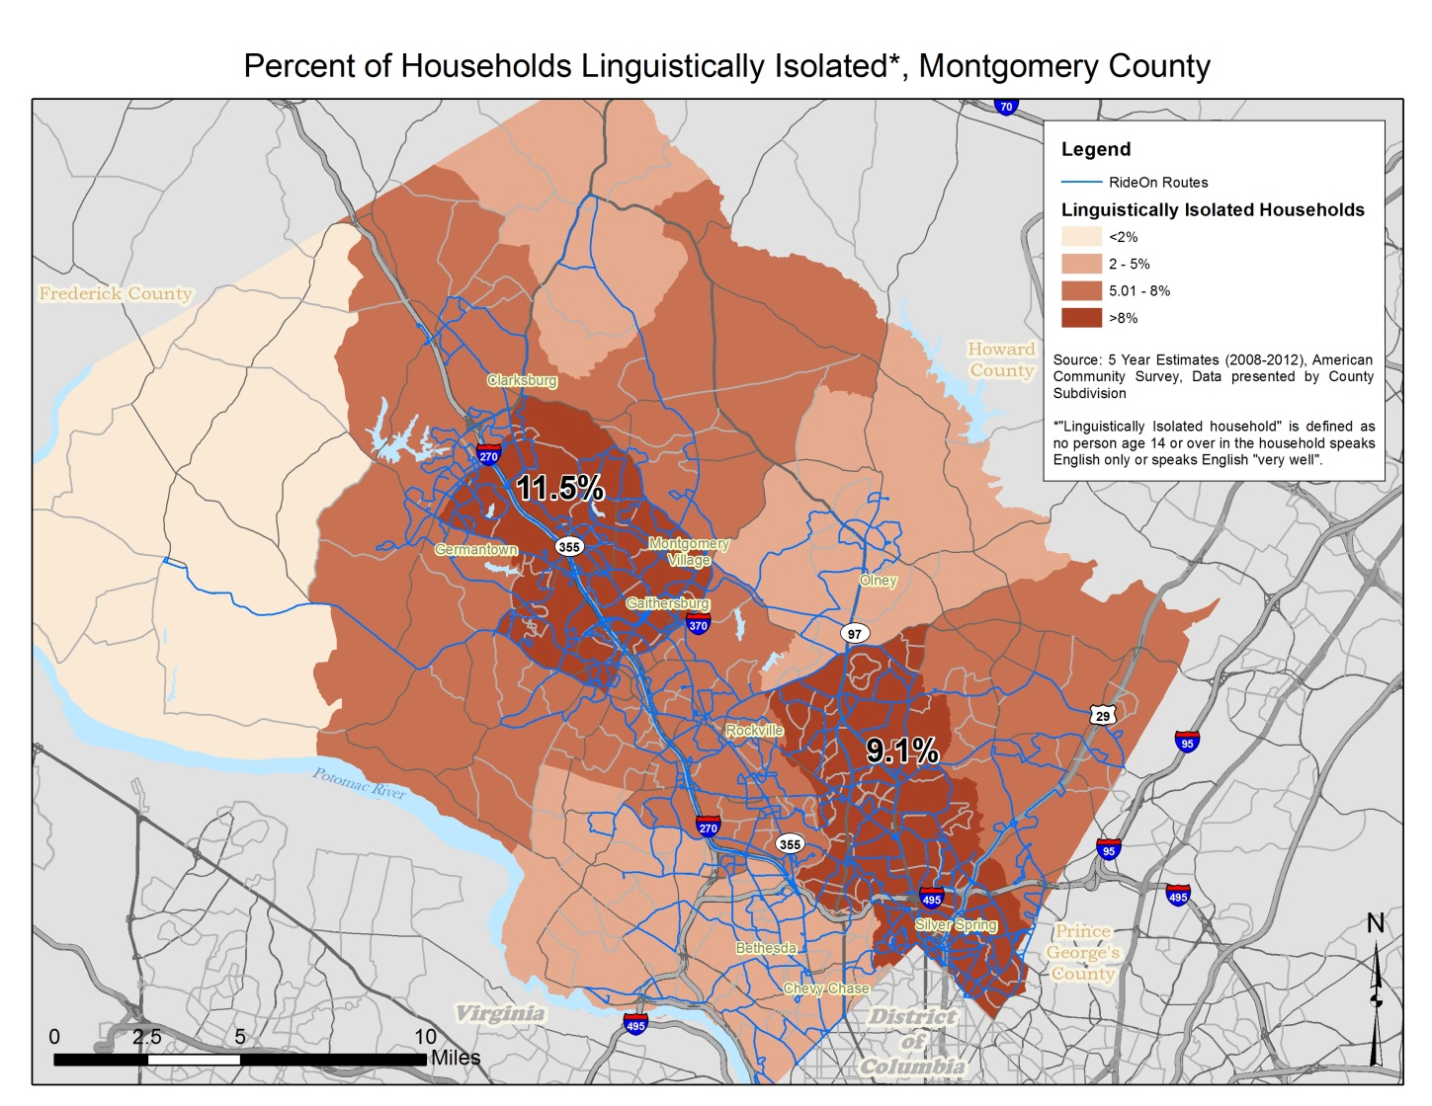

Of the Montgomery County population age 5 and over that speaks a language other than English at home, approximately 139,000 speak English less than “very well”. Spanish/Spanish Creole, Chinese, Korean, African languages, Vietnamese, and French (including Patois and Cajun) speakers make up the majority (approximately 80%) of the languages spoken at home among the subpopulation of people 5 years and over who speak English less than “very well”. Table 1 shows the number and proportion of all languages spoken.

Table 1: Language Spoken at Home of Persons that Speak English Less than "Very Well" in Montgomery County (Population 5 Years and Over)
Language | Estimate | Percent |  | Language | Estimate | Percent
Spanish or Spanish Creole | 66,472 | 47.7% |  | Arabic | 1,145 | 0.8%
Chinese | 15,880 | 11.4% |  | Urdu | 1,025 | 0.7%
Korean | 8,179 | 5.9% |  | Hindi | 902 | 0.6%
African languages | 7,255 | 5.2% |  | German | 885 | 0.6%
Vietnamese | 6,286 | 4.5% |  | Thai | 885 | 0.6%
French (incl. Patois, Cajun) | 5,147 | 3.7% |  | Other Indo-European languages | 837 | 0.6%
Persian | 3,391 | 2.4% |  | Gujarati | 830 | 0.6%
Russian | 3,365 | 2.4% |  | Greek | 779 | 0.6%
Tagalog | 2,726 | 2.0% |  | Other Pacific Island languages | 740 | 0.5%
Other Indic languages | 2,721 | 2.0% |  | Italian | 605 | 0.4%
Portuguese or Portuguese Creole | 2,179 | 1.6% |  | Mon-Khmer, Cambodian | 515 | 0.4%
Other Asian languages | 1,799 | 1.3% |  | Other (all languages below 500 LEP speakers) | 2,187 | 1.6%
French Creole | 1,428 | 1.0% |  | Total | 139,391 | 100.0%
Japanese | 1,228 | 0.9%
Source: 2008-2012 American Community Survey 5-Year Estimates

Figures 2 – 7 (pages 6-8) help identify where the highest concentration of each of the top six languages of LEP persons (Spanish/Spanish Creole, Chinese, Korean, African languages, Vietnamese, and French (including Patois and Cajun)) are spoken. The figures show the percent of the population of each county subdivision that speaks the given language at home and speaks English less than “very well”. Those subdivisions shown in red have the greatest percentage of the population with limited English proficiency that speaks the given language. These figures give reasonable guidance regarding the areas likely to have higher language assistance needs and for which languages the assistance is needed; we can be confident that those county subdivisions shown in red tones have higher concentrations of the given LEP population than those county subdivisions in green, but the rankings among subdivisions that have closer percentages may not hold true in reality.
Figure 2: Spanish Speakers with Limited English Proficiency (percent of population by county subdivision)
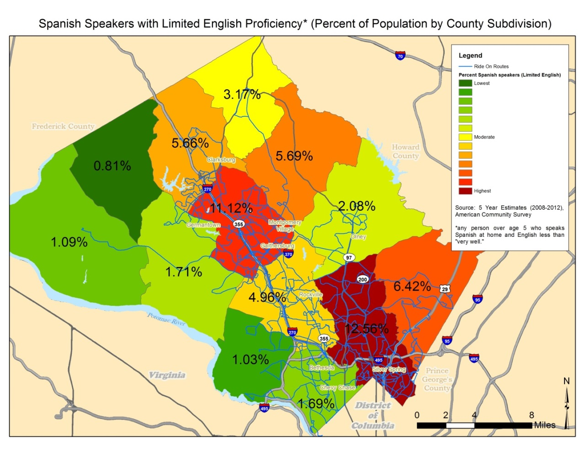

Figure 3: Chinese Speakers with Limited English Proficiency (percent of population by county subdivision)
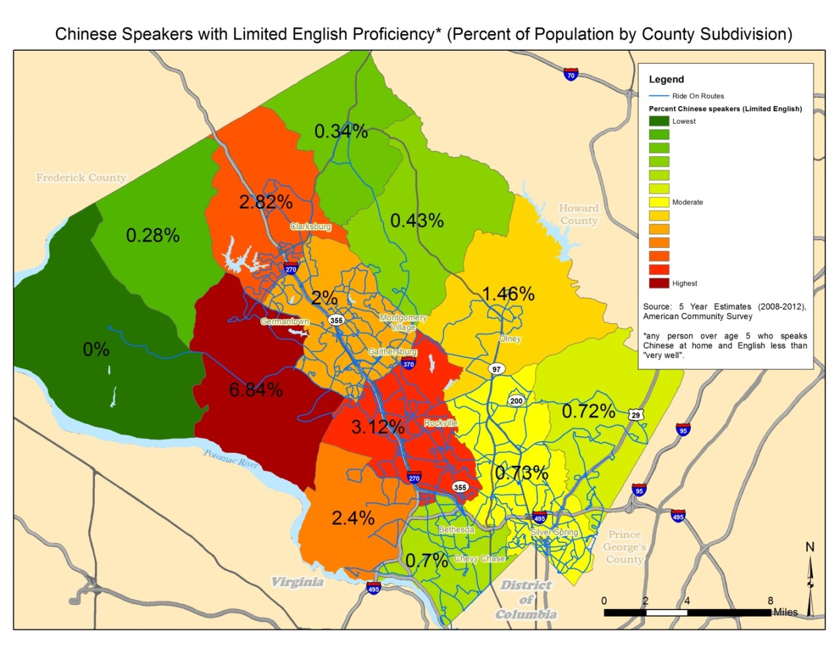
Figure 4: Korean Speakers with Limited English Proficiency (percent of population by county subdivision)
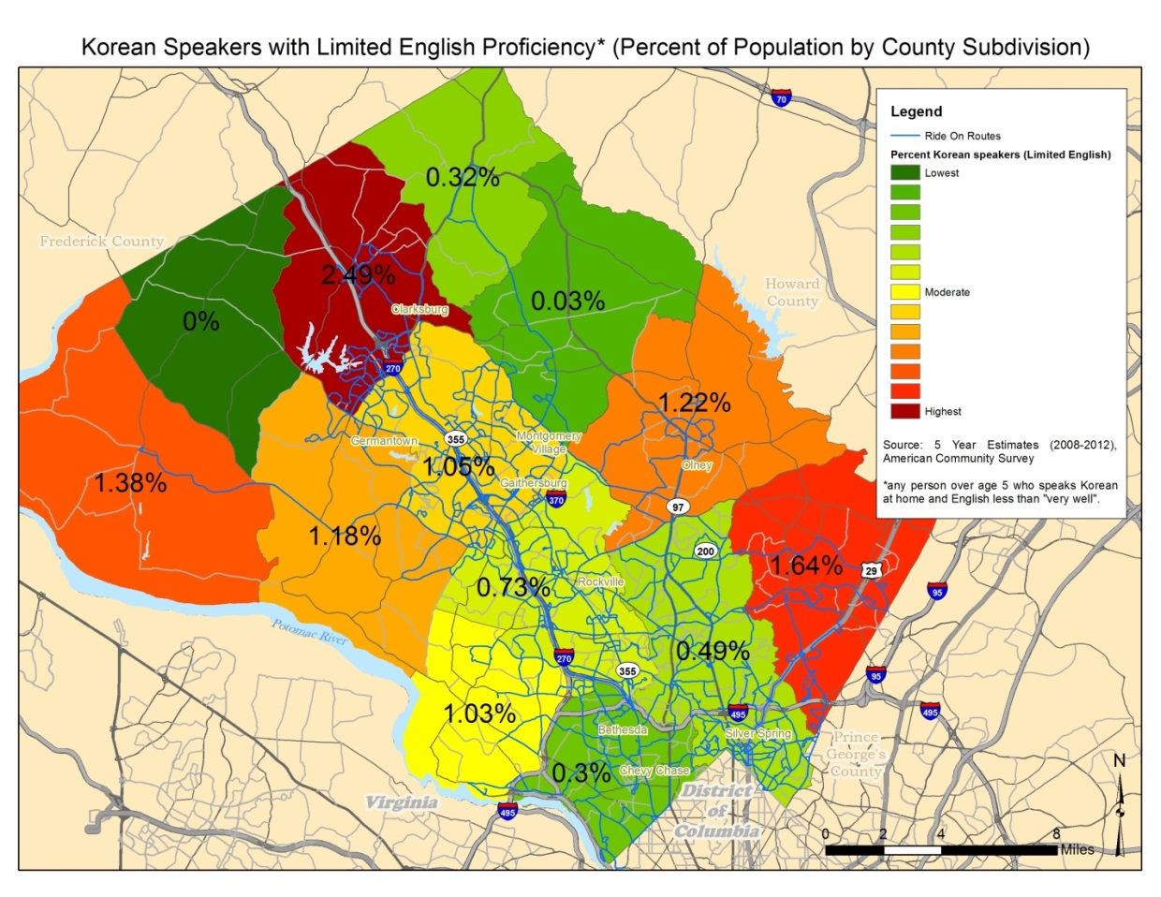

Figure 5: African Language Speakers with Limited English Proficiency (percent of population by county subdivision)
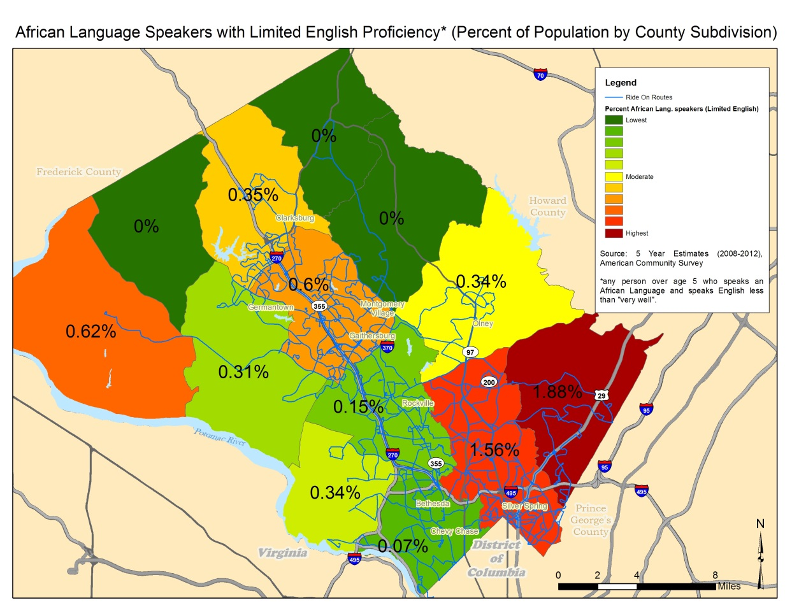
Figure 6: Vietnamese Speakers with Limited English Proficiency (percent of population by county subdivision)
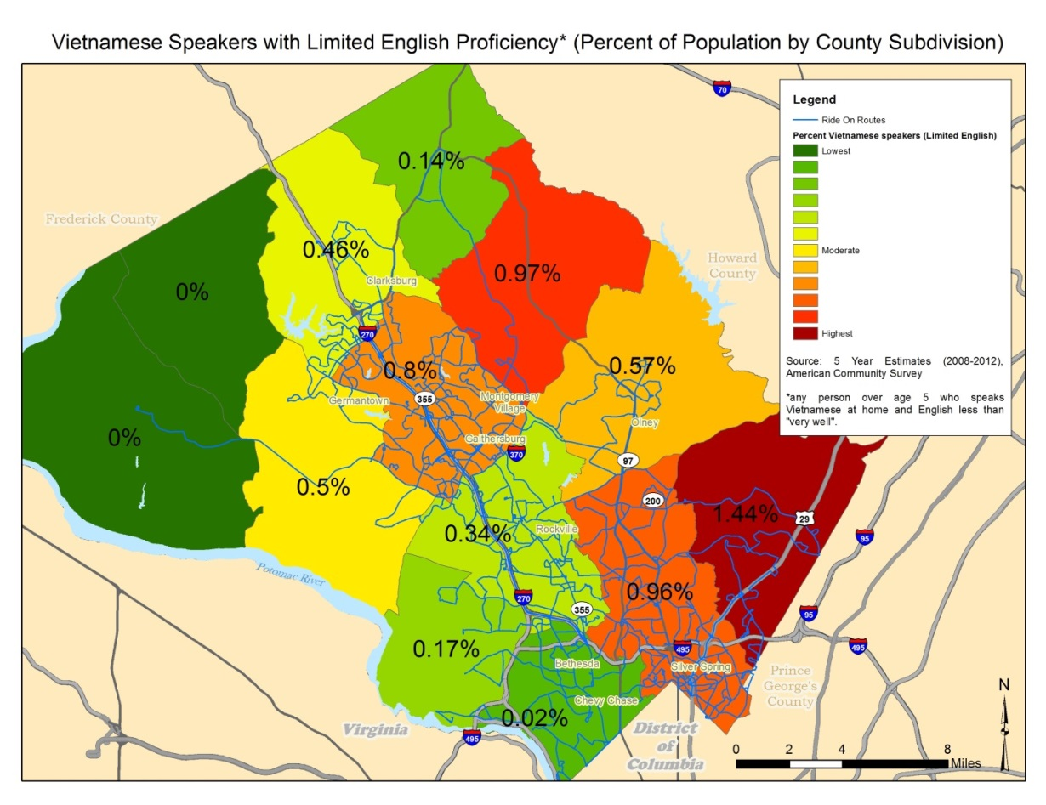

Figure 7: French Speakers (including Patois, Cajun) with Limited English Proficiency (percent of population by county subdivision)
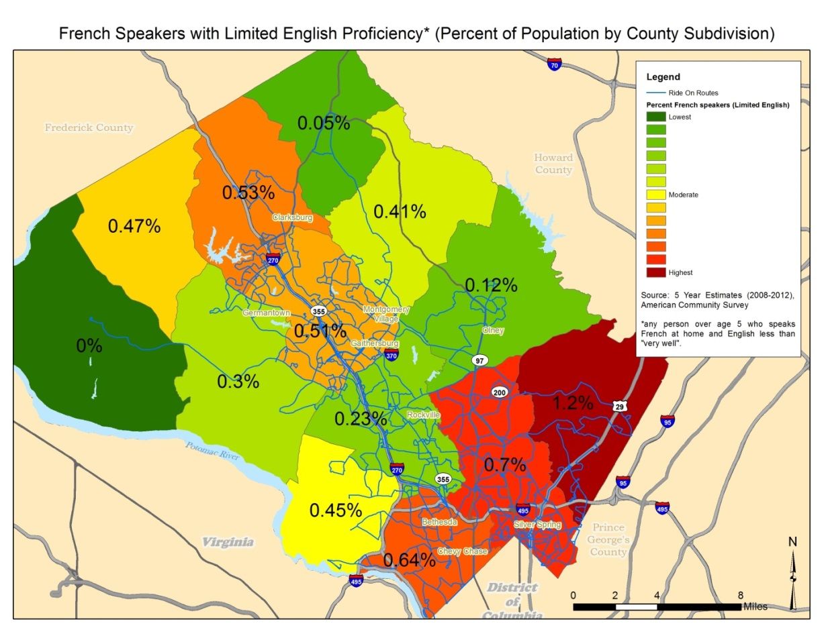

Frequency of Contact by LEP Persons with Ride On Services

Call Center – Requests for Interpretation
During the 2014 fiscal year (July 2013 through June 2014), the frequency of encounter by the Montgomery County call center of persons that require language assistance (either with the interpretation line or bilingual staff member) was approximately 22,270 calls out of a total 475,797 calls (4.7%). Spanish represented the majority of all phone based interpretation services.
The call center offers interpretation services through bilingual customer service representatives; this service was used for 1,567 calls during the 2014 fiscal year. The top languages used were: Spanish (1,353), Mandarin (58), French (28), Korean (28), Amharic (19), Vietnamese (15), Russian (12), and Cantonese (12). Translation in other languages accounted for 45 calls (approximately 3%).

Website Data Translations
The County currently is not able to identify web portal translation counts.

On-board Survey
Ride On’s 2014 on-board survey conducted from July through November 2014 asked customers questions about their language usage and skills. Over 10,600 riders participated in the survey; the data are summarized as follows:
- 42.9% of respondents report that they speak a language other than English at home. Languages spoken at home, which were reported, include: Amharic, Arabic, Bengali, Bulgarian, Chinese, Filipino, French, Hindi, Korean, Portuguese, Russian, Spanish, Swahili, Tagalog, Tamil, Vietnamese, etc.
- 7.1% indicate that they read English “not well” or “not at all”
- 7.2% indicate that they speak English “not well” or “not at all”
- 10.6% of participants chose to take the survey in Spanish and less than 1% of participants chose to take the survey in one of the other languages offered (Chinese, Korean, Vietnamese, Amharic, French)

Montgomery County Ride On Reported Data
Through regular employee meetings and interaction, Ride On management recognizes that interaction with non-english speaking riders is very frequent. Additional data has not been collected to quantify the frequency of contact.

Nature and Importance of Transit
While public transit is not an essential service, as are police, fire and medical emergency services, public transit is a key means of achieving mobility for many LEP persons. According to the 2000 Census, nationally, more than 11% of LEP persons aged 16 years and over reported use of public transit as their primary means of transportation to work, compared with about four percent of English speakers. Recent immigrants to the United States (including those persons who may not be limited English proficient) use public transit at higher rates than native-born adults. However, public transit use among recent immigrants decreases with length of residence in the United States. Many immigrants desire to switch from public transit to automobile use because personal vehicles are a symbol of assimilation and cars can provide greater mobility or access to economic and social opportunities that are beyond a transit system’s service area. Recent immigrants might elect to continue using public transit for at least a portion of their trips if their experience with public transit is positive. For transit agencies seeking to increase their “choice riders,” it may be easier to retain riders who have past, positive impressions of the system than to attract those persons who have never or rarely used transit. Catering to LEP persons may help to increase and retain ridership among Montgomery County immigrant communities.

Available Resources & Costs of Providing Language Assistance Services
As noted in section VII, MCDOT maintains a variety of support services to LEP customers and residents. During fiscal year 2014, the Division of Transit Services spent $1,512 for translating language assistance materials. Certified multilingual Division of Transit Services employees receive additional compensation which totaled $348,359 in fiscal year 2014.
The total cost for call center interpretation services provided county-wide during fiscal year 2014 was $11,203.01, (not including staff salaries and regular operating costs). Spanish-speaking representatives were used for 86% of calls requiring a bilingual customer service representative; those representatives made an additional $17,562 per year, on average, in comparison to mono-lingual colleagues.

Language Assistance Measures Employed by Montgomery County
Montgomery County Ride On supports the goals of the DOT LEP Guidance to provide meaningful access to its services by LEP persons. The County Executive Order 046-10, effective March 2010, aims to enhance the quality and effectiveness of services for individuals with Limited English Proficiency in a variety of ways. County policy and employee guidelines for implementation are explained in the LEP Employee Handbook. Under its goals of inclusion and access, the County currently offers a number of language assistance services relative to the provision of transit services, including:

Translation Services
- The Ride On web site (www.montgomerycountymd.gov/DOT-transit/index.html) permits translation of Ride On schedules and other public materials into 82 different languages.
- The County has hundreds of employees that are certified in at least one other non-english language through the Multilingual Certification Program (see Training Initiatives, below) and available to provide translating services within or outside his/her primary department. As of November 2014, the Transit Services Division had 98 certified bilingual employees, 93 of whom were bus operators. The primary function of the certified employees within MCDOT is direct communication and minor interpretation or translation services. MCDOT uses their certified languages daily as part of their work with their users of public transportation, parking, and consumer questions to the Director’s Office.
- The County’s Language Bank of volunteers is available to help translate and interpret for County government agencies and registered nonprofit organizations serving residents with limited English proficiency. Language Bank volunteers serve as interpreters and translate documents for various agencies and organizations.
- Language ID boards at all service sites to help County staff identify which language the LEP person speaks.
- The MC311 Customer Service Center offers a single point of contact for information on County services and program and includes language interpretation service with over 150 languages available. After calling 311, press 1, for Spanish, or stay on the line to ask the next available customer service representative to request to conduct the call in the language of your choice. The service can be accessed through telephone and web-based channels and is made known through community outreach efforts, which include flyers/palm cards in multiple languages, meeting with community groups, and television/radio/newspaper advertisements in Spanish. According to the 2014 report by the Office of Legislative Oversight on MC311 calls, Ride On Trip planning and arrival requests were the top requests of all callers and in the top five of Spanish-preferred callers.
- The Passenger Bill of Rights and Responsibilities is provided in English and Spanish.

Public Outreach
- A website dedicated to language access (www.montgomerycountymd.gov/lep)
- PSA videos in multiple languages to raise awareness about the availability of language assistance services.
- The Office of Community Partnerships employs a staff of over one dozen to carry out the County Executive's commitment to build a larger policy table with participation by a more diverse range and greater number of residents, particularly those from underserved and emerging communities. This program includes a network of contacts and community based resources that could help LEP persons navigate community resources, including transit use.

Training Initiatives
- Multilingual Certification Program through the office of Human Resources encourages employee certification in one of the approved languages identified as the predominant languages used by county residents to enhance its ability to serve its LEP customers. There are hundreds of certified employees who can be called upon for services outside of their primary department.
- A three hour training course for all frontline staff and those who may interact with LEP persons is mandatory.
- Community Interpreter training is a mandatory day-long training course for certified bilingual employees to learn the ethics and techniques of being a more effective interpreter.

Monitoring
- An LEP leadership Team led by the Language Access Coordinator oversees countywide policies and practices on language access; LEP Department Liaisons designated by department directors are responsible for implementing the LEP policy for the Executive Branch’s departments, office, and programs. Each Department is responsible for maintaining an up to date Language Access Plan.

Planned Language Assistance Initiatives
The Montgomery County Department of Transportation created a Title VI compliant Language Assistance Plan in June 2009 which was approved by the Federal Transit Administration on November 3, 2009. It was intended to:
- Ensure MCDOT’s compliance with applicable federal and state laws and guidelines as well as the County’s policy on providing meaningful access to people with limited English proficiency; and
- Establish expectations, processes and accountability mechanisms for all units and employees within MCDOT that interact with individuals with LEP.
To those ends, MCDOT has identified the following actions to address potential access barriers faced by LEP customers as of 2014:
Translation of Vital Documents:
- Continue the Ride On web site (www.montgomerycountymd.gov/DOT-transit/index.html) which permits translation of Ride On schedules and other public materials into 82 different languages.
- Continue to print bilingual bus notices for fare changes, schedule changes and other policy changes.
- Continue to print and advertise notices for public forums in other languages.
- Continue to translate certain media releases.
- Continue to provide other language support through the conferencing telephone at the Transit Information window.
- Maintain greeting and other messages in Spanish on the main contact numbers.
- Continue to staff certain community events with bilingual staff.
- Advertise with other language media for certain programs, such as Give and Ride Residents Guide to Services, will continue to be printed in five languages.

Public Communications:
- Continue the Ride On web site (www.montgomerycountymd.gov/DOT-transit/index.html) which permits translation of Ride On schedules and other public materials into 82 different languages.
- Display language ID posters or boards at various DOT front desk areas and visitor's centers.
- Continue to print bilingual bus notices for fare changes, schedule changes and other policy changes.
- Continue to print and advertise notices for public transit forums in other languages.
- Continue to translate certain public transit media releases.
- Continue to provide other language support through the conferencing telephone at the Transit Information window.
- Record greeting messages on the main contact numbers in Spanish.
- Continue to use bilingual staff and bilingual materials at public events and community activities.
- Maintain greeting and other messages in Spanish on the main contact number.
- Continue to staff certain community events with bilingual staff.
- Advertise with other language media for certain programs such as Give and Ride.
- Locate bilingual staff member at DOT Customer Service desk to assist customers.

Staff Training:
- All frontline staff will continue to receive the 3-hour LEP training hosted by OHR. Managers and supervisors will receive a different version of training on language access requirements and cross-cultural competency to be designed by the Language Access Coordinator in conjunction with OHR.
- All staff with public interaction will receive additional hands-on training and written instruction on how to access and properly use language resources.
- The Department's Community Relations Manager will continue to attend the monthly Community Outreach Forum sponsored by the County Executive's Office of Community Partnerships. He/She will share relevant LEP information from this meeting with division chiefs, for transmittal to their staff as appropriate.
- MCDOT will invite the Language Access Coordinator to conduct an on-site LEP briefing so as to avoid waiting for too long to bring all frontline staff to speed.

Internal and External Evaluation, Data Collection and Reporting:
- Performance evaluation of frontline staff, their supervisors and directors will reflect their awareness and work (in the form of staff training) of LEP policy, requirements and quality of work.
- The number and nature of complaints as well as response time and level of satisfaction in resolution will all be part of data collection.

households where no person age 14 or older in the household speaks English only or speaks English “very well”.
Note regarding data limitations: This calculation deals with some sub-populations that are small and in some cases the estimates come with a significant margin of error; therefore, the percentages presented in Figures 2-7 can be considered good enough to identify the areas with highest percentages of LEP, non-English speakers, but percentages should not be used as concrete figures to compare with other data.

