Title VI
Compliance Monitoring Report

December 2014

Title VI of the Civil Rights Act of 1964
(42 U.S.C. §§ 2000d, et seq.)
&
FTA Circular 4702.1B, dated October 1, 2012
TITLE VI REQUIREMENTS AND GUIDELINES FOR FEDERAL TRANSIT ADMINISTRATION RECIPIENTS

Montgomery County Department of Transportation
Division of Transit Services
Rockville, Maryland

Accessible Formats
This document will be made available in accessible formats and other languages upon request. Paper copies of this document as well as information regarding accessible formats may be obtained by contacting the Title VI Coordinator, Division of Transit Services.

Montgomery County Department of Transportation
Division of Transit Services
101 Monroe Street, 5th Floor
Rockville, Maryland 20850
240-777-5800 * http://www.montgomerycountymd.gov/dot-transit

Table of Contents
1. Overview and Recommendations 1
2. Montgomery County Service Standards 2
2.1. FTA Service Standard Requirements 2
2.2. Ride On Service Standards 2
2.3. RIDE ON Service Policies 3
3. Monitoring Methods 6
3.1. Minority Population by Bus Route 6
3.2. Vehicle Load Factor Monitoring Method 9
3.3. Route Headways Monitoring Method 9
3.4. On-Time Performance Monitoring Method 9
3.5. Service Accessibility Monitoring Method 9
3.6. Vehicle Assignment Monitoring Method 9
3.7. Distribution of Transit Amenities Monitoring Method 9
4. Monitoring Results 10
4.1. Vehicle Load Factor Monitoring Results 10
4.2. Route Headways Monitoring Results 10
4.3. On-Time Performance Monitoring Results 11
4.4. Service Accessibility Monitoring Results 11
4.5. Vehicle Assignment Monitoring Results 12
4.6. Distribution of Transit Amenities Monitoring Results 12
4.7. Load Factor Detailed Results 14
4.8. Route Headways Detailed Results 16
4.9. On-Time Performance Detailed Results 19
4.10. Service Accessibility Detailed Results 20
4.11. Vehicle Assignment Detailed Results 23
4.12. Distribution of Transit Amenities 25

Overview and Recommendations

Following the guidelines set forth by FTA Circular 4702.1B, the Montgomery County Department of Transportation (MCDOT) monitors the performance of the transit system relative to system-wide service standards and service policies on a tri-annual basis. These monitoring activities are used to compare the level of service provided to predominantly minority areas with the level of service provided to predominantly non-minority areas to ensure that the result of policies and decision-making is equitable.

The monitoring methodology groups the routes into four quartiles with quartile 1 having the highest minority population and quartile 4 having the lowest minority population. For the purpose of this monitoring report, routes grouped in quartiles 1 and 2 are considered the minority services.

This Compliance Monitoring Report has not identified any of disparity which requires additional review.

There is however one area that requires management consideration.

Overcrowding is a problem on some Ride On routes with peak loads exceeding service standards. During Fiscal Year 2014 there were four routes that exceed Ride On’s PM Peak Hour Load factor policy of 120% including Route 55 – 174%, Route 59 – 125%, Route 61 – 122% and Route 1 – 125%. Additional budget resources should be considered for needed peak hour buses and trips required to alleviate overcrowding.

Montgomery County Service Standards

FTA Service Standard Requirements
MCDOT receives FTA funding to provide service in Montgomery County, Maryland as a sub-recipient to the Maryland Transit Administration. As defined under 49 U.S.C. 5307, the county has a population of 200,000 people or greater. As such, public transit providers are required to develop service standards and policies.
Pursuant to FTA circular 4702.1B, RIDE ON has established and monitors service performance under quantitative service standards and qualitative service policies. The standards and policies that must be monitored are:

- Standards
  - Vehicle Load for each mode
  - Vehicle Headway for each mode
  - On-Time Performance for each mode
  - Service Accessibility for each mode
- Policies
  - Vehicle Assignment for each mode
  - Distribution of Transit Amenities (Policy and Standards) for each mode

Ride On Service Standards
Standards for each of the FTA requirements are described below:
Vehicle Load Factor - This standard is measured as the ratio of passengers on board to the seated bus capacity expressed as a percent. Values of 100 percent or less indicate all riders are provided a seated ride while values of more than 100 percent denote standees. Loading standards indicate the degree of crowding (i.e., standees) which is acceptable, with consideration given to both the type of service and the operating period. Acceptable load factors are as follows:
Service Type | Load Factor
Regular Routes | 1.2
Express | 1.0

Vehicle Headways - In general, frequencies or "headways" (the time between one bus and the next at the same location in the same direction) are established to provide enough vehicles past the maximum load point(s) on a route to accommodate the passenger volume and stay within the recommended load factor standards. If passenger loads are so light that an excessive time is needed between vehicles to meet loading standards, then headways should be set on the basis of policy considerations. Montgomery County has established a thirty minute headway as the minimum policy headway for routes operating in any time period.
As with all standards, the minimum headway is not an absolute measure and should be used as a guide. There may be situations where low demand and actual running times warrants even less frequent service. Further, headways should be designed, wherever possible, to conform to regularly recurring clock face intervals. There are instances where operational efficiencies may take the place of the benefits of clock face headways.
On-Time Performance – on-time performance standards have been established as follows:
Schedule Adherence (OTP): | All Service Types
2 minutes early to 7 minutes late | 85%

Service Accessibility – Within Montgomery County transit service is provided to traffic analysis zones with 3+ households per acre and/or 4+ jobs per acre.

RIDE ON Service Policies
Vehicle Assignment Policy – Ride On transit vehicles are assigned to three garages based upon their size and technology. The Nicholson Court Garage located near White Flint is a leased facility and can only accommodate diesel buses 30 foot in length or shorter. The Silver Spring Garage located near downtown Silver Spring can only accommodate diesel fueled buses. The David F. Bone Equipment Maintenance and Transit Operations Center (EMTOC) located in Gaithersburg can accommodate diesel and CNG buses up to 60 foot in length. Vehicles are assigned to routes based upon ridership loads with smaller buses assigned to routes with lighter loads and full sized buses assigned to routes with heavier loads. RIDE ON monitors the age of buses assigned to routes by periodically sampling the bus assignments for a weekday and then comparing the average age of the buses assigned by quartile to the average age for all buses assigned. If the average age of buses assigned to any quartile is one standard deviation higher than the average of all buses assigned, then further investigation of the bus assignment process will be conducted.
Distribution of Transit Amenities Policy - In accordance with RIDE ON policy Bus Stop/Passenger Facilities will generally be located at or near major trip generators or destinations or at regular intervals based on the population density and transit-related demographic factors along the route. Stops must be in locations passengers can board and alight safely and where buses can safely enter and exit. Optimally, bus stop locations will have pedestrian friendly facilities, including sidewalks and walkways that separate pedestrians from vehicular traffic. Whenever possible, stops in opposite directions on a route will be located directly opposite each other.
All stops will be fixed locations designated by RIDE ON in accordance with this policy. Additionally, Ride On has a Night Request Stop program that allows passengers to request to be let off at any location with the following limitations: after 9:00 p.m. only; alighting only; must be on the regular route; location must be safe to stop; in Maryland only.

Bus stops shall not obstruct driveways or entranceways or cause visual obstructions for motorists or for bus operators merging back into the traffic stream. In areas that have high traffic volumes, turning movements, and pedestrian crossings through intersections, the stop should be placed where it presents the least conflict with vehicular traffic and pedestrians.

Decisions for final bus stop selection are based on the following:
- Passenger origins
- Adjacent land use and activities
- Operational feasibility in accessing the stop
- Physical constraints or obstructions (trees, driveways, etc.)
- Pedestrian access including accessibility for people with disabilities
- Parking restrictions and requirements
- Traffic volumes on adjacent roadways particularly as evidenced by turning movements
- An examination of the individual bus route/routes that serve the potential stop
- Bus and intermodal (rail, park and ride) transfers to the stop
Safety is a critical consideration. Stops shall not be placed where they present a hazard to passengers, transit vehicles, or other traffic.
Park and Ride lots are a special category of bus stops intended to extend the reach of transit by collecting passengers from a wider area. Their location is based on availability of land or preexisting parking and connections to the regional highway system. Park and rides may also accommodate carpoolers, bicycle riders and serve as transit hubs. Planning and development of park and rides include a higher level of involvement with the public, other MCDOT divisions, Maryland National Capital Park and Planning Commission, WMATA and Maryland Transit Administration.
Bus stop interval spacing has a major impact on transit operations. It greatly impacts a route’s travel time, service reliability, and schedule adherence as well as the route’s attractiveness to the customer population. RIDE ON guidelines for bus stop spacing are based on a combination of factors including:
- Type of service operated
- Ridership levels
- Passenger transfer potential and demand
- Type of roadway used for operation
- Prevailing traffic conditions operating on the roadway
- Adjacent and surrounding land use, trip generators, or attractors
- Topography of the area
- Population densities and demographic characteristics
- Interface with other routes and public transportation services
Bus stops should be placed approximately 750 feet to 1000 feet apart or 5-7 bus stops per mile.
- Exceptions to Interval Spacing Requirements: Interval spacing guideline exceptions should be limited and made on a case-by-case basis in order to not confuse customers or adversely impact a route’s running time and schedule adherence. The following are examples of exceptions to interval spacing requirements:
  - Street or subdivision design causes walking distance to the stop to be excessive
  - Topographic conditions, such as hills or steep grades leading to and from a bus stop
  - Demographic characteristics of customers, such as elderly customers who are unable to conveniently travel the prescribed guideline distance between bus stops
  - High volume activity centers.
- Consolidation of Bus Stops: Where there are excessive numbers of stops located at short intervals, stops with low levels of ridership will be consolidated. Individual stops may be eliminated or adjacent stops may be consolidated at a suitable intermediate location. Determination of stops to be retained will be based on operational, safety, accessibility, customer convenience considerations and on the suitability of the site for customer facilities.

Monitoring Methods
RIDE ON will produce a Title VI Monitoring Report every three years. The monitoring method for each service standard and policy follow.

Minority Population by Bus Route

Using the most recent US Census, RIDE ON will identify the minority and majority population for each route’s service area. If a transit route travels within ¼ mile of the block group, the minority and majority population from that census block group will be assigned to the route. Each route’s minority and majority population will be totaled and a percent minority population will be calculated. The routes will then be ranked in descending order of minority population and divided into four quartiles with the highest minority percentage in the first quartile. Table 3-1 below lists the Ride On routes with minority percentages and arranged in quartiles. This minority population ranking by quartile will be utilized in the service monitoring to determine if service is being fairly and equitably provided.

Table 3-1: Ride On – Montgomery County Population by Transit Route
Ride On - Montgomery County Population by Transit Route
 | Route # | Population | Minority | Non-Minority | % Minority
Quartile 1 | 24 | 33,587 | 26,398 | 7,189 | 78.6%
 | 41 | 30,174 | 23,272 | 6,902 | 77.1%
 | 10 | 63,210 | 47,378 | 15,832 | 75.0%
 | 20 | 46,071 | 34,423 | 11,648 | 74.7%
 | 15 | 30,305 | 21,851 | 8,454 | 72.1%
 | 39 | 34,850 | 24,663 | 10,187 | 70.8%
 | 16 | 45,885 | 31,542 | 14,343 | 68.7%
 | 71 | 44,449 | 30,503 | 13,946 | 68.6%
 | 79 | 48,532 | 33,283 | 15,249 | 68.6%
 | 31 | 22,133 | 15,050 | 7,083 | 68.0%
 | 78 | 47,376 | 32,140 | 15,236 | 67.8%
 | 61 | 54,466 | 36,344 | 18,122 | 66.7%
 | 55 | 62,185 | 41,125 | 21,060 | 66.1%
 | 65 | 35,923 | 23,709 | 12,214 | 66.0%
 | 93 | 5,005 | 3,303 | 1,702 | 66.0%
 | 59 | 53,032 | 34,925 | 18,107 | 65.9%
 | 48 | 40,336 | 26,479 | 13,857 | 65.6%
 | 51 | 29,834 | 19,525 | 10,309 | 65.4%
 | 57 | 37,830 | 24,638 | 13,192 | 65.1%
 | 94 | 9,484 | 6,156 | 3,328 | 64.9%
Quartile 2 | 75 | 22,358 | 14,443 | 7,915 | 64.6%
 | 64 | 44,786 | 28,928 | 15,858 | 64.6%
 | 97 | 26,075 | 16,801 | 9,274 | 64.4%
 | 60 | 36,887 | 23,603 | 13,284 | 64.0%
 | 38 | 28,968 | 18,455 | 10,513 | 63.7%
 | 98 | 41,879 | 26,571 | 15,308 | 63.4%
 | 25 | 15,868 | 10,030 | 5,838 | 63.2%
 | 21 | 51,159 | 32,297 | 18,862 | 63.1%
 | 49 | 42,313 | 26,402 | 15,911 | 62.4%
 | 14 | 41,492 | 25,663 | 15,829 | 61.9%
 | 58 | 50,726 | 31,311 | 19,415 | 61.7%
 | 54 | 40,063 | 24,632 | 15,431 | 61.5%
 | 17 | 27,943 | 17,105 | 10,838 | 61.2%
 | 26 | 68,567 | 41,683 | 26,884 | 60.8%
 | 83 | 25,497 | 15,459 | 10,038 | 60.6%
 | 2 | 20,783 | 12,280 | 8,503 | 59.1%
 | 74 | 53,559 | 31,575 | 21,984 | 59.0%
 | 18 | 32,381 | 19,053 | 13,328 | 58.8%
 | 12 | 36,270 | 21,091 | 15,179 | 58.1%
 | 22 | 32,951 | 19,111 | 13,840 | 58.0%

Ride On - Montgomery County Population by Transit Route
 | Route # | Population | Minority | Non-Minority | % Minority
Quartile 3 | 67 | 36,924 | 21,380 | 15,544 | 57.9%
 | 100 | 42,433 | 24,310 | 18,123 | 57.3%
 | 13 | 37,053 | 21,187 | 15,866 | 57.2%
 | 28 | 18,185 | 10,368 | 7,817 | 57.0%
 | 8 | 35,651 | 20,046 | 15,605 | 56.2%
 | 33 | 29,162 | 16,144 | 13,018 | 55.4%
 | 7 | 27,990 | 15,409 | 12,581 | 55.1%
 | 19 | 35,580 | 19,263 | 16,317 | 54.1%
 | 9 | 32,913 | 17,724 | 15,189 | 53.9%
 | 44 | 20,639 | 11,005 | 9,634 | 53.3%
 | 34 | 70,860 | 37,459 | 33,401 | 52.9%
 | 3 | 34,791 | 18,368 | 16,423 | 52.8%
 | 53 | 64,523 | 32,228 | 32,295 | 49.9%
 | 43 | 14,206 | 6,948 | 7,258 | 48.9%
 | 4 | 25,253 | 12,262 | 12,991 | 48.6%
 | 45 | 32,740 | 15,620 | 17,120 | 47.7%
 | 56 | 56,030 | 26,699 | 29,331 | 47.7%
 | 66 | 15,299 | 7,225 | 8,074 | 47.2%
 | 46 | 45,536 | 21,301 | 24,235 | 46.8%
Quartile 4 | 63 | 19,716 | 8,939 | 10,777 | 45.3%
 | 5 | 47,971 | 21,277 | 26,694 | 44.4%
 | 11 | 30,077 | 13,090 | 16,987 | 43.5%
 | 76 | 41,636 | 17,965 | 23,671 | 43.1%
 | 90 | 34,751 | 14,725 | 20,026 | 42.4%
 | 1 | 35,962 | 14,882 | 21,080 | 41.4%
 | 70 | 39,321 | 15,427 | 23,894 | 39.2%
 | 81 | 20,417 | 7,938 | 12,479 | 38.9%
 | 37 | 44,939 | 16,555 | 28,384 | 36.8%
 | 52 | 37,486 | 13,571 | 23,915 | 36.2%
 | 42 | 31,758 | 11,219 | 20,539 | 35.3%
 | 96 | 16,250 | 5,491 | 10,759 | 33.8%
 | 6 | 14,946 | 4,882 | 10,064 | 32.7%
 | 47 | 42,282 | 13,592 | 28,690 | 32.1%
 | 30 | 25,633 | 6,049 | 19,584 | 23.6%
 | 32 | 18,443 | 4,290 | 14,153 | 23.3%
 | 36 | 22,806 | 5,238 | 17,568 | 23.0%
 | 29 | 34,721 | 7,701 | 27,020 | 22.2%
 | 23 | 19,542 | 4,126 | 15,416 | 21.1%
Source: 2010 US Census

Vehicle Load Factor Monitoring Method
Using the GFI Fare collection data for a recent fiscal year, ridership and service capacity data will be collected for each route and an average week day AM peak period and PM peak period will be calculated. Using the quartiles shown in Table 3-1, the average load factor per quartile for each peak period will be calculated. A disparity will exist if the average load factor for either quartile 1 or 2 is one standard deviation higher than the system average.

Route Headways Monitoring Method
Using published timetables, headway data will be collected for each route by four time periods. Using the quartiles shown in Table 3-1, the average headway will be calculated for each quartile and time period. A disparity will exist if the average headway for either quartile 1 or 2 is one standard deviation longer that the system average.

On-Time Performance Monitoring Method
Using automatic vehicle location data for a recent fiscal year, on-time performance will be collected for each route. Using the quartiles shown in Table 3-1, the average on-time performance will be calculated for each quartile and time period. A disparity will exist if the average on-time performance for either quartile 1 or 2 is one standard deviation less than the system average.

Service Accessibility Monitoring Method
Using the most recent US Census and GIS analysis RIDE ON will estimate the percentage of the minority and majority population within ¼ mile of a transit route. If a transit route travels within ¼ mile of a block group, the minority and majority population from that census block group will be assumed to have accessibility to transit services. The average minority and majority access to transit for the system will be calculated. If the minority rate of transit service access is less than 90% of the average rate of transit service access for the total population a disparity will exist.

Vehicle Assignment Monitoring Method
Using vehicle assignments for a recent weekday, the average age of all buses operating on a route during that weekday will be calculated. Using the quartiles shown in Table 3-1, the average age will be calculated for each quartile. A disparity will exist if the average bus age for either quartile 1 or 2 is one standard deviation older than the system average for all buses assigned.

Distribution of Transit Amenities Monitoring Method
Transit amenities will be mapped on GIS mapping for minority and low income populations and the number of shelters and benches will be counted in each area. The number of shelters and the number of benches will be calculated for the minority / non-minority areas and the low income areas based upon the percent of households in poverty. Rates of shelters and benches per 1,000 households will be calculated. If the rate of shelters or benches in minority / low income areas is 20 per cent less that in non-minority / non-low income areas a disparity will exist.

Monitoring Results

Vehicle Load Factor Monitoring Results

Ridership and service capacity data was collected for Fiscal Year 2014. Average weekday AM peak period and PM peak period load factors by quartiles are shown in Table 4.1.

Table 4-1: Ride On Vehicle Load Factor Monitoring Results – Fiscal Year 2014
Quartile | AM Peak | PM Peak
1 | 55.2% | 59.9%
2 | 44.5% | 54.8%
3 | 35.5% | 41.1%
4 | 38.3% | 46.1%
System Average | 43.5% | 50.7%
Standard Deviation | 19.9% | 32.0%
Disparity Limit | 63.5% | 82.7%

The monitoring methodology establishes that a disparity exists if the average load factor for either quartile 1 or 2 is one standard deviation higher than the system average. In the AM Peak and PM Peak, the load factor for quartiles 1 and 2 are higher than the system average but lower than the disparity limit.

There are four routes that exceed Ride On’s PM Peak Hour Load factor policy of 120% including Route 55 – 174%, Route 59 – 125%, Route 61 – 122% and Route 1 – 125%. Routes 55, 59 and 61 are in Quartile 1 while Route 1 is in Quartile 4. RIDE ON should review actual ridership per trip for these routes and add peak period trips if warranted.

Route Headways Monitoring Results
Using published timetables, headway data was collected for each route by four time periods. The average headway was calculated for each quartile and time period as shown in Table 4-2 below. A disparity exists if the average headway for either quartile 1 or 2 is one standard deviation longer that the system average.

Table 4-2: Ride On Route Headways Monitoring Results – August 2013
Quartile | AM Peak | Mid Day | PM Peak | Evening
1 | 26.3 | 22.0 | 29.6 | 33.1
2 | 26.3 | 28.7 | 25.9 | 37.8
3 | 27.3 | 27.6 | 32.4 | 39.2
4 | 25.9 | 28.2 | 26.8 | 50.0
System Average | 26.4 | 27 | 28.7 | 39.4
Standard Deviation | 8.4 | 8.7 | 11.2 | 18.5
Disparity Limit | 34.8 | 35.7 | 39.9 | 57.9

Analysis of the headways indicates that there are no disparities.

On-Time Performance Monitoring Results
Using the automatic vehicle location system for Fiscal Year 2014, on-time performance data for all time points was collected for each route. The average on-time performance was calculated for each quartile and summarized in Table 4-3. The monitoring methodology provides that a disparity exists when the average on-time performance for either quartile 1 or 2 is one standard deviation less than the system average.

Table 4-3: Ride On On-Time Performance – Fiscal Year 2014
Quartile | On-Time Performance
1 | 85.5%
2 | 86.7%
3 | 82.7%
4 | 87.6%
System Average | 85.6%
Standard Deviation | 9.3%
Disparity Limit | 76.3%

Analysis of the on-time performance results indicates that overall on-time performance has achieved the system goal of 85 percent.

Service Accessibility Monitoring Results
Table 4-4 presents the GIS analysis of the percentage of minority and non-minority populations within ¼ mile of a Ride On and Metro Bus transit route. The monitoring methodology provides that a disparity exists if the minority rate of transit service access is less than 90% of the majority population rate of transit service access. The data for this calculation is shown in Table 4-9 below.

Table 4-4: Ride On Service Accessibility Analysis – September 2013
 | Total Population | Minority Population | Non-Minority Population
Montgomery County | 971,777 | 493,012 | 478,765
Transit Service Area | 854,312 | 447,350 | 406,962
% of population within transit service area | 87.9% | 90.7% | 85.0%

Review of the data indicates that no disparity exists.

Vehicle Assignment Monitoring Results
Using vehicle assignments for August 13, 2014, the average age of all buses operating on a route was calculated and the average age was calculated for each quartile. The monitoring methodology requires that a disparity exists if the average bus age for either quartile 1 or 2 is one standard deviation older that the system average for all buses assigned.

Table 4-5: Bus Average Age August 13, 2014
Quartile | Average Age
1 | 6.87
2 | 6.38
3 | 6.95
4 | 7.02
System Average | 6.80
Standard Deviation | 2.34
Disparity Limit | 9.14

Review of the data indicates that the average age of buses assigned to quartile 1 is slightly older than the system average and the average age of buses assigned to quartile 2 is slightly younger than the system average. The analysis demonstrates that no disparity exists.

Distribution of Transit Amenities Monitoring Results
The location of transit amenities has been analyzed to determine if they have been fairly located for minority and low-income populations. Tables 4-6 and 4-7 compare the rate of transit amenities calculated as shelters and / or benches per 1,000 households.

The rate of transit amenities per 1,000 households is higher for census block groups that have minority concentrations greater than the county average and the rate of transit amenities per 1,000 households is highest in the low income groups. Considering this data, there does not appear to be any disparity in the location of transit amenities.

Table 4-6: Transit Amenities Relative to Minority Concentrations
Minority Census Block Groups | Households | Shelters | Benches | Shelters per 1,000 Households | Benches per 1,000 Households
Low Minority concentrations less than 41.6% | 186,442 | 234 | 507 | 1.3 | 2.7
High Minority Concentrations more than 41.6% | 166,735 | 339 | 547 | 2.0 | 3.3
County Total | 353,177 | 573 | 1054 | 1.6 | 3.0

Table 4-7: Transit Amenities Relative to Low-income Concentrations
Percent of Households less that Poverty Level | Households | Shelters | Benches | Shelters per 1,000 Households | Benches per 1,000 Households
< 10 % | 287,338 | 413 | 821 | 1.4 | 2.9
10.1% - 20% | 50,598 | 110 | 168 | 2.2 | 3.3
20.1% - 30% | 11,755 | 36 | 47 | 3.1 | 4.0
30.1% - 40% | 3,486 | 14 | 18 | 4.0 | 5.2
County Total | 353,177 | 573 | 1,054 | 1.62 | 2.98

Load Factor Detailed Results
Table 4-8: Load Factor Analysis – Fiscal Year 2014

Load Factor |  | Average Weekday - FY 2014
Q# | Route # | AM Peak Boardings | PM Peak Boardings | AM Peak Seats | PM Peak Seats | AM Load Factor | PM Load Factor
Quartile I | 10 | 531 | 512 | 606 | 455 | 88% | 112%
 | 15 | 998 | 601 | 1743 | 1440 | 57% | 42%
 | 16 | 605 | 859 | 1023 | 1023 | 59% | 84%
 | 20 | 657 | 726 | 1099 | 910 | 60% | 80%
 | 24 | 183 | 85 | 303 | 265 | 60% | 32%
 | 31 | 29 | 62 | 297 | 297 | 10% | 21%
 | 39 | 129 | 78 | 243 | 216 | 53% | 36%
 | 41 | 182 | 188 | 569 | 455 | 32% | 41%
 | 48 | 438 | 457 | 655 | 582 | 67% | 78%
 | 51 | 135 | 107 | 443 | 443 | 30% | 24%
 | 55 | 1389 | 1598 | 1200 | 920 | 116% | 174%
 | 57 | 436 | 451 | 764 | 582 | 57% | 77%
 | 59 | 806 | 863 | 910 | 692 | 89% | 125%
 | 61 | 546 | 664 | 728 | 546 | 75% | 122%
 | 65 | 137 | 50 | 218 | 182 | 63% | 27%
 | 71 | 169 | 69 | 255 | 218 | 66% | 31%
 | 78 | 145 | 83 | 291 | 218 | 50% | 38%
 | 79 | 159 | 84 | 295 | 221 | 54% | 38%
 | 93 | 17 | 11 | 162 | 162 | 11% | 7%
 | 94 | 6 | 14 | 81 | 162 | 8% | 9%
Quartile 2 | 2 | 196 | 228 | 720 | 606 | 27% | 38%
 | 12 | 336 | 375 | 834 | 758 | 40% | 49%
 | 14 | 250 | 248 | 569 | 455 | 44% | 55%
 | 17 | 215 | 229 | 682 | 606 | 32% | 38%
 | 18 | 137 | 177 | 297 | 297 | 46% | 60%
 | 21 | 106 | 74 | 189 | 162 | 56% | 46%
 | 22 | 154 | 125 | 569 | 493 | 27% | 25%
 | 25 | 268 | 168 | 594 | 459 | 45% | 37%
 | 26 | 650 | 741 | 796 | 644 | 82% | 115%
 | 38 | 230 | 239 | 720 | 493 | 32% | 48%
 | 49 | 512 | 453 | 764 | 655 | 67% | 69%
 | 54 | 472 | 503 | 692 | 510 | 68% | 99%
 | 58 | 296 | 383 | 582 | 510 | 51% | 75%
 | 60 | 193 | 129 | 291 | 218 | 66% | 59%
 | 64 | 335 | 337 | 582 | 473 | 58% | 71%
 | 74 | 242 | 284 | 546 | 437 | 44% | 65%
 | 75 | 103 | 106 | 546 | 437 | 19% | 24%
 | 83 | 112 | 137 | 540 | 432 | 21% | 32%
 | 97 | 182 | 212 | 405 | 324 | 45% | 65%
 | 98 | 88 | 89 | 432 | 324 | 20% | 27%

Load Factor |  | Average Weekday - FY 2014
Q# | Route # | AM Peak Boardings | PM Peak Boardings | AM Peak Seats | PM Peak Seats | AM Load Factor | PM Load Factor
Quartile 3 | 3 | 26 | 12 | 81 | 81 | 33% | 14%
 | 4 | 72 | 68 | 297 | 324 | 24% | 21%
 | 7 | 23 | 16 | 108 | 108 | 21% | 14%
 | 8 | 119 | 163 | 324 | 324 | 37% | 50%
 | 9 | 278 | 298 | 796 | 569 | 35% | 52%
 | 13 | 106 | 119 | 341 | 379 | 31% | 31%
 | 19 | 88 | 49 | 190 | 227 | 47% | 21%
 | 28 | 70 | 166 | 432 | 648 | 16% | 26%
 | 33 | 147 | 124 | 531 | 493 | 28% | 25%
 | 34 | 653 | 677 | 910 | 682 | 72% | 99%
 | 43 | 157 | 198 | 692 | 655 | 23% | 30%
 | 44 | 66 | 50 | 324 | 324 | 20% | 15%
 | 45 | 263 | 261 | 648 | 486 | 41% | 54%
 | 46 | 477 | 859 | 920 | 800 | 52% | 107%
 | 53 | 152 | 116 | 378 | 324 | 40% | 36%
 | 56 | 441 | 454 | 728 | 546 | 61% | 83%
 | 66 | 61 | 65 | 218 | 182 | 28% | 36%
 | 67 | 75 | 62 | 218 | 218 | 34% | 29%
 | 100 | 748 | 680 | 2288 | 1882 | 33% | 36%
Quartile 4 | 1 | 390 | 523 | 644 | 417 | 60% | 125%
 | 5 | 442 | 490 | 985 | 720 | 45% | 68%
 | 6 | 88 | 71 | 324 | 324 | 27% | 22%
 | 11 | 288 | 307 | 569 | 455 | 51% | 68%
 | 23 | 183 | 222 | 569 | 455 | 32% | 49%
 | 29 | 176 | 184 | 351 | 324 | 50% | 57%
 | 30 | 225 | 206 | 493 | 455 | 46% | 45%
 | 32 | 100 | 94 | 297 | 297 | 34% | 32%
 | 36 | 106 | 120 | 417 | 455 | 25% | 26%
 | 37 | 138 | 111 | 455 | 417 | 30% | 27%
 | 42 | 111 | 90 | 378 | 297 | 29% | 30%
 | 47 | 387 | 403 | 644 | 493 | 60% | 82%
 | 52 | 81 | 58 | 297 | 243 | 27% | 24%
 | 63 | 166 | 220 | 473 | 437 | 35% | 50%
 | 70 | 323 | 274 | 946 | 837 | 34% | 33%
 | 76 | 264 | 203 | 655 | 582 | 40% | 35%
 | 81 | 66 | 79 | 324 | 324 | 21% | 24%
 | 90 | 300 | 243 | 812 | 590 | 37% | 41%
 | 96 | 141 | 163 | 324 | 432 | 44% | 38%
System Average |  |  |  |  |  | 43.5% | 50.7%
Standard Deviation |  |  |  |  |  | 19.9% | 32.0%
Disparity Limit |  |  |  |  |  | 63.5% | 82.7%

Route Headways Detailed Results
The purpose of this evaluation is to determine if the routes that provide service to the minority quartiles (1 and 2) have significantly less frequent service (longer headways) that the routes that provide service to the non-minority quartiles (3 and 4). Because frequencies are not uniform over the time periods, the average headway has been calculated for each route by dividing the number of minutes during the period (180 minutes for the AM peak for example) by the number of trips operating on each route during that time period as counted on the public timetable. The detailed results are shown on Table 4-9 on the next two pages.

Table 4-9: Ride On Headway Analysis – August 2014
Ride On Weekday Headways by Quartile |  |  |  | AM Peak |  | MID Day |  | PM Peak |  | Evening
Q# | RT# |  | Service Type | 6:00 to 8:59 AM |  | 9:00 to 2:59 PM |  | 3:00 to 6:59 PM |  | 7:00to 10:59 PM
 |  | Line Name |  | # Trips | Headway | # Trips | Headway | # Trips | Headway | # Trips | Headway
Quartile 1 | 10 | Twinbrook Station-Hillandale |  | 6 | 30 | 12 | 30 | 8 | 30 | 7 | 34
 | 15 | Silver Spring-Langley Park |  | 9 | 20 | 26 | 14 | 30 | 8 | 16 | 15
 | 16 | Silver Spring-Takoma |  | 9 | 20 | 19 | 19 | 22 | 11 | 12 | 20
 | 20 | Silver Spring-Hillandale |  | 18 | 10 | 23 | 16 | 12 | 20 | 8 | 30
 | 24 | Hillandale-Takoma | peak only | 6 | 30 |  |  | 7 | 34
 | 31 | Wheaton-Glenmont | peak only | 6 | 30 |  |  | 6 | 40
 | 39 | Glenmont-Briggs Chaney P&R | peak only | 6 | 30 |  |  | 6 | 40
 | 41 | Aspen Hill-Glenmont |  | 6 | 30 | 12 | 30 | 8 | 30 | 8 | 30
 | 48 | Wheaton-Rockville |  | 7 | 26 | 15 | 24 | 11 | 22 | 8 | 30
 | 51 | Glenmont-Norbeck P&R | peak only | 6 | 30 |  |  | 8 | 30
 | 55 | Rockville-Germantown Transit Center |  | 12 | 15 | 24 | 15 | 15 | 16 | 8 | 30
 | 57 | Shady Grove-Lakeforest |  | 10 | 18 | 18 | 20 | 9 | 27 | 8 | 30
 | 59 | Rockville-Montgomery Village |  | 11 | 16 | 16 | 23 | 10 | 24 | 8 | 30
 | 61 | Shady Grove-Germantown Transit |  | 9 | 20 | 12 | 30 | 8 | 30 | 7 | 34
 | 65 | Shady Grove-Montg. Village -Express | peak only | 6 | 30 |  |  | 5 | 48
 | 71 | Shady Grove-Kingsview Park and Ride | peak only | 5 | 36 |  |  | 8 | 30
 | 78 | Shady Grove-Kingsview Park and Ride | peak only | 6 | 30 |  |  | 6 | 40
 | 79 | Shady Grove-Germantown Transit | peak only | 6 | 30 |  |  | 8 | 30
 | 93 | Health & Human Services-Twinbrook | peak only | 6 | 30 |  |  | 7 | 34
 | 94 | Clarksburg-Germantown MARC | peak only | 4 | 45 |  |  | 5 | 48 | 3 | 80
Quartile 2 | 2 | Silver Spring-Lyttonsville |  | 7 | 26 | 14 | 26 | 12 | 20 | 7 | 34
 | 12 | Silver Spring-Takoma |  | 11 | 16 | 16 | 23 | 12 | 20 | 8 | 30
 | 14 | Silver Spring-Takoma |  | 6 | 30 | 12 | 30 | 8 | 30 | 4 | 60
 | 17 | Silver Spring-Langley Park |  | 6 | 30 | 14 | 26 | 12 | 20 | 6 | 40
 | 18 | Silver Spring Metro/Takoma -Langley |  | 6 | 30 | 12 | 30 | 7 | 34 | 8 | 30
 | 21 | Silver Spring-Briggs Chaney P&R | peak only | 6 | 30 |  |  | 8 | 30
 | 22 | Silver Spring-Hillandale | peak only | 5 | 36 |  |  | 11 | 22
 | 25 | Takoma Metro Station-Langley Park | peak only | 6 | 30 |  |  | 13 | 18
 | 26 | Montgomery Mall-Glenmont |  | 10 | 18 | 13 | 28 | 11 | 22 | 7 | 34
 | 38 | Wheaton-White Flint Mall |  | 8 | 23 | 12 | 30 | 9 | 27 | 7 | 34
 | 49 | Rockville-Glenmont |  | 8 | 23 | 13 | 28 | 12 | 20 | 8 | 30
 | 54 | Rockville-Lakeforest |  | 7 | 26 | 12 | 30 | 9 | 27 | 7 | 34
 | 58 | Shady Grove-Lakeforest |  | 7 | 26 | 12 | 30 | 7 | 34 | 7 | 34
 | 60 | Shady Grove-Montgomery Village | peak only | 6 | 30 |  |  | 7 | 34
 | 64 | Shady Grove-Montgomery Village |  | 7 | 26 | 12 | 30 | 8 | 30 | 7 | 34
 | 74 | Shady Grove-Germantown Transit |  | 6 | 30 | 12 | 30 | 8 | 30 | 3 | 80
 | 75 | Clarksburg Correctional-Germantown |  | 6 | 30 | 12 | 30 | 8 | 30
 | 83 | GTC-Milestone |  | 8 | 23 | 12 | 30 | 11 | 22 | 7 | 34
 | 97 | GTC Transit-Gunners Lake |  | 12 | 15 | 12 | 30 | 14 | 17 | 9 | 27
 | 98 | GTC-Kingsview |  | 6 | 30 | 12 | 30 | 8 | 30 | 8 | 30

Ride On Weekday Headways by Quartile |  |  |  | AM Peak |  | MID Day |  | PM Peak |  | Evening
Q# | RT# |  | Service Type | 6:00 to 8:59 AM |  | 9:00 to 2:59 PM |  | 3:00 to 6:59 PM |  | 7:00to 10:59 PM
 |  | Line Name |  | # Trips | Headway | # Trips | Headway | # Trips | Headway | # Trips | Headway
Quartile 3 | 3 | Silver Spring-Takoma | peak only | 3 | 60 |  |  | 3 | 80
 | 4 | Silver Spring-Kensington |  | 5 | 36 | 5 | 72 | 8 | 30
 | 7 | Wheaton-Kensington | peak only | 4 | 45 |  |  | 4 | 60
 | 8 | Silver Spring-Wheaton |  | 6 | 30 | 12 | 30 | 8 | 30
 | 9 | Silver Spring-Wheaton |  | 9 | 20 | 13 | 28 | 9 | 27 | 7 | 34
 | 13 | Silver Spring-Takoma |  | 7 | 26 |  |  | 6 | 40
 | 19 | Silver Spring-Northwood |  | 5 | 36 |  |  | 6 | 40
 | 28 | FREE-Silver Spring VanGo Shuttle |  | 16 | 11 | 48 | 8 | 32 | 8
 | 33 | Glenmont-Medical Center | peak only | 6 | 30 |  |  | 9 | 27
 | 34 | Aspen Hill-Friendship Heights |  | 12 | 15 | 14 | 26 | 8 | 30 | 7 | 34
 | 43 | Shady Grove-Traville Transit Center |  | 9 | 20 | 13 | 28 | 12 | 20 | 7 | 34
 | 44 | Twinbrook-Rockville | peak only | 6 | 30 |  |  | 6 | 40
 | 45 | Rockv.Reg/Rockv.Senior/Twinbr |  | 10 | 18 | 12 | 30 | 13 | 18 | 3 | 80
 | 46 | Mont.College-Rockv-Medical Center |  | 9 | 20 | 24 | 15 | 16 | 15 | 8 | 30
 | 53 | Shady Grove-Glenmont | peak only | 6 | 30 |  |  | 7 | 34
 | 56 | Rockville-Lakeforest |  | 8 | 23 | 14 | 26 | 9 | 27 | 6 | 40
 | 66 | Shady Grove-Traville Transit Center | peak only | 6 | 30 |  |  | 6 | 40
 | 67 | Shady Grove-Traville Transit Center | peak only | 6 | 30 |  |  | 6 | 40
 | 100 | Shady Grove-Germantown Transit |  | 20 | 9 | 24 | 15 | 24 | 10 | 11 | 22
Quartile 4 | 5 | Silver Spring-Twinbrook Station |  | 7 | 26 | 13 | 28 | 16 | 15 | 8 | 30
 | 6 | Parkside/Grosvenor-Mont Mall |  | 6 | 30 | 12 | 30 | 8 | 30 | 3 | 80
 | 23 | Friendship Heights-Sibley Hospital |  | 7 | 26 | 12 | 30 | 8 | 30
 | 29 | Bethesda-Glen Echo/Friendship Hghts |  | 6 | 30 | 12 | 30 | 8 | 30 | 3 | 80
 | 30 | Bethesda-Medical Center |  | 6 | 30 | 12 | 30 | 8 | 30 | 4 | 60
 | 32 | Bethesda-Naval Ship R&D Center | peak only | 5 | 36 |  |  | 7 | 34
 | 36 | Bethesda-Potomac-via Hillandale Rd |  | 6 | 30 | 12 | 30 | 8 | 30
 | 37 | Potomac-Wheaton Metro Station | peak only | 6 | 30 |  |  | 7 | 34
 | 42 | Montgomery Mall-White Flint |  | 6 | 30 | 12 | 30 | 8 | 30 | 7 | 34
 | 47 | Rockville-Montgomery Mall-Bethesda |  | 6 | 30 | 13 | 28 | 8 | 30 | 8 | 30
 | 52 | Olney-Montg General Hospital-Rockv. | peak only | 6 | 30 |  |  | 7 | 34
 | 63 | Rockville-Shady Grove |  | 6 | 30 | 12 | 30 | 8 | 30
 | 70 | Germantown-Bethesda EXPRESS | peak only | 14 | 13 |  |  | 17 | 14
 | 76 | Shady Grove-Poolesville |  | 9 | 20 | 12 | 30 | 8 | 30 | 3 | 80
 | 81 | Rockville-White Flint | peak only | 6 | 30 |  |  | 8 | 30
 | 90 | Shady Grove-Damascus |  | 8 | 23 | 12 | 30 | 9 | 27 | 7 | 34
 | 96 | Grosvenor-Rock Spring-Montg Mall |  | 12 | 15 | 18 | 20 | 18 | 13
 | 1/11 | Silver Spring-Friendship Heights |  | 21 | 9 | 17 | 21 | 22 | 11 | 11 | 22
 |  | Average |  |  | 26.4 |  | 27.0 |  | 28.7 |  | 39.4
 |  | Standard Deviation |  |  | 8.4 |  | 8.7 |  | 11.2 |  | 18.5
 |  | Disparity Limit |  |  | 34.8 |  | 35.7 |  | 39.9 |  | 57.9

On-Time Performance Detailed Results
Table 4-10: Ride On On-Time Performance – Fiscal Year 2014
Quartile | Route | Route OTP | Quartile OTP |  | Quartile | Route | Route OTP | Quartile OTP
Quartile 1 | 10 | 81.0% | 85.5% |  | Quartile 3 | 3 | 86.1% | 82.7%
 | 15 | 86.7% |  |  |  | 4 | 94.7%
 | 16 | 80.2% |  |  |  | 7 | 90.0%
 | 20 | 81.6% |  |  |  | 8 | 75.8%
 | 24 | 79.8% |  |  |  | 9 | 84.8%
 | 31 | 76.7% |  |  |  | 13 | 76.5%
 | 39 | 62.3% |  |  |  | 19 | 70.2%
 | 41 | 90.4% |  |  |  | 28 | 41.0%
 | 48 | 91.5% |  |  |  | 33 | 84.8%
 | 51 | 81.2% |  |  |  | 34 | 82.8%
 | 55 | 82.4% |  |  |  | 43 | 87.7%
 | 57 | 96.6% |  |  |  | 44 | 93.7%
 | 59 | 86.6% |  |  |  | 45 | 88.2%
 | 61 | 86.4% |  |  |  | 46 | 80.9%
 | 65 | 99.1% |  |  |  | 53 | 80.1%
 | 71 | 95.9% |  |  |  | 56 | 82.3%
 | 78 | 89.0% |  |  |  | 66 | 88.3%
 | 79 | 88.9% |  |  |  | 67 | 85.3%
 | 93 | 87.3% |  |  |  | 100 | 98.8%
 | 94 | 85.8%
Quartile 2 | 2 | 88.8% | 86.7% |  | Quartile 4 | 1 | 89.0% | 87.6%
 | 12 | 89.1% |  |  |  | 5 | 85.7%
 | 14 | 84.4% |  |  |  | 6 | 93.4%
 | 17 | 87.1% |  |  |  | 11 | 79.8%
 | 18 | 89.0% |  |  |  | 23 | 87.3%
 | 21 | 55.0% |  |  |  | 29 | 88.8%
 | 22 | 77.7% |  |  |  | 30 | 90.9%
 | 25 | 92.7% |  |  |  | 32 | 72.0%
 | 26 | 77.6% |  |  |  | 36 | 91.7%
 | 38 | 88.0% |  |  |  | 37 | 90.8%
 | 49 | 91.8% |  |  |  | 42 | 94.8%
 | 54 | 89.7% |  |  |  | 47 | 87.4%
 | 58 | 92.5% |  |  |  | 52 | 80.2%
 | 60 | 93.1% |  |  |  | 63 | 90.2%
 | 64 | 93.8% |  |  |  | 70 | 69.9%
 | 74 | 92.7% |  |  |  | 76 | 88.8%
 | 75 | 88.1% |  |  |  | 81 | 96.3%
 | 83 | 78.9% |  |  |  | 90 | 90.8%
 | 97 | 91.7% |  |  |  | 96 | 96.7%
 | 98 | 93.0%

Service Accessibility Detailed Results

Using the 2010 census and the methodology described in Section 3.5, RIDE ON has utilized GIS to estimate the numbers of persons in Montgomery County that are within the transit service area for the Ride On and Metro Bus services. Table 4.11 below provides the numerical analysis. Figure 5-1 illustrates the minority populations served by the Ride On transit services and Figure 5-2 illustrates the low-income populations served by the Ride On transit services.

Table 4-11: Ride On Service Accessibility Analysis – August 2014
 | Total Population | Minority Population | Non-Minority Population
Montgomery County | 971,777 | 493,012 | 478,765
Transit Service Area | 854,312 | 447,350 | 406,962
% of population within transit service area | 87.9% | 90.7% | 85.0%

Figure 4-1: Ride On Service Area with Minority Population Concentrations by Block Group
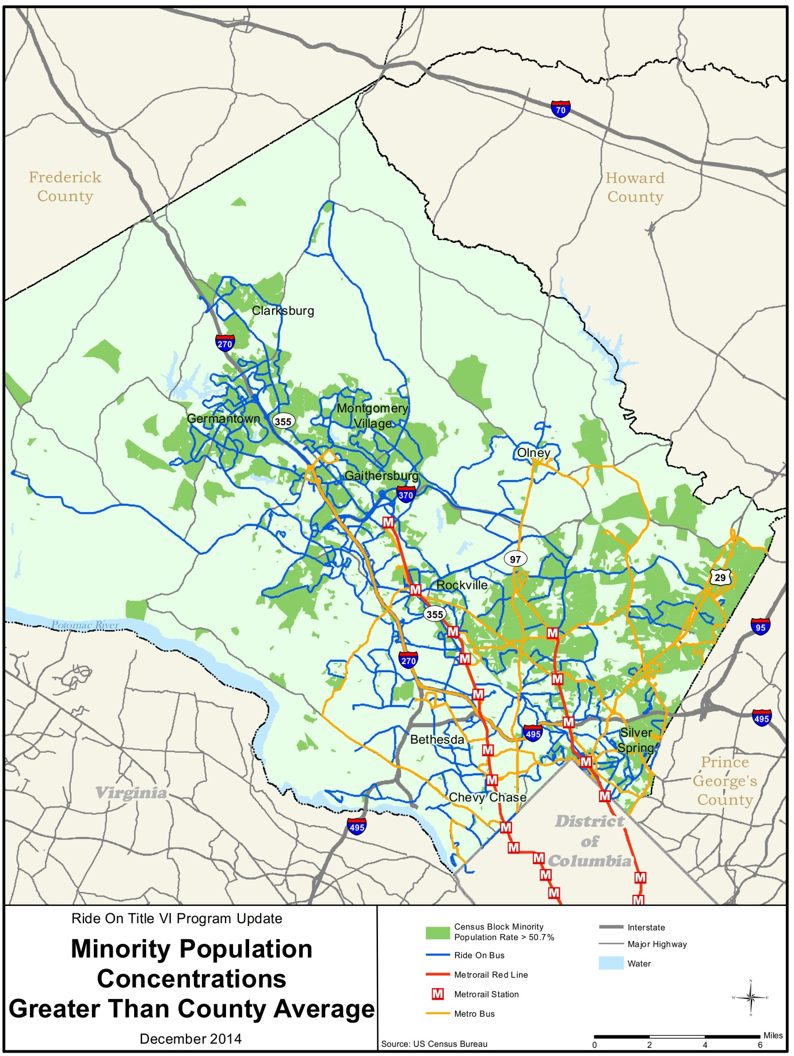

Figure 4-2: Ride On Service Area with Households below Poverty Level by Block Group
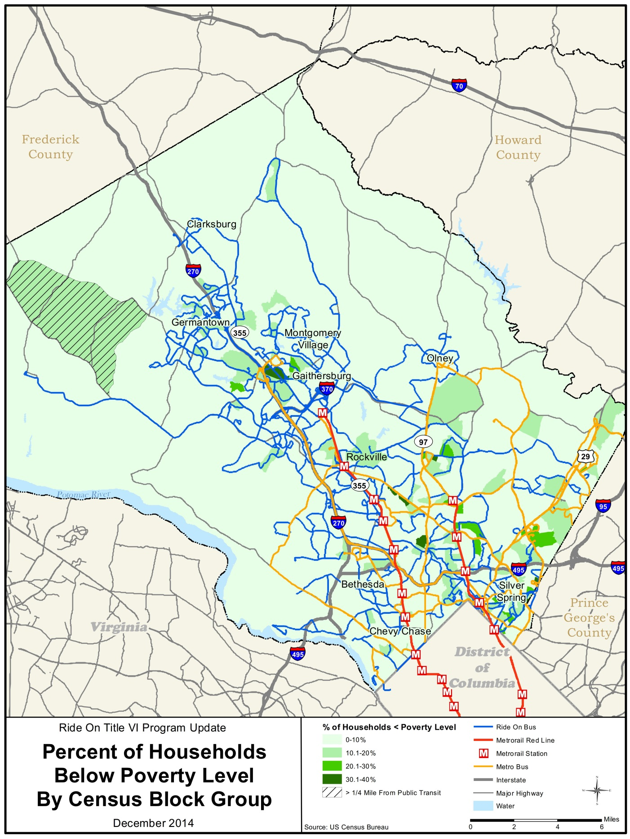

Vehicle Assignment Detailed Results
Table 4-12: Ride On Average Bus Age by Route – August 13, 2013
Quartile | Route | Trips | Total Age | Route Average Age | Quartile Average Age
Quartile 1 | 10 | 72 | 370 | 5.1 | 6.87
 | 15 | 174 | 1,128 | 6.5
 | 16 | 130 | 886 | 6.8
 | 20 | 29 | 908 | 7.0
 | 24 | 15 | 125 | 8.3
 | 31 | 22 | 199 | 9.0
 | 39 | 20 | 175 | 8.8
 | 41 | 71 | 399 | 5.6
 | 48 | 83 | 504 | 6.1
 | 51 | 28 | 134 | 4.8
 | 55 | 163 | 1121 | 6.9
 | 57 | 98 | 813 | 8.3
 | 59 | 101 | 777 | 7.7
 | 61 | 83 | 634 | 7.6
 | 65 | 11 | 88 | 8.0
 | 71 | 16 | 107 | 6.7
 | 78 | 16 | 117 | 7.3
 | 79 | 18 | 156 | 8.7
 | 93 | 14 | 42 | 3.0
 | 94 | 14 | 72 | 5.1
Quartile 2 | 2 | 78 | 646 | 8.3 | 6.38
 | 12 | 105 | 678 | 6.5
 | 14 | 64 | 433 | 6.8
 | 17 | 84 | 538 | 6.4
 | 18 | 69 | 129 | 1.9
 | 21 | 15 | 147 | 9.8
 | 22 | 34 | 337 | 9.9
 | 25 | 45 | 45 | 1.0
 | 26 | 89 | 410 | 4.6
 | 38 | 74 | 470 | 6.4
 | 49 | 89 | 581 | 6.5
 | 54 | 77 | 607 | 7.9
 | 58 | 73 | 619 | 8.5
 | 60 | 17 | 162 | 9.5
 | 64 | 71 | 600 | 8.4
 | 74 | 60 | 518 | 8.6
 | 75 | 56 | 514 | 9.2
 | 83 | 86 | 190 | 2.2
 | 97 | 52 | 114 | 2.2
 | 98 | 74 | 228 | 3.1

Quartile | Route | Trips | Total Age | Route Ave Age | Quartile Ave Age
Quartile 3 | 3 | 6 | 66 | 11.0 | 6.95
 | 4 | 37 | 253 | 6.8
 | 7 | 8 | 24 | 3.0
 | 8 | 54 | 213 | 3.9
 | 9 | 81 | 571 | 7.0
 | 13 | 20 | 142 | 7.1
 | 19 | 14 | 87 | 6.2
 | 28 | 97 | 1560 | 16.1
 | 33 | 32 | 179 | 5.6
 | 34 | 94 | 619 | 6.6
 | 43 | 72 | 623 | 8.7
 | 44 | 25 | 77 | 3.1
 | 45 | 78 | 502 | 6.4
 | 46 | 126 | 776 | 6.2
 | 53 | 31 | 131 | 4.2
 | 56 | 79 | 592 | 7.5
 | 66 | 12 | 92 | 7.6
 | 67 | 12 | 92 | 7.6
 | 100 | 193 | 1439 | 7.5
Quartile 4 | 1 | 80 | 638 | 8.0 | 7.02
 | 5 | 98 | 717 | 7.3
 | 6 | 58 | 288 | 5.0
 | 11 | 36 | 272 | 7.6
 | 23 | 60 | 728 | 12.1
 | 29 | 65 | 541 | 8.3
 | 30 | 59 | 450 | 7.6
 | 32 | 27 | 141 | 5.2
 | 36 | 54 | 328 | 6.1
 | 37 | 27 | 155 | 5.7
 | 42 | 67 | 459 | 6.9
 | 47 | 72 | 359 | 5.0
 | 52 | 21 | 121 | 5.8
 | 63 | 57 | 464 | 8.1
 | 70 | 60 | 448 | 7.5
 | 76 | 66 | 550 | 8.3
 | 81 | 31 | 199 | 6.4
 | 90 | 73 | 568 | 7.8
 | 96 | 57 | 264 | 4.6

Distribution of Transit Amenities

Transit amenities are mapped on Figures 4.3 and 4.4.

Figure 4-3: Ride On Stop Amenities Relative to Minority Population
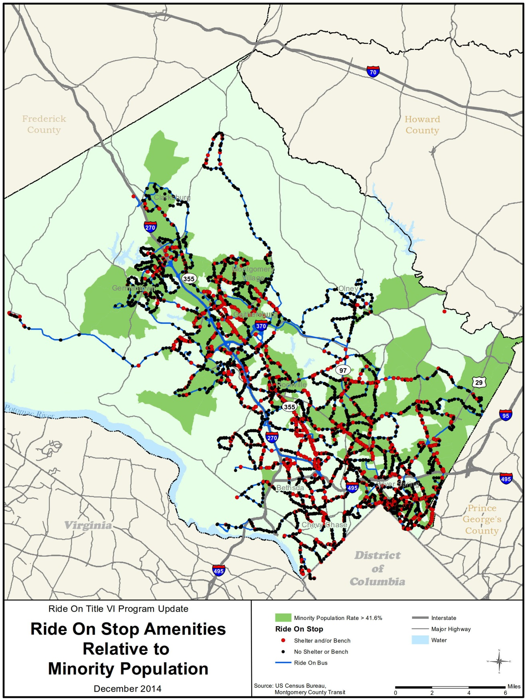
Figure 4-4: Ride On Stop Amenities Relative to Poverty Level Income
