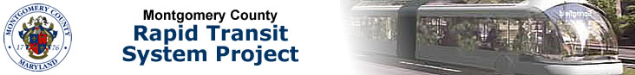
Montgomery County Rapid Transit System (RTS) Steering Committee
Proposed Agenda
September 30, 2014, 4:00 p.m. – 6:00 p.m.
Montgomery County Department of Transportation
101 Monroe Street, EOB Auditorium
- Introductions and Welcome – Arthur Holmes, Jr., Chair
- Approval of Minutes from the July 29, 2014 Meeting – Mr. Holmes
- Project Status Updates
  - Purple Line – Jamie Kendrick, MTA
  - Corridor Cities Transitway – Rick Kiegel, MTA
- Corridor Advisory Committee Plan – Mr. Holmes / Joana Conklin, MCDOT
- MDOT FY2015-2010 Consolidated Transportation Program: Rapid Transit Projects - Ms. Conklin
- Follow-up on MD 97 issues – Mr. Holmes
- BRT Scopes of Work / Project Development and Status – SHA
  - MD 97 and 586
  - MD 355 and US 29
- Metro Bus Priority Corridor Updates – Jim Hamre, WMATA
- Bus Demonstration Work Group Update – David Hauck
- Finance Work Group Update – Joe Beach
- Meeting Calendar – Next meeting is scheduled for 10/28/14 at the Rockville Library

