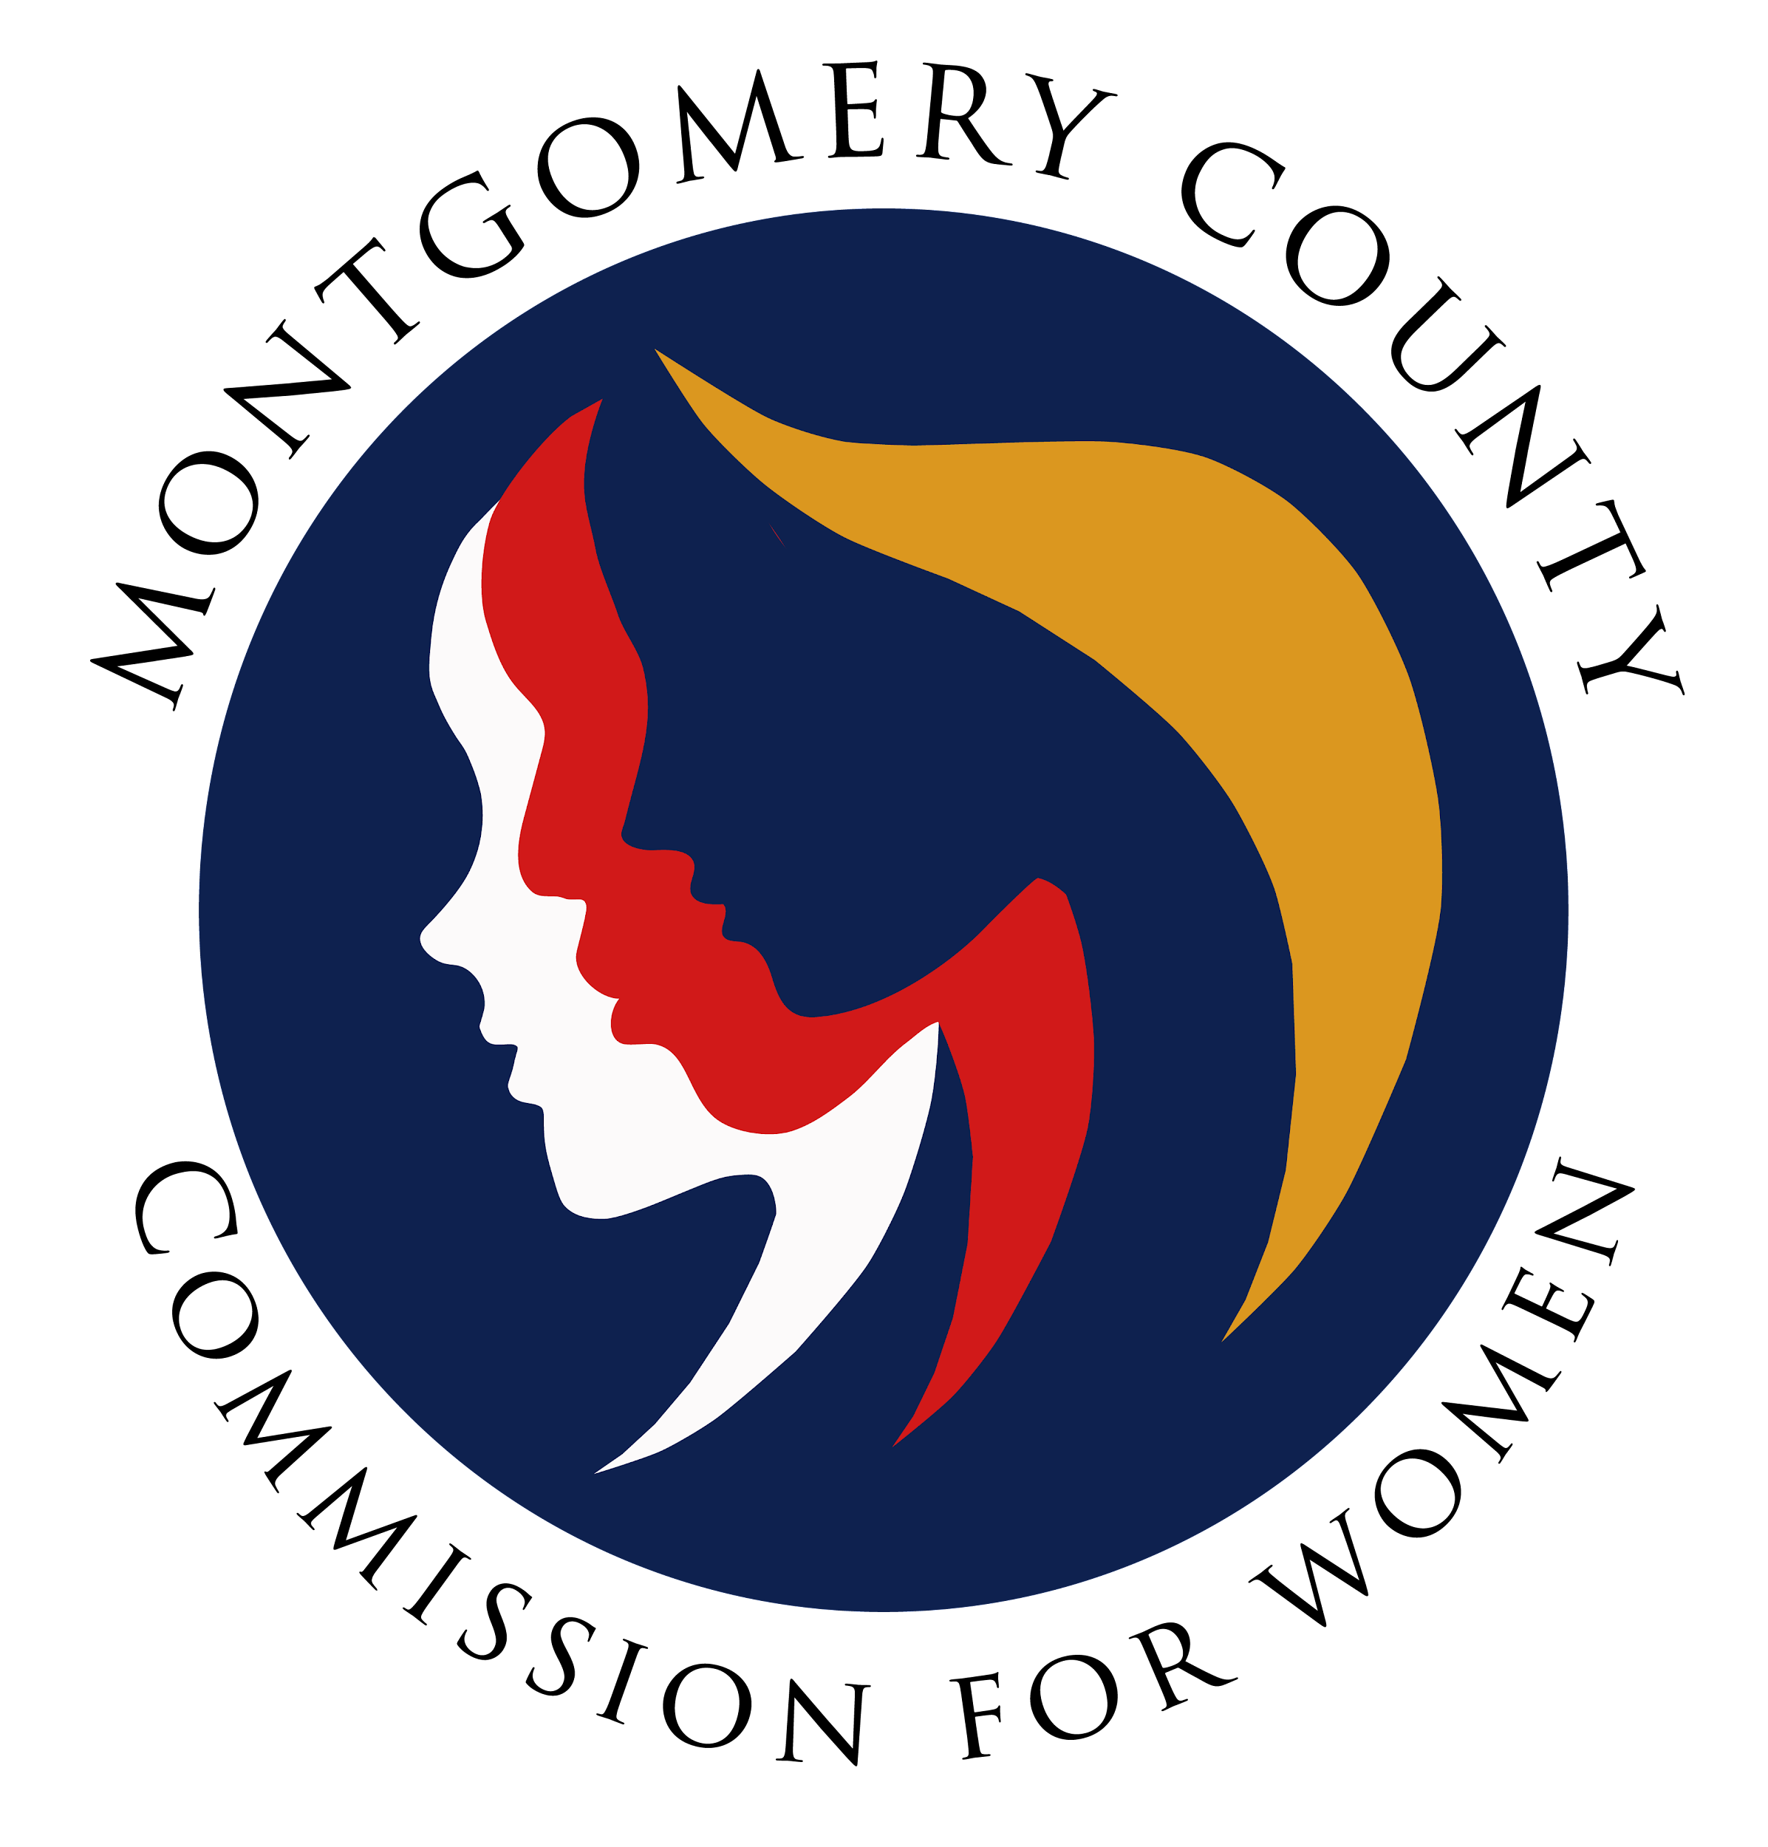
Montgomery County Commission for Women
General Meeting Minutes / Virtual
May 11, 2023 / 7:00 – 8:30 p.m.

______________________________________________________________________________
“Kindness is a sign of strength.”
Unknown
______________________________________________________________________________

Attendees
Donna Rojas, Chair
Arlinda Clark, 1st Vice Chair
Betty Romero, 2nd Vice Chair
Isabel Argoti Ijeoma Enendu Kathy Estrada
LaDonna King Helene Meister Kimberly Mouzon Liz Richards
Liz Richards Tondalayo Royster Lindsey Turnbull

CFW Team Members
Jodi Finkelstein, Executive Director / Vacation
Carmen Kaarid, Program Manager
Absent
Janet LaValle
Jodi Danis
Leah Wade
GENERAL MEETING MINUTES

I. WELCOME AND INTRODUCTIONS / CHAIR ROJAS

II. APPROVAL OF MINUTES AND AGENDA / CHAIR ROJAS

- Approval of May 11, 2023 meeting agenda
Agenda approved by Commissioners
- Approval of April 13, 2023 meeting minutes
Meeting minutes to be amended pending clarity from Commissioner Romero
Minutes will be voted on at the June meeting

III. EXECUTIVE COMMITTEE REPORT / CHAIR ROJAS
- No Report

IV. EXECUTIVE DIRECTOR REPORT / EXEC DIR., FINKELSTEIN

- Internships

- Council approved $10K stipend for interns; students will receive compensation beginning in the fall.
- CFW will have three interns this summer (two students from Walt Whitman and one summer rise student for five weeks.

- Jennifer Escobar received full time employment offer from Council Member Laurie-Anne Sayles and will begin working full time in June.
- State Commission Roundtable

- Roundtable with Lieutenant Governor, Aruna Miller and First Lady Dawn Moore will be held June 1st @ 5:00pm. Commissioners planning to attend, respond to today for submission of final count to State Commission.

- June Meeting (In Person Guests)
- New Council Members were invited for meet and greet to CFW June meeting
- Council Members Balcombe, Stewart, Fani-Gonzales and Luedtke will be in
attendance; Council Member Laurie-Anne Sayles is unable to attend and Council
Member Mink has not responded yet.

V. COMMITTEE REPORTS

- Policy and Legislation / Program Manager, Carmen Kaarid

- No Report

- Program Planning / Chair, Commissioner Enendu

- No Report

- Question for Carmen Kaarid: Has the CFW reached the pay limit for the instructor teaching self-defense classes? Carmen Responded: There is approximately $2K before reaching the limit not including what will be paid for spring classes.

- Budget / Chair Rojas)

- No Report

- Strategic Planning and Research Evaluation Committee, 2 Vice Chair, Commissioner Romero

- Email sent to committees on the roles and responsibilities; committees should be clear on the expected outcomes.
- Planning Tool established / Committees are to update spreadsheet for FY 24 action
plan

- Strategy Planning Session in September to discuss the why, how and when of priorities. All Commissioners are encouraged to attend. Date to be confirmed based on responses from Doodle Poll.

- Potential consideration of CFW addressing intersection issues in the future

- Emerging Leaders / Commissioners Argoti and Turnbull

- Girl Power winners were announced. Commissioner Argoti will send email announcing the winners.

- Public Relations / Commissioner Argoti

- Met recently and discussed implementing a contact calendar.
- Commissioners are encouraged to share events / information to be highlighted from the last few months.

- Reviewing SWAG items for future ordering.

- Women’s Legislative Briefing / 1st Vice Chair, Clark

- Planning Meeting held May 4th / Next Planning Meeting is July 6th @ 7pm
- WLB 2024 is January 28th and will be in person (details to be confirmed)
- Theme: Proposal to Passage – Collaborating for Justice and Equality
- Prices will increase due to in person event. Site visit to Shady Grove / awaiting pricing

V. LIAISON REPORTS

- MLAW / Commissioner Meister
- Attended last month’s meeting; MLAW happy their priority bills passed.
⁻ MLAW seeking new projects; perhaps, CFW can weigh in on possible priorities

- Human Trafficking Prevention (HTP) / Program Manager, Carmen Kaarid
- Budget approved for HTP ($25K)
- Successful meeting at the hospital on the blue dot campaign

- Domestic Violence Coordinating Council (DVCC) / Commissioner Royster

- Guest Speaker, Leslie Hawes, Executive Director, Court Watch sharing information on newly released Annual Report.
- Court Watch focuses on protective orders on DV cases and volunteers report observations from judges, rulings, etc.

- Maryland Commission for Women, Program Manager, Carmen Kaarid
- Roundtable scheduled June 1st with Lieutenant Governor Aruna Miller and First Lady
Dawn Moore

- RespectFest / Commissioner Mouzon
- RespectFest scheduled April 16th at Wheaton Recreational Community Center was a success.
- Approximately 1100 – 1200 attendees (virtual and in person); In person 600 attendees and 10 community booths on site to include CFW.

- Community Health Initiative / Commissioner LaValle

- No report

- CFW Scholarship / Commissioner Argoti
- No report

- Social Committee / Commissioner Rojas

- CFW Social at Muse Paint Bar on May 19th in Gaithersburg, MD (details forthcoming)

VI. AD HOC COMMITTEE REPORT(S)

- By Laws Committee / 2nd Vice Chair Clark and Commissioner LaValle
- By Laws were presented and the proposals for change were shared
- Lengthy discussion on whether or not a July meeting will take place. Carmen
shared that in the past Commissioners preferred to skip the July meeting because of
traveling season. Topic tabled for later date.

- Nominations will be announced at the July meeting but not voted on.

IX. OLD BUSINESS

- N/A

X. NEW BUSINESS/ANNOUNCEMENTS

- Chair Rojas last meeting is next month – June 2023

XI. GOOD NEWS

- Happy Mother’s Day!

XII. Meeting Adjourned

