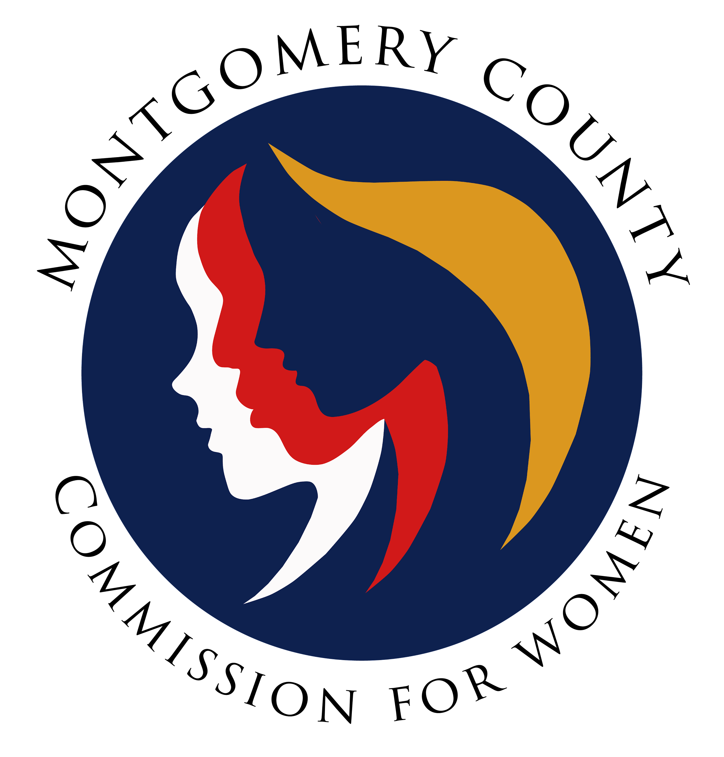
Commission for Women
General Meeting Minutes / Virtual
January 11, 2024 / 7:00 – 7:30 p.m.

______________________________________________________________________________
“Defeating human trafficking is a great moral calling of our time.”
Condoleezza Rice
______________________________________________________________________________

Attendees
Arlinda Clark, Chair
Isabel Argoti Vice Chair
Lindsey Turnbull, 2nd Vice Chair

Jodi Danis Ijeoma Enendu Kathy Estrada Janet LaValle Tonja Paylor Liz Richards

CFW Team Members
Jodi Finkelstein, Executive Director
Carmen Kaarid, Program Manager
Absent
LaDonna King
Helene Meister
Kimberly Mouzon
Betty Romero
Tondalayo Royster
GENERAL MEETING MINUTES

1. WELCOME AND INTRODUCTIONS / CHAIR CLARK
Happy New Year!
No Guests

2. APPROVAL OF MINUTES AND AGENDA / CHAIR CLARK

January agenda accepted as presented
14 December minutes accepted as presented
6 December special meeting minutes accepted as presented

3. CFW CHAIR REPORT / CHAIR CLARK
Need Nominations Committee
Let Chair know within this week if you are interested in serving on this committee
Chair will appoint committee in February
Role: Collects the names of nominees
Vice Chair Argoti volunteered for the Nominations Committee

Need Election Committee
Asked if anyone has election experience
Commissioner Turnbull has election experience
Role: Runs the election, counts the ballots

If you are planning to run for office, you cannot be on the Nominations or Elections Committee
Would like to do this electronically
Would prefer different people on the two committees, to keep roles separate

4. EXECUTIVE DIRECTOR REPORT / JODI FINKELSTEIN

Working on upcoming WLB, 28 JAN 24

5. COMMITTEE REPORTS

Policy and Legislation / Co-Chairs, Commissioners Royster and Meister

Session started yesterday
PALS preparing to advocate on priority CFW bills

Program Planning / Chair, Commissioner Enendu

Did not meet last month, will meet 22 JAN

Budget / Chair Clark

Have not spent any from the restrictive budget yet
Money spent this FY so far have been county money

Strategic Planning and Research Evaluation Committee/ Commissioner Romero

Three focus priorities:
- Women’s Economic and Financial Security
- Women in Leadership, Education, & Workforce
- Women’s Health, Safety, & Security

The above three priorities are formally adopted by the CFW

2023-2024 Strategic Focus: Women’s Economic and Financial Security

The CFW formally adopted Women’s Economic and Financial Security as our focus for 2023-2024

Emerging Leaders / Vice Chair Argoti and 2nd Vice Chair Turnbull

Working on Girl Power questions

Public Relations / Vice Chair Argoti

No Report
Women’s Legislative Briefing / Vice Chair Argoti

Buy ticket:
Ticketing Page Active: https://www.eventbrite.com/e/2024-womens-legislative-briefing-registration-738129564397?aff=oddtdtcreator (Early Bird: $40)

Press release went out today: https://www2.montgomerycountymd.gov/mcgportalapps/Press_Detail.aspx?Item_ID=44597

Sign up to facilitate a breakout session (https://www.signupgenius.com/go/10C0D49AAAB28A0F4C25-46649251-2024#/)
Emerging Leaders
Advocacy Session

Can sign up for two+ sessions, as long as the sessions are not running at the same time

Fireside chats with female County Executives

Need more hosts for the event: https://docs.google.com/forms/d/e/1FAIpQLSeBLH_kbdi6sVt6ZKmufuZGn-P7IHZibzGQmrCXFzuLaoc78Q/viewform
Need to check if students can get SSL hours for volunteering at WLB
Will check with school system
Approved for SSL hours for attending the Emerging Leader track

Wear commissioner nametag to WLB

Media toolkit should be ready by end of the week

Chair’s Breakfast from 10am-12pm
Sponsors must designate who is coming
Commission is invited but must RSVP by this week (Danis, Argoti, Richards, Estrada, Lavalle, Paylor all RSVP’d during the meeting)
If attending breakfast, pick up registration packet there
Dress code is professional

Standard Operating Procedures / Commissioner LaValle

No Report

6. LIAISON REPORTS

MLAW / Commissioner Royster
MLAW priorities sent

Human Trafficking Prevention (HTP) / Commissioner Estrada
Meeting on 17 JAN
Today is National Human Trafficking Awareness Day
#WearBlueDay – public awareness campaign
23 JAN – proclamation that January is Human Trafficking Awareness Month at the council building at 9:15am; also can view online/on social media

Domestic Violence Coordinating Council (DVCC) / Commissioner Royster

DVCC presented to over 2,000 students this semester

Maryland Commission for Women, Executive Director, Jodi Finkelstein

Trying to fill Executive Director vacancy

Choose Respect / Commissioner Royster
30 submissions so far; 7 FEB is closing date
Community Health Initiative / Commissioner LaValle

No Report

CFW Scholarship / Commissioner Argoti
Montgomery College is having their recognition luncheon on Thursday, 28 MAR

7. AD HOC COMMITTEE REPORT(S)

By-Laws / Chair Clark

No Report

8. OLD BUSINESS

No old business

9. NEW BUSINESS/ANNOUNCEMENTS
Janet is getting a dog (poodle)
Looking to do something social together in February
Thanks to Jodi and Carmen for all the prep they’ve done for the WLB!
Thank you to everyone that donated to Community Bridges' holiday gifts
The commission adopted a family of women for the holiday

10. Meeting Adjourned – 7:44pm

CFW In Person Meetings Scheduled:
March 14, 2024
June 13, 2024

Upcoming Events:
WLB, 28 JAN
January is National Human Tracking Awareness Month

