Background
There have been moderate changes made to the Probationary Employee Training Program.
Beginning with RC47, an EMS Driver Training Module replaced the Additional Knowledge Module in order to streamline the driver certification process. It is the same length as the FIRE and EMS modules and can be placed in any order at the choice of the supervisor.
Keep in mind that while these modules are grouped with similar job functions, Station Officers, preceptors and probationary employees are reminded to stay attentive to the entirety of Fire, EMS and driving job functions across all modules. The goal is to improve overall performance which may result in the need to pull handlines in the EMS Module or practice EMS skills during the FIRE module.
Finally, a complete overhaul of the testing process is taking place to align the test skills to a more scenario and realistic basis. While more direction will follow closer to the test date, basic information is provided below.
Responsibility
Station Officer
- Provides expectations to Probationary Employee
- Provides feedback to employee
- Consider implementation of a Preceptor to assist with management
- Establishes schedule of modules in accordance with period due dates
- Ensures completion of documentation in appropriate timeframe
  - Includes counseling report with each module
  - Submits IPPA in accordance with timeframe
  - Maintains supervisory file
- Verifies employee’s PCAP is correct
- Reviews Journal Entries
- Informs chain of command of deficiencies
Probationary Employee
- Ensures completed assignments are provided to Station Officer in a timely fashion (NLT the morning of the due date)
- References resources in written assignments
- Participates in routine Physical Fitness activity
- Balances assignments with station duties
- Communicates with preceptors and station officers’ needs
- Completes a journal entry for each shift worked
Probationary Employee Training Program
The program consists of SIX 3-week periods. During each period a specific module is assigned by the station officer. With the exception of the first module, the other FIVE are interchangeable and can be completed in any order. The goal of the newly implemented Driver Section is to allow adequate time to prepare for the testing process as well as complete the requirements set forth by the Driver Training staff. It is NOT required to test at the end of this module, but it is highly encouraged to take advantage of this time to be successful.
Written Assignments should identify the source material at the bottom of the response (FCGO 20-XX, Chief Goldstein, etc), but formatting is at the discretion of the BC and Station Officer. Practical assignments are to be completed to a reasonable and successful level before being signed off that they were completed.
Issues with practical skills shall be documented on counseling reports. The chain of command should be notified of issues resulting in massive failure or continued sub-par performance for guidance on appropriate action.
Documentation
Documentation is extremely vital in correcting deficiencies and providing feedback to new employees. The principal components of documenting performance during probation is through the Counseling Reports that are completed at the end of each Module.
PCAP
Station Officers need to enter the “Aide of a Basic Life Support Unit” when the probationary employee meets minimum staffing. The other entry that must be made is the “Driver of a Basic Life Support Unit”. These dates need to be correct as they affect other programs.
Station Officers should also verify the expiration date of EMT certifications in PCAP. Brand new certifications are typically allowed several extra months of certification beyond the 3 year limit in place in PCAP. Towards the end of the probation these dates may need to be adjusted to the correct date.
As the anniversary date approaches, please understand that the usage of the “Check Eligibility for Promotion” in PCAP will only show “This Candidate does not have 1 year of FF1 experience needed to qualify for a non-competitive promotion” until the time in grade requirement is meet. This response may be misleading as the employee may be missing other coursework/certifications, however until the time in grade is met, no other reasons will post.
The Tables below show entries in PCAP for verification. Inaccurate “Current Certifications” can be corrected by any supervisor. “PSTA Course Transcript” inaccuracies or issues can be reported to the Registrar and/or Recruit Training Office.
PSTA Course Transcript
Firefighter 1 and 2
EMT
EVOC
EEO/AA and the Law
Cultural Diversity
Hazardous Materials 1st Responder
Operations (or Equivalent)

Current Certifications
AED
Aide on a BLS Unit
Annual Radio Training
Blood Borne Pathogens
Confined Space
CPR
Driver of a Basic Life Support Unit
EMT (B or P)
Hazardous Materials
SCBA
Trench

EMS Unit Driver Requirement
Probationary Employees must become certified EMS Unit Drivers prior to the submission of the IPPA to the OPS Battalion Chief. The driver Certification process is managed by the Driver Training Staff. To Schedule Tests or for general inquiries, please email _frsdrivertraining. Please keep in mind that there are testing parameters in place that result in a waiting period following unsuccessful attempts. It is highly recommended to take advantage of the Driving Module prior to attempting the written tests.
Probationary Testing
The grading rubric is FAILURE, REMEDIAL, MEETS and EXCEEDS.
- FAILURE – Probationary Employee failed to successfully meet passing criteria and must retest at the PSTA.
- REMEDIAL – Probationary Employee struggled with one form of the passing criteria and needs to review/repeat material/skill at the station level.
- MEETS – Probationary Employee meet the passing criteria for the Probationary Testing Process
- EXCEEDS – Probationary Employee completed the Probationary Testing Process
Test results will be reported to the Station Officer. REMEDIAL forms will be sent to Station Officers and will need to be completed prior to the end of Probationary Testing. Issues incurred during the REMEDIAL phase should be noted to the Chain of Command.
FAILURES will result in a retest the following week via detail as outlined on the Probationary Calendar. The RTO will work with the DOCs to set up the detail.
The WRITTEN TEST will be a multiple-choice test of 50-100 questions based on material out of the written and practical skills. The primary focus of the written test is to evaluate basic understanding of Policies and Procedures, EMS Protocols and common job knowledge.
The PRACTICAL TEST will be broken into a FIRE and EMS portion. The FIRE portion will consist of Donning PPE and boarding Apparatus, Completing a scenario from the engine cab that incudes throwing a 24’ ground ladder to a second floor window for rescue, deploying a preconnected handline to a simulated IDLH and donning appropriate PPE prior to entry and demonstrating an SCBA emergency procedure.
The EMS portion of the test will remain the same as the past. This will include skills and knowledge based upon the EMT Class.
The PHYSICAL FITNESS Evaluation is based on Incumbent Performance Evaluation as the primary fitness evaluation tool for Probationary Firefighters with MCFRS. At the time of this writing, it is expected that the IPE will be the measurement of physical fitness for RC48.
Due to the Pandemic and facility usage, there may be a need to change to the standard FITNESS EVALUAITON. The criteria is posted below. In the unlikely event the IPE is not used, it will be communicated thoroughly to the employees and their supervisors.
Traditional Physical Fitness Evaluation

Fitness Component | 70% | 100%
Push ups | 30 | >60
Curl ups (Sit ups) | 50 | 90
Pull ups | 3 | >12
Aerobic Capacity (1 ½ mile run) | 12 minutes | <10:00 minutes
Flexibility (sit & Reach) | 11 inches | >22 inches
Grip Strength > | 84 pounds | 124 pounds

MCFRS Incumbent Performance Evaluation Program
The Incumbent Performance Evaluation (IPE) is a self-evaluation of an individual’s ability to physically perform essential functions required in the occupation of firefighting. The Montgomery County Fire and Rescue Service has developed an individual performance evaluation that protects the safety of the fire fighter and provides for the appropriate delivery of fire suppression and rescue services.

This program has been developed in conjunction with IAFF Local 1664 and Montgomery County Fire and Rescue management. The IPE program has been developed to initially provide individuals an opportunity to participate in a self-evaluation of their abilities to physically perform essential functions in the occupation of fire-fighting and to gather data associated with these essential functions during the pilot period.

The IPE consists of 9 events designed to provide a self-evaluation of the incumbent’s physical ability as a fire fighter to operate effectively on an incident scene. The event is timed with successful completion of 11:00 minutes.

IPE EVENTS:

- personal protective equipment
- ladder carry, raise, extension event
- forcible entry event
- high rise pack event
- stair event
- hand line advancement event
- victim rescue event
- pike pole event
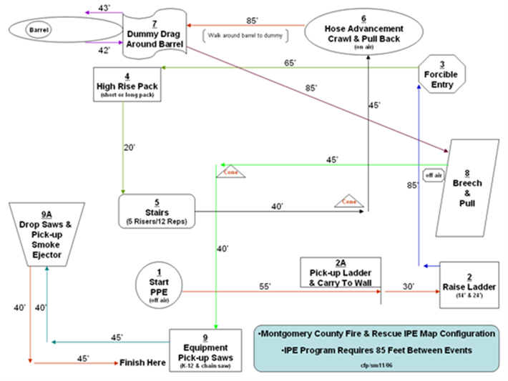
- equipment event
EMS POrtion

