E-MAIL TRANSMITTAL

Interagency Water/Sewer Map Amendment Review
January 9, 2026
TO: Tom Gingrich and Luis Tapia, Development Services Division
Washington Suburban Sanitary Commission
Christina Sorrento, Chief, Environmental Planning, M-NCPPC
Maryland – National Capital Park and Planning Commission
Geoffrey Mason, Parks Planning & Stewardship Division
Maryland – National Capital Park and Planning Commission
Heidi Benham, Well and Septic Section
Department of Permitting Services
FROM: Tim Williamson, Planning Specialist III, Water Supply and Wastewater Unit
Watershed Restoration Division, Department of Environmental Protection
SUBJECT: WATER/SEWER CATEGORY CHANGE REQUEST REVIEW –2026-2 REVIEW GROUP
Included with this message is information that identifies four (4) new individual water/sewer service area category change requests (WSCCRs) for your review and comment. This information will also be posted to www.montgomerycountymd.gov/waterworks as a PDF. These requests will be considered as proposed amendments to the County’s Comprehensive Water Supply and Sewerage Systems Plan. I would greatly appreciate receiving your review comments on these requests no later than February 10. 2026. Please notify me no later than February 3, 2026, if this schedule is not feasible.
DEP will develop and announce a schedule for administrative delegation hearing AD 2026-2, which will include all eligible FY 2026 second quarter requests. We will provide a notice of that hearing 30 days prior to the hearing date. We anticipate that requests requiring County Council consideration will be transmitted to the Council in the Spring of 2026. DEP’s recommendation process for the requests will be based in part on the review comments your agencies provide.
Note that the listing of the following requests under the administrative process versus the Council process is a preliminary determination and certainly subject to change as they proceed through the review process.
Anticipated Administrative Action WSCCRs
26-DAM-01A……WSSC Water; 11415 Kingstead Rd
26-PAT-01A……Spencerville Seventh Day Adventist Church; 16325 New Hampshire Avenue

Anticipated County Council WSCCRs
26-CKB-01A……21820 Clarksburg Rd.
26-URC-01A……6112 Muncaster Mill Rd

Undetermined WSCCRs
None.

Please do not hesitate to contact me at timothy.williamson@montgomerycountymd.gov or 202-579-3116 if you have any questions concerning these category change requests or the review schedules.
R:\Programs\Water_and_Sewer\CCRs\CCR-Review-Process\2026CCR-review-process\2026-2 Group\2026-2 Review Packet.docx
cc: Agencies
Amy Stevens, Division Chief, Watershed Restoration Division, DEP
Alan Soukup, Senior Planner, Watershed Restoration Division, DEP
Keith Levchenko, Montgomery County Council
Jamey Pratt, Upper County Planning, M-NCPPC
Mark Symborski and Ariel Zelaya, Environment and Climate Division, M-NCPPC
Fred Mejias, Development Services Division, WSSC Water
D. Lee Currey, Water and Science Administration, MDE
Jeff White, Water and Science Administration, MDE
Robin Pellicano, Water and Science Administration, MDE
Susan Llareus, MDP
Category Change Applicants & Interested Parties

Civic Organizations and Other Public Interest Groups
Nature Forward
West Montgomery County Citizens Association
Montgomery Coalition to Stop Sewer Sprawl
Cloverly/Fairland/White Oak CAC
Northern Montgomery Community Alliance
Spencerville Civic Association
Sierra Club - Montgomery County Group
East County Citizens Advisory Board
Cloverly Civic Association
Montgomery County Civic Federation
Clarksburg Civic Association
Hampshire Greens Homeowners Association
Adjacent and Confronting Property Owners
DEP will send a notice to each owner of properties adjacent to and confronting these category change request sites advising them about the filing of these requests.

[1] WSCCR: 26-CKB-01A – 21820 Clarksburg Rd.
Anticipated Action Path: County Council
Property Information and Location
Property Development
- 21820 Clarksburg Rd, Boyds, MD
- Parcel P307, Subdivision 0001, Tax acct. 00022930
- Map tile: WSSC: 230NW14; MD tax map: EV12
- Approximately 600 feet North of the Intersection at W Old Baltimore Rd.
- RE1 Zone; 5.7 ac.
- Clarksburg Planning Area
Clarksburg Master Plan (1994)
- Little Seneca Creek Watershed; MDE Use I/I-P
- Existing use: Residential, built 2003
- Proposed use: Assisted Living Facility
Applicant’s Service Area Category Request & Explanation
Existing Categories: W-1, S-6
Requested Categories: S-3
Applicant Explanation: Nursing home facility in need of public sewer to avoid septic and additional septic field area. Please see attached site map of the proposed assisted living facility. Current structures on property including the garage will be renovated into a 16 bedroom facility.

Agency Review Comments
DPS:
M-NCPPC – Planning Dept.:
M-NCPPC – Parks Planning:

WSSC - Sewer:

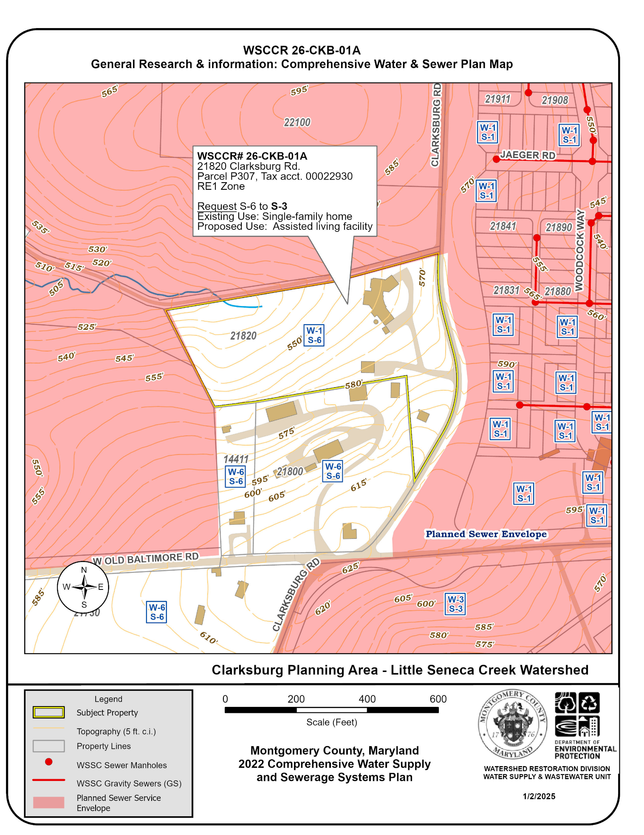
Figure 1: Water and Sewer Category Map of the subject property at 21820 Clarksburg Rd, showing service areas categories, the planned sewer envelope and nearby sewer mains. Sewer mains extensions would be needed to serve the property.

[2] WSCCR: 26-DAM-01A – WSSC Water
Anticipated Action Path: Administrative Delegation
Property Information and Location
Property Development
- 11415 Kingstead Rd, Damascus, MD 20872
- Parcel 295, Subdivision 0001, Tax acct. 00933410
- Map tile: WSSC: 235NW11; MD tax map: FX11
- Property Northeast of the Intersection at King Valley Rd and Kingstead Rd.
- RNC Zone, a portion of the property is in the AR Zone; 0.98 ac.
- Damascus Planning Area
Damascus Master Plan (2006)
- Little Bennett Creek Watershed; MDE Use III/III-P
- Existing use: Agricultural
- Proposed use: Construction of new WSSC sewer pump station.
Applicant’s Service Area Category Request & Explanation
Existing Categories: W-6, S-6
Requested Categories: W-3, S-3
Applicant Explanation:
WSSC Water is requesting to change the water and sewer service categories for 11415 Kings Valley Road (at the intersection of Kingsvalley Rd N and Kingstead Road) from W-6/S-6 to W-3/S-3 to support the development of new Spring Gardens Wastewater Pumping Station (WWPS).
This site was part of a previous category change request (WSCCR 22-DAM-05A) that received
conditional approval for W-3 and S-3 under a cluster development plan. Since WSSC Water purchased
the land from the previous applicant, a new request is needed to assign W-3 and S-3 categories
specifically for this public facility.

Agency Review Comments
DPS:
M-NCPPC – Planning Dept.:
M-NCPPC – Parks Planning:
WSSC - Water:
WSSC - Sewer:
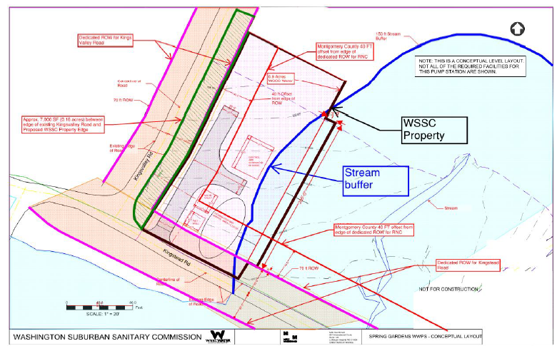
Figure 2: Spring Gardens Pump Station Concept Plan, submitted by WSSC Water.
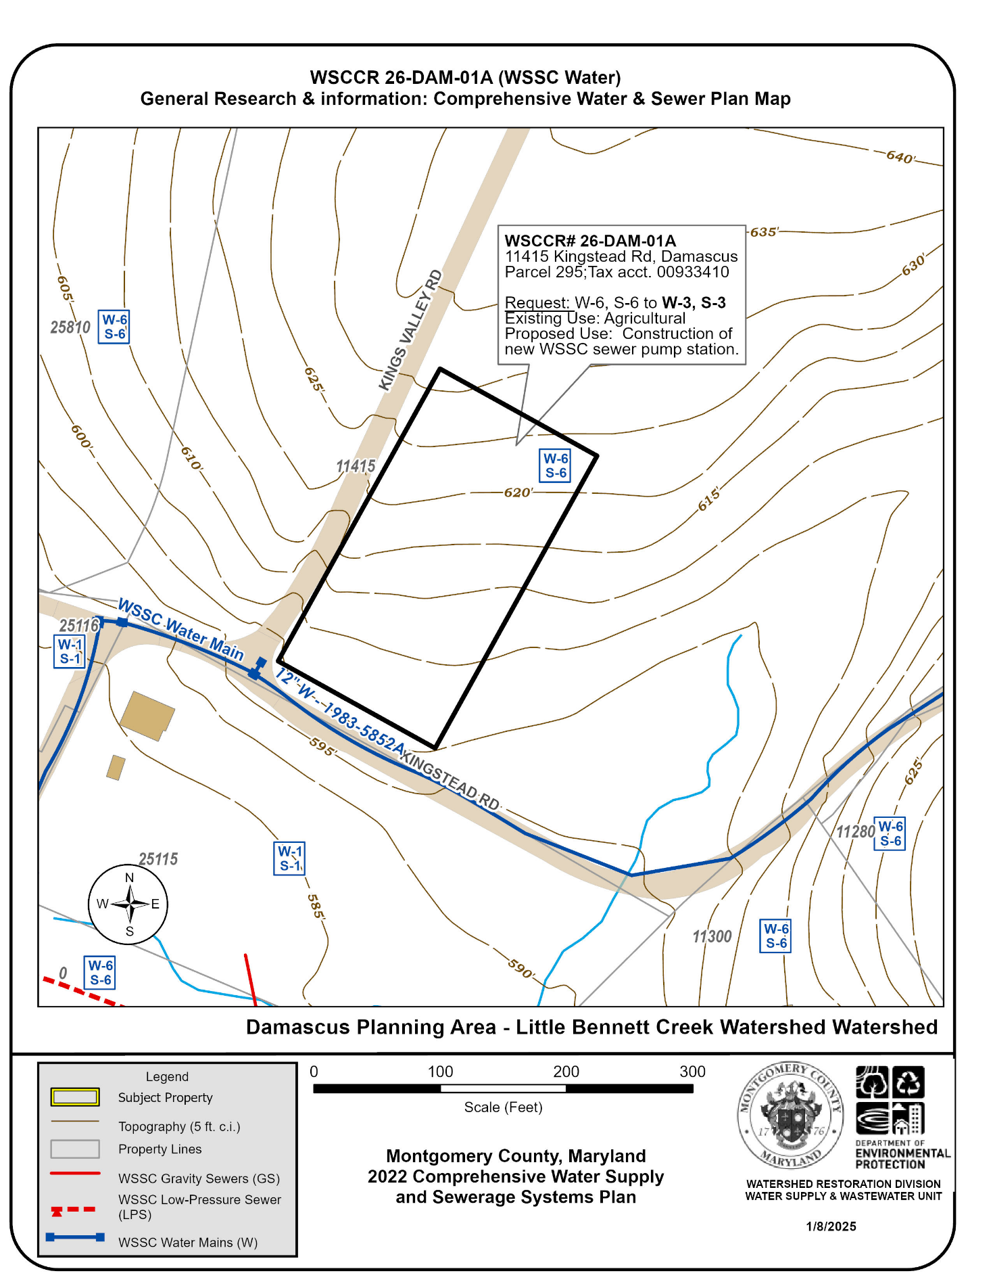
Figure 3: Water and Sewer Category Map of the subject property at 11415 Kingstead Rd, showing service areas categories, and nearby sewer mains. Sewer mains extensions would be needed to serve the property. The location and shape of the new property is approximated by DEP. See the above Concept Plan by WSSC (Figure 2) for more detail.

[3] WSCCR: 26-PAT-01A – Spencerville Seventh Day Adventist Church
Anticipated Action Path: Administrative Delegation
Property Information and Location
Property Development
- 16325 New Hampshire Ave, Silver Spring 20905
- Parcel A -Plat 11917, Parcel P677, Parcel P566; Tax acct. 01681064, 00264201, 00261550
- Map tile: WSSC: 222NE02; MD tax map: KS13
- Property 550 feet South of Milgrove Place on the eastern side of New Hampshire Avenue.
- RE1 Zone & RC Zone; 8.98 ac.
- Patuxent Planning Area
Cloverly Master Plan (1997)
- Lower Patuxent River Watershed & Northwest Branch Watershed; MDE Use I/I-P; IV/IV-P
- Existing use: Place of Worship
- Proposed use: No change.
Applicant’s Service Area Category Request & Explanation
Existing Categories: W-1, S-6
Requested Categories: S-1
Applicant Explanation:
The existing Seventh Day Adventist church and associated parking located on the Subject Property was originally built in 1981 and is currently served by public water and a private septic system. There was a recent fire in the church and due to the damage, the current church building will be torn down and replaced with a new building. During the time since the church was originally built, WSSC has approved a sewer main installation in New Hampshire Avenue, in front of the Subject Property to serve the gas station at the corner of MD Route 198 & MD Route 650. This sewer was constructed in 2017 and is a combination of gravity sewer and pressure sewer system with a transition manhole from pressure sewer to gravity sewer located directly in front of the existing church building, within the New Hampshire Avenue right-of-way. The Subject Property is also unique in that the property is split-zoned RE-1 (Residential Estate) & RC (Rural Cluster) and also sits at the ridge between the Northwest Branch Watershed and the Patuxent River Watershed. Part of the existing building and existing parking facilities sit within both zones and both watersheds. With anticipated construction of a new building that will also include allowances for growth of the congregation, the church is requesting a sewer category change from S-6 to S-1 under Chapter1, Section II.G.4: “Service for Private Institutional Facilities” of the Montgomery County Comprehensive Water Supply and Sewer System Plan. (PIF Policy) With the split-zoned property, part of the Subject Property (RE-1 Zone) is within the planned sewer service envelope as it drains to the Northwest Branch, (Please see Cloverly Master Plan recommendations) and part of the Subject Property (RC) is not withing the planned sewer service envelope as it drains to the Patuxent River. The County’s “PIF Policy” allows for administrative approval of private institutional facilities within the planned service envelope and for properties not in the planned service envelope, approval is based on the PIF policies. The church facilities located on the Subject Property have been an existing part of the surrounding community for many decades and will not be a “new development” that impacts or overburdens the local community character or environmental features of the area. The Subject Property is abutting an existing sewer main located in New Hampshire Avenue, and based on preliminary analysis, the church facility can be served by a gravity sewer connection to the existing sewer main. No new sewer main extensions are proposed and this request will not allow any new expansion of the planned sewer service envelope to
other properties.
Agency Review Comments
DPS:
M-NCPPC – Planning Dept.:
M-NCPPC – Parks Planning:
WSSC - Sewer:
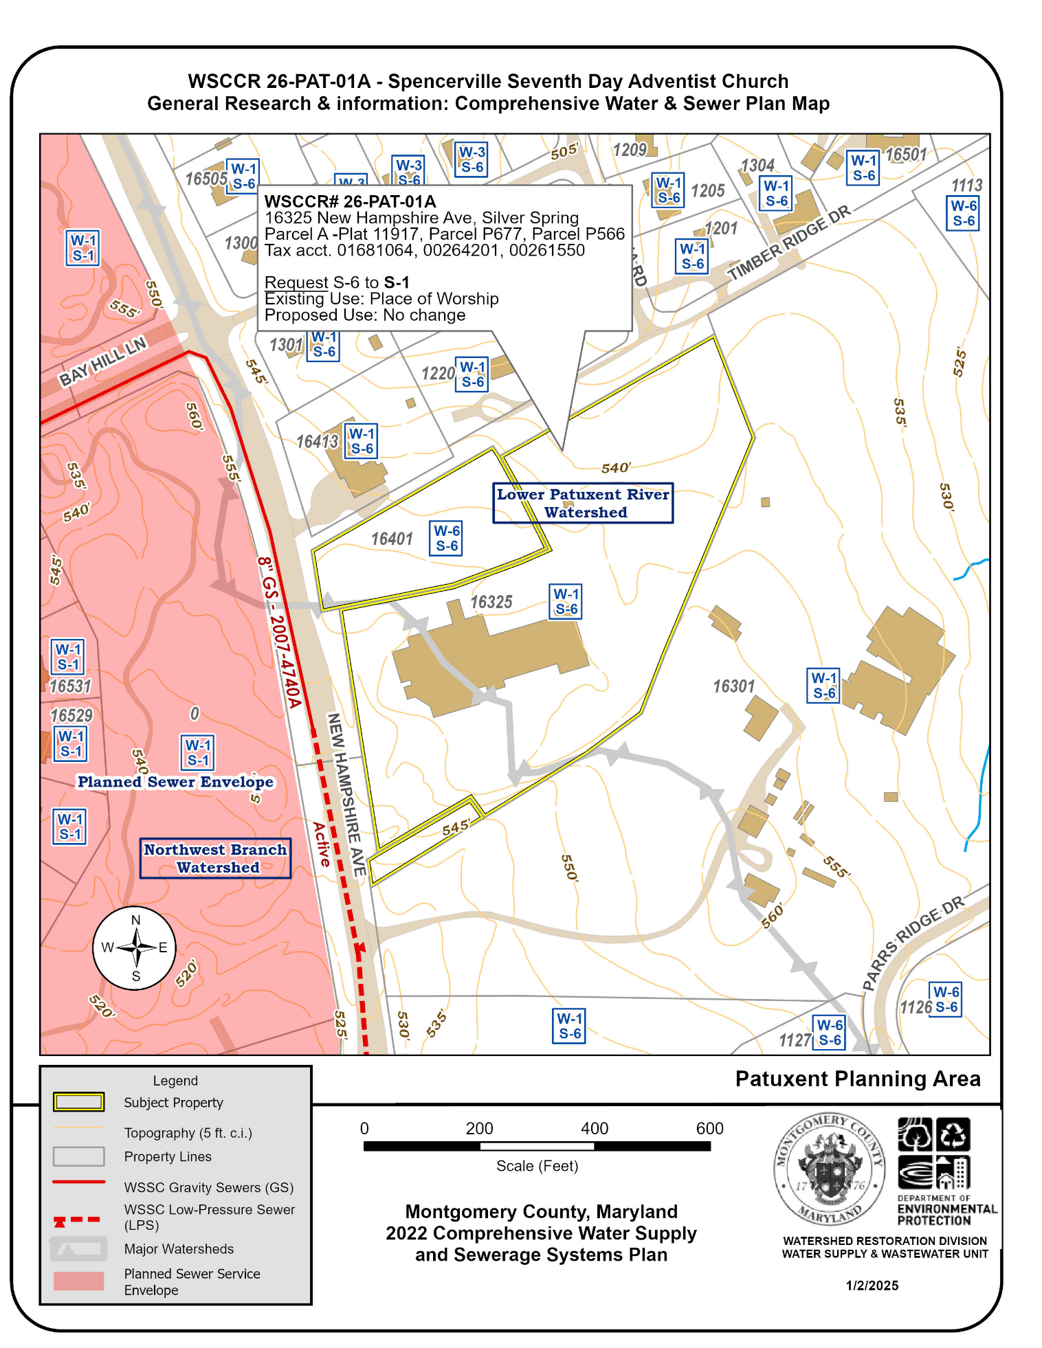
Figure 4: Water and Sewer Category Map of the subject property at 16325 New Hampshire Ave, showing service areas categories, and nearby sewer mains.

[4] WSCCR: 26-URC-01A – 6112 Muncaster Mill Rd.
Anticipated Action Path: County Council
Property Information and Location
Property Development
- 6112 Muncaster Mill Rd, Derwood, MD 20705
- Parcel P809, Subdivision 0502, Tax acct. 00056125
- Map tile: WSSC: 223NW06; MD tax map: GT61
- Property on the Western side of Muncaster Mill Rd. approximately 150 feet North of Bowie Mill Rd.
- RE2 Zone; 2 ac.
- Upper Rock Creek Planning Area
Upper Rock Creek Master Plan (2004)
- Upper Rock Creek Watershed; MDE Use IV/IV-P
- Existing use: Residential
- Proposed use: 1 single family home and 2 apartment units.
Applicant’s Service Area Category Request & Explanation
Existing Categories: W-3, S-6
Requested Categories: S-3
Applicant Explanation:
In discussion with the applicant, DEP learned that sewer access is needed for an existing additional dwelling unit with 2 apartments on the property.
Agency Review Comments
DPS:
M-NCPPC – Planning Dept.:
M-NCPPC – Parks Planning:

WSSC - Sewer:

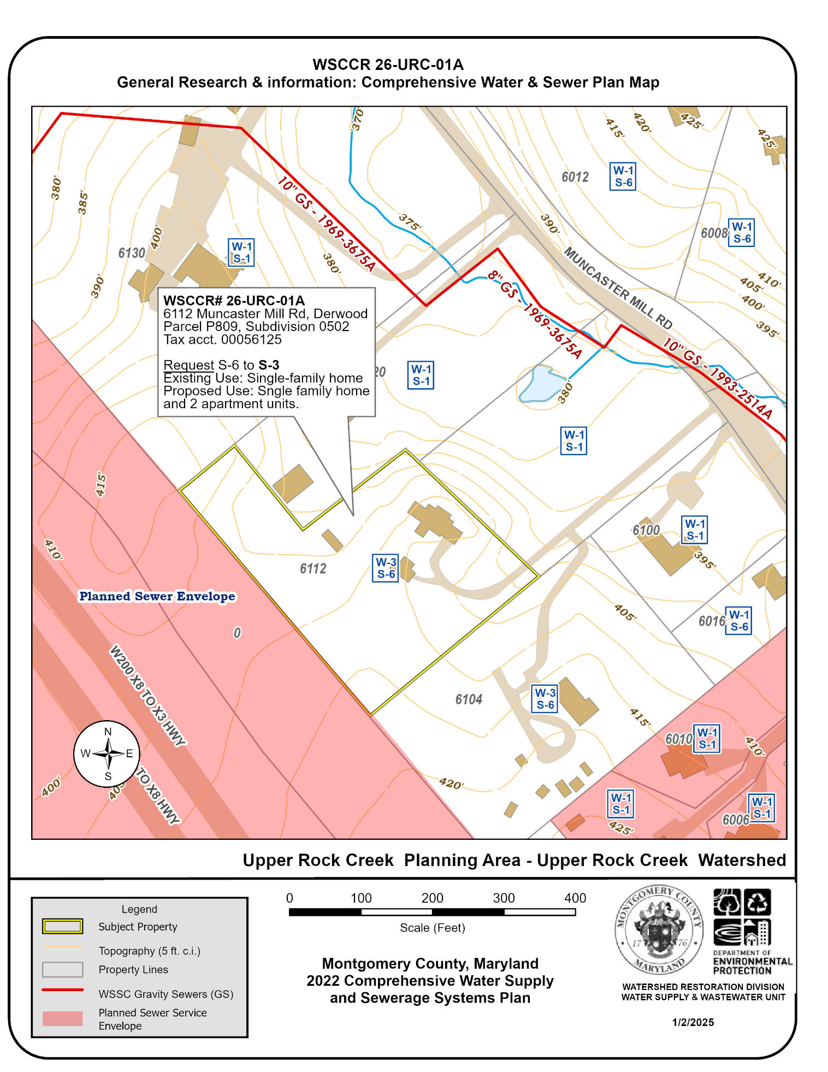
Figure 5: Water and Sewer Category Map of the subject property at 6112 Muncaster Mill Rd, showing service areas categories, the planned sewer envelope and nearby sewer mains.

