

DEPARTMENT OF ENVIRONMENTAL PROTECTION

Marc Elrich Jeffery Seltzer
County Executive Acting Director

November 18, 2025

NOTICE OF AD 2026-1 ADMINISTRATIVE PUBLIC HEARING

TO: Keith Levchenko, Senior Legislative Analyst
County Council

Christina Sorrento, Chief, Environmental Planning, M-NCPPC
Maryland - National Capital Park and Planning Commission

Fred Mejias, Development Services Division
Washington Suburban Sanitary Commission

Heidi Benham, Manager, Well and Septic Section
Department of Permitting Services

Category Change Request Property Owners and Applicants

FROM: Tim Williamson, Planner III, Water Supply and Wastewater Unit
Department of Environmental Protection

SUBJECT: Administrative Public Hearing AD 2026-1 for Water and Sewer Plan Amendments

DATE & TIME: Monday, Dec 22, 2025, at 10:00 a.m.

LOCATION: Telephone Conference

Please contact Timothy Williamson at timothy.williamson@montgomerycountymd.gov for instructions on joining the teleconference, or if you wish to submit written testimony.

Please be advised that the Montgomery County Department of Environmental Protection (DEP) will hold an administrative public hearing as specified above on the following requested category map amendments (WSCCR) to the County’s 2022 Comprehensive Water Supply and Sewerage Systems Plan:
26-CLO-01A 15801 New Hampshire Ave
26-DNT-01A 14530 Jones Lane
26-OLN-01A 2505 Tall Timbers Rd

To assist with your review of this proposed action, DEP has created and posted a PDF to the “Service Area Category Changes” webpage at www.montgomerycountymd.gov/water/supply/category-changes.html. Select the blue “Application Hearing Schedule” tab to expand the section, then scroll down to the “Current Administrative Review Packet” heading. The hearing notice PDF includes the following information for the proposed amendments:
- Information summaries
- Staff reports and recommendations
- Mapping
- Supporting documents, as appropriate

We ask that Council staff provide the posted materials to the Councilmembers for their review. If Council staff members or their aides would like to meet with DEP regarding the proposed amendments, call me to arrange a date and time to review the cases before the public hearing. We request that the Council staff submit Councilmembers’ comments to DEP no later than the hearing record closing date (see below). Please note that DEP cannot complete the administrative action without receiving this notice from Council staff.

We understand that the Montgomery County Planning Board will include this administrative packet for consideration on its agenda.

Attendance at this hearing for agencies, applicants, and others is optional. These requests will be considered at the time specified on page 1. If you wish to comment on a referenced amendment or on the staff recommendations, you may testify at the public hearing, or you may submit written testimony to:
Jeffery Seltzer, Acting Director, DEP; 2425 Reedie Drive, 4th Floor, Wheaton, MD 20902; or to timothy.williamson@montgomerycountymd.gov.

DEP will close the record on Dec 29, 2025.

Please do not hesitate to contact me at timothy.williamson@montgomerycountymd.gov or at 202-579-3116 if you have any questions concerning these category change requests or the schedule provided.

TRW/ trw R:\Programs\Water_and_Sewer\actions-AD\2026\2026-1\Public Hearing Notice WSCCR AD 2026 1.docx
cc: Kate Stewart, President, Montgomery County Council
Artie Harris, Chair, Montgomery County Planning Board
Amy Stevens, Division Chief, Watershed Restoration Division, DEP
Alan Soukup, Senior Planner, Watershed Restoration Division, DEP
Linda Kobylski, Jason Flemming & Megan Wilhelm, DPS
Jamey Pratt, Upper County Planning, M-NCPPC
Mark Symborski, Environment and Climate Division, M-NCPPC
Ariel Zelaya, Environment and Climate Division, M-NCPPC
D. Lee Currey, Water and Science Administration, MDE
Jeff White, Water and Science Administration, MDE
Robin Pellicano, Water and Science Administration, MDE
Susan Llareus, MDP

Category Change Applicants & Interested Parties

Civic Organizations and Other Public Interest Groups
Lake Hallowell Homeowners Association
Darnestown Civic Association
Nature Forward
West Montgomery County Citizens Association
Montgomery Coalition to Stop Sewer Sprawl
Cloverly/Fairland/White Oak CAC
Northern Montgomery Community Alliance
Spencerville Civic Association
Sierra Club - Montgomery County Group
East County Citizens Advisory Board
Cloverly Civic Association
Montgomery County Civic Federation

[1] 26-CLO-01A: 15801 New Hampshire Ave
DEP Staff Recommendation: Conditionally Approve S-3, based on Planning Board approval of a preliminary plan that demonstrates an environmental advantage of a development using public sewer as opposed to septic systems in keeping with the Cloverly Master Plan. Advancement to S-3 is consistent with administrative policy V.D.2.a.: Community Service Consistent with Existing Plans.
Property Information and Location
- 2 adjoining parcels at 15801 New Hampshire Avenue, Silver Spring
- Parcel P463 and Parcel P509 – Bealls Manor. Tax acct. 00259044 and 00259033.
- Map tile: WSSC – 221NE01; MD –JS62
- Two adjoining parcels on New Hampshire Ave 500 feet Southwest of Harding Lane.
- RE-1 Zone; Combined property size: 13 acres. (4.15 acres + 8.88 acres = 13.03 acres)
- Cloverly Planning Area
Cloverly Master Plan (1997)
- Paint Branch Watershed; MDE Use: III/III-P Upper Paint Branch Special Protection Area
- Existing use: Agricultural
- Proposed use: 11 Single Family Homes on 40,000 sq ft lots.
Applicant’s Service Area Category Request & Explanation
Existing Categories: W-1, S-5
Requested Categories: W-1 (no change), S-3 (public sewer service)
Applicant Explanation: “One existing single-family residence on the property connected to private well and septic system. Would like to have access for future water and sewer connections if existing systems fail. And access to sewer and water connections for future subdivision development.”
DEP Staff Report:
This category change application is for two adjacent properties held in common ownership by the applicant. The applicant intends to develop the two properties as a single residential development for 11 homes.
The two properties are roughly 13 acres combined in the RE-1 zone and within the Upper Paint Branch Special Protection Area. This combination places a condition for public sewer service in this area. To be eligible for public sewer service, an applicant must demonstrate that development using public sewer service provides an environmental advantage over development using onsite septic systems. This advantage typically occurs where a sewer-dependent plan allows for the use of the cluster development option, reducing impervious area from buildings and roads and allowing for more dedicated open space (stream buffers and forest preservation). These conditions are not generally compatible with 40,000 sq. ft. building lots for proposed residential development in the SPA.
To enable development, the applicant has requested a category change of S-5 to S-3. S-5 is defined as areas planned for public service, but which need to use private, onsite systems on a long-term basis (Montgomery County Comprehensive Water and Sewer Plan; pg. 1-21). Currently the properties are served by public water service and onsite septic systems.
Review by M-NCPPC found that although the Montgomery County Comprehensive Water and Sewer Plan does not provide for public sewer service to properties within the RE-1 zone except as recommended by local area master plans, the Cloverly Master Plan recommends an exception. There are no parks impacts from providing sewer service as long as no sewer connection or main crosses the adjacent Paint Branch Stream Valley Park. Therefor the category change is consistent with the existing plans for the area.
DPS found there is no septic reserve area on the record for the property and that in 1998 WSSC had considered sewer service to the property, presumably after completion of the abutting low-pressure main along New Hampshire Avenue (completed in 1997).
WSSC provided two potential sewer alignments to serve the development.
Alternate 1 proposes a dedicated, private Low Pressure Sewer System (LPSS) that connects to the existing low-pressure system along New Hampshire Avenue (Figure 1; as shown on pg. 7). Such an alignment requires an expansion of the existing water main easement on the property from 20’ wide to 24’ wide to accommodate development of the property as well as upgrades to the Low-Pressure-System along New Hampshire Avenue to accommodate development.

Alternative 2 proposes a public gravity sewer main that runs through the property and connects to the existing main on Wembrough Street (Figure 2; as shown on pg. 7). The new public main would require a public utility easement along the length of the new gravity sewer main. An existing easement on lots 10 & 9 and Lots 11 & 12 would need to be widened from 20’ to 30’. This alternative would require analysis by WSSC to determine whether upgrades are needed to accommodate new wastewater flows from the new homes.

DEP recommends conditional approval of the category change from S-5 to S-3. Advancement to S-3 will require Planning Board approval of a preliminary plan that demonstrates an environmental advantage of a development using public sewer as opposed to septic systems. This is consistent with the recommendation for the Upper Paint Branch SPA in the Cloverly Master Plan.

Agency Review Comments
DPS: There is a permit record for a repair to the septic system in 1965. The property has no septic reserve area. Based on correspondence in our file with WSSC, it appears a sewer connection was contemplated in 1998.

M-NCPPC – Planning Dept.:
The applicant requests a change from S-5 to S-1 to enable public sewer service for parcels 463 and 509, New Hampshire Ave., Silver Spring MD. One existing single-family residence on the property is connected to a private well and septic system. The applicant plans to build 11 single-family homes on 40,000 square foot lots with access to public sewer service. The 13.03-acre property is located within the 1997 Cloverly Master Plan (“Master Plan”) area, lies within the Upper Paint Branch Watershed (Upper Paint Branch Special Protection Area [SPA]), abuts a low-pressure sewer main, and is zoned RE-1.
The Master Plan recommends RE-1 zoning for much of the headwaters of Paint Branch, which is designated as a Special Protection Area. The county’s Comprehensive Water Supply and Sewerage Systems Plan (“Water and Sewer Plan”) policies generally do not provide for the extension of community sewer service to areas zoned RE-1, except as recommended by local are master plans. The Cloverly Master Plan recommends such an exception. The County Council has previously concurred with the provision of service to the RE-1 areas in Cloverly provided the main extensions were logical, economical, and environmentally acceptable. The Master Plan further recommends that the approval of community sewer service to properties zoned RE-1 in the Upper Paint Branch SPA should be coordinated with the approval of subdivision plans which address the environmental concerns associated with development in these headwater areas, and which further must demonstrate an environmental benefit resulting from development supported by community sewer service, rather than that supported by septic systems.
The Master Plan recommends encouraging clustering to provide the environmental benefits associated with less impervious surfaces. The combined acreage of the parcels, however, is too small to qualify for clustering under the zoning code provisions for RE-1. Nevertheless, providing community sewer service to the proposed 11 homes would provide an environmental benefit over 11 homes on septic systems because it would avoid the long-term risk of malfunctioning or failing septic systems in the future. As a result, the proposed sewer category change is consistent with the Master Plan.
The approval of a category change does not indicate support for or against approval of necessary subdivision plans or whether the proposed development can meet the impervious cap requirements of the Upper Paint Branch SPA.
M-NCPPC – Parks Planning: Any new sewer connection cannot cross through Paint Branch SVP. In Paint Branch our parkland plays an important role of protecting water quality within the Special Protection Area (SPA) by preserving large tracts of forest and undeveloped land, any encroachment into this land interferes with the protection of water quality in the SPA. There is language in the Policy for Parks, Appendix 7 of the PROS Plan: Lands and facilities under the control of The Maryland-National Capital Park and Planning Commission are held as a public trust for the enjoyment and education of present and future generations. The Commission is pledged to protect these holdings from encroachment that would threaten their use as parkland. The Commission recognizes that under rare circumstances non-park uses may be required on park property in order to serve the greater public interest.

WSSC - Water: Not Requested at this time.
WSSC - Sewer:
1. Basin: 02 Paint Branch
2 Alternative 1:
A 1 ½-inch pressure sewer line in New Hampshire abuts the property (contract no.1994-9907A). A dedicated Low Pressure Sewer System (LPSS) along Parcel P463 and Parcel P509 is required to serve the property. This LPSS would connect to 1 ½ inch pressure sewer line in New Hampshire (contract no. 1994-9907A). Easements would be required. Upgrades would be required in the existing LPSS downstream of the connection.
Alternative 2:
A 1,900-foot-long non-CIP-sized sewer extension is required to serve the property. [DEP note: Only approx. 300 feet would be offsite.] This extension would connect to an 8-inch sewer main to along Wembrough Street (contract no 1969-4114C) and would abut approximately 4 properties in addition to the applicant. Easements would be required. Construction of this extension may involve the removal of trees, temporary disruption of wetlands and stream valley. Upgrades might be required in the existing sewer system downstream of the connection.
3 Average wastewater flow from the proposed development: 3,010 GPD
4 Program-sized sewer mains are not required to serve the property.
5 Based on the proposed development, this project will connect to an existing Low Pressure
Sewer System (LPSS) and/or may require a Sewer Extension. Therefore, additional review
will be necessary. This special review typically occurs during a formal WSSC hydraulic
review and will determine whether downstream system improvements are needed
6 Interceptor capacity is adequate.
7 Treatment capacity is adequate.

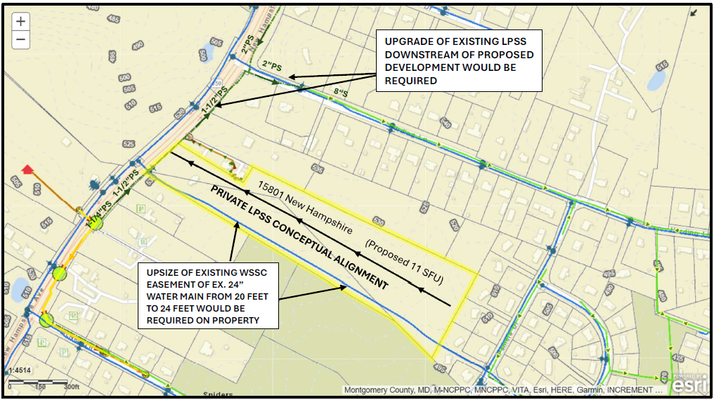
Figure 1: The above map shows the subject properties and the sewer alignment Alternative 1 as referenced in the DEP staff report on page 3 & 4. Map concept by WSSC Water.
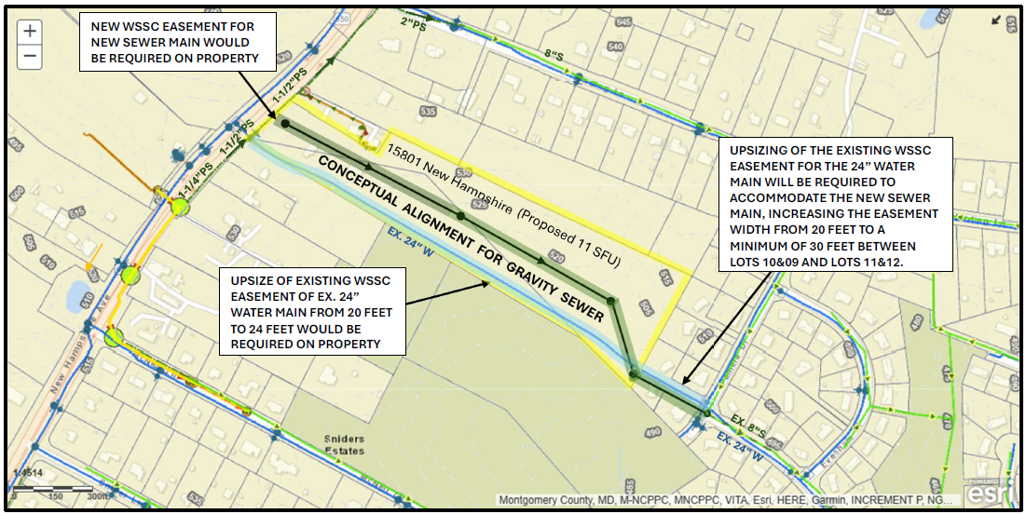
Figure 2: The above map shows the subject properties and the sewer alignment Alternative 2 as referenced in the DEP staff report on page 3 & 4. Map concept by WSSC Water.

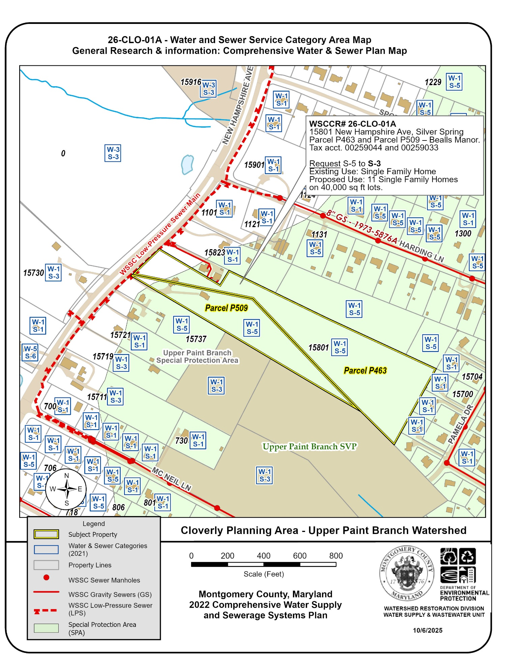
Figure 3: Water and Sewer Map of the two properties at 15801 New Hampshire Avenue proposed for public sewer service to accommodate an 11-lot housing development. The map shows the site within the Special Protection Area and an abutting low-pressure sewer main.

[2] 26-DNT-01A: 14530 Jones Lane
DEP Staff Recommendation: Approve W-1. Policy V.D.2.a.: Administrative Delegation - Community Service Consistent with Existing Plans.
Property Information and Location
- 14530 Jones Ln, Gaithersburg
- Parcel P340; tax acct. 00404588
- Map tile: WSSC – 219NW13; MD – ER43
- On the West side of Jones Lane at the intersection with Young Lane.
- R200 Zone; 2 acres
- Darnestown Planning Area; Potomac Subregion Master Plan 2002
- Muddy Branch Watershed MDE Use I/I-P
- Existing use: Single Family Home
Proposed use: No change in use.
Applicant’s Service Area Category Request & Explanation
Existing Categories: W-4 , S-6
Requested Categories: W-1, S-6 (no change)
Applicant’s Explanation: “Failing Well”
DEP notes
On July 18, 2025, DEP requested that WSSC Water expedite the provision of public water service to this property. DEP directed to proceed with public service despite the existing W-4 water category. The DPS Well and Septic Section had notified DEP about a failed well at this location on July 14, 2025. Documentation available upon request to DEP.

DEP Staff Report:
The applicant requests a Water Category change from W-4 to W-1 to allow for the provision of public water service to alleviate a failing well system for the existing home. The property is 2 acres, in the R-200 zone within the planned water service envelope.
On July 18, 2025, DEP requested WSSC Water to expedite the provision of community water service to this property ahead of the category change. WSSC confirmed that the property can be served without a main extension from a 16-inch water main in Jones Lane. M-NCPPC Planning staff concur that water service to the property is consistent with the 2002 Potomac Subregion Master Plan and the 10-year Comprehensive Water and Sewer Service Plan. M-NPPC confirmed that there are no park impacts.
DEP staff recommendation is for the approval of W-1, consistent with existing plans.
Agency Review Comments
DPS: The existing well is the original well from 1961, and pump replacement has not resolved the ongoing yield issues with the well. An expedite memo was sent to DEP in July 2025.

M-NCPPC – Planning Dept.:
The applicant requests a change from W-4 to W-1 to allow public water service for an existing single-family detached house. One existing single-family residence on the property is connected to a private well. The applicants state that their well is failing. The 2-acre property is located within the 2002 Potomac Subregion Master Plan (“Master Plan”) area, lies within the Muddy Branch Watershed, and is zoned R-200 zone. It borders properties in the W-1 water category on two sides and faces a property in the W-1 Water category. A water main runs along Jones Lane abutting the property.
The Master Plan recommends that public water service be provided in conformance with the county’s Comprehensive Water Supply and Sewerage Systems Plan (“Water and Sewer Plan”). The Water and Sewer Plan supports public water service for moderate- to high-density residential development zones, such as R-200. As a result, the proposed water category change is consistent with the Master Plan.

M-NCPPC – Parks Planning:
No parks impacts.

WSSC - Water:
1. Water pressure zone: 560F
2. A 16-inch water line in Jones Lane abuts the property (contract no. 1995-1340A).
3. Local service is adequate.
4. Program-sized water main extensions (16 inches in diameter or greater) are not required to serve the property.
WSSC - Sewer: Not requested.
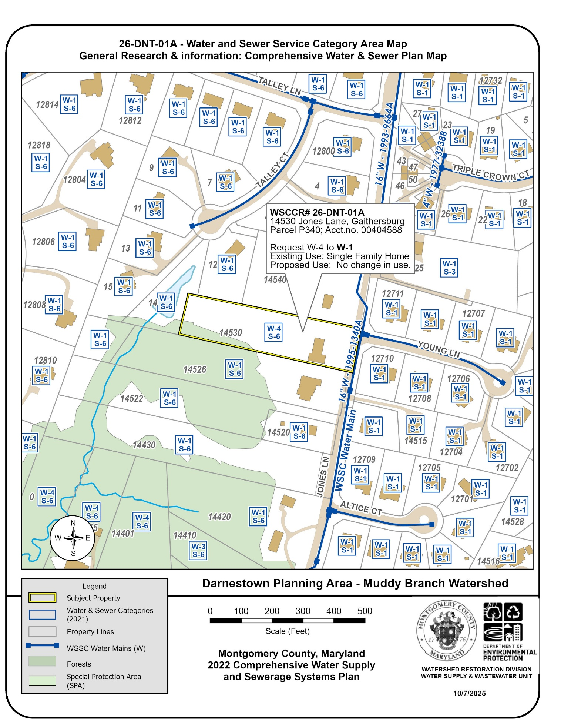
Figure 4: Water and Sewer Category Map of the subject property at 14530 Jones Lane proposed for public water service to replace a failing domestic well. The map shows the subject property abuts a WSSC water main that can provide service without an extension. The property is within the Planned Water Service Envelope.

[3] 26-OLN-01A: 2505 Tall Timbers Rd
DEP Staff Recommendation: Approve S-3 for one single family home. Policy V.D.2.a.: Administrative Delegation - Community Service Consistent with Existing Plans.
Property Information and Location
Property Development
- 2505 Tall Timbers Rd., Olney
- Parcel # P088, tax acct. 00723255
- Map tile: WSSC – 224NW03; MD HT62
- An Undeveloped parcel at the Eastern end of Tall Timbers Lane.
- R200; 65,340 sq.ft.
- Olney Planning Area; Olney Master Plan (2005)
- Hawlings River Watershed, MDE use: IV/IV-P
- Existing use: Undeveloped; forested.
- Proposed use: 1 single family home.

Applicant’s Service Area Category Request & Explanation
Existing Categories: W-1 , S-6
Requested Categories: W-1 (no change), S-3
Applicant’s Explanation
“For the sale of the property. To assure the buyer will have access to public water and sewer for development of the property for one single family residential home to be built. All existing homes surrounding and abutting to this parcel are connected to public utilities for both water and sewer. The parcel is currently on the market and a ratified contract has been executed for the purchase of the parcel with a proposed settlement date of September 30, 2025. The buyer is currently in the process phase of a feasibility study.”

DEP Staff Report: This category change request is for an undeveloped property at the eastern end of Tall Timbers Road. The request is for public sewer service (S-6 to S-3) to enable the development of a single family on the property. Although not specified by the applicant, DEP’s assumption is that the new house location will be at the southern end of the parcel. The property is within the Public Sewer Service Envelope, abuts an existing sewer main and is in the R-200 zone.
M0NCPPC in their review found that the category change request is consistent with the Comprehensive Water and Sewer Plan and the Olney Master Plan. There are no parks impacted by the provision of sewer service.
WSSC found that providing sewer service is technically feasible by connecting to the main that abuts the main. The existing main runs through the property of 2500 Tall Timbers Road. Connecting to this main would require an easement, unless it is connected within an existing Public Utility Easement between 2600 and 2601 Tall Timbers Road held by WSSC.
DPS reviewed septic records and found none for the property. They stated that property shape and natural elements on the property would make siting a septic reserve area difficult for the property owner.
DEP recommends the category change because the request is consistent with existing plans; the Comprehensive Water and Sewer Plan and the Olney Master Plan.
Agency Review Comments
DPS: There are no DPS records for the property. Existing conditions would likely make identifying a septic area difficult. The narrow shape of the property, drainage swale, and stream present issues.

M-NCPPC – Planning Dept.:
The applicant requests a change from S-6 to S-1 to enable public sewer service for P088, Tall Timbers Rd, Olney MD. The applicant plans to build 1 single-family home with access to public sewer service. The 65,340 sq. ft property is located within the 2005 Olney Master Plan (“Master Plan”) area, lies within the Hawlings River Watershed, abuts a sewer main, and is zoned R-200.
The master plan recommends that public sewer service generally be provided in conformance with the county’s Comprehensive Water Supply and Sewerage Systems Plan, which typically excludes areas zoned for low-density development (RE-1, RE-2 and RC) not already approved for service from further extensions of sewer mains, and the property is within the planned sewer service area shown in the plan. As a result, the proposed sewer category change is consistent with the Master Plan.

M-NCPPC – Parks Planning:
No parks impacts.

WSSC - Water: Water service not requested.
WSSC - Sewer:
1. Basin: Patuxent North, 26-003

2 An 8-inch sewer main at the end of Tall Timbers Road abuts the property (contract no. 1969-4066A). This main is located directly to the south and is located on the property of 2500 Tall Timbers Road. Connection to this part of the sewer main would require an easement. However, the connection could be made to the west, through the public easement between 2600 and 2601 Tall Timbers Road (which directly adjoins 2505 Tall Timbers Road), and it appears that no easement would be required for this option. Construction of the sewer extension may involve the removal of trees.

3 Average wastewater flow from the proposed development: 280 GPD

4 Program-sized sewer mains are not required to serve the property. This extension would not be required to appear in an adopted Capital Improvement Program since it does not meet the criteria for a major project (Maryland Code Annotated, Public Utilities Article, §23-301).

5 Interceptor capacity is adequate.

6 Treatment capacity is adequate.
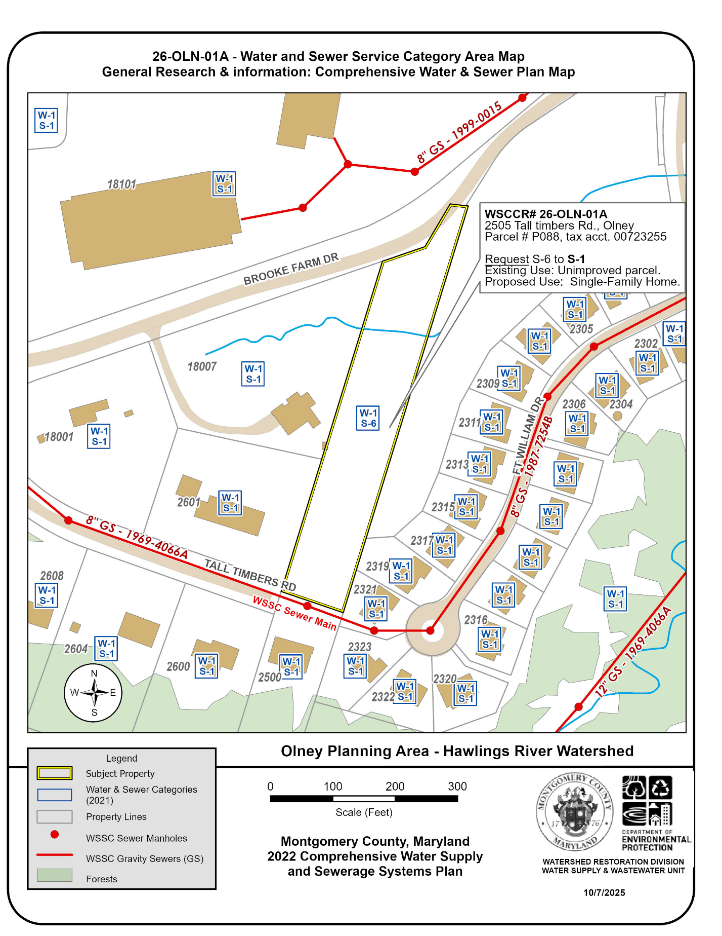
Figure 5: A Water and Sewer Category Map of the subject property at 2505 Tall Timbers Rd. proposed for public sewer service to accommodate the development. The map shows the property abuts a WSSC sewer main that can provide service. The property is within the Planned Sewer Service Envelope.

