

DEPARTMENT OF ENVIRONMENTAL PROTECTION

Marc Elrich Jennifer Macedonia
County Executive Director

February 26, 2026

NOTICE OF AD 2026-2 ADMINISTRATIVE PUBLIC HEARING

TO: Keith Levchenko, Senior Legislative Analyst
County Council

Christina Sorrento, Chief, Environmental Planning, M-NCPPC
Maryland - National Capital Park and Planning Commission

Fred Mejias, Development Services Division
Washington Suburban Sanitary Commission

Heidi Benham, Manager, Well and Septic Section
Department of Permitting Services

Category Change Request Property Owners and Applicants

FROM: Tim Williamson, Planner III, Water Supply and Wastewater Unit
Department of Environmental Protection

SUBJECT: Administrative Public Hearing AD 2026-2 for Water and Sewer Plan Amendments

DATE & TIME: Wednesday, April 8, at 10:00 a.m.

LOCATION: Telephone Conference

Please contact Timothy Williamson at timothy.williamson@montgomerycountymd.gov for instructions on joining the teleconference, or if you wish to submit written testimony.

Please be advised that the Montgomery County Department of Environmental Protection (DEP) will hold an administrative public hearing as specified above on the following requested category map amendment (WSCCR) to the County’s 2022 Comprehensive Water Supply and Sewerage Systems Plan:
26-DAM-01A……WSSC Water; 11415 Kingstead Rd

To assist with your review of this proposed action, DEP has created and posted a PDF to the “Service Area Category Changes” webpage at www.montgomerycountymd.gov/water/supply/category-changes.html. Select the blue “Application Hearing Schedule” tab to expand the section, then scroll down to the “Current Administrative Review Packet” heading. The hearing notice PDF includes the following information for the proposed amendments:
- Information summaries
- Staff reports and recommendations
- Mapping
- Supporting documents, as appropriate

We ask that Council staff provide the posted materials to the Councilmembers for their review. If Council staff members or their aides would like to meet with DEP regarding the proposed amendments, call me to arrange a date and time to review the cases before the public hearing. We request that the Council staff submit Councilmembers’ comments to DEP no later than the hearing record closing date (see below). Please note that DEP cannot complete the administrative action without receiving this notice from Council staff.

We understand that the Montgomery County Planning Board will include this administrative packet for consideration on its agenda.

Attendance at this hearing for agencies, applicants, and others is optional. These requests will be considered at the time specified on page 1. If you wish to comment on a referenced amendment or on the staff recommendations, you may testify at the public hearing, or you may submit written testimony to:
Jennifer Macedonia, Director, DEP; 2425 Reedie Drive, 4th Floor, Wheaton, MD 20902; or to timothy.williamson@montgomerycountymd.gov.

DEP will close the record on April 15, 2025.

Please do not hesitate to contact me at timothy.williamson@montgomerycountymd.gov or at 202-579-3116 if you have any questions concerning these category change requests or the schedule provided.

TRW/trw R:\Programs\Water_and_Sewer\actions-AD\2026\2026-2\Public Hearing Packet\Public Hearing Notice WSCCR AD 2026 2.docx
cc: Natali Fani-González, President, Montgomery County Council
Artie Harris, Chair, Montgomery County Planning Board
Amy Stevens, Division Chief, Watershed Restoration Division, DEP
Alan Soukup, Senior Planner, Watershed Restoration Division, DEP
Linda Kobylski, Jason Flemming & Megan Wilhelm, DPS
Jamey Pratt, Upper County Planning, M-NCPPC
Mark Symborski, Environment and Climate Division, M-NCPPC
Halley Johnson, Environment and Climate Division, M-NCPPC
D. Lee Currey, Water and Science Administration, MDE
Jeff White, Water and Science Administration, MDE
Robin Pellicano, Water and Science Administration, MDE
Susan Llareus, MDP

Category Change Applicants & Interested Parties

Civic Organizations and Other Public Interest Groups
Nature Forward
West Montgomery County Citizens Association
Montgomery Coalition to Stop Sewer Sprawl
Northern Montgomery Community Alliance
Sierra Club - Montgomery County Group
East County Citizens Advisory Board
Montgomery County Civic Federation

[1] WSCCR: 26-DAM-01A – WSSC Water

DEP Staff Recommendation: Approve W-3, S-3, Policy V.D.2.a.: Administrative Delegation - Community Service Consistent with Existing Plans.
Property Information and Location
Property Development
- 11415 Kingstead Rd, Damascus, MD 20872
- Parcel 295, Subdivision 0001, Tax acct. 00933410
- Map tile: WSSC: 235NW11; MD tax map: FX11
- Property Northeast of the Intersection at King Valley Rd and Kingstead Rd.
- RNC Zone, a portion of the property is in the AR Zone; 0.98 ac.
- Damascus Planning Area
Damascus Master Plan (2006)
- Little Bennett Creek Watershed; MDE Use III/III-P
- Existing use: Agricultural.
- Proposed use: Construction of new WSSC sewer pump station.
Applicant’s Service Area Category Request & Explanation
Existing Categories: W-6, S-6
Requested Categories: W-3, S-3
Applicant Explanation:
WSSC Water is requesting to change the water and sewer service categories for 11415 Kings Valley Road (at the intersection of Kingsvalley Rd N and Kingstead Road) from W-6/S-6 to W-3/S-3 to support the development of new Spring Gardens Wastewater Pumping Station (WWPS). This site was part of a previous category change request (WSCCR 22-DAM-05A) that received conditional approval for W-3 and S-3 under a cluster development plan. Since WSSC Water purchased the land from the previous applicant, a new request is needed to assign W-3 and S-3 categories specifically for this public facility.
DEP Staff Report:
The applicant, WSSC Water, has requested both a water and a sewer category change from W-6, and S-6 to W-3, S-3 allowing for public service. The subject property is proposed to be the new Spring Gardens Wastewater Pumping Station (WWPS). In the past, the property was granted conditional approval for W-3 and S-3 under the cluster development plan. Since then, the property has been purchased by WSSC Water and new category change request is being filed.

Planning staff found that the category change is consistent with the Master Plan. They also noted that the Planning Board voted to approve this site for the location of the Spring Gardens WWPS on November 17th, 2020.

DEP recommends approval of the category change request under Policy V.D.2.a.: Administrative Delegation - Community Service Consistent with Existing Plans.
Agency Review Comments
DPS: No well and septic permit records on file for this property.
Maryland Department of Natural Resources (DNR): Impacts to the stream buffer should be avoided. If during construction of the project temporary impacts to this buffer are unavoidable, the area should be restored to original conditions and revegetated with native species.

M-NCPPC – Planning Dept.: WSSC Water is requesting to change the water and sewer service categories for 11415 Kings Valley Road (at the intersection of Kings Valley Rd N and Kingstead Road) from W-6/S-6 to W-3/S-3 to support the development of the new Spring Gardens Wastewater Pumping Station (WWPS).
This site was part of a previous category change request (WSCCR 22-DAM-05A) that received conditional approval for W-3 and S-3 under a cluster development plan. Since WSSC Water purchased the land from the previous applicant, a new request is needed to assign W-3 and S-3 categories specifically for this public facility. The 0.98-acre property is located within the 2006 Damascus Master Plan (“Master Plan”) area, lies within the Little Bennett Creek Watershed, and is zoned RNC and AR.
The Master Plan states that the Little Bennett Creek Watershed is a unique situation on the sewer service system. The Spring Garden pumping station was built to provide sewer service for development to a limited area in the Little Bennett Stream Valley east of Kings Valley Road. This pumping station is small and is now near capacity. The Master Plan anticipates the need for additional WSSC Water-owned and operated pumping stations. As a result, the proposed water category change is consistent with the Master Plan. In addition, on November 17th, 2020, the Planning Board voted to approve this site for the location of a new WSSC Water pumping station.
M-NCPPC – Parks Planning: No parks impacts.
WSSC - Water:
1. Water pressure zone: 842A
2. A 12-inch water main in Kingstead Road abuts the property 1983-5852A.
3. Local service is adequate.
4. Program-sized water main extensions (16 inches in diameter or greater) are not required to serve the property.

WSSC - Sewer:
1. Basin: Monocacy
2. This property will be used to construct a replacement for an existing WSSC wastewater pumping station. This project is currently in the WSSC Capital Improvements Program as CIP project number S-94.14, Spring Gardens Wastewater Pumping Station. The pumping station is currently in the planning stages. This upgrade is necessary because the capacity of the existing pumping station must be increased to accommodate build-out of the service area. The project provides for the planning, design, and construction of a 1.12 MGD wastewater pumping station. In addition, 7,500 feet of force main and 900 feet of gravity sewer will be required as a separate project.
3. Average wastewater flow from the proposed development: None

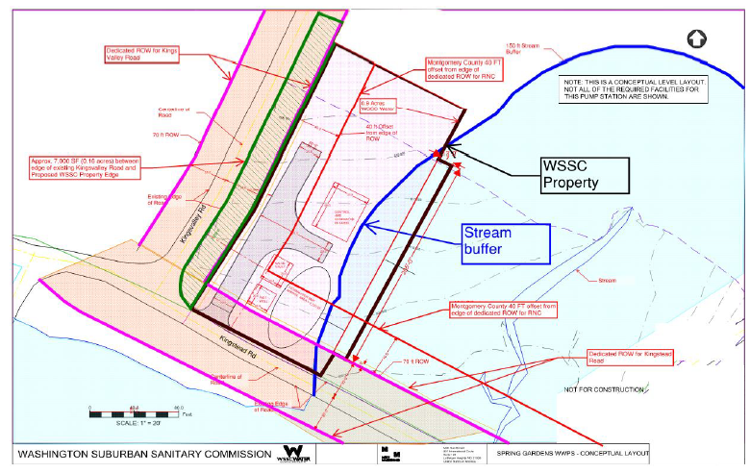
Figure 1: Spring Gardens Pump Station Concept Plan, submitted by WSSC Water.
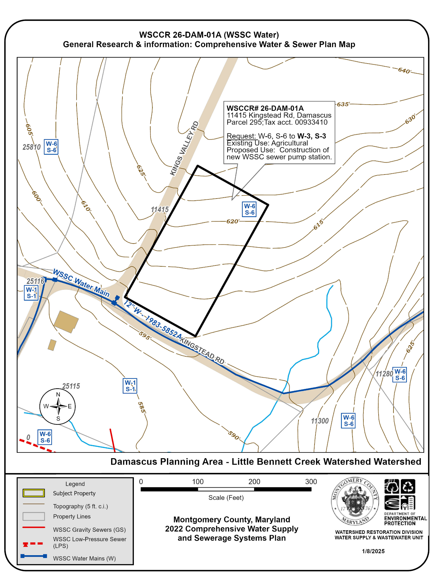
Figure 2: Water and Sewer Category Map of the subject property at 11415 Kingstead Rd, showing service areas categories, and nearby sewer mains. Sewer mains extensions would be needed to serve the property. The location and shape of the new property is approximated by DEP. See the above Concept Plan by WSSC (Figure 1) for more detail.

