
Why is my Pond Green and What do I do?
A Guide to Pondweed, SAV, and Algae

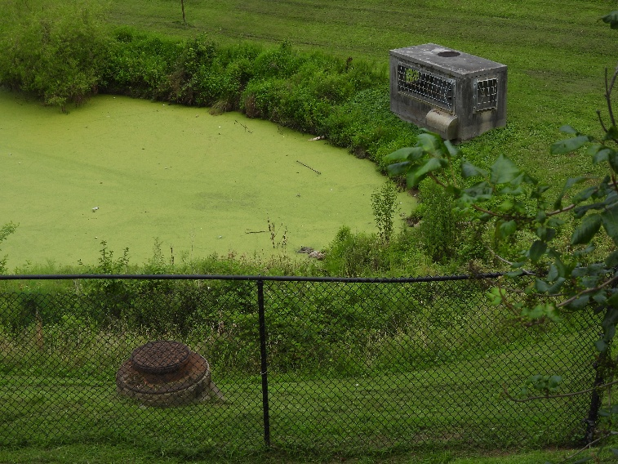
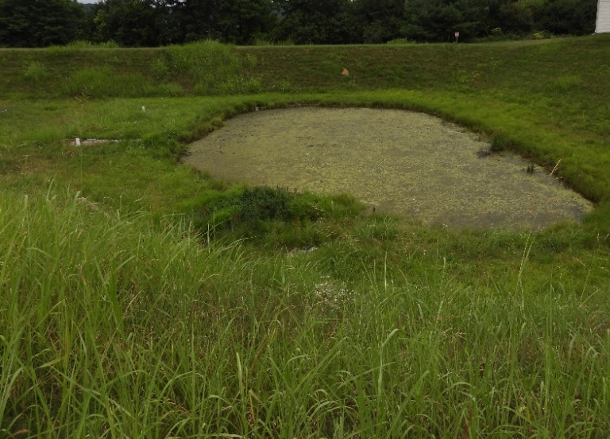

Pondweeds and other SAV
Algae
It is mid-summer. Your grass is growing lush and tall; your gardens are blooming …and your stormwater pond looks like mother nature has installed a new green pool cover.
Unsettling as this may seem, this is a sign your stormwater pond is completing one of the services stormwater treatment facilities are designed to provide. Stormwater ponds serve as a pollution buffer for all the habitats and water sources downstream. In addition to slowing down the water during storm surges and providing a place for the sediment and floating trash to settle out, our stormwater ponds also serve as a sponge for waterborne pollutants from motor oil to lawn fertilizer. Similar to your lawns and gardens, the naturally present submerged aquatic vegetation (SAV) and algae experience increased growth or an algal bloom when exposed to nitrogen and phosphorus – the main ingredients in many fertilizers and animal waste. The best way to prevent both problems is to locate and reduce sources of nitrogen and phosphorus upstream of the pond. Once past the point of prevention the next steps depend on whether you have an overgrowth of SAV or algae so let’s get familiar with both and their natural roles in the nutrient cycle.
Many types of algae grow in freshwater ponds. We will focus on the two categories visible from the surface. There are others but they are not problematic unless swimming or fishing which should never be done in a stormwater pond. Planktonic algae are free floating and make the water look translucent green. These are microscopic single celled organisms. They are primary producers in the local ecosystem, forming the base of the pond food web. These are usually desirable and should be left alone.

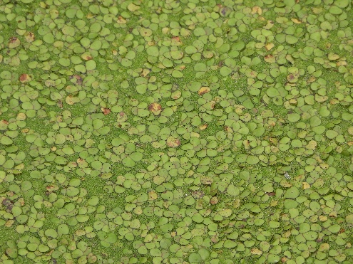

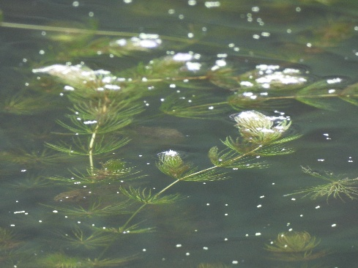

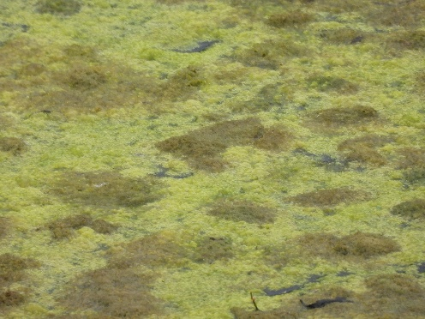
Pondweed sp.

Filamentous Algae

Filamentous algae are the floating mats most residents with algal pond complaints are referring to. Known colloquially as “pond scum” filamentous algae starts as a chain of single cells on the bottom of the pond then form a colony. Gasses are trapped as the mats grow and eventually float to the surface by July. This rapid appearance is referred to as an algal bloom and is associated with aquatic hypoxia problems.
Watermilfoil sp.
Submerged aquatic vegetation are vascular plants that grow underwater and can have many of the plant structures we see on land like roots and leaves. Pondweed is a grouping of aquatic plants native to Maryland and the most common SAVs found in our stormwater ponds. They can look like floating peas, like duckweeds or more feathery like the watermilfoils. There are some invasive species to look out for, like the Eurasian watermilfoil, but several are native to Maryland.

Why is my Pond Green and What do I do?
A Guide to Pondweed, SAV and Algae

Pondweeds and other SAV
Algae
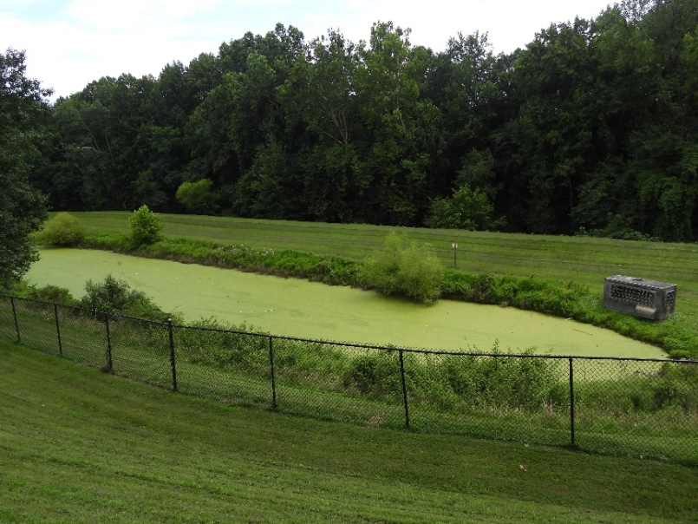
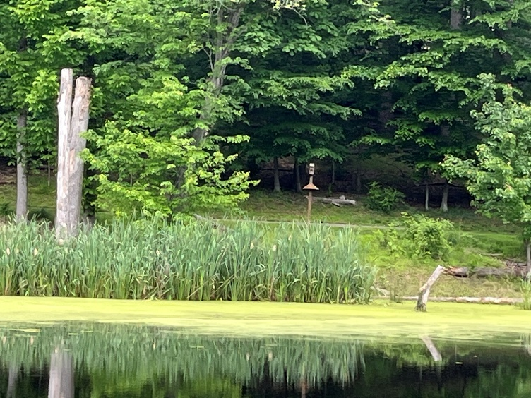
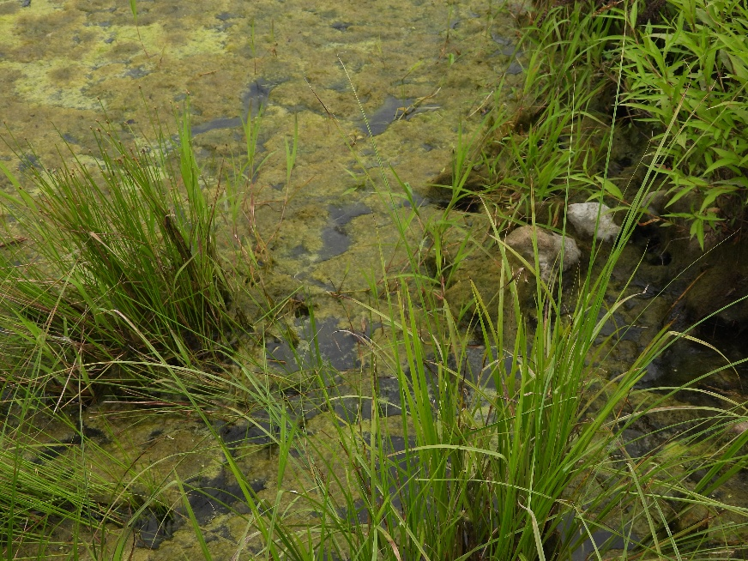
The problem is not that the organism is present, but the density at which it grows. A bank to bank covering can block out sunlight for all aquatic life below. If the plants were to die of in mass the decomposition of all that material at once could cause a drop in the dissolved oxygen levels (the “air” that fish breathe thru their gills). While it can occur, fish kills are not typically associated with pondweed growth.

In a natural ecosystem filamentous algae is a food source for insects, fish, and microscopic organisms in the water. In moderation it can even be pretty, like aquatic moss on rocks in a stream. As single celled organisms, filamentous algae absorb nutrients directly from the water column across the cell wall. This makes them extremely efficient nitrogen and phosphorous filters.

Our native pondweeds are powerhouses! In a balanced ecosystem these plants provide food for waterfowl, shelter and breeding habitat for aquatic life, and filter nutrients from the water. Through tiny filaments on the leaves called rootlets, our native pondweeds remove nitrogen and phosphorous from the water column the same way terrestrial plant roots remove nutrients from the soil and help reduce the nutrient load in the water.

Snag

Bird Box

Pondweed
Just like the pondweeds and other SAV the problem is less that the filamentous algae are present but the density in which it appears. The growth rate of algae is significantly faster than that of vascular plants. This makes it useful in detecting a rapid influx of nutrients from a single event. Algal mats can potentially block the sunlight similar to pondweed but the larger concern is their shorter life cycle and the consequences of mass die off. Decomposition requires dissolved oxygen from the water column so an entire colony decomposing simultaneously has the potential to make the water hypoxic – without their “air” fish and other aquatic life may suffocate.

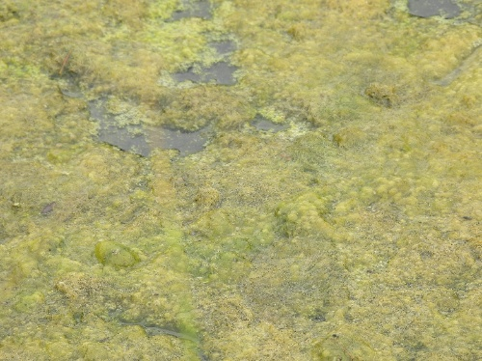
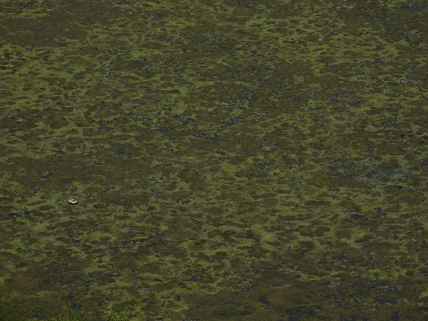

Why is my Pond Green and What do I do?
A Guide to Pondweed, SAV and Algae

What to do: Algae
What to do: Pondweeds and other SAV
The algae can be physically removed with rakes or nets similar to the SAV removal. This is physically demanding but can be very effective for small ponds. If all debris is removed from the site a large source of future nutrients in the cycle are also removed slowing down the growth rate. In county maintained ponds the algae is removed during dredging projects that also remove sediment. Aeriation is critical to replenish dissolved oxygen. Aeration can also help prevent regrowth as most algae prefer warm stagnant conditions but is better used as a preventative tool than a method of algae removal.
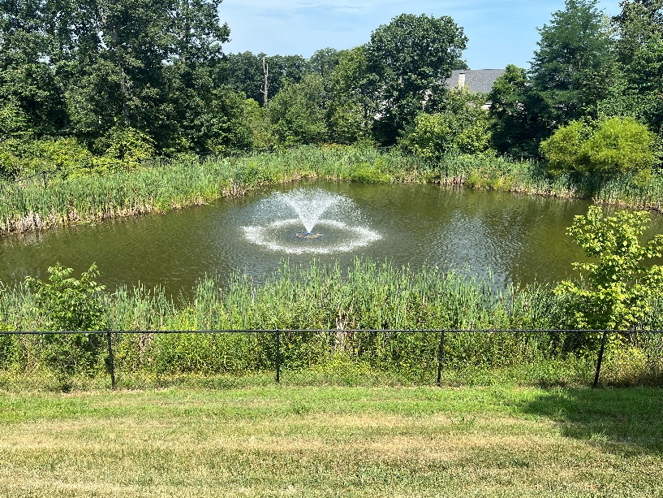
If there are windows to sunlight in your stormwater pond, leave it alone. This is great habitat for observing wildlife especially if some snags are left nearby for birds and there is a vegetative buffer around the water’s edge.
Can’t see an inch of water surface? Go plant fishing! Manual removal of SAV works like terrestrial weeding. Use a rake, grappling devices or bare hands to haul out enough vegetation to reestablish a window to the sun is typically enough. Your local wildlife might even help you out by creating trails through the water as they sate their curiosity regarding the soggy primate in their yard. Make sure that all the debris is moved off site as decaying plants on the side can leach nutrients back into the water in the next rain event.

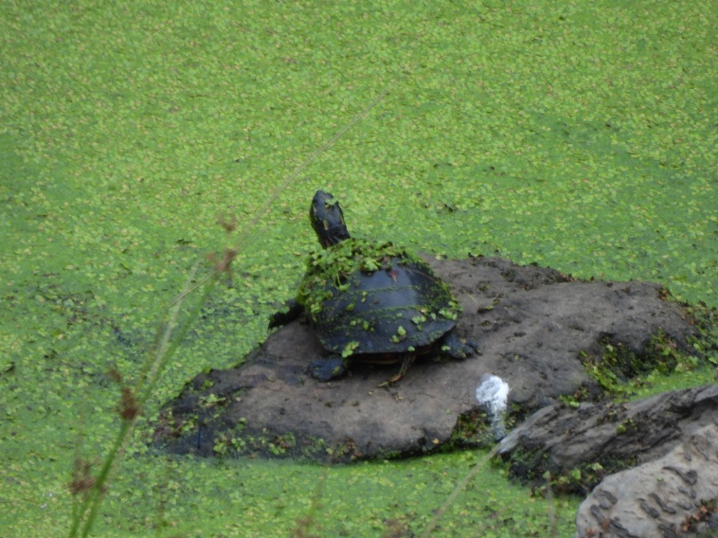

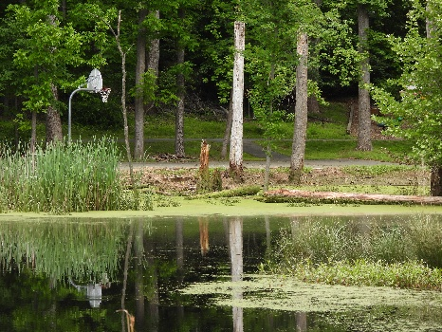
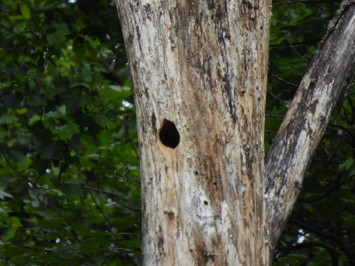
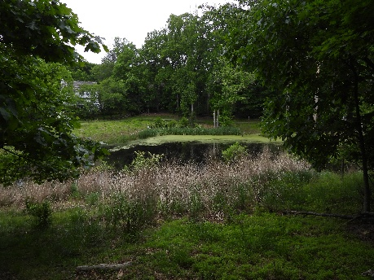
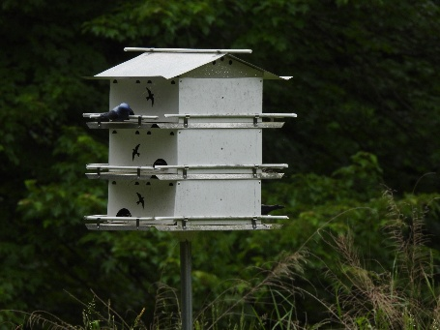
Nest Box
Chemical Controls
While algaecides and aquatic herbicides exist, it is critical to identify the target species correctly. An algaecide works differently than an aquatic herbicide, and there is variety among those as well. It is best to hire a certified professional to ensure both effectiveness of the application and compliance with the Montgomery County Pesticide Law. For more information on Montgomery County Pesticide Laws please visit:

https://www.montgomerycountymd.gov/DEP/property-care/lawns/law/allowed-pesticides.html

As always prevention is easier than clean up and is a great way to be a good neighbor to our local flora & fauna. Keep the nutrient levels in balance, scooping the poop, minimizing fertilizer on lawn and gardens, and please don’t pee in our riffles and pools.
Lovely views
Cavity Nest in Snag
Wildlife Habitat
Basketball

