 | DEPARTMENT OF ENVIRONMENTAL PROTECTION  Energy, Climate and Compliance Division 2425 Reedie Dr. 4th Floor  Wheaton, MD 20902 | 
Marc Elrich  County Executive |  | Jennifer Macedonia  Director

Quarry License

THIS CERTIFIES THAT: | Amrize Mid-Atlantic Inc. (Formerly Holcim – MAR, Inc.)
is hereby granted a license to operate the quarry named: | Travilah Quarry
located at: | 13900 Piney Meetinghouse Road, Rockville, MD, 20850

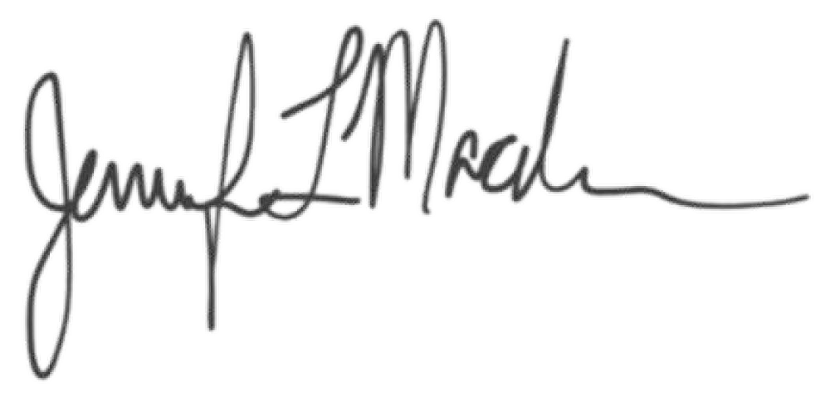
This license is issued pursuant to the authority contained in Section 38-5 of the Montgomery County Code and will remain valid for thirty-six months from the date of issue unless revoked or suspended according to the provisions of the Code. This license is subject to the attached conditions detailing procedures for response to blast vibration complaints.

February 7, 2026
Date of Issue |  | Director, Department of Environmental Protection

This license shall be conspicuously posted on the premises.

