April 9, 2026

Mr. James Carroll
Regional Environmental Manager
Amrize Mid-Atlantic Inc.
6401 Golden Triangle Drive, Suite 400
Greenbelt, MD 20770

Re: Quarry License Renewal

Dear Mr. Carroll:

Please find enclosed your Quarry License issued in response to your completed application for renewal. This license is issued pursuant to the authority contained in Section 38-5 of the Montgomery County Code and will remain valid for thirty-six months from the date of issue unless revoked or suspended according to the provisions of the Code.

Be advised that you are required to undergo an annual license review on the first and second anniversaries of the issuance or renewal date of your Quarry License. Please refer to Section 38-5A of the Montgomery County Code for details regarding the annual license review process.

If you have any questions, please contact me at 240-777-7750 or by email at Gretchen.Ekstrom@MontgomeryCountyMD.gov.

Sincerely,
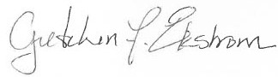
Gretchen F. Ekstrom
Acting Environmental Compliance Supervisor

Enclosure

Cc: Jennifer Macedonia
Stan Edwards

