Montgomery County, MD
Department of Environmental Protection Solid Waste Management Planning Community Engagement Report

April 2026




Table of Contents

Executive Summary 1
Introduction 3
Community Engagement 3
Promotion of Open Houses and Survey 3
Open Houses 5
Methodology 5
Observations 6
Digital Survey 10
Methodology 10
Observations 10
Findings and Recommendations 25
APPENDIX 26

Executive Summary

Project Overview
Raftelis analyzed community feedback from the recent Montgomery County solid waste planning engagement effort, which included 2,609 digital survey responses and participation from more than 200 residents across two in-person open houses and one virtual webinar. The objectives of this analysis were to:
- Evaluate customer satisfaction of solid waste services
- Assess preferences for future waste management infrastructure, includes the Aiming for Zero Waste (AZW) initiative and the closure of the incinerator (also known as the Resource Recovery Facility or RRF), and
- Identify key communication gaps to inform future master planning

Open House Key Takeaways
At the open houses, more than 200 attendees provided deeper insights into the community's preferences for future waste infrastructure and policy:
- Strong Support for Advanced Waste Processing (AWP): A significant majority (72%) of virtual attendees favored closing the incinerator, implementing countywide food composting, and building an Advanced Waste Processing facility. Overall, 58% of attendees indicated they “definitely” or “likely” would support the financial investment in AWP, with another 21% saying they were open to it with more information.
- Demand for Waste Reduction Policies: Attendees prioritized environmental protection above all other system goals. They strongly advocated for proactive waste reduction measures, including countywide food scrap collection, bans on single-use plastics, and the creation of “freecycle” or scrap exchange sites.
- Communication Preferences: Aligning with broader survey trends, open house attendees overwhelmingly prefer direct email from the County to stay informed on these topics, followed by community webinars.

Digital Survey Key Results
A digital survey was offered to County residents for one month (mid-February to mid-March 2026) and received 2,609 responses. Key takeaways were provided by participants as a whole and by geographic area and other demographics.

Geographic Trends
Responses were analyzed by five distinct geographic areas based on zip codes to identify localized trends.
- Bethesda (32% of total survey respondents): Residents in this region predominantly live in single-family homes and report the highest overall satisfaction with waste services. They prioritize environmental preservation and display strong support for zero-waste initiatives, with less focus on service affordability.
- Mid-County (27% of total survey respondents): This area relies heavily on curbside collection. While general satisfaction is stable, residents show mixed awareness of County programs, indicating a need for straightforward education on proper recycling guidelines to reduce contamination.
- Upcounty (18% of total survey respondents): Proximity to the facility seems to drive the highest awareness of the incinerator closure among these residents. They also report the highest rates of at-home yard waste composting compared to other regions.
- Silver Spring (10% of total survey respondents): Featuring the highest density of multi-family housing, residents in Silver Spring report lower satisfaction with recycling access. They frequently cited shared dumpsters as a barrier and rely heavily on property managers for service information.
- Eastern Montgomery (9% of total survey respondents): Residents in this diverse region cited affordable services as a critical priority. The area presents the greatest need for multilingual materials and alternative outreach methods, as reliance on the County website is lower than average for this group.

Demographic and Behavioral Trends
- Housing Type: Single-family residents (76%) report excellent satisfaction (4.1 out of 5) with curbside collection. Conversely, multi-family residents face systemic barriers to convenient recycling and report lower overall satisfaction (3.6 out of 5).
- Household Income: Lower-income households identify affordability as their primary concern (72% rate it critically important) and report the lowest awareness of how the County funds solid waste operations.
- Language Access: Non-English-speaking residents experience significant information gaps, with only 18% aware of the Aiming for Zero Waste initiative. They prefer receiving information through direct mail, text messages, and social media rather than traditional web platforms.

Strategic Recommendations
To ensure equitable service and build public consensus for future solid waste planning, Raftelis recommends the following:
- Capitalize on AWP Support: Leverage the strong baseline support for Advanced Waste Processing and countywide composting by developing an educational campaign that fills in the details for the 21% of residents who are “undecided” but open to learning more.
- Deploy Targeted Multilingual Campaigns: Distribute translated, visual recycling guidelines through direct mail, SMS, and community networks to better engage residents in Eastern Montgomery and non-English-speaking households.
- Enhance Multi-Family Infrastructure: Collaborate with property managers and homeowner associations (HOAs), particularly in Silver Spring, to improve shared recycling facilities and distribute localized service updates.
- Align Policy Messaging with Affordability: Proactively communicate the financial implications of the incinerator closure and new infrastructure investments, ensuring messaging directly addresses the cost concerns held by lower-income stakeholders.

Introduction

This report provides a summary of the recent community engagement efforts for the Montgomery County Department of Environmental Protection’s (DEP) solid waste management options. The engagement was focused on informing and gathering feedback on three options the County is considering for its future solid waste management program. The engagement included three open houses (two in-person and one virtual) held the first week of March 2026 and a digital survey for County residents that was open for one month. This report provides information about how the open houses and survey were developed, promoted, and implemented, and it includes survey results as well as summaries of the feedback received. Last, key findings and recommendations are provided to guide the County’s next communications and outreach steps. A PDF summary of the survey from the Zoho software is included in the Appendix, along with any comments provided to open-ended questions.

Community Engagement

Promotion of Open Houses and Survey
The open houses and survey were promoted through the County and DEP digital channels including, websites, social media platforms, and email lists. DEP created and disseminated the promotional materials for its various channels. Social media posts were also translated into six additional languages: Spanish, Amharic, French, Korean, Traditional Chinese, and Vietnamese. The promotional materials also included an email address for participants to request interpretation services.

The following is a summary list of the promotional efforts.
- 2/17 – Open House and Survey promotion on DEP website: https://www.montgomerycountymd.gov/dep/
- 2/17 – Survey promotion on DEP X account, open house and survey promotion on DEP Facebook account
- 2/17 – Open House and Survey information provided to all Councilmembers and staff along with a social media toolkit
- 2/18 – County reshared Open House post and created new post for Open Houses and Survey
- 2/18 – Open House and Survey information provided to the Solid Waste Advisory Committee, Dickerson Area Facilities Implementation Group, Sugarloaf Citizens Association, and Zero Waste Montgomery County
- 2/19 – Promotion on County’s homepage: https://www.montgomerycountymd.gov/
- 2/19 – Open Houses promoted as events DEP Facebook account
- 2/20 – Open house and Survey promotion to 9,655 recipients via email lists
  - Commercial Food Scraps Recycling – 2,165 recipients
  - SORRT (Business Recycling) – 4,147 recipients
  - TRRAC (Multi-Family Recycling) – 4,315 recipients
  - Backyard Food Scraps Composting – 997 recipients
  - Civic Loop (Community and Civic Leaders) – 5,022 recipients
- Week of 2/22 – Open House and Survey promotion to Recycling Volunteer email list
- 2/23 – Survey promotion on DEP Facebook account and Open House promotion on DEP X account
- 2/23 - Media release about the Survey and Open Houses
- 2/24 – March 2 Open House promoted as event on County Facebook account
- 2/25 – Survey promotion on DEP Facebook account
- 2/25 – Open House and Survey promotion to 57,988 recipients via County collection information email list
- 3/2 – Open House reminder post on County and DEP Facebook accounts
- 3/2 – March 2 Open House promoted as event on County Facebook account
- 3/4 – Open House reminder post on DEP Facebook account
- 3/4 – Survey promotion on County and DEP Facebook account
- 3/5 – Virtual Open House reminder post on County and DEP Facebook accounts
- 3/31 – Provided information from the open houses in Spanish on the “Montgomery al Día” Spanish-language radio show
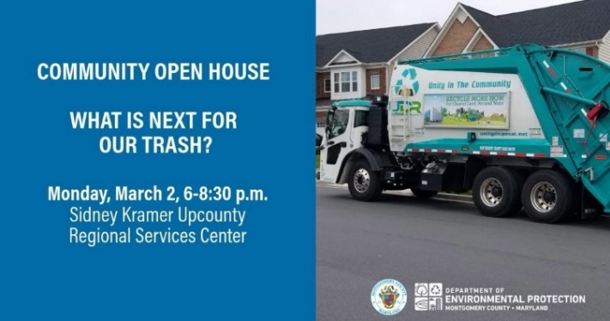
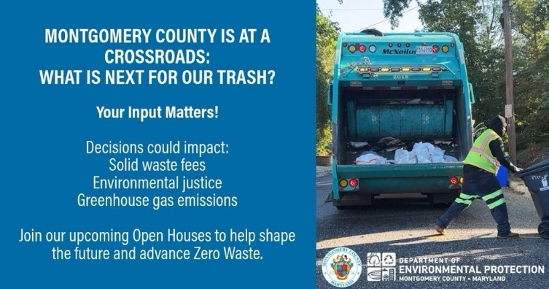
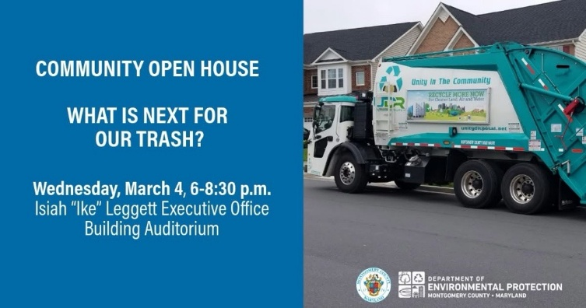
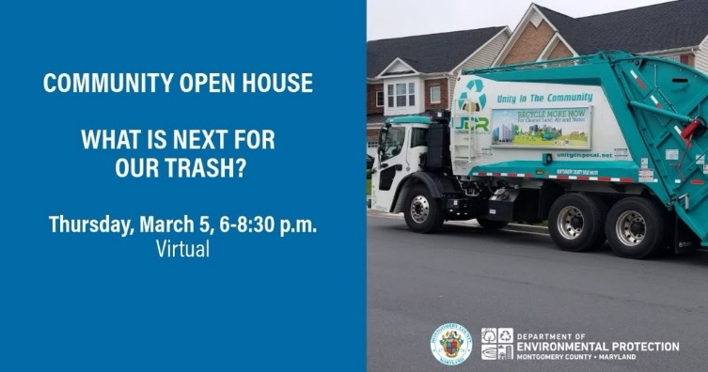
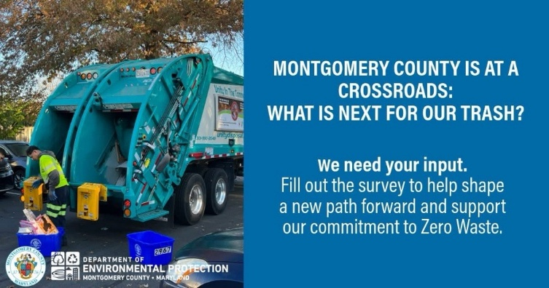
Samples of Social Media Post Graphics

Open Houses

Methodology
Open Houses are an informal setting with multiple displays where participants rotate through stations and discuss specific topics with staff members. Information is presented cafeteria-style, one-on-one, with participants choosing the stations that have information of interest to them. This enables quality back-and-forth conversations with subject matter experts. The County hosted three open houses during the first week of March 2026.
- Monday, March 2, 2026, 6 – 8:30 p.m.: Sidney Kramer Upcounty Regional Services Center, Germantown
- Wednesday, March 4, 2026, 6 – 8:30 p.m.: Isiah “Ike” Leggett Executive Office Building, Rockville
- Thursday, March 5, 2026, 6 – 7:30 p.m.: Virtual, Zoom

The in-person Open Houses were set up with six stations and 18 presentation poster boards. The presentation boards were developed by the project team with review and approval by County and DEP staff. Each station was staffed by a DEP subject matter expert that could explain the topic presented and answer questions. Each station also included an opportunity for input. Comment cards were available at all stations and could be submitted in a collection box. During both of the in-person Open Houses the County Executive provided brief remarks to attendees.

In-person Open House Stations
- Welcome Station: Welcome sign and sign-in sheet
- System Overview
  - Where are we now?
  - County materials management system
  - What is the incineration process?
  - Goals for our solid waste management system (public input)
- Aiming for Zero Waste
  - What is Aiming for Zero Waste?
  - How can we help you produce less trash? (public input)
- What is Advanced Waste Processing
  - What is advanced waste processing?
  - How supportive are you of investing in AWP? (public input)
- Options and Their Impacts
  - Options for managing waste in the future
  - Option 3: organics + AWP + residual to landfill
  - How will your bill change?
  - Keeping items out of landfill
  - Environmental justice and environmental impacts
  - Which option do you favor? (public input)
- Looking Ahead
  - Where do we go from here?
  - Why we must act now
  - What's the best way to reach you? (public input)

The virtual Open House was facilitated as a webinar presentation via the Zoom platform. The webinar used the same information presented at the in-person Open House as presentation slides with DEP staff taking turns presenting the information. The public input posters were converted into polls that gathered votes and displayed results in real time. The Q and A function in Zoom allowed participants to ask questions and DEP staff could respond. More than 100 questions were received. Some questions were answered live (aloud). The presentation was recorded to be reposted on the DEP website and its YouTube channel. All questions and answers were gathered to be presented as FAQs on the DEP website.

Observations
Fifty-two people attended the two in-person open houses, and eight people submitted comment cards. The virtual open house had 382 registrations and about 168 attendees joined the webinar within the first 10 minutes of the session.

In-person Open House Poster Feedback

Which goal for the solid waste management system matters most?
- Environmental protection – 11
- Maximum waste diversion – 6
- Reliable operations – 3
- Environmental justice – 1
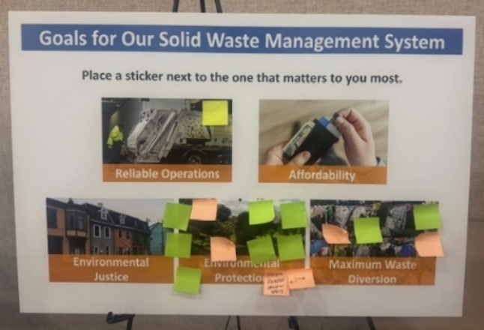
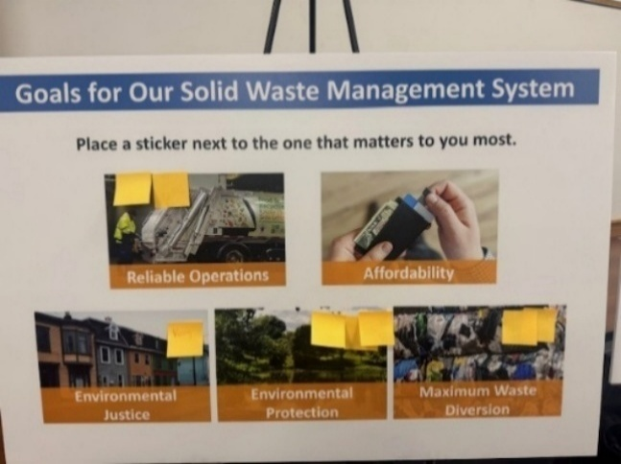

How supportive are you of investing in AWP?
- Definitely support – 12
- Likely to support – 1
- Might support with more info – 1
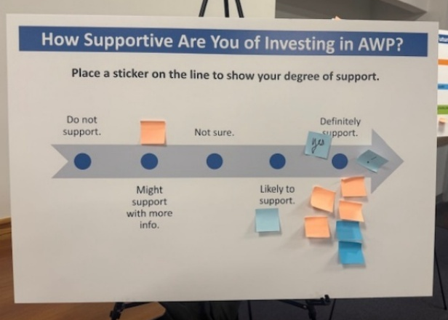
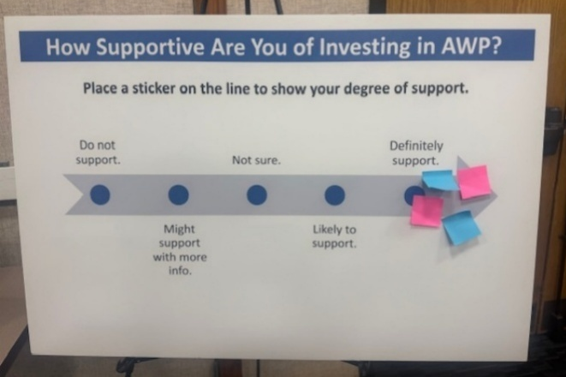

How can we help you produce less trash?
- Compost and food scraps countywide – 3
- More beauty spots all around the county – 2
- Ban single-use plastics – 2
- Bottle bill – 2
- Work with Annapolis on EPR – 2
- Freecycle sites – 1
- Require restaurants to use compostable ware – 1
- Clever, fun, creative engagement campaign – 1
- Pay as you throw – 1
- Compost facility – 1
- More clarity on plastics recycling – 1
- Make trash bins very small and recycling bins large to force people to change behavior – 1
- Incentivize a nonprofit to open and run a “scrap exchange” to reuse smaller materials – 1
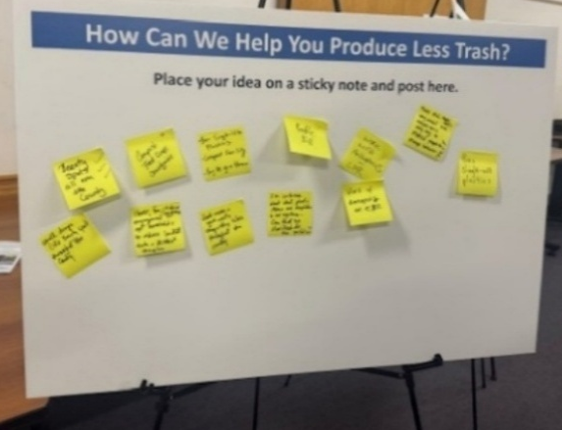
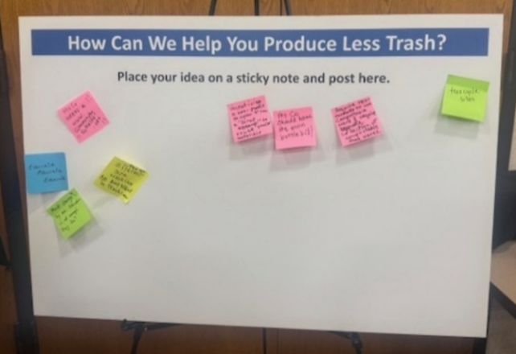

Which option for managing waste in the future do you like best?
- Option 3: Close the incinerator + food composting + build an Advanced Waste Processing Facility (AWP) + long-haul leftover waste to landfill – 14 votes
- Option 2: Close the incinerator + food composting + long-haul leftover waste to landfill – 2 votes
- Option 1: Continue to operate the incinerator + long-haul ash to landfill – 0 votes
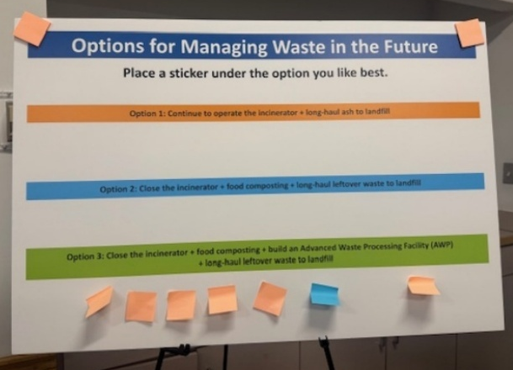
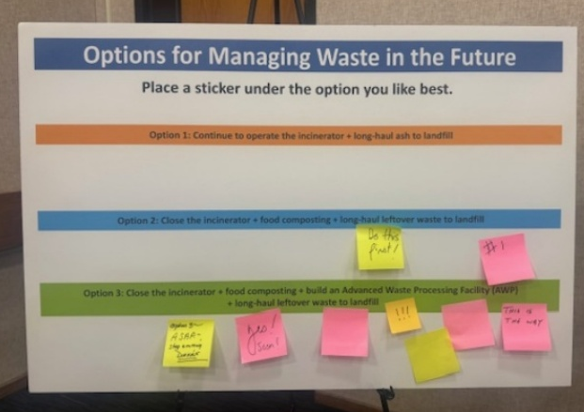

What is the best way to reach you?
- Email – 12
- Regular mail – 2
- Meetings – 2
- Social media – 1
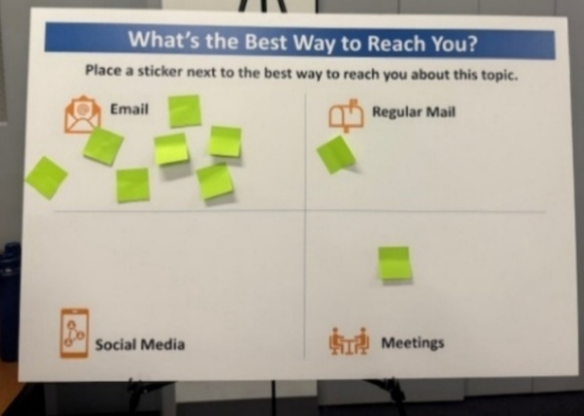
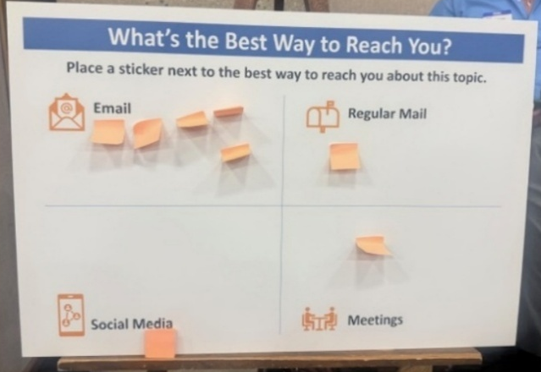

Sample Comment Card Feedback
- “Because of this gathering, I have a better understanding of the issues and challenges of our waste management in the county.”
- “ ‘Where there is a will, there is a way.’ Close the incinerator. Expand food composting – more pilot programs or universal, countywide composting. Insist you give full presentation to County Council.”

Virtual Open House Polls

The following polls were conducted during the Zoom Webinar March 5, 2026.

Which of the following matters most to you, when it comes to solid waste management?
- Environmental Protection (55/113) 49%
- Maximum Waste Diversion (20/113) 18%
- Reliable Operations (19/113) 17%
- Environmental Justice (10/113) 9%
- Affordability (9/113) 8%

How supportive are you of the County investing in Advanced Waste Processing?
- I am likely to support (34/119) 29%
- I definitely support (34/119) 29%
- I might support with more information (25/119) 21%
- I am undecided (18/119) 15%
- I do not support (8/119) 7%

Which option do you like best for managing our waste, based on what you heard today?
- Option 3: Close the incinerator + food composting + build an Advanced Waste Processing Facility (AWP) + long-haul leftover waste to landfill (77/107) 72%
- Option 1: Continue to operate the incinerator + long-haul ash to landfill (22/107) 21%
- Option 2: Close the incinerator + food composting + long-haul leftover waste to landfill (8/107) 7%

What is the best way to reach you?
- Email (67/101) 66%
- Community meetings or webinars (20/101) 20%
- Regular mail (11/101) 11%
- Social media (3/101) 3%

Open House (Physical and Virtual) Key Takeaways

Environmental protection tops list of customer waste management goals
Open House attendees identified environmental protection as their primary concern, ranking it as the most important goal for the County’s solid waste management system. Maximum waste diversion and reliable operations had nearly the same ranking for second place. Environmental justice and affordability also had nearly the same ranking among attendees for third place among the goals.

Options with Advanced Waste Processing had the most support
From the virtual Open House, approximately 72% of attendees favored closing the incinerator, implementing countywide food composting, and constructing an Advanced Waste Processing (AWP) facility. This approach received highest number of votes (14) among the options from the in-person Open Houses. Overall support for AWP is high, with 58% of virtual Open House attendees stating they “definitely” or “likely” supported the investment. An additional 21% indicated they might support the project if provided with more information, suggesting that further education could strengthen public support. Only 21% of virtual Open House attendees preferred continuing to operate the incinerator, while a small number supported closing the incinerator without building an AWP facility.

Attendees want countywide food scrap collection and more waste reduction programs
Attendees from the in-person Open Houses suggested several proactive measures to help the community produce less trash. Top recommendations included:
- Implementing countywide composting and food scrap collection
- Banning single-use plastics and requiring compostable service ware in restaurants
- Establishing freecycle sites, scrap exchanges, and more beauty spots
- Collaborating with state leaders on Extended Producer Responsibility (EPR) and bottle bills

Attendees prefer email from the County
To stay informed about this topic, the community prefers digital and direct engagement. Email was rated the highest among attendees, followed by community meetings or webinars. Other methods like regular mail and social media were less preferred.

Digital Survey

Methodology
Surveys are a quantitative tool to identify a baseline of awareness of a topic, and they allow for comparison measurement later. The digital survey was developed by the project team and was reviewed and approved by DEP staff. The survey was hosted via the Zoho platform. The survey was available in English plus six additional languages: Spanish, Amharic, French, Korean, Traditional Chinese, and Vietnamese. The translation was provided through a Google Translate plug-in in the survey software. The survey was active for one month from February to March 2026.

Observations
The survey received 6745 visits and 2609 total responses over the one-month period. Results by question follow. A survey results report from Zoho is included in the Appendix.

Survey Results

- Managing municipal waste is a critical service the County provides as it impacts your life in many ways. Rank the following goals of waste management on a scale of 1 to 5, where 5 is “critically important” to you and 1 is “not at all important.” Consider 3 to be neutral.

Protecting my health and safety and providing a quality living environment was scored as most important among the County’s listed goals, though all five goals scored as some degree of importance to survey takers.

- Protecting my health and safety, and providing a quality living environment: 4.72
- Preserving and protecting the natural environment: 4.52
- Promoting recycling, waste reduction, and reuse of materials throughout the County: 4.44
- Affordable services for all County residents: 4.39
- Ensuring that all customers pay their fair share of these services: 4.06

- What service or services do you most often use to dispose of your household trash (note this does not include recyclables)? Check all that apply.

The majority (90%) of survey takers said they have curbside or alley collection. Note that respondents could choose more than one service.

- Curbside or alley collection: 90%
- I take my trash to the county transfer station: 14%
- I produce minimal to no trash: 7%
- Shared trash dumpster, container, or chute: 4%
- Other (please describe): 8% (199 responses)

The Other category included responses like home or private company composting, and names of municipalities or private trash companies. Composting-related responses had the highest count, followed by private collection.

- What service do you most often use for recycling?

The majority (91%) of respondents said they have curbside or alley recycling service.

- Curbside or alley: 91%
- Shared recycling dumpster: 3%
- I take mine to the county recycling center: 2%
- I do not recycle: <1%
- Other (please specify): 3% (70 responses)

The Other category responses mostly included a transfer station and county center, retail drop-off, private services, composting, condo/HOA, and multi-family collection.

- If a respondent selected “I do not recycle” in question 3, they were given the opportunity to answer the following question: Based on your previous answer, which best describes why you don’t recycle?

Eleven people answered the question. These were their responses:

- I don’t have adequate space at my home to store a recycling container.
- I reuse my recyclables on my own property.
- I am unsure how to recycle.
- I do not want to recycle/don’t believe it matters.
Six people provided comments if they chose “other,” and their responses reflected skepticism and lack of trust or operational barriers.

- What do you most often do with your yard waste like leaves, branches, grass clippings, etc.?

Nearly half (46%) of respondents use curbside or alley collection for yard waste.

- Curbside or alley collection: 46%
- I usually compost them in my backyard: 17%
- I typically just leave my yard wase in my yard or on my property: 14%
- A landscaper or gardener manages our property: 14%
- Shared yard waste dumpster: <1%
- I take my yard waste to the county recycling/mulch drop-off site: 1%
- Other (please specify): 7% (179 responses)

The Other category responses included the following categories of responses:
- Combination of methods
- Condo/apartment/no yard
- Mulched/left in yard
- HOA/landscaper
- Private haulers or other disposal methods

- On a scale of 1 to 5, with 5 being “very satisfied” and 1 being “not at all satisfied,” how would you rate your satisfaction with your waste collection service.

The majority of respondents were satisfied or very satisfied with their trash collection and recycling collection.

- Trash collection: 4.56 and about 86% gave it a 4 or 5 rating combined
- Recycling collection: 4.49 and about 88% gave it a 4 or 5 rating combined

- On a scale of 1 to 5, with 5 being “very satisfied” and 1 being “not at all satisfied,” how would you rate your satisfaction with the County’s solid waste drop-off centers?

A lower majority (but still the majority) of respondents reported satisfaction with trash and recycling drop-off centers.

- Trash drop-off: 4.33 and about 57% gave it a 4 or 5 rating combined
- Recycling drop-off: 4.31 and about 57% gave it a 4 or 5 rating combined

- Rate how important organic material recycling (food scraps, yard waste, etc.) services are to you on a scale from 1 to 5, with 5 being “highly important” and 1 being “not at all important.”

This service scored an average of 3.8, indicating only a slightly larger number of respondents scoring
this as some level of importance to them.

- Are you aware of the County’s Aiming for Zero Waste (AZW) initiative?

More than half of respondents are not aware of the County’s Aiming for Zero Waste initiative.

- No: 56%
- Yes: 28%
- Unsure: 16%

- Do you think Aiming for Zero Waste is good idea?

Despite more than half of respondents not being aware of the County’s AZW initiative, two-thirds (65%) believe, based on no additional information, that it’s a good idea.

- Yes: 65%
- No: 11%
- Unsure: 11%
- Comments: 13% (97 responses)

Comments are summarized into the following themes:
- Feasibility or Impracticality: Many respondents feel that a Zero Waste goal is unrealistic or not feasible, potentially showing some misunderstanding about what “Aiming for Zero Waste” means.
- Logistics and Services: Requests for expanded services, specifically county-wide food waste composting, better curb pickup, and more convenient drop-off locations
- Cost and Financial Concerns: Concerns about the impact on taxes and whether the program provides a good return on investment compared to other priority needs
- Education and Rules: Suggestions for better education in schools and clearer communication on what materials belong in recycling bins
- Plastic Recycling Issues: Frustration with the non-recyclability of some plastic products and the perceived failure of existing plastic recycling programs

- What do you think would be a better idea than Aiming for Zero Waste? Please add your ideas for supporting Aiming for Zero Waste or new program ideas the County may not have considered.

Many respondents misunderstood this question and reiterated some of the same comments from question
10.

Among the alternatives to AZW, respondents suggested focusing on improving recycling accessibility,
expanding composting programs and increasing public education. Some respondents expressed a preference
for maintaining and modernizing the existing Resource Recovery Facility (incinerator) instead of shipping
waste to other locations.

Sample comments:
- “Zero waste is misleading and not truly possible to achieve without significant impacts to the economics of the county. Sustainable consumption with an emphasis on not overbuying or overconsumption is a better approach. Policies that promote reducing restaurant food waste for example.”
- “There is no such thing as zero waste in a modern society. But more trash and recycling drop off points would be good as the current trash drop off in Gaithersburg gets very backed up with traffic.”
- “Maximize recycling and composting, make it easier to discard ‘nonregular’ items without requesting special collection. Educate school age children on how to handle waste.”
- “You should really take a hard look at the Placer County, CA, approach to waste and recycling, which is designed to make waste disposal easier for residents while ensuring high-volume, efficient recovery of materials”

- Are you aware of the County goal to close the Resource Recovery Facility (RRF), also known as the Incinerator or Waste-To-Energy Facility, in Dickerson, Maryland?

The majority (59%) of respondents were not aware of this goal.

- No: 59%
- Yes: 36%
- Unsure: 5 %

- Do you think closing the Resource Recovery Facility is good idea?

Responses as to whether the County should close the RRF were mixed indicating a need for more information about it.

- Unsure: 33%
- Yes: 30%
- No: 23%
- Comments: 14% (136 responses)

Comments are summarized into themes such as:
- Environmental and health concerns, like dioxins, greenhouse gases, air quality, and general concern that the RRF isn’t being maintained properly.
- Fear of what comes next, such as rail-hauling waste or reverting to traditional landfills; shipping waste to other jurisdictions; or tax increases to fund new solutions.
- Appreciation for benefits, like electricity and revenue generation.
- Preference for the facility's volume reduction over landfilling.
- Some view the facility as a financial burden and suggest funds are better spent on zero-waste initiatives

- Rate how safe you believe the Resource Recovery Facility to be, as a way to manage our waste in the County on a scale from 1 to 5, where 5 is “extremely safe” and 1 is “extremely unsafe.” Consider 3 to be neutral. (N/A was also a choice among the options.)

The average score here of 3.13 suggests that about the same number of respondents find the RRF to be unsafe as those who find it safe.

- 33% selected 3
- 30% selected N/A
- 12% selected 4
- 9% selected 5
- 9% selected 2
- 7% selected 1

- Rate how effective you believe the Resource Recovery Facility is as a way to manage our waste in the County, on a scale from 1 to 5, where 5 is “extremely effective” and 1 is “extremely ineffective.” Consider 3 to be neutral. (N/A was also a choice among the options.)

On this question, the average rating: 3.31 also suggests equal number of respondents believe it is effective versus not effective.

- 33% selected 3
- 28% selected N/A
- 14% selected 4
- 13% selected 5
- 7% selected 2
- 5% selected 1

- Which of the following best describes how you feel about the County hauling your waste to another state for disposal in an out-of-state landfill.

The majority of respondents, by a very small margin, are supportive of long hauling, as long as some assurances can be made about the impact to others and the costs.

- I am fine with it, so long as it doesn’t harm someone else’s health or environment: 39%
- I do not support this option due to environmental and/or ethical concerns: 37%
- I am fine with it, so long as it’s not more expensive than dealing with it here: 20%
- I am fine with it, no matter what: 4%

- Which of the following best describes how you feel about building a new landfill in Montgomery County?

The majority of respondents are supportive of building a new landfill in the County, as long as some assurances can be made about the impact to others and the costs.

- I am fine with it, so long as it doesn’t harm anyone else’s health or the local environment: 56%
- I do not support this option due to environmental and/or ethical concerns: 22%
- I am fine with it, so long as it’s not more expensive than other options: 12%
- I am fine with it, so long as it isn’t built in a place where I can see it or smell it as I go about the course of my day: 7%
- I am fine with it, no matter what: 3%

- Some residents are putting non-acceptable items into recycling bins, which contaminates the recycling stream and drives up costs. How do you suggest we get residents to recycle correctly? Check all that apply.

A strong majority (75%) advocate for more education to tamp down on contamination, with a sizeable percentage in support for translating information into other languages.

- Make the recycling guidelines easier to read and understand: 75%
- Provide recycling guidelines in other languages: 44%
- Impose fees for trying to recycle non-acceptable items: 36%
- Other (please specify): 763 responses, 30%

Comments are summarized into the following themes:
- Prioritize clear communication: About a third of responses requested educational materials, and easily accessible sorting guides.
- Balance enforcement with encouragement: About a third of the responses related to issuing penalties and incentives, and respondents favor positive reinforcement.
- Provide immediate feedback: About 20% of responses suggested direct feedback mechanisms such as cart tags, to explain why a bin was not serviced
- Streamline the process: More than 15% of comments focused on making the system easier to use.

Sample comments:
- “Have coaches help people and leave tags on bins with the wrong items explaining why.”
- “Multi-pronged approach involving education, motivation, and better processing to filter out non-acceptable items.”
- “In my opinion, the guidelines and educational items the County provides are easy to read and understand. I recommend that the County continues to provide as much education and as many reminders as possible.”
- “Stickers―big ones with clear images―of acceptable items that can be put on the bins to help customers presort properly.”
- “I like the orange tags on bins with unacceptable items, though people may not know what in their bin is unacceptable. Too much consumption―too convenient to overconsume.”
- “Providing context is important, so provide information on what happens when the recycling stream is contaminated.”

- Do you know how Montgomery County funds its trash and recycling services?

Nearly half of all respondents do not know how these services are funded.

- No: 47%
- Yes: 33%
- Unsure: 19%

- Which of the following best describes how you pay for trash and recycling services. (Respondents could choose only one answer.)

More than two-thirds (68%) believe they pay for services through taxes. The County should check the accuracy of these responses against actual cases to determine whether communications about payment should be enhanced.

- These services are included in my taxes: 68%
- I pay a private trash or recycling hauler either directly or through my HOA:14%
- I receive a separate bill for these services in the mail each month or quarter: 4%
- I pay directly when I drop off materials at drop-off centers: <1%
- Trash and recycling services are free for me: <1%
- I’m unsure how I pay for these services: 2%
- Other (please specify): 11% (95 responses)

More than half of the comments listed in “Other” suggested there was a mixed payment option like recycling through property taxes and trash through a private hauler. Other comments included HOA, condo or community fees, or municipal billing.

- How much do you pay annually for trash and recycling services?

The majority of respondents do not know what they pay annually for trash and recycling service.

- I don’t know: 57%
- $200+ per year: 23%
- $0-50 per year: 5%
- $150-200 per year: 5%
- $100-150 per year:4%
- $50-100 per year: 2%
- I would prefer not say: 5%

- Rate the degree to which you believe the service you receive from the County for trash and recycling is a value for the price you pay, where 5 is “excellent value,” 1 is “poor value,” and 3 is neutral.

Ratings for value were mostly high, with 60% giving a 4 or 5.

- Average rating: 4.05 and about 60% gave it a 4 or 5 rating combined

- When something (such as a small appliance) breaks, I am more likely to repair it than throw it away and get a new one.

Most (80%) are repairing small appliances.

- Some of the time: 49%
- Most of the time: 31%
- Never: 11%
- All of the time: 8%

- True or False - I know how to properly dispose of my Household Hazardous Waste.

Most know how to properly dispose of Household Hazardous Waste.

- True: 87%
- False: 13%

- Where do you go for information about trash and recycling services in the County? Check all that apply:

The website is, by far, the most accessed channel for trash and recycling information. Note that social media scores among the lowest.

- County website: 95%
- County notification system: 15%
- Friend or family or neighbor (word of mouth): 10%
- Property manager or homeowner’s association: 7%
- Local newspaper 3% (68 responses)
- Facebook: 2%
- Nextdoor: 2%
- YouTube: 1%
- Instagram: <1%
- Other (please specify) 245 responses

The local newspaper category responses included:
- The Washington Post
- Olney News/Newsletter
- Bethesda Beat
- Bethesda Today
- Monocacy Monocle
- Banner
- The Beacon
- Rockville Reports
- MoCo Show
- Neighborhood association emails

The Other category responses included:
- Direct County contact (311, DEP, phone calls)
- Search engines, internet, and AI
- Mailed and other collateral materials
- Community and social networks (neighborhood listservs, Nextdoor, or word of mouth)
- On-site/transfer station personnel

- The best way for the County to reach me in the future with information about trash and recycling include: (Check all that apply)

A combination of direct email and the County website, with traditional mail, are the top three most preferred channels of communication.

- Email: 69%
- County website: 62%
- Mail to my mailbox: 53%
- County notification system: 31%
- Text: 22%
- Property manager or homeowner’s association: 11%
- Nextdoor: 6%
- Facebook: 5%
- Local newspaper 5% (136 responses)
- Instagram: 2%
- YouTube: 2%
- Other: 1%
- Other (please specify) 84 responses

Local newspapers mentioned more than once were:
- Washington Post
- Banner/Montgomery Banner
- Bethesda Beat
- The Banner
- Beacon
- Olney Gazette
- Monocacy Monocle
- Moco Show

The Other category responses included:
- Broadcast media (TV/radio)
- Community/neighborhood groups (HOA/listservs)
- County newsletters/updates (e.g., Montgomery update)
- Physical/direct communication (flyers/mailers/bins)
- Educational institutions (schools/PTA)
- Local government/municipalities (Rockville/Takoma Park)
- Digital/social media (X/discussion groups)
- Community events (fairs/tents)

- How would you describe your home?

- Single-family: 85%
- Townhouse or duplex: 10%
- An apartment or condominium within a larger building: 4%
- Unit in a small multi-family building with up to 4 units: <1%
- Prefer not to answer: <1%
- Other (please specify): <1% (19 responses)

- Do you rent or own your current residence?

- Own: 94%
- Rent or lease: 4%
- Prefer not to answer: 2%

- How many are in your household?

- 2-3: 62%
- 4: 16%
- 1: 15%
- 5-10: 6%
- More than 10: 1%

- Which zip code do you live in?

Top 10 Zip Codes
- 20817: 8%
- 20902: 7%
- 20854: 7%
- 20910: 6%
- 20904: 5%
- 20906: 5%
- 20852: 5%
- 20853: 5%
- 20895: 5%
- 20878: 4%

- Which language do you prefer to receive spoken or written information in?

- English: 97%
- 2% is spread out in less than 1% increments among the other answers
- 1% chose “prefer not to answer.”

- What is your total household income?

- $150,000 or more: 39%
- Prefer not to answer: 32%
- $100,000 to $149,999: 12%
- $75,000 to $99,999: 7%
- $50,000 to $74,999: 4%
- $25,000 to $49,999: 2%
- Prefer to self-describe: 2% (47 responses)
- Less than $25,000: <1%

Survey Key Takeaways

Public health and environmental protection cited as most common goal
Managing solid waste is an essential service, and while Survey respondents rated the goals of waste management at a 4 or greater on a 5-point scale, they placed the highest value on public health and environmental protection. Respondents prioritized protecting their health and safety (4.72) and preserving the natural environment (4.52). Affordability (4.39) and ensuring all customers pay their fair share (4.06) also ranked highly, showing that residents expect high-quality, environmentally responsible services at a reasonable and equitable cost.

Residents report high degree of satisfaction with trash and recycling services
Respondents reported high satisfaction with current waste collection services with scores of 4 and greater on a 5-point scale. Curbside or alley collection is overwhelmingly the most common method for both trash and recycling. While 47% of respondents use yard waste collection, 16% choose to compost yard waste in their own backyards.

Service Type | Usage Rate | Average Satisfaction (out of 5)
Trash Collection | 90% | 4.56
Recycling Collection | 91% | 4.49
Trash Drop-off Centers | 14% | 4.33
Recycling Drop-off Centers | 2% | 4.31

Varied responses for waste management options
Some respondents showed support for progressive waste management policies, provided the County protects their health and the environment, but the survey responses also suggest that residents may need more information about waste management options.
- Aiming for Zero Waste: 65% of respondents support the initiative, even though 56% were unaware of it before taking the survey.
- Landfill Options: Respondents are open to landfills if environmental safeguards are guaranteed. More than a third, 39%, support out-of-state landfilling, and more than half, 56%, support a new in-county landfill, provided it does not harm public health or the environment in both cases. Cost was also a consideration in these responses with 20% saying it shouldn’t cost more to landfill out of state and 12% saying it shouldn’t cost more for in-county.
- Incinerator/RRF: Opinions on the incinerator are mixed. Only a third of respondents are aware of the goal to close the facility and when asked if closing it is a good idea, less than a third support the closure, nearly a quarter oppose it, and a third are unsure. Respondents rated the facility's safety and its effectiveness at about a 3, which is neutral on a 5-point scale. Note: More than 2,000 survey responses were collected before the Open Houses held March 2-5.

Opportunities exist for building understanding around costs and funding for services
There is a gap in respondents’ understanding of how waste services are funded. More than half (57%) do not know how much they pay annually for trash and recycling, and 47% do not know how the County funds these services. More than two-thirds (68%) say they pay for trash and recycling services through their taxes. Additionally, 60% rated the degree to which they believe the service they receive from the County for trash and recycling is a value for the price they pay as a 4 or 5 (with 5 being an “excellent” value).

Residents prefer clearer guidelines and direct communications
When addressing recycling contamination, 75% of respondents suggest making the recycling guidelines easier to read and understand, rather than imposing fees (36%). While 95% of respondents currently rely on the County website for information, they show preferences for direct outreach via email (69%), direct mail (53%), and text (22%).

Cross-Tab Results (Home type, income, and language preference)
The survey responses are not evenly distributed across all demographics. Respondents identifying as multi-family, renters, or non-English speaking, have notably fewer respondents. This means findings for these categories should be treated as directional and not statistically significant.

Single-family vs. multi-family residents
The most pronounced differences in results for this group are in service access and satisfaction. Single-family residents overwhelmingly use curbside collection (85%) and report higher satisfaction (4.1/5), while multi-family residents depend on shared dumpsters/chutes and report notably lower satisfaction (~3.6/5), especially for recycling. Multi-family residents also have lower awareness of County programs like Aiming for Zero Waste and the incinerator closure, and more frequently cite “no convenient option” as a recycling barrier. Property managers and HOAs are a critical information channel for this group.

Household income
Affordability is the headline difference for this group. Lower-income respondents (<$50K) rate “affordable services” as critically important at significantly higher rates (72%) than higher-income respondents (53%). They also perceive less value for the price they pay and are less aware of how the County funds services. Higher-income residents are more engaged with environmental policy questions (incinerator closure, Aiming for Zero Waste) and place greater emphasis on environmental preservation and recycling promotion. Interestingly, lower-income residents report repairing broken items at higher rates.

Language preference
Non-English speakers (4% of respondents, including Spanish, Chinese, Korean, French, and ASL) face the most significant information barriers. They have substantially lower awareness of AZW (18% vs. 40%) and the incinerator closure goal (22% vs. ~48%). They are more likely to cite confusion about recycling guidelines and strongly support multilingual materials. Critically, they rely on word of mouth, social media, mail, and text for information rather than the County website―meaning current outreach strategies may not reach them effectively.

Cross-cutting insights
Lower-income, non-English-speaking, and multi-family residents share overlapping vulnerabilities, including lower program awareness, more recycling barriers, and different communication preferences. The County's outreach strategy should diversify beyond the website to include multilingual materials, community-based channels, and partnerships with property managers.

Cross-Tab Results by Region
The survey responses are not evenly distributed across zip codes. Bethesda and Upcounty residents contributed the largest shares of mapped responses, while Silver Spring and Eastern Montgomery had notably fewer responses. This means findings for smaller regions should be treated as directional and not statistically significant.

Upcounty
Proximity to the Dickerson facility is likely driving significantly higher awareness of the incinerator closure goal and the strongest opinions (both for and against). While there are more rural waste disposal patterns in this group, such as higher transfer station use and more backyard composting compared to other regions, this group is still predominantly served by curbside collection. Affordability is a higher priority in this region than in Bethesda, reflecting a somewhat more moderate income profile. Residents are more likely to repair broken items here rather than replace them.

Mid-County
This region had a balanced, middle-of-the-road profile across nearly all metrics―satisfaction, awareness, and priorities. We noted strong curbside collection usage and high recycling participation. This region showed moderate awareness of AZW and the incinerator closure, suggesting this area would be good targets for general education campaigns about both concepts. The notion of “fair share” in paying for services resonates more here than in Bethesda, suggesting sensitivity to equity in funding mechanisms in Mid-County.

Bethesda
This was the highest income region with the largest share of $150K+ households and the highest homeownership rates. Their environmental priorities, of preserving the environment and promoting recycling, were higher here than other regions. This region also had the highest service satisfaction rate for both trash and recycling collection, and the strongest perceived value for price. They were most engaged with policy questions, showing support for AZW, and expressing a lot of comments on the incinerator. This region’s residents are more likely to use a landscaper for yard waste pickup rather than composting or curbside. This group can be considered early adopters of new technologies and champions for new sustainability programs.

Silver Spring
This is the most urban and diverse region with the highest share of multi-family housing (apartments, condos), renters, and non-English speakers. This group expressed lower satisfaction with both trash and recycling services, consistent with the challenges of shared-service infrastructure in multi-family settings. They had lower program awareness for AZW and incinerator closure, suggesting that county outreach has not penetrated as effectively here. This group has greater reliance on property managers/HOAs and word of mouth for information, rather than the County website. Affordability is a higher priority here than in other regions, and residents are less likely to know how the County funds its services.

Eastern Montgomery
This group showed moderate engagement across all metrics, sitting between Silver Spring and Mid-County on most measures. They had somewhat lower awareness of County programs, suggesting a gap in outreach to this area as well. Like the Upcounty respondents, this group had higher use of the transfer station than the urban regions but less composting than their Upcounty neighbors. This is a potentially underserved area where targeted community outreach could meaningfully increase recycling participation and program awareness.

Findings and Recommendations

Support for county-wide composting, AZW, AWP, and closing the incinerator is correlated with higher awareness and understanding of options
Participants of the Open Houses seemed to be more aware of the three options the County is considering and were generally supportive of the County’s plan to close the incinerator, add countywide composting, implement AZW, and invest in Advanced Waste Processing (AWP). This was presented as Option 3. The Survey results also showed general support for more progressive approaches to waste management. Together, this seems to indicate general support for Option 3, so long as awareness of all the options and risks is high. Lower-income households may not be as aware of the County’s plans, or as financially prepared to handle an increase in service fees without some assistance. An intensive, strategic educational campaign could be effective in tipping the 21% of residents who are “undecided” on these ideas but open to learning more.

The County’s strong track record of service and value brings credibility to its decisions
Survey results and Open House feedback suggest a mostly good track record of service with the exception of Silver Spring, but that may be due to their experience with their HOA or multi-family property manager. This track record of good service can mean the County has earned credibility for its approach and decision making with respect to trash and recycling services, and this credibility can help boost success when announcing adoption of a new plan.

One of the biggest opportunities for communications is about costs and funding
Costs and funding were two areas of awareness where scores were lower than others, suggesting the County has an information gap to close, particularly with lower-income regions. The County should consider aligning its policy messaging with affordability by proactively communicating the financial implications of the incinerator closure and new infrastructure investments, ensuring messaging directly addresses the cost concerns held by lower-income stakeholders. Affordability is a concern for many so any assistance programs, cost changes, and money-related messaging should be prominent in all communications about service changes.

Equity and access to service are pain points for underserved populations in the County
To increase equity of service and access, the County would benefit from expanding its recycling education and enforcement in multi-family buildings (shared bins, clear signage) and enhancing translated, visual recycling guidelines through direct mail, SMS, and community networks to better engage residents in regions of non-English-speaking households.

Opportunities exist for enhancing outreach and engagement to build understanding and support
The County stands to reach more residents by investing more in direct-to-consumer channels such as emails, text, regular mail, and community-based outreach. In addition, by increasing its partnership with property managers, HOAs, and community organizations, the County will enhance its ability to reach multi-family and non-English-speaking residents. Finally, gaps exist among underrepresented groups in knowledge about AZW and incinerator decisions, so it’s advised the County spend some focused education and outreach with these groups about these topics before policy changes take effect.

APPENDIX
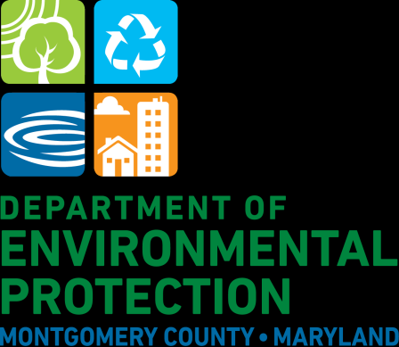

Montgomery County Solid Waste Planning Survey

Response Statistics
2609
Total Responses
6745
Survey Visits
0
Partial Responses
2609
Completed Responses
0
Over Quota Responses
0
Disqualified Responses

Special Statistics

Overall CSAT Score
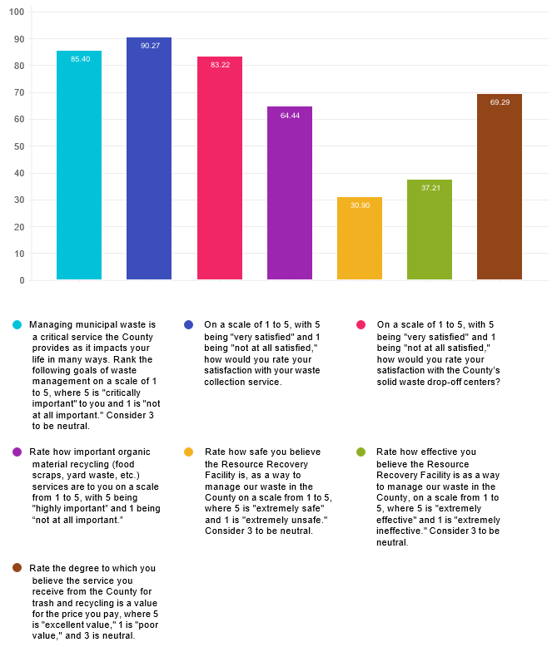
Questions | Negatives | Neutrals | Positives | CSAT Score
Managing municipal waste is a critical service the County provides as it impacts your life in many ways. Rank the following goals of waste management on a scale of 1 to 5, where 5 is "critically important" to you and 1 is "not at all important." Consider 3 to be neutral.  On a scale of 1 to 5, with 5 being "very satisfied" and 1 being "not at all satisfied," how would you rate your satisfaction with your waste collection service.  On a scale of 1 to 5, with 5 being "very satisfied" and 1 being "not at all satisfied," how would you rate your satisfaction with the County’s solid waste drop-off centers?  Rate how important organic material recycling (food scraps, yard waste, etc.) services are to you on a scale from 1 to 5, with 5 being "highly important” and 1 being “not at all important.”  Rate how safe you believe the Resource Recovery Facility is, as a way to manage our waste in the County on a scale from 1 to 5, where 5 is "extremely safe" and 1 is "extremely unsafe." Consider 3 to be neutral.  Rate how effective you believe the Resource Recovery Facility is as a way to manage our waste in the County, on a scale from 1 to 5, where 5 is "extremely effective" and 1 is "extremely ineffective." Consider 3 to be neutral.  Rate the degree to which you believe the service you receive from the County for trash and recycling is a value for the price you pay, where 5 is "excellent value," 1 is "poor value," and 3 is neutral. | 516  136  139  421  389  310  117 | 1361  345  445  461  852  836  555 | 10975  4461  2897  1598  555  679  1516 | 85.4  90.27  83.22  64.44  30.9  37.21  69.29

Overall CSAT Score: 76.72
The CSAT score is calculated for each of the 5-point scale questions. It represents the percentage of positive responses (4 or 5 rating) out of the total number of survey participants. 90% or higher indicates that
the vast majority of respondents are satisfied/have positive reaction.

Average Ratings
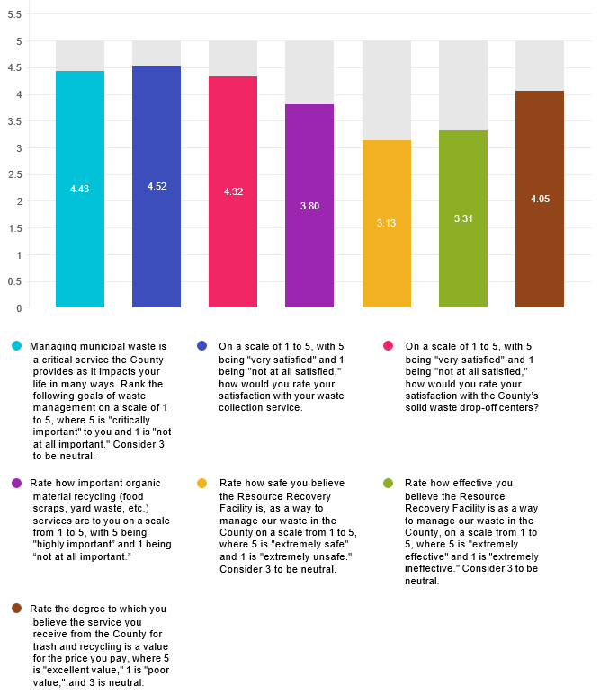
Questions | Average Ratings | Out of
Managing municipal waste is a critical service the County provides as it impacts your life in many ways. Rank the following goals of waste management on a scale of 1 to 5, where 5 is "critically important" to you and 1 is "not at all important." Consider 3 to be neutral.  On a scale of 1 to 5, with 5 being "very satisfied" and 1 being "not at all satisfied," how would you rate your satisfaction with your waste collection service.  On a scale of 1 to 5, with 5 being "very satisfied" and 1 being "not at all satisfied," how would you rate your satisfaction with the County’s solid waste drop-off centers?  Rate how important organic material recycling (food scraps, yard waste, etc.) services are to you on a scale from 1 to 5, with 5 being "highly important” and 1 being “not at all important.”  Rate how safe you believe the Resource Recovery Facility is, as a way to manage our waste in the County on a scale from 1 to 5, where 5 is "extremely safe" and 1 is "extremely unsafe." Consider 3 to be neutral.  Rate how effective you believe the Resource Recovery Facility is as a way to manage our waste in the County, on a scale from 1 to 5, where 5 is "extremely effective" and 1 is "extremely ineffective." Consider 3 to be neutral.  Rate the degree to which you believe the service you receive from the County for trash and recycling is a value for the price you pay, where 5 is "excellent value," 1 is "poor value," and 3 is neutral. | 4.43  4.52  4.32  3.80  3.13  3.31  4.05 | 5  5  5  5  5  5  5

Overall average survey rating: 8.41/10
The Average Rating is a weighted mean for each of the 5-point scale questions. Each response is assigned a numerical weight (e.g., 1 to 5). If an "N/A" (Not Applicable) option is selected by a respondent, it is excluded from the mean and standard deviation calculation.

P1

Q1

Managing municipal waste is a critical service the County provides as it impacts your life in many ways. Rank the following goals of waste management on a scale of 1 to 5, where 5 is "critically important" to you and 1 is "not at all important." Consider 3 to be neutral.
Answered: 2595 Skipped: 14
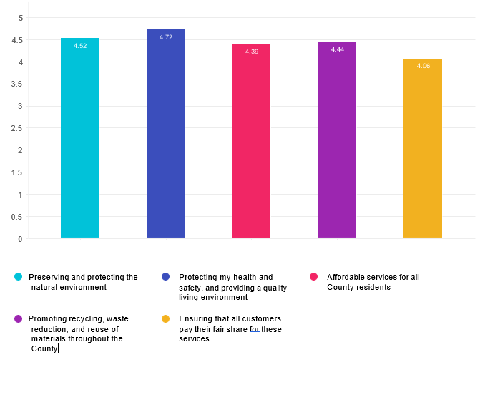

Row | 1 (Not at all important) | 2 | 3 | 4 | 5 (Critically important) | N/A | Average rating | Response count
Preserving and protecting the natural environment  Protecting my health and safety, and providing a quality living environment  Affordable services for all County residents  Promoting recycling, waste reduction, and reuse of materials throughout the County  Ensuring that all customers pay their fair share for these services | 1.55%  (40)  0.54%  (14)  1.05%  (27)  2.36%  (61)  3.57%  (92) | 1.71%  (44)  0.97%  (25)  1.78%  (46)  2.74%  (71)  3.73%  (96) | 7.56%  (195)  3.94%  (102)  12.47%  (322)  7.96%  (206)  20.82%  (536) | 20.90%  (539)  14.58%  (377)  26.44%  (683)  21.99%  (569)  25.83%  (665) | 67.93%  (1752)  79.70%  (2061)  58.03%  (1499)  64.76%  (1676)  44.82%  (1154) | 0.35%  (9)  0.27%  (7)  0.23%  (6)  0.19%  (5)  1.24%  (32) | 4.52  4.72  4.39  4.44  4.06 | 2579  2586  2583  2588  2575

Average rating: 4.43

Q2

What service or services do you most often use to dispose of your household trash (note this does not include recyclables)? Check all that apply.
Answered: 2602 Skipped: 7
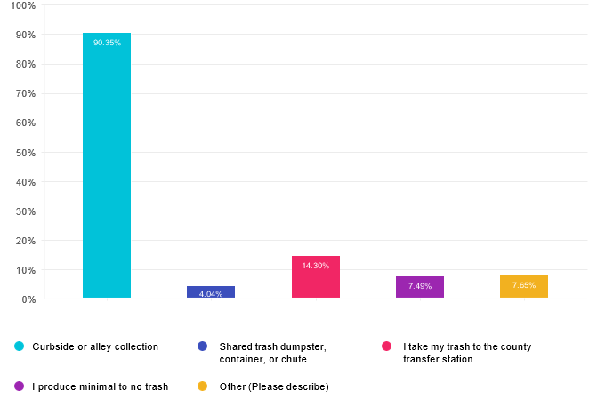

Choices | Response percent | Response count
Curbside or alley collection | 90.35% | 2351
Shared trash dumpster, container, or chute | 4.04% | 105
I take my trash to the county transfer station | 14.30% | 372
I produce minimal to no trash | 7.49% | 195
Other (Please describe) | 7.65% | 199

Other (Please describe)

- At home food composting
- Bulk pickup
- Special collections for metal, electronics and bulk

- I throw everything in the trash because it's cheaper than your recycling programs
- I pay for trash collection
- Private trash collection contractor
- I also compost in backyard that significantly reduces trash.
- private cash hauler
- We pay HOA fees for dumping our trash
- I pay for trash pickup. The county doesn't pickup my trash. I guess I need to live in Takoma Park to get that.
- trash weekly pickup service
- Private curbside pickup
- Because the county only picks up trash once a week and my community needs it more often, a private company hauls away our trash, not the county.
- Why doesn’t Gaithersburg have trash collection paid by our county taxes?
- we also compost vegetable matter
- 1 bag per week (we compost food in yard)
- We contract out our trash collection because we live outside the City of Gaithersburg.
- Compost of vegetable trimmings
- Private waste management service
- Bulk trash pick ups
- I am using a private service to pick up food waste for composting
- Composting
- Private trash service in the Ag reserve
- Private company curbside collection
- Food scrap drop off
- Private compost service
- Take hazardous waste and other special items to the transfer station
- Compost collection
- However, I pay to have compost picked up
- Special pickups for metal items and other large household items. Pickup of tree trimmings/branches, brush, and leaves
- Collection in my high rise building
- pay for compost
- HoA contractor
- I pay for private company collection
- Condo dumpster
- i compost kitchen waste at home.
- Private trash pickup
- Private trash company
- Note: HOA private collection, not in county collection area
- w/family-normal trash//Now By Myself-Very Little trash
- HOA trash collection not county services
- Transfer station for hazardous waste, electronics, large tree trimming
- Curbside through Titus Trash
- Private pay trash pickup

- I live in an apartment.
- Private service for condominium
- I deal with it.
- Private paid collection. My area does receive county trash collection
- private compost service
- compost at MV Farmers market
- I compost.
- Private collection services
- Private company pickup
- Private trash, recycling and composting
- My part of the County has to pay for private trash pickup. We should get County service or a reduction in our taxes.
- also compost -bit difference reducing trash
- We pay for private contractor who picks up door side.
- I pay for my own trash pickup
- We use to have twice a week pick up at the side of our house. Now we have once a week at the curb and they don't bother to pick up trash/recycled material that falls out of the cans. Paying more for less.
- We live in a community with each home contracting individually for private trash pick up. This is terrible for the environment
- compose
- HOV uses a private trash contractor company
- HOA fees cover trash collection
- Don't have county trash pickup
- Private contractor, county service unavailable
- Compost
- Pay for private trash service
- Private trash collecting service
- we compost so our trash production is approximately one bag per month.
- I use a private compost service
- I compost most yard and kitchen waste
- Our area is not serviced by the County; we use a private service
- I compost most food products as I am vegetarian.
- Private company.
- HOA pays for garbage
- My senior community collects our trash for recycle et al
- I compost food waste to limit trash
- Composting drop off
- private curbside pickup--no county svc where I live
- Need more options for food scrap recycling. Just using the farmers markets is not enough.
- Have a compost service pick up compost trash weekly
- My community has a private trash collection service.
- I compost and buy products that can be recycled
- START CURBSIDE PICKUP ON MY STREET NOW!

- We reuse and recycle everything possible and buy items which can be responsibly recycled
- I compost food waste at home
- live in a condo so trash pick up is on a contract but is curbside.
- I have curbside compost pick up
- Need a curb side plastic bag solution, maybe a bin at the back of the library or around the county?
- Some larger or non biodegradable items go to the recycling center
- I take compostable kitchen stuff to MOM's
- As an HOA, trash pick-up is part of our HOA costs - and they seem reasonable- good service by our company
- I pay for my curbside trash pickup
- pick-up (as needed) of large items
- I pay for private collection
- Private trash service
- Private Compost pickup from Compost Guys
- I compost and recycle. My trash is about 1/4 of a trash bag a week
- Do not have MoCo trash removal
- Itake some of my trash to the transfer station

Q3

What service do you most often use for recycling?
Answered: 2598 Skipped: 11
\
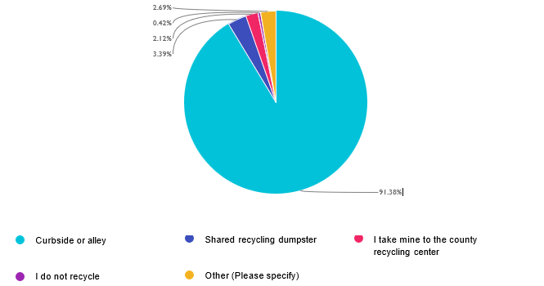

Choices | Response percent | Response count
Curbside or alley | 91.38% | 2374
Shared recycling dumpster | 3.39% | 88
I take mine to the county recycling center | 2.12% | 55
I do not recycle | 0.42% | 11
Other (Please specify) | 2.69% | 70

Other (Please specify)

- I always take special items to the transfer station.
- use compost crew for food waste composting
- This should be multiple selection. I do use curbside recycle collection for most paper, plastic, metal and glass recycles . But I do take paint, batteries, oil, electronics, appliances, etc. to county recycling center to drop in the right counter.
- I recycle metal & styrofoam
- My building has recycling bins that ate collected most of the times by a landfill trash truck (5/7)
- Not specified

- Curbside except for plastic bags which I take to the county recycling center.
- Collection in my high rise building
- Mom
- Plastic bag recycling through store return
- Condo mangt. general collection
- Private recycling pickup
- w/family-a lot to recycle//Now By Myself- Little to Recycle
- Ok
- I recycle boxes curbside but not other trash
- I take plastic wrap and bags to stores thar recycle
- Not specified
- Store drop off for plastic bags, Thrift donation and other recycling options
- Reuse milk jugs and egg cartons to grow seedlings for veggie patch
- Not specified
- I recycle other items via Terracycle. I used to have a service for compost but now I'm retired and need to cut expenses
- Many residents are careless re: recycling rendering it “contaminated” and treated as trash.
- Not specified
- Recycling at MOM’s grocery store
- Not specified
- recycling in bldg
- Metal recycling at the transfer center
- Private service through Condo's HOA
- When they drop recycled material,they should pick it up instead of just leaving it on the ground.
- We take other recyclable material and bulk metals to the county transfer station. we find this service (transfer station)most valuable.
- Compost service and occasional trip to recycling cemter
- Curbside AND take items to recycle center
- Condo recycling bins on each floor
- I use curbside mostly but I also go to the recycling center with catagories of things that I have saved up like plastic bags.
- see above answer
- Terracycle
- Recycling centers
- In
- Not specified
- The collectors of recycling do not care about their job. They just throw the empty bins wherever they want to be (not in the original curbside spot that I leave the bin). bin is cracked so bad
- Transport yard waist
- Place trash and trash and recycles in County provided receptacles.
- Also take some to Transfer station
- Curbside for bottles and containers. Grocery store for plastic bags.
- Metals, Electronics, and hazmats are dropped at the transfer station
- for all recycling

- county curbside and now I pay Ridwell to take plastics that the county doesn't recycle
- add to my recycling bottles and cans left on nearby walkways
- Condominium recycling room pickup
- private firm for plastic bags, all types
- Please ask the men to stop throwing the recycling bins. They always end up broken.
- FOOD SCRAP WASTE is collected on Saturday mornings at Veterans Plaza. This program should instituted Statewide.
- Not specified
- Not specified
- Buy Nothing to rehome unneeded items
- Both curbside and county recycling center
- Some curbside recycling, and I take larger loads to the recycling center
- I live at Asbury Methodist Village where we have a very active community recycling system.
- curbside for some, private compost collection for food waste, plastic to recycle at local store
- County recycling center for paints etc
- Recycling every Two weeks or three
- Offer things free for the extended neighborhood
- i also use the transfer station-Shady Grove
- I would love to recycle but everything is thrown away. Prior it was curbside.
- I
- I use both curbside recycling collection services and drop off recycling services at the Shady Grove Transfer Station for e-waste, clothing, books, and scrap metal.
- Cover stores for plastic bags
- Attempting to use as little plastic as possible. Have switched back to bar soap instead of liquid hand soaps in plastic.
- I take compost to Whole Foods
- Live in Takoma Park

Q4

Based on your previous answer, which best describes why you don’t recycle?
Answered: 11 Skipped: 2598

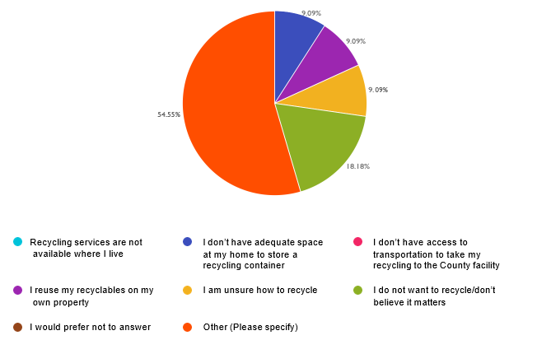

Choices | Response percent | Response count
Recycling services are not available where I live | 0.00% | 0
I don’t have adequate space at my home to store a recycling container | 9.09% | 1
I don’t have access to transportation to take my recycling to the County facility | 0.00% | 0
I reuse my recyclables on my own property | 9.09% | 1
I am unsure how to recycle | 9.09% | 1
I do not want to recycle/don’t believe it matters | 18.18% | 2
I would prefer not to answer | 0.00% | 0
Other (Please specify) | 54.55% | 6

Other (Please specify)
- I'm very positive you lie about everything and use the environment to balance your budget instead of truly trying to save it
- We are not unpaid labor, time and resourcesfor corporations to get cheaper raw materials. Tax corporations instead of households.
- so few items are actually recyclable and I think the energy used to recycle is worse than the items actually useable (driving entire extra diesel trucks around; the water used to rinse - show me it’s worth it and I’ll recycle
- What I thought was recyclable was refused so I had to keep it until the following week to include in regular trash. That's too hard and not worth the trouble.
- 1/4 mile Long driveway, I use rolling can meant for paper products for glass/cans/plastic. County employees reuse to pick up large container, only small one will not pick up, so we stoped
- I don't have a bin!

Q5

What do you most often do with your yard waste like leaves, branches, grass clippings, etc.?
Answered: 2598 Skipped: 11

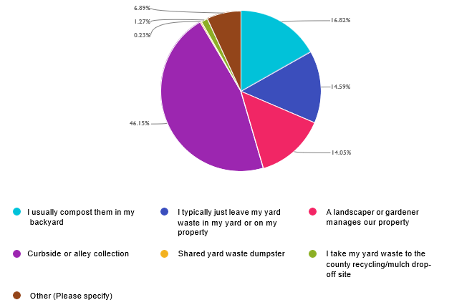

Choices | Response percent | Response count
I usually compost them in my backyard | 16.82% | 437
I typically just leave my yard waste in my yard or on my property | 14.59% | 379
A landscaper or gardener manages our property | 14.05% | 365
Curbside or alley collection | 46.15% | 1199
Shared yard waste dumpster | 0.23% | 6
I take my yard waste to the county recycling/mulch drop-off site | 1.27% | 33
Other (Please specify) | 6.89% | 179

Other (Please specify)
- we use a landscaper that leaves significant yard waste to overwinter and composts the rest
- I store some yard waste in my yard that will easily compost but let the City of TP pick up invasive waste at the curb
- Condominium composting
- I dont have any
- Bagged and set out for pickup
- HOA landscapers cut grass
- Grass usually stays in the yard, yard waste - leaves that don't mulch with mower and sticks, curbside or to county dump/recycle
- mulch grass clipping back to yard put large branches into paper recycling bags after breaking up
- n/a (apartment)
- no yard
- Grass clipping stay in yard. Weeds and Fall leaves go to curb. We compost rest
- Curbside for initial onslaught of leaves in the front yard. Backyard leaves I leave.
- Curbside compost pilot program
- landscapers at high rise
- A combination - I use a mulching mower, put some of my leaves in a device that the County provided me, put some in a composting bin that I put ALL my food waste in, and put everything else on the curb.
- No yard...
- Curbside and also backyard composting
- N/A-Condo Resident
- Compost or burn
- clippings are mulched into the grass, some leaves are mowed into grass mulch, large bulk is collected curbside for county composting
- landscaper removes it
- Branches I cut and use in fireplace/Lots of sticks I put out for recycle
- Not specified
- Mulch leaves with lawn mower.
- do not have a yard
- Huglkulture & mushroom to break down wood
- Combination of mulching mower, composting and curbside when there's too much
- compost in wooded area near my backyard
- Curbside collection by County
- Done by condo mgmt
- Combination of compost and curbside
- Not specified
- No
- i do a combination of curbside pickup and composting in my yard
- once a month I put yard waste on the curb for collection
- Grass clippings and some leaves are mulched, branches are collected.
- I live in a high rise bldg with no landscaping.

- Grass stays, leaves get picked up 2/3x in fall by a service
- Mulch grass and leaves. Curbside collection for branches
- A mix of composting and curbside. I’d happily compost all, but volume is too much. I already have 3 compost bins.
- I live in an apartment
- I compost a lot, and also rely on county pick up for larger and medium sizebranches
- Both, curbside for branches, compost for leaves and grass
- no yard
- Bag grass & branches for curbside collections, but compost leaves in my backyard
- Not applicable
- curbside pickup and backyard compost
- Private company
- We do not have County pickup and must pay for private removals.
- I will leave some on the yard but most are put out on the curb.
- equal curbside and compost
- both compost and curbside pickup
- landlord manage it
- I don't have a yard
- I don't have a yard
- Also use as mulch
- Grass stays on lawn, branches go to curbside county collection. leaves are collected by my homeowner community's management company.
- no yard waste, I live in an apartment
- Sticks and branches go out for curb collection; leaves are raked and left in the yard to compost.
- Compost what we can and curb pickup for larger items
- I use a lot in my yard and leave excess at the curb(need 2 choices)
- Compost and Curbside
- Grasscycle; landscaper removes branches
- The grass clippings are mulched when the grass is cut and when all the leaves fall I have them mulched in the grass.
- Grass clippings are left on the grass. Branches are burned in our fireplace. Some yard waste is put out for curbside collection.
- Do not have a yard where we live
- I do not have a yard but compost any leaves, branches flowers, etc.
- Grass clippings are the only thing we put out curbside. Leaves and branches stay on property
- Does not apply
- Mix of compost and curbside collection (when compost space is full or for wood and weeds)
- I compost leaves, grass and kitchen peels but large things like branches go to curbside
- Leaves get collected curbside; we can't accommodate them. But we leave grass clippings in our yard and consume branches.
- I compost AND use curbside pickup
- I live in a condo building.
- Curbside meaning county collection
- Leave some, landscape company mulches some

- Combo: Most leaves stay in the yard, branches, limbs, Xmas tree broken up into bins for curbside disposalcurbside
- N/A
- I pay for Compost Crew collection of food scraps; I compost yard waste and some food scraps in my backyard compost bin; and about half my leaves are recycled at curbside.
- branches and plant debris - curbside collection; Leaves get shredded and used as mulch for my gardens
- Combination of landscaper, curbside collection and in yard compost
- Mulch leaves and curb side for anything else
- Living in a condo bldg so I don’t have yard waste
- mix of above: curb, landscaper, compost
- mix of leaving on property and removal by gardener
- And leave in my yard
- Front yard leaves - curbside collection. There a huge oak tree close to my property and it's too much to compost
- I both compost and set out yard waste, depending on what is is (leaves and some other yard waste are composted but branches, etc are set out for curb pickup
- P
- Both curbside (pruning etc) and leave on property ( leaves grass)
- I usually compost in my yard, but county picks up branches etc for recycling.
- I also put some in cans for yard pick up
- No yard waste (and why wasn't this an option!)
- I pick up twigs/branches after a storm; leaves are picked up by a lawn service in the Fall.
- No real yard
- Compost in back may not working well
- And starting composting
- Put it out at curb marked yard waste
- n/a
- Burn

Q6

On a scale of 1 to 5, with 5 being "very satisfied" and 1 being "not at all satisfied," how would you rate your satisfaction with your waste collection service.
Answered: 2593 Skipped: 16

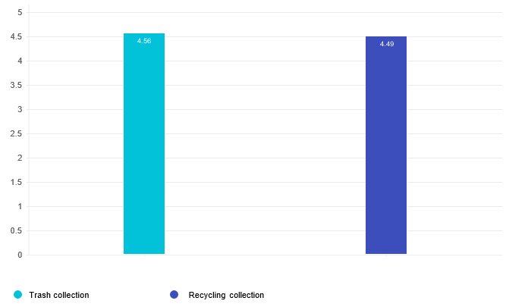
Row | 1 (Not at all satisfied) | 2 | 3 | 4 | 5 (Very satistfied) | N/A | Average rating | Response count
Trash collection | 1.39%  (36) | 0.93%  (24) | 5.64%  (146) | 21.83%  (565) | 63.72%  (1649) | 6.49%  (168) | 4.56 | 2588
Recycling collection | 1.02%  (26) | 1.97%  (50) | 7.82%  (199) | 24.96%  (635) | 63.36%  (1612) | 0.86%  (22) | 4.49 | 2544

Average rating: 4.52

Q7

On a scale of 1 to 5, with 5 being "very satisfied" and 1 being "not at all satisfied," how would you rate your satisfaction with the County’s solid waste drop-off centers?
Answered: 2594 Skipped: 15

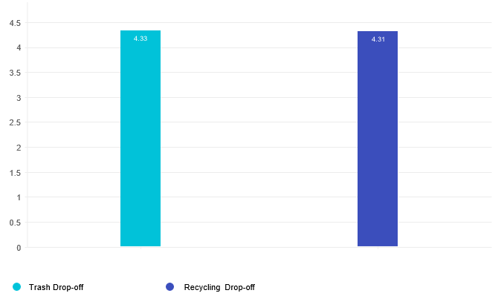

Row | 1 (Not at all satisfied) | 2 | 3 | 4 | 5 (Very satistfied) | N/A | Average rating | Response count
Trash Drop-off | 1.12%  (29) | 1.40%  (36) | 8.57%  (221) | 19.39%  (500) | 36.64%  (945) | 32.88%  (848) | 4.33 | 2579
Recycling Drop-off | 1.22%  (31) | 1.69%  (43) | 8.81%  (224) | 19.63%  (499) | 37.49%  (953) | 31.16%  (792) | 4.31 | 2542

Average rating: 4.32

Q8

Rate how important organic material recycling (food scraps, yard waste, etc.) services are to you on a scale from 1 to 5, with 5 being "highly important” and 1 being “not at all important.”
Answered: 2578 Skipped: 31

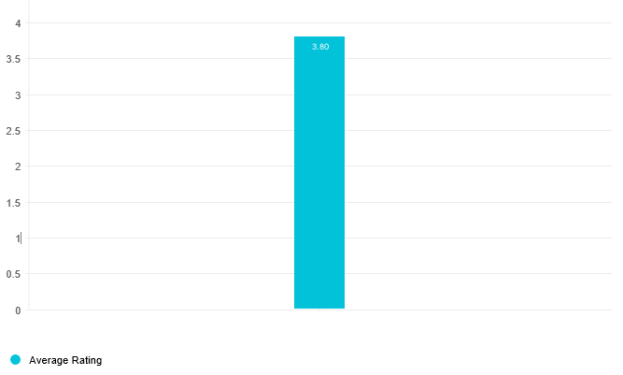
Rating | Response percent | Response count
1 (Not at all important)  2  3  4  5 (Highly important)  N/A | 9.19%  7.14%  17.88%  21.57%  40.42%  3.80% | 237  184  461  556  1042  98

Average rating: 3.80

Q9

Are you aware of the County’s Aiming for Zero Waste (AZW) initiative?
Answered: 2601 Skipped: 8
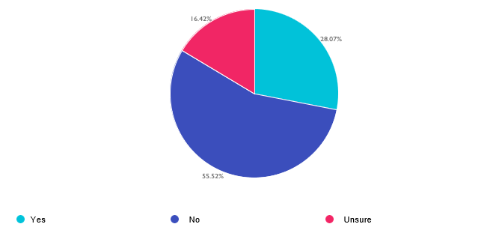

Choices | Response percent | Response count
Yes  No  Unsure | 28.07%  55.52%  16.42% | 730  1444  427

Q10

Do you think Aiming for Zero Waste is good idea?
Answered: 726 Skipped: 1883
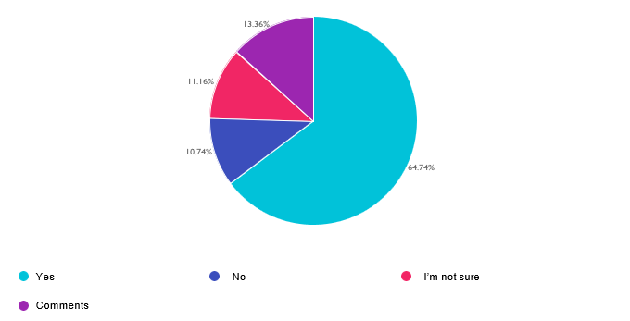

Choices | Response percent | Response count
Yes  No  I’m not sure  Comments | 64.74%  10.74%  11.16%  13.36% | 470  78  81  97

Comments

- Not moving anywhere near fast enough; glad there is more recycling of hard to recycle products eg mattresses, badly used clothes
- We all need to consume far less and reuse more.
- as an idea of course but is not realistic.
- plastic recycling is a waste since very little is recycled
- A survey flaw - not allowing comments to those that want to answer "yes" "no" or "I'm not sure". My answer to Zero Waste is No, not a good idea. I think it is misleading and sets an false goal.
- while might be good, but how expensive to residents?
- Good for a goal but not realistic target for policies
- A great idea but not realistic. People still don't know what does not belong in the small recycling bins!
- Not specified

- Residents should be charged for how much waste they generate
- I think the county could do better. Eliminating plastic grocery bags is fine but there are so many "lite" plastics from vegetables and other groceries. County curb pickup would encourage more people to recycle them.
- Yes - A goal we should all strive for
- The goalIs laudable but I can’t tell if it is feasible and worth the expense
- Will have to read more about it, but am all for zero waste.
- Ridiculous base target-get real
- A lofty goal, but there are many higher priority needs than this Zero Waste initiative.
- The gains will not be worth the cost and inconvenience to residents
- Zero waste is not possible due to the amount of single use plastics used in manufacturing.
- I would like to see the Resource Recovery Facility continue operations to generate electricity from as much waste as possible rather than creating more dump facilities.
- Would love to see more convenient Upcounty food composting & less spillage of recyclables & trash on curb pick-up days
- not sure how well we can get there as a community.
- Definitely a good idea, but there needs to be more education around this in schools and easily accessible resources for implementing this in lower income neighborhoods.
- A good idea that may require additional services
- Not sure "zero" is achievable, but should be minimalized
- The goal is impractical. Making recycling collection widely available will minimize waste, but waste cannot be eliminated entirely.
- Impractical fantasy.
- good idea, yes...possible, not sure
- I think that grocery, restaurant centers, apartment complexes should get compactor dumpsters to reduce waste size and not attract rodents/pests
- collecting food scraps is very important
- Too many people do not follow proper rules for this.
- I'd like to see waste prevention, restricting packaging where possible, say
- Some waste is inevitable. We need to be able to deal with it without making doing so more expensive for residents. It’s a basic, fundamental service of local government.
- Not a practical goal
- Zero waste starts with family values not just municipal enforcement. Education and Volunteer actions goes farther than civil enforcement. Respect, reuse & recycle all go together!
- right now it's not practical, force plastic manufacturers to make plastic that can be recycled, not thrown into landfill.
- I don’t think it’s practical, but rather some measured, targeted reduction in waste or increase in recycling is a more realistic goal.
- Need more options for food scrap recycling
- Mainly a feel good program but not necessary one
- Ha ha!! Funny joke!
- You miss manage so much. A great example is the plastic bag tax. Little to nothing went to the environment and the sale of bags increased every year. Numbers spoke so try not to pimp the earth to fill yours and the county's pockets
- Zero waste- what does that mean? There will always be soem trash, unless we continue to burn and make electriciyt.. that is also recycling
- It’s a good concept, but reality is different.
- I would love country compost pickup as a way to reduce waste

- Yes, but perfection need not be the enemy of the good.
- I am not sure implemention makes sense. We spend a lot of money thinking but rarely are programs well implemented.
- Compost service would be much better overall
- Containers for organic recycling should be distributed to every County household
- Provide food waste composting for all homes in the county, please!
- I don't think residents know about it, though
- it needs to-be a balance
- not practical
- Goals should be achievable — this is very unrealistic.
- County action on most subjects is suspicious.
- Unrealistic
- It's an excellent idea. So why is the compost collection pilot still just a pilot after so many years?
- Seems impractical
- To make it a reality, food waste collection county wide will be critical
- It really depends, a lot fishy numbers happen when hauling out of state because then the county gets to be zero but they are just moving the issue elswhere
- This puts a large burden on many households.
- Zero waste is unrealistic - least long term (20 year minimum) all-in cost which equates to minimum waste feasible with minimum carbon footprint for the entire process.
- Ridiculous to believe that Zero Waste is feasible.
- I compost my own; too many will not drive to compost sites.
- We need to have county-wide composing services and recycle solid waste construction material to reduce the volume of solid waste sent to landfills, at the same time we are closing the incinerator.
- It’s not possible. As long as we continue to lie about plastic recycling, it can’t happen.
- That is a goal that is not at all achievable.
- People will dump wherever, I remember when they dumped in our neighborhood
- This is really vague. What does this actually say?
- So many important issues
- Yes, but needs to be made more convenient for drop-offs.
- Don’t think it’s possible
- Im curious what you do w plastic since most of it is not recyclable
- Its costly and those cast are passed to the tax payers.
- it is unrealistic in this lazy American society
- if the cost is balanced, not the sky is the limit to recycle the next ton
- good goal but impossible to achieve
- Seems like it's a double edge sword
- However the cost to do this should be considered.
- Good aspiration but unrealistic name!
- Good Aim, but extremely unlikely given the amount on non-recyclable materials out there
- Don't encourage rats or stinky sidewalks..
- recycle fat and meat scraps, pet waste?
- Please continue to provide updates online and in local papers

- I would need to know more about the cost and impact. I love the idea of the county picking up my compost as I currently have to drive it on a regular basis to a composting station..
- The ZW goal is a waste of County money.
- Want to see targets .
- A goal of zero waste is not realistic. Set a goal that pushes everyone to make more effort, but that is in the realm of reality.
- Very important to reduce waste, reduce chemicals, recover materials for reuse, and generate compost to capture minerals and improve soil quality.
- Zero waste is not possible; a goal should be reality based.
- Zero waste is not achievable.
- There is no such thing as zero waste. Go back to the goals that were realistic, achievable and pushed people to do more.
- Zero waste is not possible. There is always some level of waste.
- It's not realistic to think that there will be no waste at all.
- Zero Waste isn't likely; it's like the Paperless Office was in the 1990's -- and no one ever talks about that anymore.
- doesn't seem to be something that can be accomplished
- Doesn't seem realistic.
- Absolute zero waste isn't possible.
- There's no such thing as zero waste.

Q11

What do you think would be a better idea than Aiming for Zero Waste? Please add your ideas for supporting Aiming for Zero Waste or new program ideas the County may not have considered.
Answered: 42 Skipped: 2567

- You should really take a hard look at the Placer County, CA, approach to waste and recycling, which is designed to make waste disposal easier for residents while ensuring high-volume, efficient recovery of materials.
- Providing the most effective waste collection at the lowest cost to residents and taxpayers.
- Zero is not possible. Not everyone cares about your thinking too high of a goal. Just to say it too look impressive. We were doing clean burning. Why did we stop. Bad decision!!
- Lowering waste is a fine goal but zero is not worth the cost. Make companies pay for their packaging. Make Costco accept clearly marked packaging return/drop off.
- Send the trash to some rural area. Pay them off.
- Curbside trash, recycling, and yard waste pickup. Curbside bulk trash pickup 5 times a year. Don’t waste money on anything else.
- You cvall it zero waste - I call it the County Shell Game
- Zero waste is a nice goal but we need to find less costly options
- Land fill or burn waste
- maximize recycling and composting, make it easier to discard "non regular" items without requesting special collection. Educate school age children on how to handle waste
- Burn it, bury it, or ship it elsewhere. Zero waste is just another slogan for all the money wasted on climate
- I believe closing the incinerator, which creates jobs, produces energy, and makes money in order to pay to ship it somewhere to sit in somebody else's neighborhood and turn a profit into a huge deficit is ignorant and typical of the wastefulness of MC. I imagine some politician's friends will get the contract to haul it all away.
- There is no such thing as zero waste in a modern society. But more trash and recycling drop off points would be good as the current trash drop off in Gaithersburg gets very backed up with traffic.
- It seems an impossible goal.
- It's unattainable in a COUNTRY (not just our county) where nearly everything is disposable.
- Set realistic goals that reduce waste. Also provide incentives such as charging per bag
- Zero waste is an impossible goal. Trash is always going to exist. Agree with maximizing effect of composting and recycling though.
- "Zero" is an impossible target.
- To be realistic and try to reduce waste but recognize that zero waste is likely very costly, not practical, and dirty/unhealthy as waste will continue to be produced, it just won’t be disposed of properly.
- Keeping costs affordable and not wasting money and effort on liberal nonsense like this county always does.
- Making it so people can actually afford to live here.
- Rfr
- Zero waste is not a reasonable civic / governmental goal in the real world.
- Come up with new solutions for existing waste sources.
- Enough is enough with your bs ways to tax us and control us as in totalitarian regimes
- Common sense approach. The idea shows a lack of logic and reality.
- Landfill. County management is only concerned with self opinion not the general public
- Modernize and increase capacity for the Dickerson incinerator and add co-generation capacity. Allow solar farms in portions of the county's agricultural reserve.
- Need to be realistic, don’t set unrealistic goals and then go too extreme to try to reach it.
- free trash collection for the entire county. not just for low income neighborhoods

- Aim for education about how to reduce food waste; safe composting to manage critter control.
- A balanced approach that understands that pursuit of "zero" is never a viable approach in the real world.
- Just pick up the trash.
- Carry on with the current, timed-tested program. Update & improve as necessary (which should have been a continuous project not an afterthought). Think realistically: zero waste is an idea, not an absolute and not achievable. What are you doing with medical waste, animal feces in baggies, waste from compromised/infectious individuals, tainted food, etc. Bury this hazmat in backyards to contaminate soil & water? What about commercial enterprises? A start: stop accepting Washington, D.C.'s trash.
- Using the money for much more important matters would be a better idea. The County has some deep seated issues. We are loosing our tax base, education outcomes are in decline, infrastructure is suffering, we can't get new police offering to accept positions in the county. The county already has a robust recycling and trash management system. Resources are finite. The state has a budget deficit, many models predict the same for the county. Let's apply these resources to the big issues we face. Solid Waste isn't one of them.
- One can’t have zero waste. It’s an idiotic concept!
- Organic separation and treatment should be implemented here in the County out near where the incinerator is. That's the ideal spot.
- Zero waste is misleading and not truly possible to achieve without significant impacts to the economics of the county. Sustainable consumption with an emphasis on not overbuying or overconsumption is a better approach. Policies that promote reducing restaurant food waste for example
- Having attainable goals is better than trying to shoot for a goal that is impossible. I'd prefer having more recycling programs (split stream recycling for glass, aluminum and plastic, rather than lumping them all together).
- If you can do it for no additional taxes or cost and no impact on convenience. Go for it. But the “green” initiatives of this state and county are killing us. Electricity is outrageous. We have a high gas tax….not to mention big property taxes and now you want another initiative that will no doubt be costly to me in one way or another. I think the count has other priorities.
- it costs taxpayers money to recycle - just to use the material once more, please stop! and be honest about what it costs and what we get for the cost. Its not realistic to aim for zero waste and creates an undue burden on people who pay A LOT of money in property taxes and all other MOCO, State taxes. Retiring in 4 yrs, looking for our new state to move to now for the reason of TAXES! My dad's family has been in MOCO for 6 generations- we pay through the nose and services get worse. How about repaving streets that are in terrible shape instead of putting little patches on them? Why do other states do this and collect less taxes CUT SPENDING NOW. End
sanctuary policies, stop drawing illegal migrants here to this county with massive social services! And dont say that they done qualify, I work in the field and see it daily. That would save us millions. As a high tax payer, I wish I could retire and leave now.
- Keep the Resource Recovery Facility (RRF) up and running!

Q12

Are you aware of the County goal to close the Resource Recovery Facility (RRF), also known as the Incinerator or Waste-To-Energy Facility, in Dickerson, Maryland?
Answered: 2600 Skipped: 9
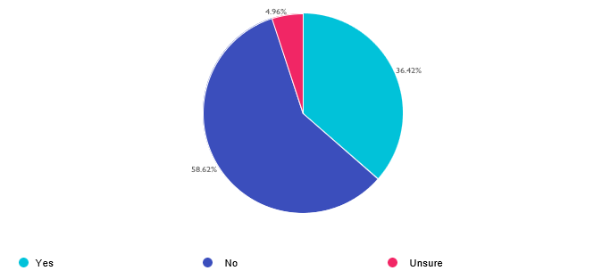

Choices | Response percent | Response count
Yes  No  Unsure | 36.42%  58.62%  4.96% | 947  1524  129

Q13

Do you think closing the Resource Recovery Facility is good idea?
Answered: 947 Skipped: 1662

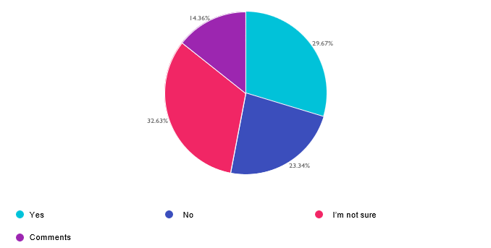

Choices | Response percent | Response count
Yes  No  I’m not sure  Comments | 29.67%  23.34%  32.63%  14.36% | 281  221  309  136

Comments

- Yes, I think it’s a good idea and I’m using this comment box to tell you that you don’t have my ZIP Code in your selections it is 20837 outside of the town of Poolesville and the agricultural reserve
- Please stop poisoning my family with this facility
- Unless it’s costing us money, leave it open.
- If sustainable and cost effective
- Not until all options have been explored. An updated system would be preferable.
- Yes, the incinerator is a significant environmental concern. It is also badly in need of repair to keep functioning. It should be closed as soon as possible and the county should expand its zero waste initiatives.
- Absolutely. It should have been closed years ago once the debt was paid off and the county was entitled to ownership. I am upset how long it is taking.
- It is unsafe and polluting. Careful landfill site selection is less polluting.

- Not sure since it depends on 1) effective segregation of trash fed to RRF 2) precautions to eliminate/reduce emissions 3) RRF process clean
- It produces high carbon & greenhouse emissions
- If the gas used to ship the waste out doesn't cause more pollution then yes
- It totally depends on what is going to happen to the trash instead of it going there. Closing it just to be closing it is stupid.
- Greatly reduces the volume needed to transport. Glad we control the emissions.
- ⁸
- Depends on how efficient the facility is at scrubbing the pollutants produced
- Erlich said he would
- I don't know how much energy is produced by the incinerator, vs the amount of damage to 5he environment.
- It’s required by law
- Terrible idea, we used to care about turning waste into energy, just like we used to care about saving trees before going back to paper bags
- No, I've been to the RRF; it's a win-win solution - waste is not buried but turned into useful energy. No extra financial costs incurred sending waste out of county. It's elitist, pawning it off to others to deal with.
- What is the in county alternative?
- The facility is bad for its neighbors, so I would say yes, close it. But putting all this trash, including what must be mountains of soiled diapers (baby and adult) into a land fill plus all the other trash is not appealing.
- Been waiting on this since 2016
- Don’t do it.
- I think we have to do something with ALL the trash. Burning the trash is better than burying it somewhere, I'm not surThe facility that burns the trash should be STATE OF THE ART meaning the least amount of pollution emitted into the atmosphere.
- No. Waste should be productive, like incinerating it, instead of collecting and amassing huge quantities in places that will as a result never be habitable - even if those places are not within the county.
- waste to energy is better than burying trash
- Dumping the burden on households is a terrible idea. Do not cancel incinerator, build a better one. Landfills cost a fortune!
- Efficient and generates energy - Alternative?
- Incineration is one of the most efficient ways to dispose of large quantities of trash.
- It’s probably a benefit for the air quality & those who live near it. However, it will increase the demand on landfills.
- Do it already please, taking too long
- But what alternative will replace the existing facility
- Yes as long as it does not mean trucking waste to another area outside of Montgomery Cnty
- This particular facility makes it so we do not need to store our trash or send our trash elsewhere. Closing this seems to have one outcome: What do we do with all our trash. How is BURYING it or THROWING IT IN A LANDFILL good for our environment?
- Probably right to close it but it seems like there may be a way to operate it without all of the negative impacts.
- I need to learn more.
- It can be closed only if there is a viable alternative which does not add materially to the expense and is not ecologically more damaging.
- Don't know ROI
- I don’t think a good alternative has been found
- Can incineration be made safer?
- As above. Irresponsible and ignorant.

- I think it could be very polluting, but I don't know. I also think with proper pollution prevention, it could be a sensible way to regain some energy. but it's making the best of a bad system, diverting waste would be better
- yes, but... not sure there is another good option
- then what
- It's in the AG reserve-Dickerson, near potamac River
- We have to close the incinerator, as it is leaking unsafe amounts of dioxins and is too old.
- Concerned about leaking chemical, gases
- Reducing waste that ends up in landfills and the ocean is really important, and this facility helps with that goal while generating much needed electricity for the already strained grid. I do not support its closure
- Burning trash creates its own issues.
- I don't think it is wise to close off any avenues for disposing off waste right now. It is impossible to get a new incineration facility in Maryland, fix the one we have not close it.
- There is no viable alternative that doesn’t increase environmental damage and injustice
- Why is it taking so long to stop this dangerous practice??
- It generates electricity that you force us to use. The fuel source is something that comes from MC. How are you planning to replace the energy generation? Think of the gas refineries in CA.
- Local solution BUT sadly not well maintained
- It pollutes our air
- Just don’t turn it into a data center
- I believe it was reckless to not maintain this facility, or replace it sooner, because of politics.
- Closing isn't a good idea if it means shipping our trash elsewhere.
- don't understand the alternatives
- Yes, provided the money savings are used to help reduce waste streams and disposal at another site is held to the same high standards that MoCo observes.
- Considero que los hay muchos ingenieros , y científicos capacitados en temas ambientales, y si se diera la posibilidad de encontrar varios que donen su tiempo
- If it's not broken, don't fix it.
- If the polution is as bad as reported, closing is a good idea
- Not fully aware of the reason to close.
- How will this affect small businesses doing tash pickup??
- depends on the back up plan
- The emissions make me nervous
- I'm in favor of upgrading and expanding use of the incinerator, even if it means increased taxes.
- I feel really bad for that community that is being poisoned by burning trash but I don't know how you fix it.
- Closing it will be way, way too expensive, especially now that we have no money in this county!
- I’d rather burn it CLEANLY than bury it in a landfill.
- Stopping the pollution is, yes, but can we convert the RRF to return its own smoke? While we wait, wait, wait for this elusive goal.
- It depends on the alternative?
- I am not sure because I thought the incinerator provides electricity and allows for metal to be recovered.
- burning provides electricity - just keep developers & buildings away from the incinerator so people are not harmed
- Need to find the best environmental solutions that do not produce airborne emissions.
- Other options are not good and expwnsive. Also we need all the energy we can get.
- the alternative of transporting trash to someone else's back yard and the cost of doing that is daunting

- its not hurting anything
- Not necessarily, land fills are also major pollutants. I think a strategy that uses all options and pays more attention to treating the waste stream and properly treating and distributing it would be best.
- Repair or build new
- What will happen to couty waste if the Dickerson site is closed?
- Most definitely!!!
- Creating energy sounds great but not if they continue to violate the pollutant and dioxin levels.
- Yes but only if it can be replaced with something that uses renewable energy to get rid of waste somehow
- Not specified
- I think it is time for replacement. I am not aware of any proposed alternatives that will support the AZW and current needs. The facility maintenance and operational challenges need to be addressed.
- I do not think it is a good idea. The idea of no long haul is great. You are not moving your emissions to other areas
- depends on the cost and i will like to get yearly report
- It's toxic the sooner it can be closed the better
- I don't know enough about what we would do with our waste if it closed
- What are the alternatives?
- Not if it is going to cost more for residents.
- Yes, if appropriate alternatives are achieved
- We need a solution that is safe for the earth and residents.
- Not until there is a viable alternative
- It is toxic , please close it alreadyb
- Where will we bury our trash?
- The incinerator is old, it fails emissions tests, and it is going to get more and more expensive. Close it and landfill the County's waste.

Q14

Rate how safe you believe the Resource Recovery Facility is, as a way to manage our waste in the County on a scale from 1 to 5, where 5 is "extremely safe" and 1 is "extremely unsafe." Consider 3 to be neutral.
Answered: 2558 Skipped: 51
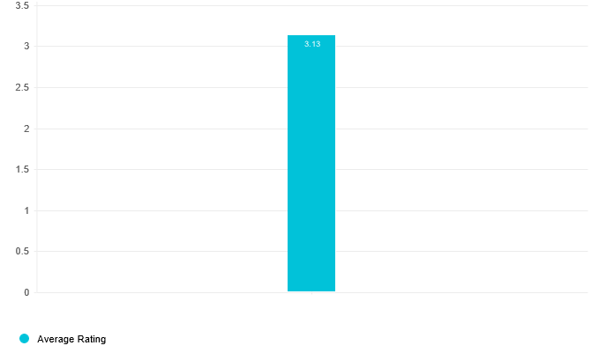
Rating | Response percent | Response count
1 (Extremely unsafe)  2  3  4  5 (Extremely safe)  N/A | 6.65%  8.56%  33.31%  12.39%  9.30%  29.79% | 170  219  852  317  238  762

Average rating: 3.13

Q15

Rate how effective you believe the Resource Recovery Facility is as a way to manage our waste in the County, on a scale from 1 to 5, where 5 is "extremely effective" and 1 is "extremely ineffective." Consider 3 to be neutral.
Answered: 2544 Skipped: 65
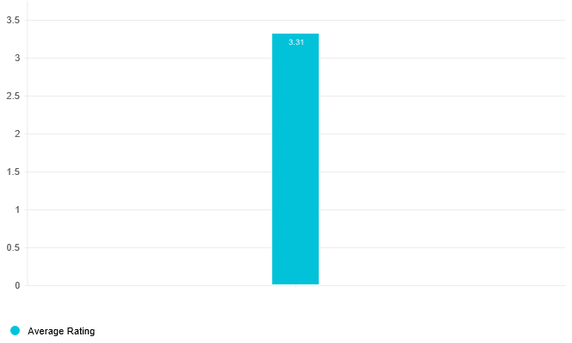
Rating | Response percent | Response count
1 (Extremely ineffective)  2  3  4  5 (Extremely effective)  N/A | 5.27%  6.92%  32.86%  13.88%  12.81%  28.26% | 134  176  836  353  326  719

Average rating: 3.31

Q16

Which of the following best describes how you feel about the County hauling your waste to another state for disposal in an out-of-state landfill.
Answered: 2576 Skipped: 33
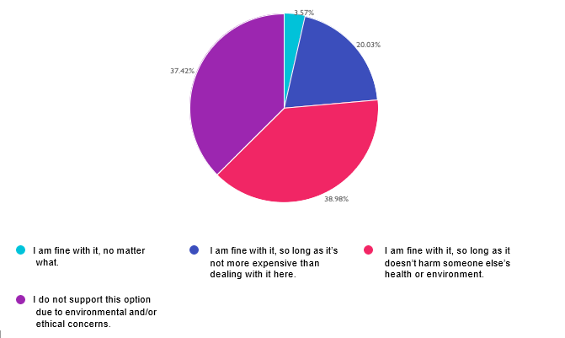

Choices | Response percent | Response count
I am fine with it, no matter what. | 3.57% | 92
I am fine with it, so long as it’s not more expensive than dealing with it here. | 20.03% | 516
I am fine with it, so long as it doesn’t harm someone else’s health or environment. | 38.98% | 1004
I do not support this option due to environmental and/or ethical concerns. | 37.42% | 964

Q17

Which of the following best describes how you feel about building a new landfill in Montgomery County?
Answered: 2561 Skipped: 48

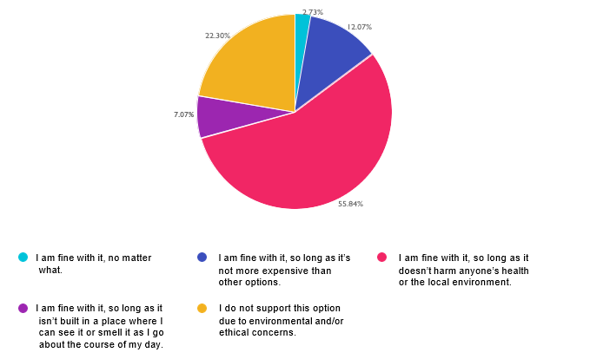
Choices | Response percent | Response count
I am fine with it, no matter what. | 2.73% | 70
I am fine with it, so long as it’s not more expensive than other options. | 12.07% | 309
I am fine with it, so long as it doesn’t harm anyone’s health or the local environment. | 55.84% | 1430
I am fine with it, so long as it isn’t built in a place where I can see it or smell it as I go about the course of my day. | 7.07% | 181
I do not support this option due to environmental and/or ethical concerns. | 22.30% | 571

Q18

Some residents are putting non-acceptable items into recycling bins, which contaminates the recycling stream and drives up costs. How do you suggest we get residents to recycle correctly? Check all that apply.
Answered: 2575 Skipped: 34
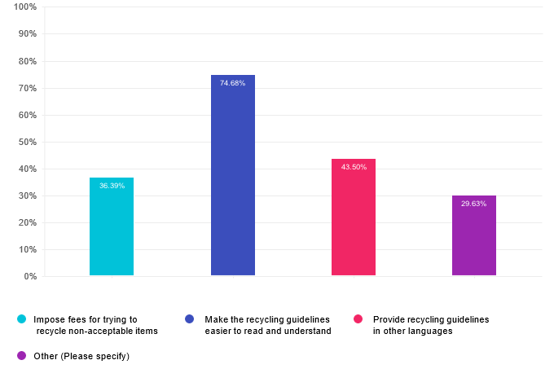

Choices | Response percent | Response count
Impose fees for trying to recycle non-acceptable items | 36.39% | 937
Make the recycling guidelines easier to read and understand | 74.68% | 1923
Provide recycling guidelines in other languages | 43.50% | 1120
Other (Please specify) | 29.63% | 763

Other (Please specify)

- Community volunteers. Bring back mini recycling stations with more sorting options. Do special drop off days at known locations for things like scrap metal.
- Collect recyclables in shared areas. This makes putting non-acceptable items in front of other neightbors less an appealing idea. Plus, people will meet and share this knowledge about recycling.
- Don’t punish for incorrect recycling. Provide better guidance and reward for good recycling

- key guidelines printed on bins
- Institute a Pay/Save as you Throw system which provides incentives for people to reduce their waste and increase their recycling.
- Single source recycling. It’s done in other counties and makes recycling more straightforward.
- Notify household with warnings before fees
- Refrigerator magnets with pictured guidelines
- Hire more people to sort through recycling, or just get rid of it.
- Make recycling easier and more convenient by switching to "mixed recycling" (as in paper, plastic, etc can be mixed together in the same recycling bins) as is done in other counties such as Frederick County.
- Public outreach like pamphlets and videos. Get grocery stores to help too by specifying what can go in where. And for the love of God, BOTTLE DEPOSITS AND RETURNS like every other civilized state
- I’m worried fees will discourage recycling. But I like the idea for extreme cases. I think finding a way to educate people properly will be most helpful.
- Stickers--big ones with clear images--of acceptable items that can be put on the bins to help customers presort properly
- There will never be an effective way bc people won’t listen
- Don't bother
- I’m
- Spend more resources to clean up recycling steam
- You waste so much money. If you can do anything for free, try it and I'll contribute. Raise our taxes and lie, I'll throw it out and continue to treat the taxes you charge me as fees and you clean up the mess.
- only collect recycle items that actually get recyled.
- Stop changing the guidelines all the time
- Educate kids and incentivize them to pass on to their parents
- Do all the checked boxes above on social media and local TV news stations.
- expand what is accepted; improve recycling technology, capacity, and safety
- Do not pick up recycling with non-acceptable items
- Continue to use labels (in different languages)explaining why a bin was not picked up
- better and more educational outreach
- I like the orange tags on bins with unacceptable items, though people may not know what in their bin is unacceptable. Too much consumption - too convenient to overconsume\.
- If possible to track, impose fees to the resident that are not correctly recycling
- Frederick Co. promotes, "if in doubt, throw it out." Is this practical in MCG? Fees may discourage recycling.
- Be much more transparent about recycling, especially plastic
- Put pictures on the bins
- 1. More communication: e-mails, flyers. 2. Do not pick up curbside bins that have non-acceptable items.
- Teach children in schools, and they will educate their parents
- EDUCATION at the schools. I will suggest more education at the school age level. There is nothing in the MCPS curriculum about Montgomery County waste management and recycling program and goals.
- Enforce and educate on current published educational pieces.
- Make it clear which products are truly being recycled Which plastics..etc
- Leave notes for the residents when recycling collectors find unacceptable items
- question can't be answered with further info, corporations need to be more accountable
- work with MCPS to include in curriculums.
- Make us single stream and county sort everything, like other developed countries do

- Publish the recycling guidelines all over the place, all the time.
- Stop with mixed recycling and switch to separated recycling (ex. Glass, cardboard, aluminum) - also introduce a bottle bill
- Always include photos of recyclables and non-recyclables
- Providing context is important, so provide information on what happens when the recycling stream is contaminated.
- Advanced Waste Sort if possible
- Warning signs directly to residents’ bins.
- Not sure this is possible. There are pamphlets, etc about what's recyclable but people don't seem to notice/care
- Better outreach and monitoring. Haulers pick up almost everything regardless of condition
- Do sorting at the facility
- Don’t collect if filled with incorrect items
- Don’t collect from bins with obvious unacceptable materials, and leave a sticker explaining why
- Recycle many more types of items
- Provide looser guidelines. Figure out how to recycle plastic bags.
- Provide pick up for hazardous waste for seniors unable to get to the dump
- Not specified
- take all recycling and create a program for zero waste and a way to recycle just about everything
- Not specified
- put the numbers for recycling on recycling containers. put what not to put in paper containeers
- You shouLook at the Placer County, CA, approach.
- In some areas, an agent comes around and spot checks recycling bins. that agent can write tickets and talk to people.
- Do not pick up and leave a note as to why
- Fees from the trash AND recycle stream (e.g. Europe). Also Europe charges a LOT for trash bags. We also could do bottle buy backs like MI, NY and others do. Adding stickers to recycle bins of simple to understand things.
- Single stream and presort
- Publicize more
- I have lived in cities abroad (in Japan) that truly put us to shame. I'm sorry we can't all seem to comply and think that fees could help. Guidelines should have pictures and at least Spanish and English, if not also Amharic and French.
- Train the collectors to take what is accepted rather than leave everything if there is one incorrect item.
- Provide labeled containers
- One source recycling co-mingled like Howard County
- First, a warning. Then a fine for repeat offenders
- People are doing the best they can, leave them alone.
- Don't take the container and leave a note.
- Figure out how to separate and recycle more products so there aren’t unacceptable items
- City of Rockville
- Don't pick up bins
- Expand what is recyclable to meet the expectations of the residents
- Hard to say as I’d need more info on the issue
- Put a notice on the recycling bin in a bright color with why it is not compliant. I have seen this done in other countries and areas.
- Just deal with it!!

- Reject unacceptable items
- Not specified
- Is recycling actually happening at all or is it a myth that makes us feel good
- don't pick up such items, even skip the whole bin
- Offer the guides as a magnet that can stick to the trash can or fridge
- All of the above
- Public affairs info—in Clipper flier, ads at bus stops or on busses, in local newpapers. Stress what NOT to include.
- Don't accept recycling that is not properly sorted or has obvious contamination and educate residents by leaving stickers on trash bins.
- Put labels on bins like "No paper", etc.
- It’s better to be able to recycle fewer items but be clear do those items aren’t contaminated rather than allowing a lot but being too complicated so the whole batch is ruined
- Provide curbside collection for these items, and make the beauty spot accept everything
- Teach it in school!!
- Don’t pick any up if wrong things are included. Leave a notice.
- mail information about recycling guidelines to all residents
- Have preprinted cards/notes that could be left in bin to educate people on what is not ok in the bin
- Require training as you do a drivers license
- Signage on bins
- Make more items recyclable. Make it easier for residents.
- Fees for companies who do not clearly print recycling information or try to appear recyclable when not
- End the recycling program
- Take the unacceptable stuff out and leave it on their property
- Leave it with tag saying to seperate comingled items

Q19

Do you know how Montgomery County funds its trash and recycling services?
Answered: 2593 Skipped: 16
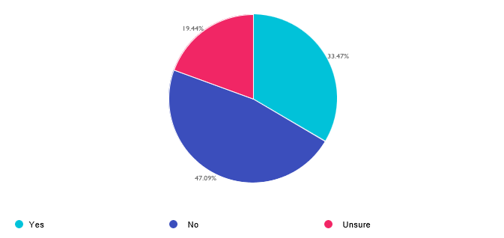

Choices | Response percent | Response count
Yes  No  Unsure | 33.47%  47.09%  19.44% | 868  1221  504

Q20

Which of the following best describes how you pay for trash and recycling services:
Answered: 863 Skipped: 1746

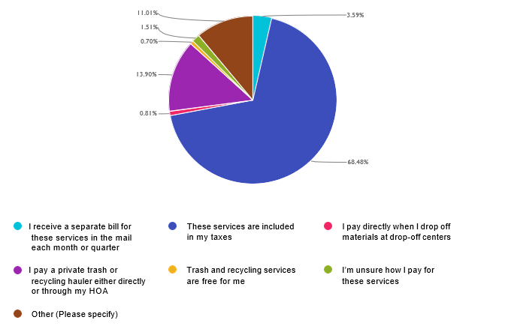
Choices | Response percent | Response count
I receive a separate bill for these services in the mail each month or quarter | 3.59% | 31
These services are included in my taxes | 68.48% | 591
I pay directly when I drop off materials at drop-off centers | 0.81% | 7
I pay a private trash or recycling hauler either directly or through my HOA | 13.90% | 120
Trash and recycling services are free for me | 0.70% | 6
I’m unsure how I pay for these services | 1.51% | 13
Other (Please specify) | 11.01% | 95

Other (Please specify)
- pay for trash and county collects recycables
- I receive a separate bill for trash, but recycling is included in my taxes
- With Property taxes
- It is covered in my condo fees and I still have to pay the multifamily building fee with my property taxes
- Through a line on property tax bill with a limit on free annual large item curbside pickup and I pay separately for county pick up of curbside fall leaves
- These services are included in my taxes. However, I put out a bag of trash once a month, and recycling about 2X per month. I think we need pay as you throw, and I did not see a place for comments about that.
- I also pay at transfer station for large loads
- Trash services - pay a private company. Recycling services - country includes in taxes as a separate itemized line item.
- I pay a private trash service, and recycling by the county, paid by taxes.
- recycling and general transfer station fees through taxes, trash collection through my hoa
- I live in Takoma Park, which does its own trash/recycling services, hence my N/A responses to some of the previous questions.
- Private trash hauler paid directly; recycles paid through my property taxes
- I pay for a private service but also pay for others to have there picked up by the county, LOL!!
- I receive recycling services through the County and pay for private trash pickup
- Pay a trash hauler quarterly, no fee for county recycle pickup.
- solid waste service fee appears on property tax bill as a fee-for-service line item
- Private trash,county recycling
- Not specified
- Recycling is on property tax, trash is private pay
- The county collects my recycling, which i contribute to , through my taxes. I Also pay a private trash collector for my non recyclable material.
- Property tax; pay third party (landscaper, etc) to Jo drop at collection site
- we pay for trash pick up but recycling is paid for by taxes
- I pay for private trash and county taxes for recycling
- Our recycling services are paid for by our homeowners property tax
- I live in an apartment so I assume it is part of my rent.
- We are taxed and I pay for trash hauling.
- recycling by taxes but I have private trash collection
- City of Rockville includes with W&S bills
- recycle services incl in property taxes - commercial vendor for refuse
- I pay a company for trash pickup and I pay for county recycling which is a waste of money get rid of it
- Recycling in tax bill, trash as HOA fee
- Private trash, recycling on my taxes
- Property tax
- I pay for trash. Recycling is free
- We pay a private trash company, and our taxes pay for recycling
- Taxes for Recyc / Pay Titus for Trash
- Private trash service for condo and in taxes

- Tax dollars ; but also included in the WSSC quarterly bill.
- Recycle = free/taxes but garbage/trash billed by HOA
- It is NOT included in my taxes, tho it is a fee I must pay as part of my property tax bill. Big difference. Who wrote these answers? You can’t deduct solid waste fees from your income tax as part of your property tax exemption
- I pay for recycling in my property tax and for trash pickup to a private company
- I pay for the existing infrastructure now and earlier. Plus, now I also pay a separate community fee.
- pay private trash service, use county curbside recycling and yard waste pick up
- Solid waste charge on property taxes
- I only get Recycling in my taxes
- I pay private trash hauler and recycling costs are included in property taxes
- We pay a trash collector AND fees included in our property taxes. The County does not pick up trash in our community.
- it's with property tax bill
- I pay for MoCo services through my taxes. I pay out of pocket to compost and recycle materials not accepted by local govt.
- Pay private trash pick up and use county pick up for recycling. I still get charged for solid waste pick up on my tax bill even when the county doesn’t offer it to me
- I pay a private trash company pick up my trash and I am billed for recycle on my tax bill.
- I have to pay for private trash collection but our recycling is provided by Montgomery County through taxes.
- I pay a private company to collect my trash; the recycling services are included in my taxes
- Recycling thru taxes; trash thru direct payment to private trash hauler
- Recycling is part of my property taxes, trash is through a private hauler
- recycling paid w. property taxes &trash pail directly to Titus
- Trash service is provided by a private company that I pay each quarter and recycling is provided by the county.
- Included in my condo fees
- Private trash hauler and my taxes
- Taxes for recycle; HOA fee for trash
- I don't have time to look it up how much. You know.
- I paypickup for county recycling program and its services such as weekly recycle and yard waste pick ups via my annual property tax. I pay out of pocket for private trash collecting company for weekly trash puckup.
- I pay a private firm through my retirement community.
- I have to pay for private trash, but get county recycling and organic pickup
- pay Titus separately and taxes for recycling county
- Property owners pay the most
- I pay for private hauler for trash; pay county for recycling and yard waste
- I know the is a charge in my Property Tax, not sure if therre are other costs in my Income Tax calculation.
- Recycling is included in my property tax bill. I pay for private trash collection through my HOA
- I pay a private trash hauler, but the county collects my recycling, which I pay for in taxes.
- Pay for private trash and receive County Recycling
- I pay for trash quarterly and receive a bill for recycling as part of my property tax bill.
- in nursing home,, prior to that, through rent.
- I am in the City of Rockville
- I live in a town that contracts for trash & recycling pickup
- I pay an extra yearly fee with my taxes

- Property taxes specify; not looking it up for survey
- annual "Refuse Billing"
- I live in Rockville city so my trash bill is part of the water bill
- Is pay though HOA fees
- I pay for certain trash and recycling services in a User Fee, which is delivered as a separate charge, in the same bill as my taxes. I pay for my own trash collection because I have to hire my own trash collector.
- I pay for trach pickup through my HOA; I pay for recycle services and trash disposal in my taxes.
- These are paid through the solid waste User Fee I pay, which is NOT a tax but a user fee. I pay for trash collection separately on my own.
- Pay a solid waste charge that is a line item delivered on the annual tax bill.
- There is a fee for solid waste services that is a line item on the annual property tax bill.
- We pay a User Fee for Solid Waste. It's a line item in our property tax bill sent every July.
- Pay an annual user fee for solid waste.
- There is a solid waste charge that's listed on our tax bill.
- There is a line item for solid waste in the property tax bill mailed each year.
- There is a solid waste charge listed separately on my tax bill each year. I pay for collection of my trash and recycling in my condominium fee.
- Solid Waste user fee
- We pay a solid waste charge delivered on our tax bill each year, and we pay for trash collection separately to hire a trash company.
- Charged a user fee for solid waste and I pay to hire my own trash collector.
- Solid Waste User Fee
- Solid Waste charge delivered on the property tax bill as a matter of delivery but not part of the property tax

Q21

How much do you pay annually for trash and recycling services?
Answered: 2581 Skipped: 28

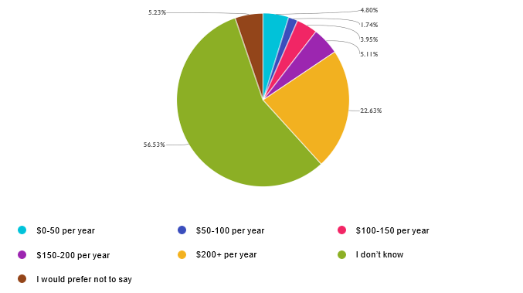

Choices | Response percent | Response count
$0-50 per year | 4.80% | 124
$50-100 per year | 1.74% | 45
$100-150 per year | 3.95% | 102
$150-200 per year | 5.11% | 132
$200+ per year | 22.63% | 584
I don’t know | 56.53% | 1459
I would prefer not to say | 5.23% | 135

Q22

Rate the degree to which you believe the service you receive from the County for trash and recycling is a value for the price you pay, where 5 is "excellent value," 1 is "poor value," and 3 is neutral.
Answered: 2542 Skipped: 67
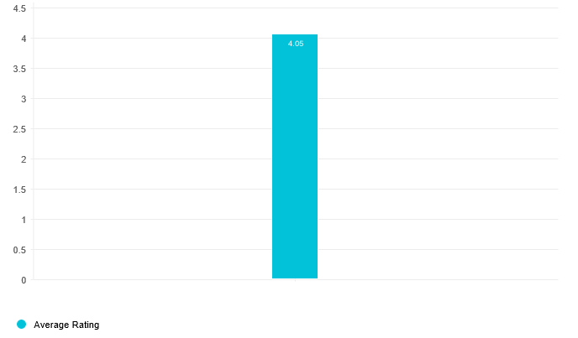
Rating | Response percent | Response count
1 (Poor value)  2  3  4  5 (Excellent value)  N/A | 2.01%  2.60%  21.83%  22.70%  36.94%  13.93% | 51  66  555  577  939  354

Average rating: 4.05

Q23

When something (such as a small appliance) breaks, I am more likely to repair it than throw it away and get a new one.
Answered: 2597 Skipped: 12

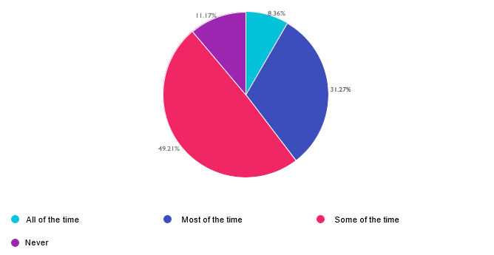

Choices | Response percent | Response count
All of the time  Most of the time  Some of the time  Never | 8.36%  31.27%  49.21%  11.17% | 217  812  1278  290

Q24

True or False - I know how to properly dispose of my Household Hazardous Waste
Answered: 2593 Skipped: 16
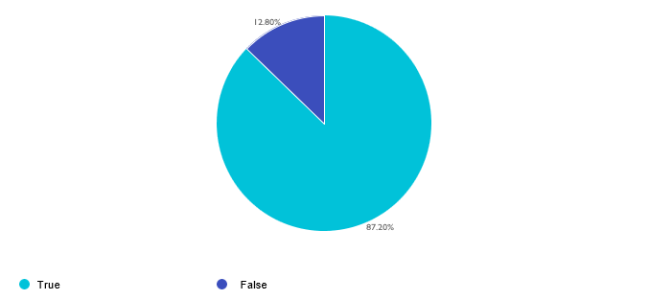

Choices | Response percent | Response count
True  False | 87.20%  12.80% | 2261  332

Q25

Where do you go for information about trash and recycling services in the County? Check all that apply:
Answered: 2593 Skipped: 16

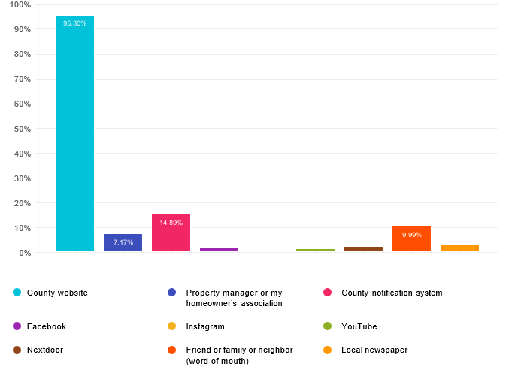

Choices | Response percent | Response count
County website | 95.30% | 2471
Property manager or my homeowner’s association | 7.17% | 186
County notification system | 14.89% | 386
Facebook | 1.62% | 42
Instagram | 0.39% | 10
YouTube | 1.08% | 28
Nextdoor | 1.85% | 48
Friend or family or neighbor (word of mouth) | 9.99% | 259
Local newspaper | 2.62% | 68
Other (Please specify) |  | 245

Local newspaper
- Local news outlets
- Flyer showing items to be recycled via my mailbox
- Not specified
- Leaf collection on mailer
- Not specified
- Olney News
- Washington Post
- Not specified
- washington post
- Not specified
- Not specified
- Rockville Reports
- Not specified
- Not specified
- washington post
- Washington Post
- Not specified
- Not specified

- Beacon
- Not specified
- Bethesda Today, MoCo Show, Banner
- Not specified
- Other neighbors
- Not specified
- Not specified
- Parkwood Residents Assn emails
- Not specified
- Not specified
- List serve
- MoCo has distributed some fliers
- Olney Community Newpaper
- Not specified
- 311
- Not specified
- Not specified
- Bethesda Today
- Not specified
- Not specified
- MoCoShow
- Not specified
- 311
- Not specified
- Washington Post
- Not specified
- Not specified
- mostly county website but others apply in lesser deggree
- Not specified
- Not specified
- I usually receive an email about changes or updates.
- Bethesda Beat
- Google
- I don't see any information
- Washington Post
- Not specified
- Not specified
- Olney Newsletter
- Not specified
- Washington Post, Monocacy Monocle, Banner
- Not specified

- Not specified
- G
- The postcards mailed to my house are effective in terms of keeping me informed about recycling.
- Washington Post
- Not specified
- Call number available
- Internet
- Not specified
- Didn't know the info was on social media

Other (Please specify)

- I would like to opt out of leaf pick up. Why should I pay for this when I compost my leaves?
- MC311
- I don’t really have a good way to get info! Send me info of how to get my info!
- To an earlier question … there can be no value in these waste programs if you are poisoning us with that decrepit, antiquated, inefficient incinerator .. I don’t appreciate trick questions in these surveys
- PLEASE START PAY AS YOU THROW.
- I call Public Works in Takoma Park
- E-mails that the County sends out.
- Google
- Neighborhood email list and council representatives
- 311
- Flyers sent via US Mail
- ⁸
- 311
- I recycle everything at the Transfer station that is accepted. I pay to send other items not accepted to TerraCycle or another vendor who supports recycling. The county should have more common areas for compost and should partner more with companies who are willing to recycle items like styrofoam and plastic. Should charge a fee for waste based on amount- only way to change behaviors. Absolutely should be doing better to prohibit businesses from using non recyclable materials. Where’s the enforcement especially when we have to leave our names when filing complaints, should be a better way to report.
- Neighborhood list serve
- I call 311 and the agent either knows the answer, or knows who will! And I assume my taxes pay for waste pickup.
- Reddit
- Is it feadible to cut collection to once a week. It may have the benefit of reduce, reuse or recycle. California chooses this option
- Brochures and literature from the county.
- Please offer compost pick up in my zip code. I’ve been paying Compost Crew for years.
- City of Rockville
- I call 311
- Shady Grove Transfer Station website
- Mailing of large postcards
- You send recycling fliers all the time or at least a few times a year. Trash you do not do for me!!
- I have many usable and working items, including items I have inherited, that I struggle to dispose of or donate. Others, like old phone charger cords, how are we supposed to safely dispose of those?

- Some products mislead consumers on if material is recyclable. Most instruct to drop off at designated centers. Encourage residents to properly separate packaging components. Provide better weather proofed recycling bins to reduce litter and securely contain items. Don't accept recycling that is not properly sorted or has obvious contamination and educate residents by leaving stickers on trash bins.
- Google
- County mail pieces
- County handouts and guest speakers
- General keyword search on Google
- I ask at the recycling center
- Mi
- 311 and weekly County Internet messages
- By calling 311 and being directed to proper department
- Message
- County mailers
- Your website is EXCELLENT!!!
- call 311
- 311
- Again, educate the public on trash and recycling thru community meetings, drop off materials, notices, posters at bus stops and stores. U need to be noticed and educate the public. No one goes to the County website though it is very thorough and educational. Be in our face as my neighbors are in my face with their left out trash, recycling mixed and left out and trash blown away or the large crows break open the bags. yes they put it out in bags not containers or overflowing containers. Provide county approved trash containers for a reasonable price.
- General Internet search
- None of the above
- Phone the county 411
- 311
- Internet
- 311
- This is in response to question abt sending our trash out of state. I feel each state needs to take care of its own trash. If the incinerator needs to be shut down for health and safety reasons, ok, but what is plan B? Educate the public abt waste and recycling. Incentivize less trash production and more recycling. Credit those who produce less and recycle more and penalize those who do not. Educate citizens abt the consequences of their waste production. Not a fun or pretty discussion but people need to be knowledgeable abt what happens to their trash after it gets picked up. I am not opposed to landfills but we need to be mindful of its harmful effects too. Is there a safe way to burn trash? Is there some trash that is ok to burn? More options needed. More research. This needs to be top priority. Dumping our waste in another state seems irresponsible. We need to manage our own mess.
- 311
- Need more info about coated plastics like organic milk cartons and items like it
- Mc transfer station
- It is frustrating to see how many people don't pay attention to the recycling guidelines.
- Google search
- I only checked never for repairing small appliances because I have found when I have tried to get things repaired I’m told it would be easier and cheaper to buy something new. This is more a problem of capitalism than something the county can do something about.
- Call 311 for info
- I go to the recycling facility in Derwood and ask.
- I don'tknow of any real, up-to-date and reliable source of information on this topic! I rely on privately funded food scraps composting services, as well
- Sometimes I go to a search engine to look it up

- Neighborhood listserv
- Community List Serve
- internet
- county mailers
- Curbside compost service would reduce a lot of waste from our home. I'm concerned about composting in my yard because I'm afraid it will attract rodents.
- 311
- building newsletter
- flyers
- would like to see curbside pickup of compost for food scraps
- Thank you for caring about the environment.
- Neighborhood Listserv
- I have county guidelines on the fridge.
- internet search for 'maryland paint recycle'
- Note: my zip code - 20901 - does not appear as an option in the next question. Please correct this.
- Internet feeds and local news services
- transfer station
- Specifically, email notification.
- County recycling and refuse collection handbook
- Flyers sent out by the county
- The paper fliers sent out to homes are well designed and effective.
- Derwood transfer station personnel
- Telephone
- Please note: the large item recycling was out of commission for a very long time. We had a desk that a friend finally took to recycle because the county would not take it and we drove to the recycling center in Gaithersburg several times! Thrift furniture stores would not take it either.
- Google
- 311
- Search the web
- Twitter
- 311
- Recycling in apartment buildings must provide an entirely different set of issues. For my building, it is frustrating that people don't recycle properly - they don't care, can't figure it out, figure it's not their problem.
- Listserv emails
- County notifies me if holiday schedules etc.
- I write an environmental column for our neighborhood newsletter and answer questions from neighbors. As result, I check the DEP website regularly, receive its updates, and do my own research. But simple questions like which plastics are not recyclable and what needs to be rinsed are not easy to find for most residents.
- don't call 311 !
- Call 311
- Markings on blue bins.
- If unsure or the County website doesn’t cover the items, calling 311 is also an option.
- Mailings to my mailbox
- 211?
- Information distributed by the county.

- Call 311
- 311
- Google

Q26

The best way for the County to reach me in the future with information about trash and recycling include: (Check all that apply)
Answered: 2589 Skipped: 20
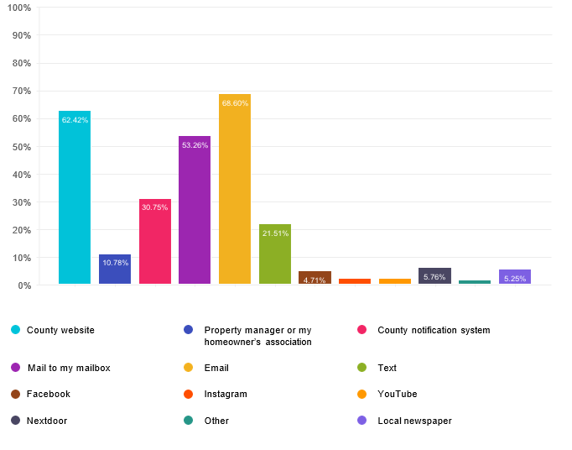

Choices | Response percent | Response count
County website | 62.42% | 1616
Property manager or my homeowner’s association | 10.78% | 279
County notification system | 30.75% | 796
Mail to my mailbox | 53.26% | 1379
Email | 68.60% | 1776
Text | 21.51% | 557
Facebook | 4.71% | 122
Instagram | 2.01% | 52
YouTube | 1.89% | 49
Nextdoor | 5.76% | 149
Other | 1.20% | 31
Local newspaper | 5.25% | 136
Other (Please specify) |  | 84

Local newspaper
- Not specified
- Monocacy Monacle
- Montgomery Banner
- Not specified
- Not specified
- Not specified
- Not specified
- Not specified
- Washington Post and The Banner
- Not specified
- Not specified
- washington post, beacon

- Washington Post
- Washington Post
- Patch
- Not specified
- Wash Post
- Not specified
- Bethesda magazine or the Source of the Spring
- Not specified
- Not specified
- Not specified
- Rockville Reports
- Not specified
- Banner
- Not specified
- Not specified
- don't recall name - comes with mail
- Not specified
- The Banner
- Not specified
- Not specified
- Not specified
- Not specified
- Banner-Montgomery Washington Post, Bethesda Beat
- Not specified
- Not specified
- Not specified
- Beacon
- Not specified
- Washington Post
- Banner, Bethesda Today,
- Not specified
- the Banner newspaper
- Not specified
- Banner
- Not specified
- Not specified
- Not specified
- Not specified
- Not specified
- Banner
- Montgomery Banner

- Washington Post
- Olney Gazette
- The Banner and Wash Post
- Not specified
- Olney newspaper
- Olney Community Newsletter
- Not specified
- Not specified
- Not specified
- Not specified
- The Montgomery Banner
- Not specified
- Bethesda Beat
- online Washington Post
- Bethesda Today
- Washington Post
- Washington Post
- Not specified
- Moco Show
- Not specified
- Washington Post
- Not specified
- Not specified
- Not specified
- I
- Not specified
- Not specified
- Not specified
- Not specified
- Not specified
- Not specified
- Bethesda News (division of Bethesda Magazine)
- Greater Olney News
- Not specified
- Not specified
- Bethesda Beat
- Not specified
- Not specified
- Not specified
- Poolesville Monocle
- Not specified

- Washington Post
- Not specified
- Not specified
- Not specified
- Olney Gazette
- Not specified

Other (Please specify)

- Do programs at kids schools. Send flyers home with kids, grocery stores, houses of worship, Casa, chamber of commerce, clubs like Lions, garden, at sporting events and fairs, at MVA (while people wait!)
- Don't. Your flyers just end up in the trash
- Mailings that describe what can and cannot be recycled help -
- County exec Friday newsletter
- City of Rockville
- Information tent at county fair. This could be expanded to other large community events
- Why are you closing the incineration facility?
- Please avoid sending physical mail
- Letter taped to bin after emptying
- See above re education.
- County executive newsletter
- In the zip code question my zip code isn’t offered, I live in 20818, Cabin John
- It is sad that you provide us with no way to opt-out of your paper flyers.
- Teach kids at their school.
- I found out about the survey thru the Executive's Newsletter
- I realizee this comment doesn't belong in this box, but seems there is no other place to put it. I wish Montgomery County would start compost, food scraps, etc. collection in Silver Spring 20902.
- Home Mailers
- Montgomery Update newsletter
- T.V.
- Please address trash left on roads. That needs to be dealt with as individuals are disposing of trash on the side of the road. Fines and notices need to be made clear to all, especially Rte 28!!!!!
- I’m very disappointed that all of these questions pertain to my particular service I live in a townhome where once a week curbside collection is fine, but I am very concerned about all of the people who I see living in apartments who have to live very close to a community trash bin that is always overflowing. I think that the County needs to pick up the apartment trash three times a week, not once a week or twice a week however, much the apartment trash is being picked up. It needs to be doubled or tripled throughout Europe. Trash is being picked up on a daily basis or handled in modern way so even if we picked up trash from apartment building three times a week, we would still be much less and doing things more economically than our European counterparts.
- flyers
- County executive newsletter or county website
- Twitter
- I wish I could scan the barcode that is on most products and have it tell me whether I can recycle the packaging. I'm certain I make wrong decisions because the website and mailer I consult can't include absolutely every package type.
- County executive's news letter
- Mi
- County Executive newsletters

- Badly worded questionnaire, as many of us have to pay for garbage (or HOA does) but MoCO taxes pay for recycle
- E-mail is a good way to highlight any changes in recycling procedures, followed by updated hard-copy printed cards. I like the print version, since I can keep the latest version near my recycling receptacle for easy reference. [NOTE: I live in an HOA area, with trash collection paid for via my monthly dues; I have not paid attention to the line item in the budget, so I don't know how much it costs, and therefore had trouble answering Qs about whether I think fees are proportionate to services.)
- TV adds
- Neighborhood list serves (posts by local MD general assembly members to these lists are common)
- City of Rockville mailed monthly publication
- community list-serve emails
- Mailed notifications end up unread in my recycling bin. Please consider radio ads on multiple-language stations or local tv stations.
- Television announcement on the local news
- Local media (TV and radio stations) announcements/broadcasts.
- Sent to County Regional Directors for inclusion in their email blasts
- wish we had single-stream recycling!!!!
- Multiple channels
- Ii think that providing info in non-English languages is a great idea, and not just in Spanish. You guys know the stats on what other languages are predominantly spoken in Mo Co.
- get word to neighborhood associations also
- WAMU or other radio stations
- Already took survey but wanted to add a comment: would really like to see a food waste collection system such as PG County has. Thank you!
- HOA will reach our tenant (we tell her, too). NextDoor reaches many people who don't pay attention to other things.
- Local civic association
- 새
- I would like to see the trash collectors leave our bins where we place them at the street rather than make us retrieve our bins 50 feet away on our neighbor's property. The county should also issue fines for residents who leave their trash cans at the curb for days at a time. It would be a great way to generate income and beautify the community.
- Ex
- an online discussion group
- The Potomac Loop. (If you don't know about it...Google it.) It is the best source for local information without the nonsense on Nextdoor.
- Neighborhood Listserve
- Banners placed at certain locations - similar to what you do to inform when yard waste will be collected in the fall.
- C
- Please use common sense!!!!!
- Email or text.
- Radio on the local radio including WHUR - Publish reports and give the public schools curricula on studying them. Like Charts and long term studies with discussion.
- Teach kids in school and send them home with flyers about significant changes or procedures for disposing of trash, hazardous materials, or recycling in multiple languages.
- Radio and television announcements and local news channel feature stories and interviews.
- Schools, PTA and PTSA
- Posters in all local libraries, community centers etc with information and also list of contacts, websites, classes to learn more.

- Local news networks like NBC4
- Local news
- All of the above
- please consider county-wide curbside food waste collection and composting, separate from trash and recycling
- Regional newsletter
- There was no space to write additional comments but I would like to have my compost picked up at my door. I would like this to be a county service.
- I am very concerned about waste disposal and limited recycling and what is happening to our environment.
- through Takoma Park
- cont from above: That you think residents are incapable of doing something "correctly" is offensive and ignorant. Why is the recycling stream so incapable of dealing with 'non-acceptable items'? Why do we allow "non-acceptable" items to be produced and sold to the public? Why do residents bear the brunt figuring out this engineering/business commerce problem? Why isn't Kraft, or Safeway, or Dominoes etc responsible for (paying for) the proper disposal of solo cups, cereal box liners or used pizza boxes? You are asking the WRONG question.
- "Good housekeeping type of awards to HOAs, condos, businesses, schools
- I don't know what the county notification system is.
- Encourage MCPS to discuss the brochures about sorting trash as part of the reading curriculum; children could draw their own pictures, and stamp on some empty plastic bottles to flatten them. I have seen groups of public school children in Flanders given pointed sticks, plastic bags, and gloves on class jaunts to parks, having fun- so wholesome to see them keeping their country beautiful.
- W
- Social media is helpful for reaching people in general but is not an avenue i use now. Emails, informational meetings, and messaging via my HOA works best
- County Executive "Montgomery Update"
- being present at community events with a market stall, for example
- flyers mailed to my home - please extend these to me personally since I'm excluded because I live in Takoma Park! The oversized cardboard flyers aregreat.

- Make your own EPA employees care ! How are civil servants not interested in helping citizens?
- Magnets with recycling info can be mailed out and provide a permanent reference - very useful (I have one about plastic film recycling and use it all the time)
- Reddit
- Put it on the trash cans. Everyone will see it when they bring it in
- Local community associations
- Using community-based social marketing strategies

Q27

How would you describe your home?
Answered: 2593 Skipped: 16

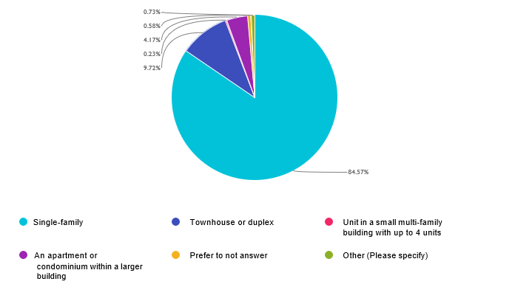

Choices | Response percent | Response count
Single-family | 84.57% | 2193
Townhouse or duplex | 9.72% | 252
Unit in a small multi-family building with up to 4 units | 0.23% | 6
An apartment or condominium within a larger building | 4.17% | 108
Prefer to not answer | 0.58% | 15
Other (Please specify) | 0.73% | 19

Other (Please specify)
- Not specified
- Apartment in a home
- Farm
- Independent living facility
- With acreage. We have a lot of brush and fallen tree branches. Do not need leaf pickup. Mulch it into the grass.
- Multi apartment-building in a senior community
- Single family but single occupant. I certainly am not generating the waste that higher occupancy homes generate. I could get by with trash/recycling pickup twice monthly.
- In
- He
- Not specified
- We also own a townhouse across town
- too personal
- small horse facility
- N
- Not specified
- Not specified
- Nursing home. Prior to that, renting a townhouse.
- Apartment complex Galvan at Twinbrook
- Farm

Q28

Do you rent or own your current residence?
Answered: 2594 Skipped: 15
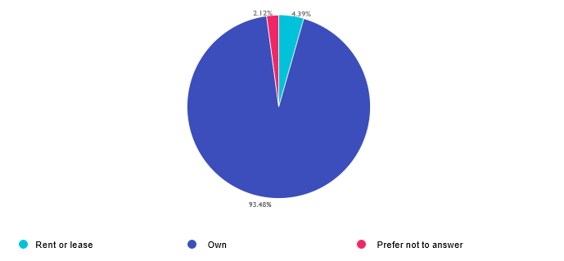

Choices | Response percent | Response count
Rent or lease  Own  Prefer not to answer | 4.39%  93.48%  2.12% | 114  2425  55

Q29

How many are in your household?
Answered: 2575 Skipped: 34
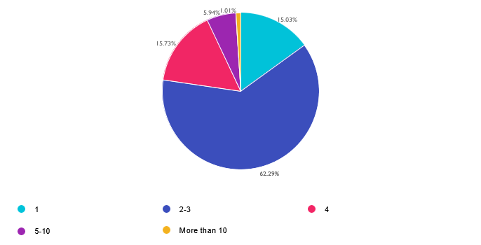

Choices | Response percent | Response count
1  2-3  4  5-10  More than 10 | 15.03%  62.29%  15.73%  5.94%  1.01% | 387  1604  405  153  26

Q30

Which Zip code do you live in?
Answered: 2513 Skipped: 96

Choices | Response percent | Response count
20817  20902  20854  20910  20904  20906  20852  20853  20895  20878  20814  20832  20815  20850  20816  20855  20874  20901  20905  20882  20871 | 8.32%  6.88%  6.65%  6.09%  4.89%  4.85%  4.66%  4.66%  4.54%  4.02%  3.78%  3.22%  3.06%  3.02%  2.90%  2.83%  2.83%  2.83%  2.43%  1.71%  1.31% | 209  173  167  153  123  122  117  117  114  101  95  81  77  76  73  71  71  71  61  43  33

20872  20876  20842  20879  20912  20837  20841  20886  20903  20877  20866  20833  20851  20838  20861  20896  20860  20839  20810  20880  20824 | 1.31%  1.27%  1.11%  1.11%  1.11%  0.99%  0.88%  0.88%  0.88%  0.80%  0.72%  0.68%  0.56%  0.40%  0.32%  0.28%  0.20%  0.16%  0.12%  0.12%  0.08% | 33  32  28  28  28  25  22  22  22  20  18  17  14  10  8  7  5  4  3  3  2

20825  20875  20812  20823  20836  20840  20845  20862  20868  20885  20907  20915  20811  20813  20820  20821  20827  20830  20831  20835  20847 | 0.08%  0.08%  0.04%  0.04%  0.04%  0.04%  0.04%  0.04%  0.04%  0.04%  0.04%  0.04%  0.00%  0.00%  0.00%  0.00%  0.00%  0.00%  0.00%  0.00%  0.00% | 2  2  1  1  1  1  1  1  1  1  1  1  0  0  0  0  0  0  0  0  0

20848  20849  20857  20858  20859  20873  20881  20883  20884  20887  20889  20890  20891  20892  20897  20898  20899  20908  20911  20913  20914  20916 | 0.00%  0.00%  0.00%  0.00%  0.00%  0.00%  0.00%  0.00%  0.00%  0.00%  0.00%  0.00%  0.00%  0.00%  0.00%  0.00%  0.00%  0.00%  0.00%  0.00%  0.00%  0.00% | 0  0  0  0  0  0  0  0  0  0  0  0  0  0  0  0  0  0  0  0  0  0

20917  20918 | 0.00%  0.00% | 0  0

Q31

Which language do you prefer to receive spoken or written information in?
Answered: 2589 Skipped: 20
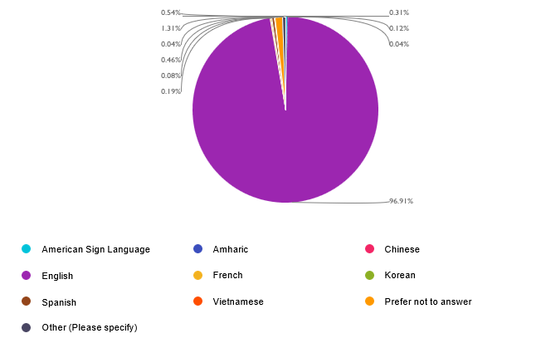

Choices | Response percent | Response count
American Sign Language  Amharic  Chinese  English  French  Korean  Spanish  Vietnamese  Prefer not to answer  Other (Please specify) | 0.31%  0.12%  0.04%  96.91%  0.19%  0.08%  0.46%  0.04%  1.31%  0.54% | 8  3  1  2509  5  2  12  1  34  14

Other (Please specify)
- You don't have my zip code 20853
- 20874
- Try visual not written materials
- Norwegian (jk jk jk)
- I think in this County English Spanish Hawk in Mandarin are most common but maybe French as well
- Not specified
- Not specified
- My African dialect but I can only understand English due to the maafa.
- English
- English AND Spanish
- English
- Klingon
- ENGLISH
- J

Q32

What is your total household income?
Answered: 2574 Skipped: 35
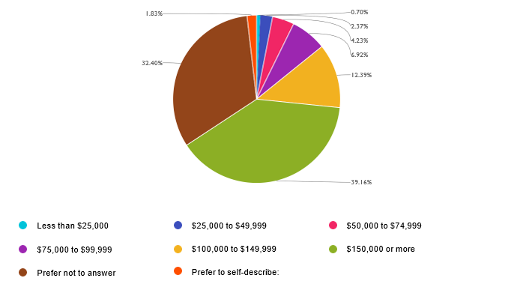

Choices | Response percent | Response count
Less than $25,000 | 0.70% | 18
$25,000 to $49,999 | 2.37% | 61
$50,000 to $74,999 | 4.23% | 109
$75,000 to $99,999 | 6.92% | 178
$100,000 to $149,999 | 12.39% | 319
$150,000 or more | 39.16% | 1008
Prefer not to answer | 32.40% | 834
Prefer to self-describe: | 1.83% | 47

Prefer to self-describe:
- Not specified
- Not specified
- Unemployed
- Not specified
- Currently unemployed and surviving on savings and the odd sale of old collectibles
- retired
- not sure
- B
- Fixed income pension
- Retired.
- You didn’t provide option for My Zip!! - I live in 20901
- Not specified
- Every one has a responsibility in this matter
- Depends if I am employed or not
- Not specified
- Retired on SSI and savings
- retired, own home outright
- Not specified
- retired
- Not specified
- Retired on fixed income
- Retired
- Not specified
- Not specified
- Thanks
- Work on lowering Taxes and unnecessary Fees
- My income is all retire money
- Not specified
- Unemployed
- Not specified
- None of your business
- Not specified
- Retired
- Not specified
- Not specified
- 75,000,000,000.00
- Retired
- Not specified
- the county must do more to educate the public

- Not specified
- retired
- Not specified
- Not specified
- Why does this matter
- None I was laid off in feb. 2025
- Not specified
- Be

