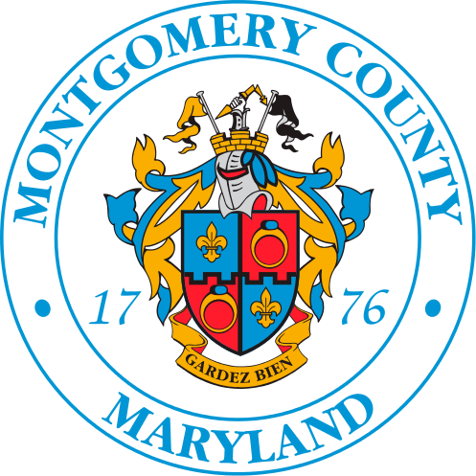
EAST COUNTY CITIZENS ADVISORY BOARD (ECCAB)
Wednesday November 5, 2025 Meeting Summary

Attendees:
- Board Members: Fisseha Adugna, LaTonya Brooks, George Brown, Radwan Chowdhury, BJ Dawkins, Ken Flemmer, Metassebia Kefelegn, Elizabeth Kelly, Len Newman, Mark Pharaoh, Susan Price, Kimberly Price-Evans, Calandra Tate Moore, Porsche Vanderhorst, and Dan Wilhelm. Board Members Absent: Sheala Durant, Tina Oyeniya, and Peter Myo Khin
- Regional Office Staff: Jewru Bandeh, and Cicero Salles
- Guests: Chris Conklin, Haley Peckett, and Nino Ranjo, Lt. Rebecca Innocenta (POL), Lt. Kevin Conroy, Chris Howe-Smith, Chris Wilhelm, Erik Copeland, Sharon Brown, Carlos Bonner, Eileen Finnegan, Rob Richardson and Ed Weiler.
Welcome and Introductions. The meeting was called to order at 7:05 p.m. by chair Radwan Chowdhury. Everyone introduced themselves.
Approval of Meeting Summary: The summary for the October 1, 2024 meeting was approved without any objections.

Montgomery County Police Update
- District 4: Lt. Kevin Conroy introduced himself as being recently assigned to District 4 and plans to attend the meetings in the future. He reported that crime in the district is down 24% compared with last year.
- District 3: Lt. Innocenta gave the following update:
- They now have vehicle license plate readers. They are not allowed by state law to share any information they collect.
- They conducted a speed enforcement patrol on US29 between 6AM and 9AM earlier in the week.
- They are continuing with increased patrols on Lockwood Road in the area of the transit center. The number of calls for that area has dropped from 91 last year to 31 this year.
Presentation: Chris Conklin, Montgomery County Department of Transportation Director, along with Haley Peckett and Nino Ranjo (MCDOT staff) provided an update on DOT activities in east county. Copies of the presentation were handed out to Board members. Some of the topics covered include the following:
- Burtonsville Access Road is under construction. They were not funded to connect businesses to the new road.
- BRT US 29 Phase 2 design is 35% complete and will be presented to the Planning Department before year’s end.
- BRT Randolph Road Alternatives Study has not yet been funded.
- BRT New Hampshire Ave Alternatives Study (Randolph Rd to Ft Toten) is complete and will be presented to the Planning Board in Feb/March 2026 and Council T&E Committee after that.
- Ride On Flex Route 918 is targeted to start in Jan 2026 and will operate during peak periods. Flex rides are requested from a mobile app or phone. A public forum about this service will be held in early December. This service will cover the area around New Hampshire Avenue, north of White Oak.
- Ride On reimaging Year 1 has been implemented. There are also 5 year and future year improvements planned, subject to funding.
- The requirements have been relaxed for communities to obtain the installation of traffic calming features.
- Safe routes to school studies have started for Page ES, Key MS, and Drew ES.
- Street lighting will be added along US29.
- In response to a question about improvements to MD198, Chris indicated it is included in the county’s list of priority projects, but the state doesn’t have the funds, in part because of the additional costs to build the Purple Line.
- There was an extensive discussion about the many recently installed “No Right Turn on Red” signs. These were installed in downtown and town center areas per Bill 11-23 to reduce vehicle accidents with walkers and cyclists. If the signs are creating a more hazardous situation and substantially increasing congestion, email Chris, and DOT will investigate, and remove signs if justified.
ECCAB Committees: The ECCAB priority list from the summer retreat was approved. Each of the two committees will decide which items they will work on this year. The Committees will meet next week on Monday and Wednesday.
County Reports/Updates:
Jewru Bandeh, Montgomery County Regional Office Director:
- A regional job fair will be held at the East County Community Recreation Center on November 6.
- An official ribbon cutting event was held for the new Federal Job Center in Wheaton on Oct 9.
- For those facing food insecurity, there are six places in east county where food is available.
- The Executive submitted the Viva White Oak Tax Increment Financing (TIF) package to the council earlier in the day. It consists of some 100+ pages in the main body and another 300 pages in the appendix.

Chris Wiilhelm (Office of Councilmember Kristin Mink):
- The above TIF package will be introduced on November 18 with a hearing set for December 9 or in January.
- The Public Safety Committee received a report concerning police staffing. The total number of police officers has not changed much, but there are a large number of retirements and new recruits.
- MCPS is proposing to create magnet schools throughout the county in two years. While more magnet schools is a good idea, the schedule is too aggressive. There are many issues that need to be addressed with staff and community, including teacher training, facility availability, and transportation (buses and drivers). Based upon discussion, it sounded like the number of seats for existing programs in east county may be reduced.

