Dates to Remember
2018

Election Worker Training Classes Begin
April 2, 2018

Voter Registration &
Party Affiliation Change Deadline
June 5, 2018

Election Worker Training Classes End
June 9, 2018

Walk-in Practice Sessions
June 11 – 20, 2018

Early Voting
June 14 – 21, 2018

Primary
Election Day
June 26, 2018

Early Voting
October 25 -November 1, 2018

General
Election Day
November 6, 2018



Last month, we started our recruitment for the Primary election and many of you completed your application renewals, took the Stage I Training Quiz, and scheduled your hands-on training class.

If you haven’t done so already, please renew your application online today. Under Maryland law a new or updated application is required for each election cycle.

Training started on Monday, April 2nd and classes are filling up already. We are offering training at four offsite locations this time; the White Oak Community Center, the Damascus Community Center, the Silver Spring Civic Building, and the Rockville Campus of Montgomery College.

Note that you must have completed the Stage I Training Quiz, to be eligible to schedule and take the hands-on training. Turn the page for information on getting started.

Renewing your Application

Since you are already registered in our system, we just need you to confirm your information and electronically sign or affirm the data on file.

- Go to the Montgomery County, Board of Elections website www.777vote.org and click on Election Workers (on the left side of the screen). Next click on EJ Connection to open the log-in page. This is the site for returning workers.

- Enter your User Name and Password (previously provided by BOE) to open the Election Worker Dashboard. To avoid login errors do not copy and paste; type in the log-in information.

- Click on Application Renewal in the ACTION box to open the application screen. Confirm or enter the required information in each section and click NEXT to navigate to the next page. Review the Summary of your information and if everything is correct click NEXT to continue. Click PREVIOUS to go back to change your responses.

- In Section F, read the Affirmation statement and click on the circle to confirm your agreement. Click on Submit. Congratulations, you’re finished! You will receive a “thank you” message immediately on the screen and an email confirmation within a few minutes. The next step is to complete your training.

Note: If you have changes to your name, address or party affiliation (which affect your voter registration) you will see a message directing you to print, sign and submit an Update Form. Click on the Confirmation Form button to open and print the pre-filled form. If you forget to print the form at that time, you can log back into the dashboard to print it. We must receive your signed form to process your application; fax it to 240-777-8578 or scan and email it to election.judge@montgomerycountymd.gov.

Please let us know if you need help logging in or completing the application; we’re here for YOU. (Note: Firefox is not compatible with our online program, please use a different browser.)

Training

Training consists of two stages – the Stage I online training quiz and Stage II in-person, hands-on training.

- All Workers will need to complete the online training quiz before scheduling their hands-on training. Once you have passed the training quiz, your Recruiter will provide you with information to schedule your hands-on training.

Stage I - Online Training Quiz

This portion of the training is required and has been designed to complement the hands-on training and enhance your preparation for Election Day. Follow these steps:

Go to our Website
Click on this hyperlink www.777vote.org
Click on “Election Workers”, on the left of the screen, to expand the list of choices. Click on “EJ Connection” and enter your Username and Password (as provided by BOE).

Once you are logged in, follow these steps
- Click on “Training Materials” to open the Election Judge Manual.
- Click on and read Chapters 1 through 4.
- Click on and watch the video “Assisting Voters with Disabilities”.

When you are ready to take the quiz
- Log back into the EJ Connection.
- Click on “Take Stage I Quiz” to open the quiz.
- Follow the instructions for taking the quiz.
- We recommend that you keep a copy of your answers, so print the quiz before you hit Submit.
- When finished, click “Submit” to send the quiz to the Board of Elections.
Don’t have a computer? Call 240-777-8533 to make an appointment to take the training quiz in person in our Gaithersburg office.
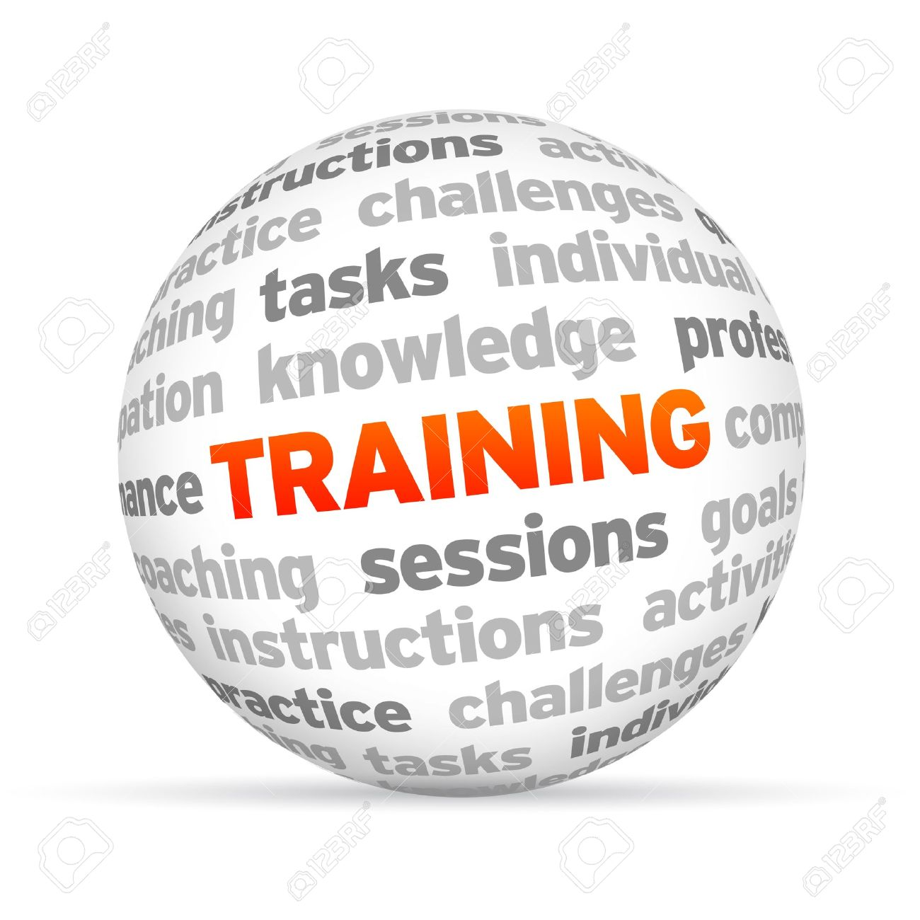

Stage II - Hands-On Training

Scheduling

Hands-on training for the Primary Election began April 2nd. We will use our online scheduling feature for the hands-on training, allowing workers to select and schedule a class and location that best matches their schedule. Most classes will be held at our Gaithersburg office. However, a limited number of classes will be held at:

- White Oak Community Center (April 8 – 20)
- Damascus Community Center (April 16 – 21)
- Silver Spring Civic Building (April 22 – May 19)
- Montgomery College, Rockville (May 12 - 26)

Class Format

All election workers, regardless of prior service, will attend a new training class. The course is a combination of lecture and hands-on training. Students will receive instruction on the procedures, processes and responsibilities of the precinct team and their specific position. Students will work individually and in groups to set up, operate and close the voting equipment and to complete practice exercises and forms. We strongly encourage you to review each chapter of the Election Judge Manual prior to attending class.

Election Day Assignments

Remember that you must complete all required training to be eligible to serve. To ensure that we have enough workers assigned to every precinct, we ask that you complete your training as soon as possible; especially if you would like to work in your own voting precinct. You will get an email when you have been assigned.

Each precinct has a limited number of positions. Workers who wait to complete their training will be assigned to precincts closest to their homes, that have vacancies or asked to serve as a Standby Worker.

Working Early Voting

If you are interested in working at one of the eleven Early Voting centers between June 14 and 21, 2018, follow the steps below:

- Schedule your election day hands-on training as soon as possible;
- Notify Jessica Jones by email that you are interested in working early voting (Jessica.jones@montgomerycountymd.gov);
- Complete your election day hands-on training;
- Schedule and complete the additional early voting training class;
- When you have finished early voting training you may submit your availability to your assigned early voting recruiter;
- Receive early voting assignment information.

Your Vote

All election workers are asked to vote either by absentee ballot or during the early voting period. Chief and Voting Operation judges who are not assigned to work in their voting precinct must vote by absentee ballot or during early voting (or cast a provisional ballot in their work precinct), since they will be unable to go to their voting precinct on Election Day.

- Absentee Ballot – Complete, sign and submit an Absentee Ballot Application as soon as possible. The Absentee office will send you the appropriate ballot to vote. Your ballot must be returned to the office or postmarked (by the Postal Service) by Election Day. Absentee ballots cannot be left at the polls for return to BOE; this is prohibited by Maryland law.

- Early Voting - Vote at one of the county’s early voting centers between Thursday June 14 and Thursday June 21, 2018. Voting hours are 10:00 a.m. to 8:00 p.m. For more information on the eleven early voting locations, go to our website at www.777vote.org.

Important Information

- Keeping us informed – Please keep your voter registration and contact information current. Update your personal information online in the EJ Connection portal. Click on Update Personal Data to enter your information. Phone numbers and email addresses will only be released to the Chief Judges for election related use.

- Future Vote Student Aides - School-age students, grades 6-12, can serve as Election Day student aides for 2018 elections. The program’s intent is to educate, strengthen and increase ties related to civic participation. Interested parents/guardians can register their student(s) online by visiting the Montgomery County Board of Elections’ website. For additional information, email future.vote@montgomerycountymd.gov.

  - Note: Students 16 years old and registered to vote are eligible to work as an election worker for payment ($ 210) or SSL credits through the Future Vote Program.

- Bilingual election workers are needed - As mandated by Section 203 of the 1975 Voting Rights Act workers with Spanish speaking fluency are needed in every precinct. We are also looking for workers that speak Chinese, French, Korean and Vietnamese. Please indicate all languages on your application. Contact Gilberto Zelaya for more information 240-777-8532 or email him at gilberto.zelaya@montgomerycountymd.gov.

- Manna Food Drive to be held during training. Once again, we are working with Manna to help feed county residents. Please join us in this much-needed effort by bringing a non-perishable food item to your scheduled training class.

Election Workers Needed for the Nursing Home Program

We are currently recruiting workers to participate in the Nursing Home and Assisted Living Program. Selected individuals will work in bi-partisan teams. The program begins the week of May 6, 2018 and is expected to end the week of June 18, 2018.

Qualifications:

- Must have completed Election Day training;
- Must be a team player;
- Must have own transportation;
- Must be available during normal business hours;
- Must attend Nursing Home and Assisted Living Program training session;
- Must be willing to pick-up and deliver ballots and polling place supplies to the Board of Elections and to the facilities that are to be visited daily;
- Must be willing to visit facilities throughout the county;
- Must perform check-in and ballot accounting duties daily; and
- Must be able to assist elderly and disabled voters in completing applications.

If interested, send an email to Nursing.home@montgomerycountymd.gov or call 240-777-8597 or 240-777-8561.

Contacting Us

- General Questions: Call 240-777-8533

- Email: election.judge@montgomerycountymd.gov.

- Fax: 240-777-8578; Website: www.777vote.org.

- Mailing Address
Montgomery County Board of Elections
Election Worker Program
P.O. Box 4710
Rockville, MD 20849-4710

Recruiters

Election Day

Uricka Battle – Districts 1, 2, 3, 9, 11 and 12 240-777-8659

Deborah Hamer – Districts 4, 6, and 10 240-777-8571

Kara Springer – Districts 5, 7 and 8 240-777-8576

Rahel Hailemariam – District 13 240-777-8572

Early Voting

EV Lead – Jessica Jones 240-777-8577

Maria Rodriguez-Henao 240-777-8573


Aishah Mills-Pherigo 240-777-8567

