Executive Summary

Aging-in-Place in Rockville

October 17, 2015

The Rockville Village Concept Advisory Committee began in July 2014 when Leanne Sherman, former CMR’s Senior Program Director and Lynn Arndt, Deputy Director of Community Ministries of Rockville (CMR) invited Pazit Aviv (Village Coordinator, Montgomery County Department of Aging & Disability Services invited to discuss the village concept and how it can be applied to Rockville. In the meeting, it was decided to convene a meeting to assess the level of interest in Rockville in developing neighborhood aging in place villages. Invitations were sent to as many organizations and individuals as were identified by both organizations and recipients were encouraged to forward the invitation.

In September 2014, Community Ministries of Rockville hosted the first meeting to discuss possible models for aging-in-place in Rockville that might :

* facilitate stronger social connections in neighborhoods,
* support neighbors helping neighbors programs,
* help seniors access the wide range of services provided by the city and other local providers.

The group identified its main vision as reaching out to all seniors who live in the city regardless of ethnicity, economic status or religious affiliation to determine what, if any, their preferences were and also how established senior services group**s** could provide support for Rockville Aging-in-Place villages.

**Background**

US Census predicts that between 2006 and 2030, the U.S. population of adults aged 65 and over will nearly double from 37 million to 71.5 million.  According to AARP, over 80% of people 65 and older prefer to age-in-place in their homes as long as possible. To make that feasible and safe, communities must rethink how senior services are delivered.

One trend is the creation of villages—neighborhood-based groups of seniors and volunteers who help each other with everything from transportation to snow shoveling to social gatherings.  Villages can be volunteer- or membership-based, and there are many different models.  The first village was formed in late 2001 (Beacon Hill, Boston). The Washington DC area leads the country in villages, starting with five in 2010, there are now over 50 running or in development. In Montgomery County there are currently 16 active villages, 9 in development and many starting the village discussion.

Rockville, with a population of 61,209 (US Census Bureau April 1, 2010) and a strong network of senior support, is an ideal place to develop villages, the group concluded.   The city is already funding an audit of existing services for and needs of the elderly in Rockville that is expected to be complete in 2015.   The group decided that it would be valuable to continue to explore and understand the dynamics of creating and supporting Villages and agreed on the following actions:

* Continue to meet monthly and set a second meeting in October 2014
* Use the following committee name:  Rockville Village Concept Advisory Committee
* Work to increase and broaden participation
* Explore different village models
* Define mission of the committee

Our first meeting attracted 17 people representing most of the sectors we wanted to be involved: citizens, village residents, profit and nonprofit groups working in senior services, city staff with an interest in understanding how these diverse groups could work together to facilitate village development.

The Committee met monthly through May 2015. Our agendas typically included an update on county and national village activities from Pazit, a presentation from a functioning, successful village, occasional presentations by service groups (profit or nonprofit), and a discussion of next steps. We developed a working group of about 15 people who attended all meetings and a mailing list of over70 who attended sporadically or wanted to be included in the updates.

Our initial vision of the Rockville Village Concept Advisory Committee was to act as a clearinghouse and resource to all organizations, businesses and individuals who serve seniors in Rockville and to provide information and support for any neighborhood or group that wants to develop a village. To that end, a Rockville Villages resource page has been added to the Montgomery County Village website (<http://tinyurl.com/rockvillevillages>) where the we post relevant articles, reports and presentations, as well as the minutes from each of our meetings. We also maintain a Facebook page (www.facebook.com/rockvillevillages).

In spring 2015, we agreed that it was time to start a formal outreach program in order to both inform Rockville seniors about aging-in-place and to gauge their interest in forming a Village. We first defined a new mission for the group:

* Begin holding informational events and presenting to neighborhood groups and existing villages
* Develop best practices for village formation
* Create recommended model for city-wide support for villages
* Develop information resources to support village formation

Three task forces were formed:

* Events
* Village Structure/Governance
* Communications/Outreach

The Events group planned and executed our first event: Aging in Place Community Forum in Rockville. The event took place at the Rockville Senior Center on October 17, 2015. The event was promoted through the membership list, the Senior Center newsletter, Engage Rockville, Rockville Seniors Facebook page the Rockville Police Facebook page and the Rockville Villages Facebook pages, as well as to many Rockville villages formed or in development and the Neighborhood Watch listserv. The Agenda is published in Appendix A.

The primary goal of the event was to attract Rockville residents interested in aging-in-place. We had a great turnout (137) and a very good representation from the Rockville City Council, Mayor, Police and Fire Chief and several candidates running for the council and/or mayoral positions. Police Chief Terry Treschuk introduced Former Mayor Rose G. Krasnow who provided opening remarks. Ann Seltz, Chair of the committee, and Pazit Aviv gave a short overview of the village movement, the committee and plans for 2016. Then the group divided into groups to discuss four questions:

1. What is the village concept?
2. What’s your plan for aging in your community?
3. What kind of support do you think you might need; now or in the future?
4. How would you like to receive that support---from the city, residents, other organizations

The discussions were lively and very strong interest in aging-in-place was expressed by about 75% of the attendees. They also provided detailed information about what they needed from a Village and how they would like to be helped.

Following is the summaries from the discussion groups as well as their list of “wants.” The complete list is included in Appendix B.

Summary

Aging in Place Community Forum

After the opening remarks and an overview of villages, the audience of about 137 broke into 6 discussions groups. Our original plan was to have the discussion group formed by neighborhoods or neighborhood groups, but that proved unwieldy—both in attendees knowing which neighborhood they were in (as we combined some) or insufficient number of people from the same neighborhood(s) to form a discussions group.

Our moderators were from our standing Village Advisory Committee and they were:

**Lynn Arndt**, Deputy Directory, Community Ministries of Rockville (CMR)

**Pazit Aviv**, Village Coordinator, Montgomery County Department of Aging & Disability Services

**Beryl Feinberg,** Rockville Council Member

**Ryan Frederick,** CEO & Founder, Smart Living 360

**Ruth Hanessian**, Interested Citizen

**Virginia Olney**, Rockville Council Member

The following summaries are drawn from the moderator notes and the discussion group responses are combined to avoid repetition. We received summaries from 4 of our 5 moderators. The complete notes of the discussion groups are included in Appendix B.

**Moderator 1:** Our group was very enthusiastic about the village concept and creating new ways to age in the community. It was clear in our discussion that most people are not drawn to traditional senior housing and many cannot reasonably afford it.

The village concept gives people hope to make aging in community more possible.  At the same time, our discussion revealed how complicated it can be to age.  Our discussion highlighted challenges related to: stairs, landscaping, transportation, errand support, technology and meals, among others.  The primary concern was around the need for social connection.  Our group would love to be involved with a village community, particularly one that is intergenerational in nature.

**Moderator 2.** There was awareness of the village concept. Interest in a central access point for all senior services include

* Transportation
* Communication - choices of computer, phone, email, direct mail, block captain
* Home service
* Food and supplies like Top Banana used to be.
* Technology assistance
* Financial assistance
* Alternative living incl. co-housing and/or younger roommate/families as options
* Desired a formal structure - Village or City
* Enable pride and independence, facilitate connections
* 75% prefer aging in place and being healthy
* Help with laundry, changing linens, food emergencies, forming local groups for reading, studying, movies
* Housing support: Walkable neighborhoods with transportation available, no stairs, not alone, no outdoor maintenance, tool sharing, indoor modifications
* Activities: Coop trips, beach house to share
* Big concern: Trusting others!

**Moderator 3:** Had more than 20 participants, with a large contingent from New Mark Commons, another group from Twinbrook area and two individuals from other neighborhoods. All came because they were very interested in their ability to age in place and wanted to learn more about the effort to create a village or villages in Rockville. Some had a general familiarity with the concept but others came because they heard about the event and wanted to get an understanding of what is available.

The group addressed community issues such as

* Type of residence (multi-level townhome or split level home)
* Maintenance of homes
* Transportation after they could no longer drive themselves
* Cost of maintaining homes
* Loneliness

The group also quickly offered solutions, such as

* Chair elevators for solution for stairs-- battery operated so would operate when electricity is out.
* House-sharing
* Scam alert

All were unanimous in opinion that the village they envision would be intergenerational.

They agreed that it would be helpful to have a Village Coordinator who could serve as a resource for the community and it was suggested that the coordinator work from the Senior Center. The group thought that each neighborhood could be a resource for others depending how well established they were or what kind of services they had available to one another. So perhaps an association could be formed with representatives from each neighborhood. As the group disbanded, plans were being made about their next steps.

**Moderator 4:**

We had about 25 people in the group. The group was very interested in the village concept and how it can be modified to communities that do not have a lot of older adults. A strong interest for intergenerational models was expressed by at least half of the participants and they had some questions about the TimeBank concept. We were fortunate to have the TimeBank founder present in the group and he was able to answer some questions.

The group touched on issues such as:

* The difficulty of organizing a village and the amount of work it may take
* Many people expressed an interest in volunteering
* Some people talked about how difficult it is to ask for help
* The group mentioned the challenge of connecting with people who do not speak English in the city.
* The group discussed the fact that there are many resources and service that people are not aware of and that one thing we can start doing is to share information about that.
* The group was concerned about affordable housing and long term insurance.

Additional comments listed from at least two discussion groups

There was of course much repetition among the groups and I’ve edited to avoid repetition. The discussion points can be found in Appendix B.

**What is the village Concept?**

Most attendees were familiar with Village concept and interested in aging-in-place.   
The lowest level of awareness in the groups was 50%.

**What is your plan for aging in the community?**

Most want to stay in their current home, but need a plan

Build an addition

Live with children

Live with a pet

Take advantage of existing senior services

**What kind of support do you think you might need; now or in the future?**

More affordable housing in Rockville

Hub-and-spoke model with Senior Center being the hub

Help with issues such as: Liability, getting to know neighbors (eliminate “strangers”)

Encourage community building through block captains and “town crier”

Provide village-to-village communications

Define role of religious entities

Long-term care policy

Negotiate group prices for seniors

**What entity would you like to provide the necessary support to stay in your home?**

City involvement via

Senior Center-- Senior outreach services

CMR

Individual community residents’ ability

Next door community

Buddy system with neighbors

Rockville village coordinator

Daughter/son

Move to assisted community

Community support

Businesses work with community to provide transportation

Modify building codes to make more options for seniors sharing accommodations

Church

Reading/study/conversation groups

Skyping

Phone Group

Start with block party, progress to village

Appendix A: Agenda

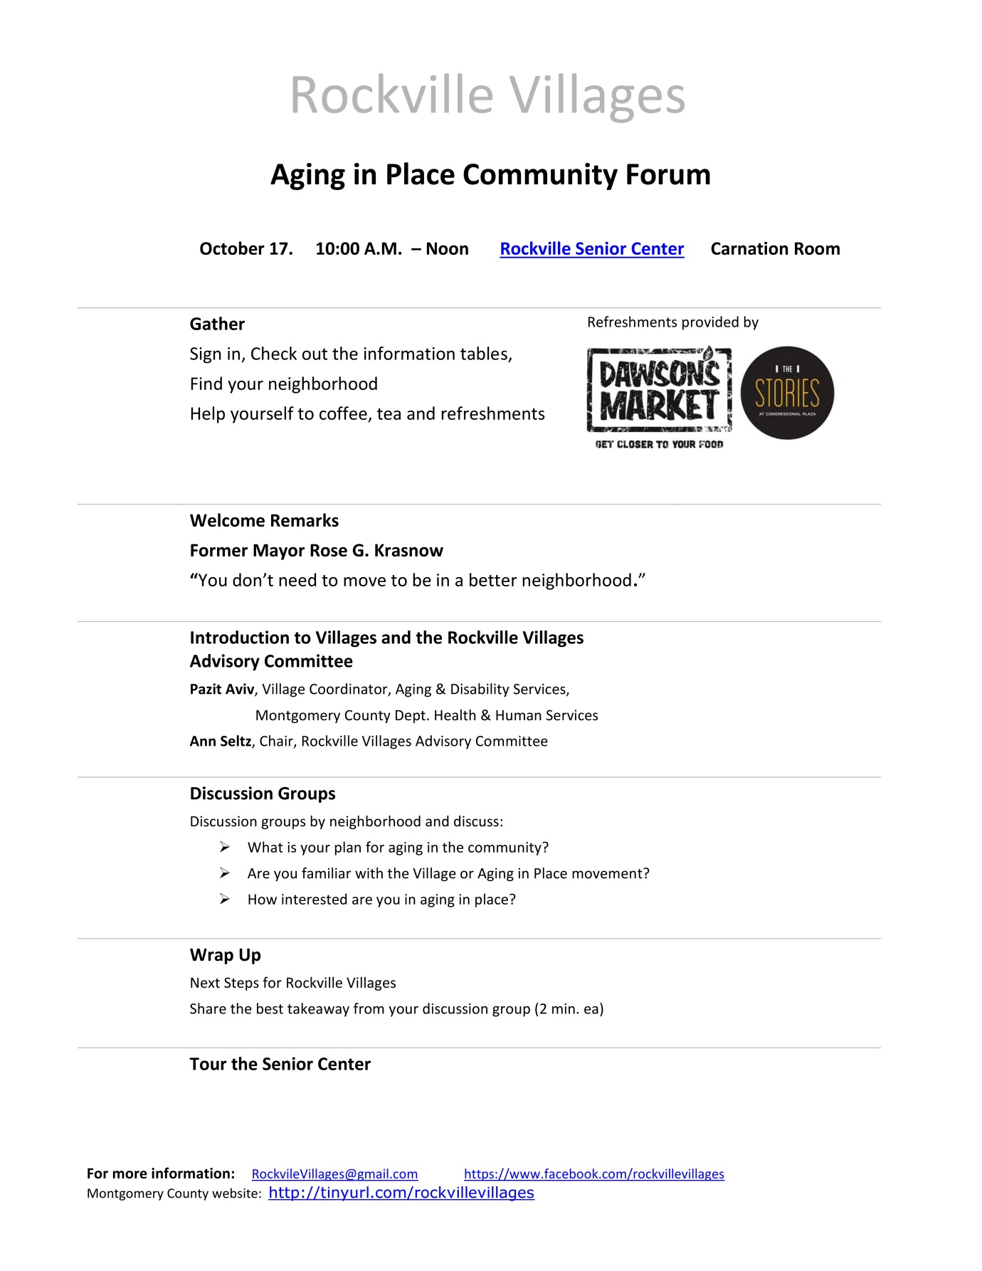

**Appendix B**

Summary

Discussion Group Notes

Group 1

What is your plan for aging in the community?

1. Prayer: never get old
2. Stay healthy
3. Check out senior living options
4. Live with children
5. Live with a pet
6. Take advantage of existing senior services

**Are you familiar with the Village or Aging in Place Movement?**

1. Model in Princeton, N.J.
2. Other examples
3. Need for making connections
4. Hub and spoke model with Senior Center being the hub
5. Issues: Liability, getting to know neighbors (eliminate “strangers”)

**How interested are you in in aging in place?**

1. Importance of walkability
2. Close to transportation
3. Circulation (?)
4. Flexible transportation
5. Need for pride and independence
6. Intergenerational presentation

**What entity would you like to provide the necessary support to stay in your home?**

Make support a formal structure that includes (or coordinates?)

* Health
* Transportation
* Technology
* Home Services
* Wellness (exercise, etc)
* Food/supplies
* Financial management
* Wills, leases, etc
* Encourage community building through block captains and “town crier”
* Make the senior center the hub of support for villages
* Provide village-to-village communications
* Define role of religious entities

**Group 2**

**What is your plan for aging in the community?**

* Stairs are a problem
* Driving ability
* Living alone
* Reorganizing the home spaces
* Townhomes
* No affordable senior housing in Rockville
* Outdoor maintenance of home
* Tool sharing
* Need village to be intergenerational
* Younger roommates in the home
* Co-housing
* Student Service Learning Hours for senior assistance for home maintenance and other assistance

**What entity would you like to provide the necessary support to stay in your home?**

* City involvement
* Individual community’s ability within its residents
* Next door community
* Buddy system with neighbors
* Senior outreach services
* CMR
* Rockville village coordinator
* Negotiate group prices

Group 3

What is your plan for aging in the community?

* Meet people locally
* Active
* Mobility
* Lifestyle
* Drive

**Are you familiar with the Village or Aging in Place Movement?**

* People outside the city
* Generations – time/energy
* Average Age 75---no limit
* Edgar-Time Bank

**How interested are you in in aging in place?**

Yes

**What entity would you like to provide the necessary support to stay in your home?**

* Centralized place
* Create youth involvement
* Neighborhood/civic association
* You can start!

Group 4

**What is your plan for aging in the community?**

* Activities
* Help
* Transportation
* Network
* Family
* Time banking/sharing volunteers
* Planned community
* Connect with others
* Place at the beach
* Long-term care policy

**Are you familiar with the Village or Aging in Place Movement?**

50% of the group were familiar with villages

**How interested are you in in aging in place?**

75% very interested. And also notes said @the beach)

**What entity would you like to provide the necessary support to stay in your home?**

* Daughter/son
* Transport company
* Move to assisted community
* Community support
* Businesses work with community to provide transportation
* Doctors?

Group 5

**What is your plan for aging in the community?**

* Most want to stay in their current home, but need a plan
* Build an addition
* Stay healthy
* Place for kids
* **Help ?new w/eye to future?**
* Stairs a challenge

**Are you familiar with the Village or Aging in Place Movement?**

Very few in the group were

**How interested are you in in aging in place?**

Wasn’t a clear answer to this, more like a list of problems, such as

* Stairs
* Lawn mowing
* Landscaping
* Transportation
* Errands
* Laundry
* Changing linens
* Food/temporary meals
* Scam alert
* Help with computer
* Modify building codes to accept senior residents?
* More affordable housing for seniors

**What entity would you like to provide the necessary support to stay in your home?**

* Church
* Reading/study/conversation groups
* Skyping
* Phone Group
* Movie Night
* Interest Group
* Start with block party, progress to village
* City of Rockville
* Senior Center
* Linkage of all above

**Other notes from this group:**

* Where are existing villages?
* How contact them?
* How to know who can be trusted to help you?
* Communication: Not everyone has a computer