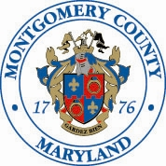

**COMMITTEE EVALUATION AND REVIEW BOARD (CERB)**

Virtually by MICROSOFT TEAMS

Thursday, August 8, 2024 – 7:00 p.m.

(Meeting Two)

*CERB Members*

Anthony Buccitelli Muriel Hairston-Cooper Karl Pitt

Justin Carlson Mary Ann Keeffe Catherine Sindos

Jake Didinsky Deeptaanshu Kumar Jeffrey Slavin

Zanethia Eubanks Sofya Orlosky Clint Sobratti

Rodrigo Figueroa

**A G E N D A**

1. Review BCC Interview Questions

**Meeting Accessibility Notice:** Sign language interpreter services and other auxiliary aids or services will be provided upon request with as much advance notice as possible, preferably at least three (3) full business days before the meeting/event. To request any other reasonable accommodation or to advise us of any dietary considerations, please send a request to [MCCPWD@montgomerycountymd.gov](mailto:MCCPWD@montgomerycountymd.gov). Taking these steps will help us have sufficient time to best meet your needs.