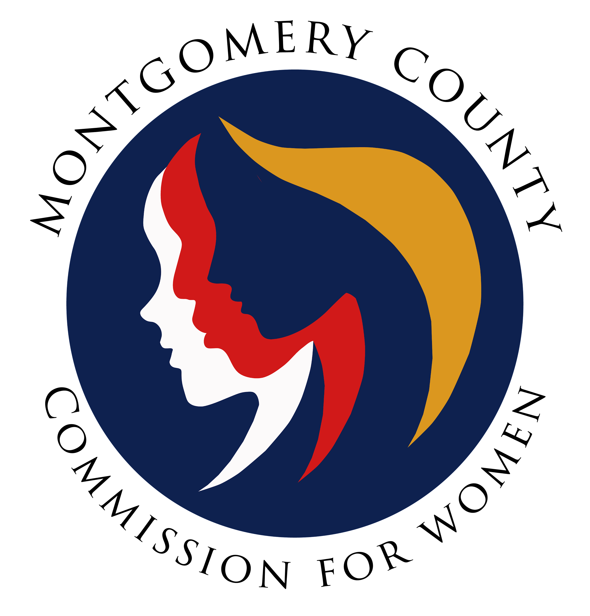
Montgomery County Commission for Women
General Meeting Minutes
September 8, 2022 / 7:00 – 8:30 p.m.

______________________________________________________________________________
“When women thrive, all of society benefits.”
Kofi Annan
______________________________________________________________________________

Commissioner Attendees
Donna Rojas (Chair)
Arlinda Clark Janet Lavelle Kimberly Mouzon
Ijeoma Enendu Jan Molino Tondalayo Royster

Absent:
Chai Shenoy, Betty Romero, Isabel Argoti
CFW Staff:
Jodi Finkelstein, Executive Director
GENERAL MEETING MINUTES

I. WELCOME AND INTRODUCTIONS / CHAIR ROJAS
- Introduction by Commissioners in attendance

II. APPROVAL OF MINUTES AND AGENDA / CHAIR ROJAS

- No vote for August 8, 2022 Minutes and Agenda (no quorum)

III. EXECUTIVE COMMITTEE REPORT / CHAIR ROJAS
- CFW Onboarding Update
- Interviews are completed
- Names of recommended candidates were sent to County Executive for review
- After approval of County Executive, County Council will confirm selected candidates

- CFW Intern is Jennifer Escobar
- Program Manager position closed today (09.08.22)
- Executive Director, Jodi Finkelstein will begin interview process once applications are received
- Executive Director, Jodi Finkelstein will be on leave September 14-26, 2022

IV. COMMITTEE REPORTS

- Strategic Planning and Research Evaluation (SPRE) / Commissioner Molino
- Reminder of upcoming strategic planning meeting on October 8th
- Preliminary work to be completed by Commissioners prior to October 8th session

- Policy and Legislation (PALS) / Commissioner Molino

- Maryland Legislative Agenda for Women (MLAW) is the resource utilized by the CFW to select what legislation the Commission will support
- Seeking members for committee
Members: Commissioners Betty Romero, Jan Molino and Tondalayo Royster
- Commissioner Janet Lavelle agreed to join the committee

- Programming / Chair Rojas

- No report. Currently in the process of completing fall programming schedule
- Commissioners are encouraged to proctor at least one session
- Commissioner Molino shared she has proctored the Separation and Divorce session
- Commissioner Molino suggested more time is needed for the Divorce and Separation seminar since there is a lot of important information shared during the session

- Budget Committee / Chair Rojas

- Committee has reconvened
- Committee reviewed the latest budget report to determine how organization and itemization should appear on future reports
- Budget reports will be displayed on one overall spreadsheet with categorized worksheets within to track funds
- Budget Committee and the Office of the Commission will be able to share how funds are spent with restricted and unrestricted funds
- Request for funds will go through the budget committee for approval and to the body for approval
- Chair Rojas will send request form to Committee Chairs / request comes from Chairs only
- Funding for each CFW committee will be discussed at future Budget Committee mtg.

- Emerging Leaders / No Report (Chair Pending)

- Public Relations / No Report / Chair Rojas

- Women’s Legislative Briefing (WLB) / Commissioner Clark
- One Chair this year
- Commissioners are encouraged to share talents and work together to plan WLB
- Seeking Commissioners to join planning committees with sponsors/volunteering
(Committees: Planning, Emerging Leaders, Publicity, Evaluation and Chairs Reception / Sign-up sheet will be emailed by Executive Director, Jodi Finkelstein)

WLB Details:
Theme: Empowered Women Protect Democracy
Date: Sunday, January 29, 2023 (virtual)
Registration: $23.00 (through Jan. 27th), $30.00 (Jan. 28th & 29th), $5.00 (Students)
*Chairs Reception will be in person

V. LIAISON REPORTS

- Human Trafficking Prevention (HTP) / Executive Director, Finkelstein

- Upcoming meeting on 21st and will focus on upcoming legislative priorities

- Domestic Violence Coordinating Council (DVCC) / Commissioner Royster

- Planning for Domestic Violence Awareness Month in October 2023
- Theme: Walk in their Shoes
- Display shared stories of survivors or friends who helped survivors
- Stories will be displayed on small boards with shoes attached to represent their story
- Seeking to place stories throughout Montgomery County – whom ever is willing to display stories
- Apartment Initiative information forthcoming

- Community Health Initiative / No Report / CFW Liaison Pending

- Commissioner Lavelle agreed to represent the CFW

- RespectFest / No Report / CFW Liaison Pending
- Commissioner Mouzon agreed to represent the CFW

VI. AD HOC COMMITTEE REPORT(S) – No Reports
IX. OLD BUSINESS

- None

X. NEW BUSINESS/ANNOUNCEMENTS
- None

XI. GOOD NEWS
- Chair Rojas is a grandma!

XII. Meeting Adjourned (7:56 p.m.)

