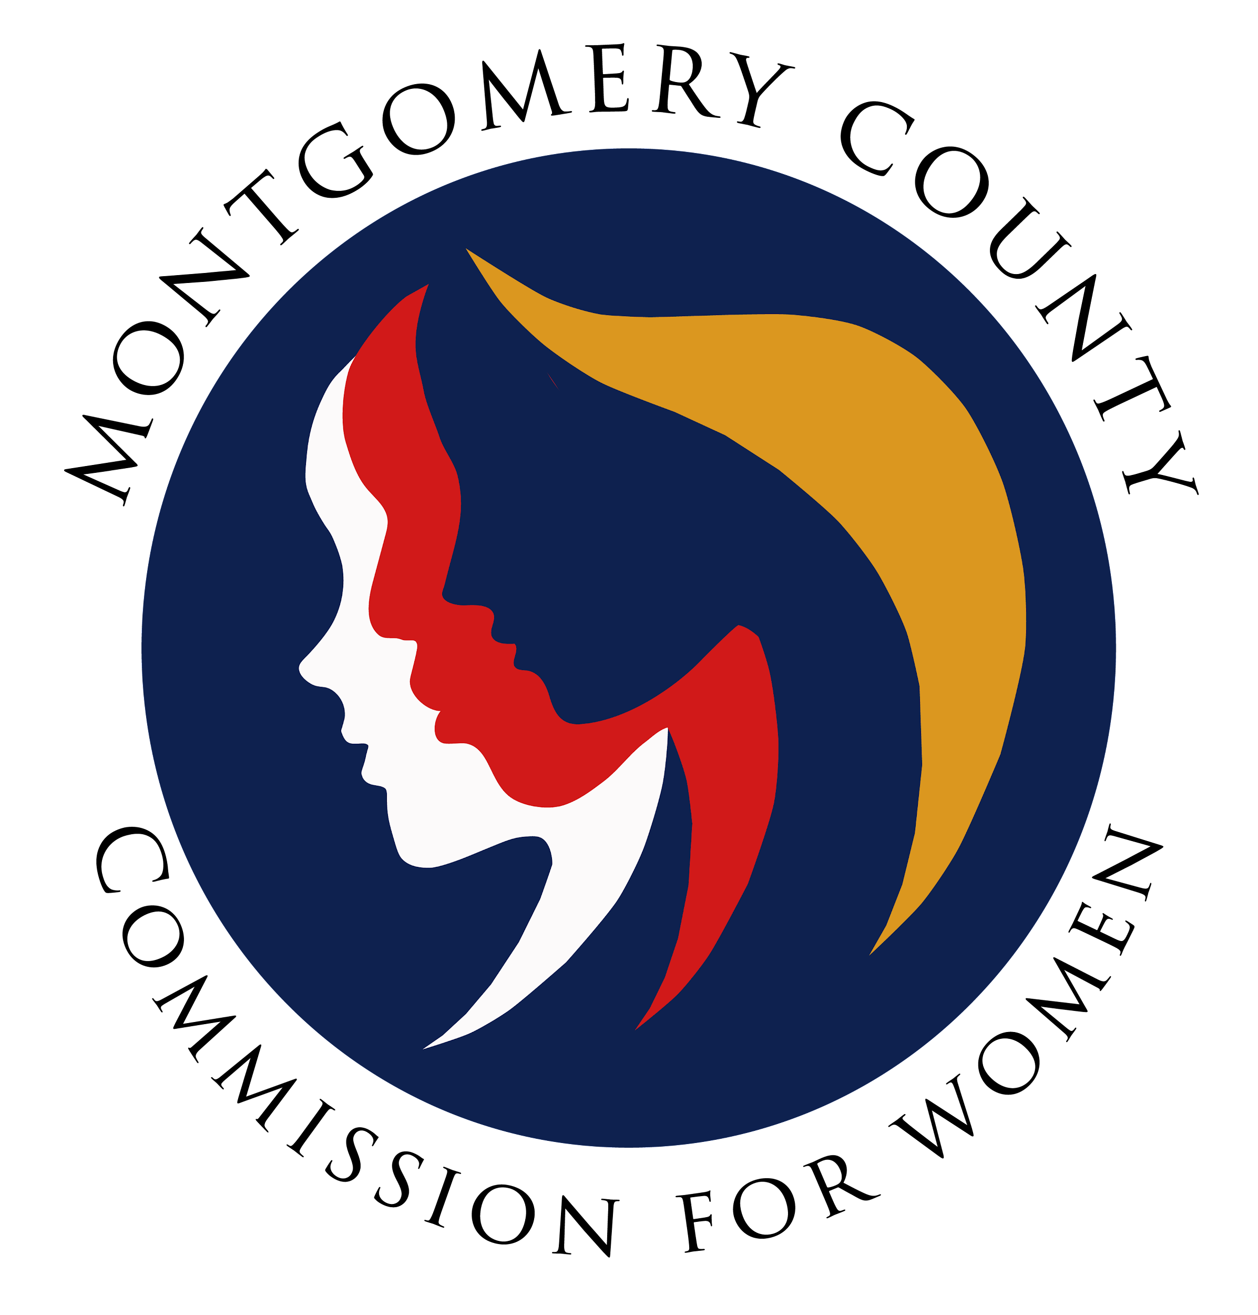
Montgomery County Commission for Women
Monthly Meeting January 13, 2022

Attendance
Attending | Not Attending | Guests
Donna Rojas – Chair  Patricia Maclay – 1st Vice Chair  Tonia Bui – 2nd Vice Chair  Isabel Argoti – Secretary  Arlinda Clark  Angela Whitehead Quigley  Ijeoma Enendu  Nicole Drew  Jan Molino  Chai Shenoy  Janet Lavalle  Betty Romero  Diana Rubin  Tondalayo Royster  Staff  Jodi Finkelstein | Meredith Weisel

MEETING MINUTES
January 13, 2022

I. WELCOME AND INTRODUCTIONS Commissioner Rojas
- Meeting called to order at 7:01pm.
- Welcome our two new commissioners, Janet and Tondalayo!

II. APPROVAL OF MINUTES AND AGENDA Commissioner Rojas
- November 2021 Minutes and January 2022 Agenda
  - Add report outs for Domestic Violence and Choose Respect. Commissioner Maclay to approve as amended, Commissioner Shenoy seconds. All in favor.

III. EXECUTIVE COMMITTEE REPORT Chair Rojas
- Commissioners in the Community
  - Commissioner Rojas was a part of a church event for their women-to-women organization to share resources with an international audience.
  - Student interviewed Commissioner Rojas about the Violence Against Women Act (VAWA) for the CSPAN StudentCam contest. The student was connected with more speakers and resources.
- Meeting with Council President Albornoz - we have shared a few dates for a meeting with the executive committee.

IV. EXECUTIVE DIRECTOR REPORT Executive Director Finkelstein
- CFW shirts ordered, in office end of January – will email once they are in to schedule a time to pick up.

V. COMMITTEE REPORTS
a. PALS Commissioner Rubin
- In attendance were 8 commissioners and 13 legislators. Del. Ariana Kelly did a great job kicking off the session. Overall, there was great discussion from all participants. Perhaps next year, we can do it over the weekend to promote more attendance.
- All 5 of our bills are on the MLAW Agenda this year! The session started yesterday.
- Commissioner Rojas thanks Commissioner Rubin for all her work and organizing the event. All commissioners did a great job in presenting bills. Thank you to the committee too!
b. Program Planning Commissioner Enendu
- November was a month for a lot of new programs!
  - November 17 - Planning for children with Special Needs. This went very well and will likely be doing another.
  - November 18 - women’s sexual health awareness program. Will host another in the Spring. We forgot to record but will record next time.
  - Separation and Divorce seminars are continuing through June.
- We are accepting applications for MoCo Women Making History. We now have 29 responses. Commissioner Enendu will seek help to evaluate nominations.
- Programming and SPRE are working together to see how we can create partnerships and enhance our programming.
g. WLB Commissioner Maclay and Argoti
- Voting Women Change Everything on Sunday, January 30, 2022. Registration is now open! Please share with your networks.
- We also got SSL hour approval for Emerging Leaders! Flyers will be updated accordingly for distribution.
- Commissioner Drew suggested reaching out to family shelters to potentially sponsor student registrations to have access to the information. Commissioner Whitehead Quigley confirmed that this goes out through MCPS reaching all schools. Please pass along to your connections if those are more effective. Commissioner Drew suggests we send it to those specific organizations as a free opportunity i.e. Linkages to Learning, ACES, Family Justice Center, BAK Center.

VII. LIAISON REPORTS

b. HTPC Commissioner Maclay
- Presentation on missing children was held with Office Witherspoon.
- It is Human Trafficking Prevention Awareness month. There was a proclamation issued and social media efforts.
- They are working on putting together a poster contest for the spring with MCPS.
- The Committee is looking to issue a blue dot program (currently active in Baltimore) where resources can easily be shared with victims.
c. Domestic Violence Commissioner Drew
- Current issue being discussed regarding paroles and probations, where GPS monitoring procedures are being re-evaluated to streamline the availability and transferrin. The committee is writing a letter to alleviate this issue.
- Supporting various bills around domestic violence and stalking.
- The Outreach committee will be connecting with healthcare services (OBGYNs, PCPs).
- Follow HTPC on social media!
e. Choose Respect Commissioner Whitehead Quigley
- The PSA Contest is open for students to submit a video on healthy teen relationships. The deadline is February 28 and there are already 40 submissions.
- For the actual RespectFest event, they are hoping to do a hybrid event due to a great virtual program last year, but the committee will re-evaluate within the next month to make a call on moving forward with a hybrid event. Tentative events:
  - Virtual Kick-off call on Sunday, March 20 with asynchronous activities to be done during the week. The week would end on March 27 with an in-person awards ceremony at the Wheaton Recreation Center.

VIII. AD HOC COMMITTEE REPORT(S) - NONE

IX. OLD BUSINESS - NONE

X. NEW BUSINESS
- Climate Stories Ambassadors Project Commissioner Maclay and Argoti
- Commissioner Argoti explained the local initiative which is now recruiting for another round of ambassadors. This is county government and supports a national initiative aimed at amplifying the voices of county residents. This would be an opportunity to include women’s voices in the project. The extent of this partnership would simply be to share the information and have our logo be included on their website.
- Commissioner Maclay motions that we partner with the Climate Stories Ambassadors Project supporting the Montgomery County Department of Environmental Protection. Commissioner Romero seconds the motion
- Commissioners asked for more time to review materials to discuss logo guidelines.
- Commissioner Clark moves to postpone the motion until we have more information. Commissioner Romero seconds.
- Procedural Question: Commissioner Shenoy asked about the process for adding items under new business. It was clarified that if a vote is needed, having it ahead of time is helpful to flag for the executive committee.
b. Maryland Reentry Alliance Commissioner Rojas
- Commissioner Rojas will send more information via email for an email vote. The pre-release center has been closed since 2019 so the CFW needs to find new strategies to help this population and hire for that part-time position. The U.S. Attorney's Office for the District of MD is looking to put together a re-entry council and is looking for a representative for all counties. Commissioner Rojas made a point that Baltimore is usually very well represented and we should connect with these statewide efforts including training and funding opportunities.
- The next meeting is on January 25 so we need to vote before then.
- Commissioner Shenoy asked if we are able to participate in these Maryland-wide efforts without approval from our county council. ED Finkelstein gave an example that the U.S. Attorney's Office also runs the HTPTF and she sits on this.
- Commissioner Rojas moves that the CFW joins the Maryland Reentry Alliance as a liaison position. Commissioner Maclay seconds.
- All in favor with (11 votes). The motion is approved.
c. Please sign up to proctor CFW Programs!
d. Commissioner Weisel has resigned from the commission. The search committee will reach out to the next person on our list.

XI. Adjourn
Meeting adjourned at 8:49pm.

