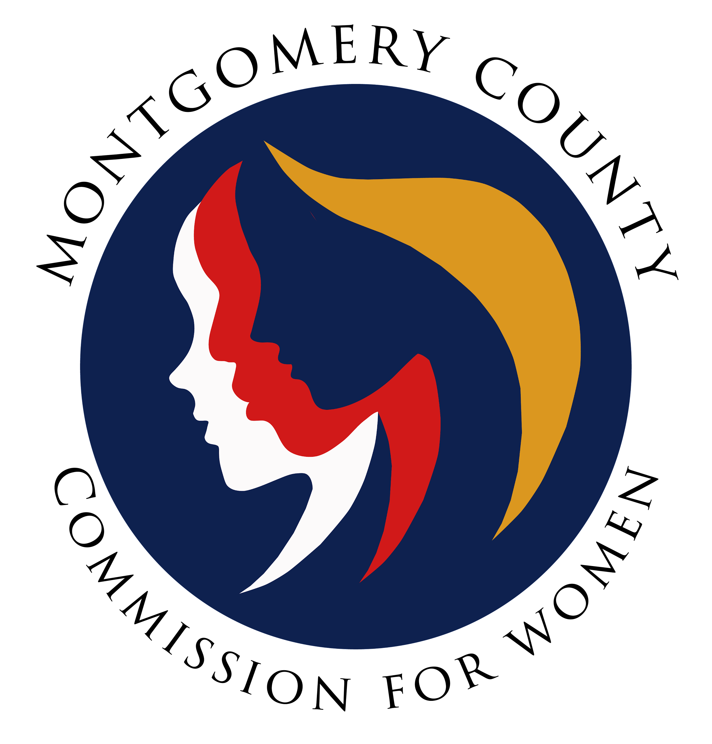
Montgomery County Commission for Women
General Meeting Minutes
January 12, 2023 / 7:00 – 8:30 p.m.

______________________________________________________________________________
“The more you care, the stronger you can be.”
Unknown
______________________________________________________________________________

Attendees
Arlinda Clark (1st Vice Chair)
Betty Romero (2nd Vice Chair)
Isabel Argoti Jodi Danis LaDonna King Helen Meister Kimberly Mouzon Liz Richards Tondalayo Royster Lindsey Turnbull
Ijeoma Enendu

CFW Team Members:
Jodi Finkelstein (Executive Director)

Absent:
Donna Rojas, Leah Wade, Janet LaValle

GENERAL MEETING MINUTES

I. WELCOME AND INTRODUCTIONS / VICE CHAIR CLARK
- Introduction by Commissioners in attendance and welcome to new Commissioners

II. APPROVAL OF MINUTES AND AGENDA / CHAIR ROJAS

- Approval of January 12, 2023 meeting agenda
Agenda approved by Commissioners
- Approval of December 8, 2022 Minutes
Minutes accepted by Commissioners

III. EXECUTIVE COMMITTEE REPORT / VICE CHAIR CLARK
- Team Building Session Overview
- Session went very well, lots of interaction among Commissioners, great information
gleaned from experience.

- Lobby Day / MLAW Overview
- Wonderful and robust discussion, excellent warm up to legislative session. Jodi
Finkelstein thanked Commissioners who participated in lobby day.

- MLAW’s 2023 Legislative Briefing will be virtually on February 1, 2023. Registration required.

- MLAW Sponsorship $50.00 – Commissioners voted/agreed to support the sponsorship for this years MLAW 2023 Legislative Briefing

- Mission Statement

- Revised mission statement presented to the body for review/vote as new mission statement in the CFW Charter.

- Mission statement was adopted as the new mission statement for the CFW.

- Invitation/Discussion with new Council Members

- Consideration for CFW to meet six (6) new Montgomery County Council Members at future meeting

- Commissioners agreed to virtually meeting with Council Members at CFW General Meeting; timing/scheduling to be discussed at Executive Committee meeting

- Jodi Finkelstein suggested to have the meeting in March 2023 for Women’s History Month and Commissioner Argoti recommended sending Council members a recognition for their historic leadership

- Communication within Committees

- Question: How are outsiders (non-CFW Commissioners) invited to committee meetings? Is it the Chair’s discretion or should the Chair convey to the committee prior to inviting the guest?

- Commissioners feedback: Chair should provide a courtesy response prior to extending invitation to guest; information required on guest background, purpose for attending the meeting, confirm previous interaction with CFW. Guest should not weigh in on the Commission’s working meeting; if so, the Chair must be notified in advance. Guest should attend meeting for required section of the meeting and not for the entire committee meeting session.

- Committee Membership
- Commissioners needed to serve on committees (Advisory, Budget, Emerging Leaders,
Policy and Legislation, Programming, Public Relations, Strategic Planning, etc.).
- Commissioners are welcomed to join any committee but the spreadsheet highlights the committees that are in need to be filled.

- Commissioners are encouraged to talk to committee Chairs to learn more about the Committee

IV. EXECUTIVE DIRECTOR REPORT / EXEC DIR., JODI FINKELSTEIN

- On-Boarding

- One (1) vacancy for the CFW; application date closed prior to the holidays; interviews will be conducted once official list of candidates are established; onboarding members will be the same team as before; updates will be shared with the group.

V. COMMITTEE REPORTS

- Policy and Legislation (Executive Director, Jodi Finkelstein)

- Legislative Session 2023 started yesterday, January 11, 2023
- Jenny will be monitoring the progress of bills supported by the CFW/Human Trafficking Prevention Committee and working the Commissioners who are testifying and sending legislative alerts via social media.

- Program Planning (Committee Chair, Ijeoma Enendu)

- Self Defense Seminars / Financial Wellness Seminars (dates to be shared soon)
- Requesting Commissioners sign up to proctor; sign-up sheet forthcoming

- Women Making History event scheduled in March; help needed from Commissioners to rate the candidates

- Budget

- No Report

- Strategic Planning, Research & Evaluation / Committee Chair, Betty Romero

- Committee worked on the following task: created vision and mission statements, the commission’s roles and responsibilities and detailed guidance/task for committees to work on – all to be reviewed by the body for input and agreement.

- Emerging Leaders / Executive Director, Jodi Finkelstein

- Emerging Leaders have a few members and will be meeting soon to assist with the upcoming Girl Power contest.

- Public Relations / Chair, Isabel Argoti

- Worked on media packet for WLB, Facebook page for WLB
- Next project, supporting the Women in History Month project
- Commissioner Danis inquired if CFW has done PR with the MoCo MLK day? It was suggested the Emerging Leaders could participate in the future.

- Women’s Legislative Briefing / Vice Chair Clark

- Video report by Commissioner Arlinda Clark
Theme: Empowered Women Protect Democracy
Sunday, January 29, 2023 (virtual)
Time: 12:30 p.m. – 5:00 p.m.
Registration:
$23.00 (through Jan. 27th)
$30.00 (Jan. 28th & 29th)
$5.00 (Students)

*Commissioners must purchase tickets to attend event.

Chairs Reception will be in person (January 28, 2023/ 10:00 a.m. 12:00 p.m.)
- Commissioners needed to serve on the following committees:
Programming: 1st Thursday of the Month/6:00 p.m.
Planning: 1st Thursday of the Month/7:00 p.m.
Emerging Leaders, Evaluation and Public Relations committees

V. LIAISON REPORTS

- Human Trafficking Prevention (HTP) / Executive Director. Jodi Finkelstein

- Proclamation of Human Trafficking Prevention Awareness Month – January 17, 2023 / 1:00 p.m. at the county council office building

- Domestic Violence Coordinating Council (DVCC) / Commissioner Royster

- Thomas Manion is now the Chair of the DVCC and Jessica Volt is the Vice Chair
- Expect Respect in schools now. 6K students reached in middle school / high school in Montgomery County
- Choose Respect video contest is open for students; submissions due March 16, 2023 – student will receive SSL hours

- Maryland Commission for Women / Executive Director, Jodi Finkelstein
- Jodi to follow-up with Donna, Chair on the submission for the Women’s Hall of
Fame
- RespectFest / Commissioner Mouzon
- Promoting video contest via MCPS; 37 entries thus far
- RespectFest: Planning for resource fair, seeking performers, self-defense class,
content booth and requesting CFW to have a table at the event, seeking survivor
speaker and volunteers overall.
- Community Health Initiative / No Report / Chair LaVelle

- No report

- CFW Scholarship

- No report

- Social Committee

- Five commissioners signed up for the social committee
VI. AD HOC COMMITTEE REPORT(S)
– No Reports
IX. OLD BUSINESS

- Reviewed the background for the WLB (testing shades of blue)

X. NEW BUSINESS/ANNOUNCEMENTS
- Information forthcoming about the WLB/CNR – stay tuned…

XI. GOOD NEWS
- None
XII. Meeting Adjourned (8:06 p.m.)

