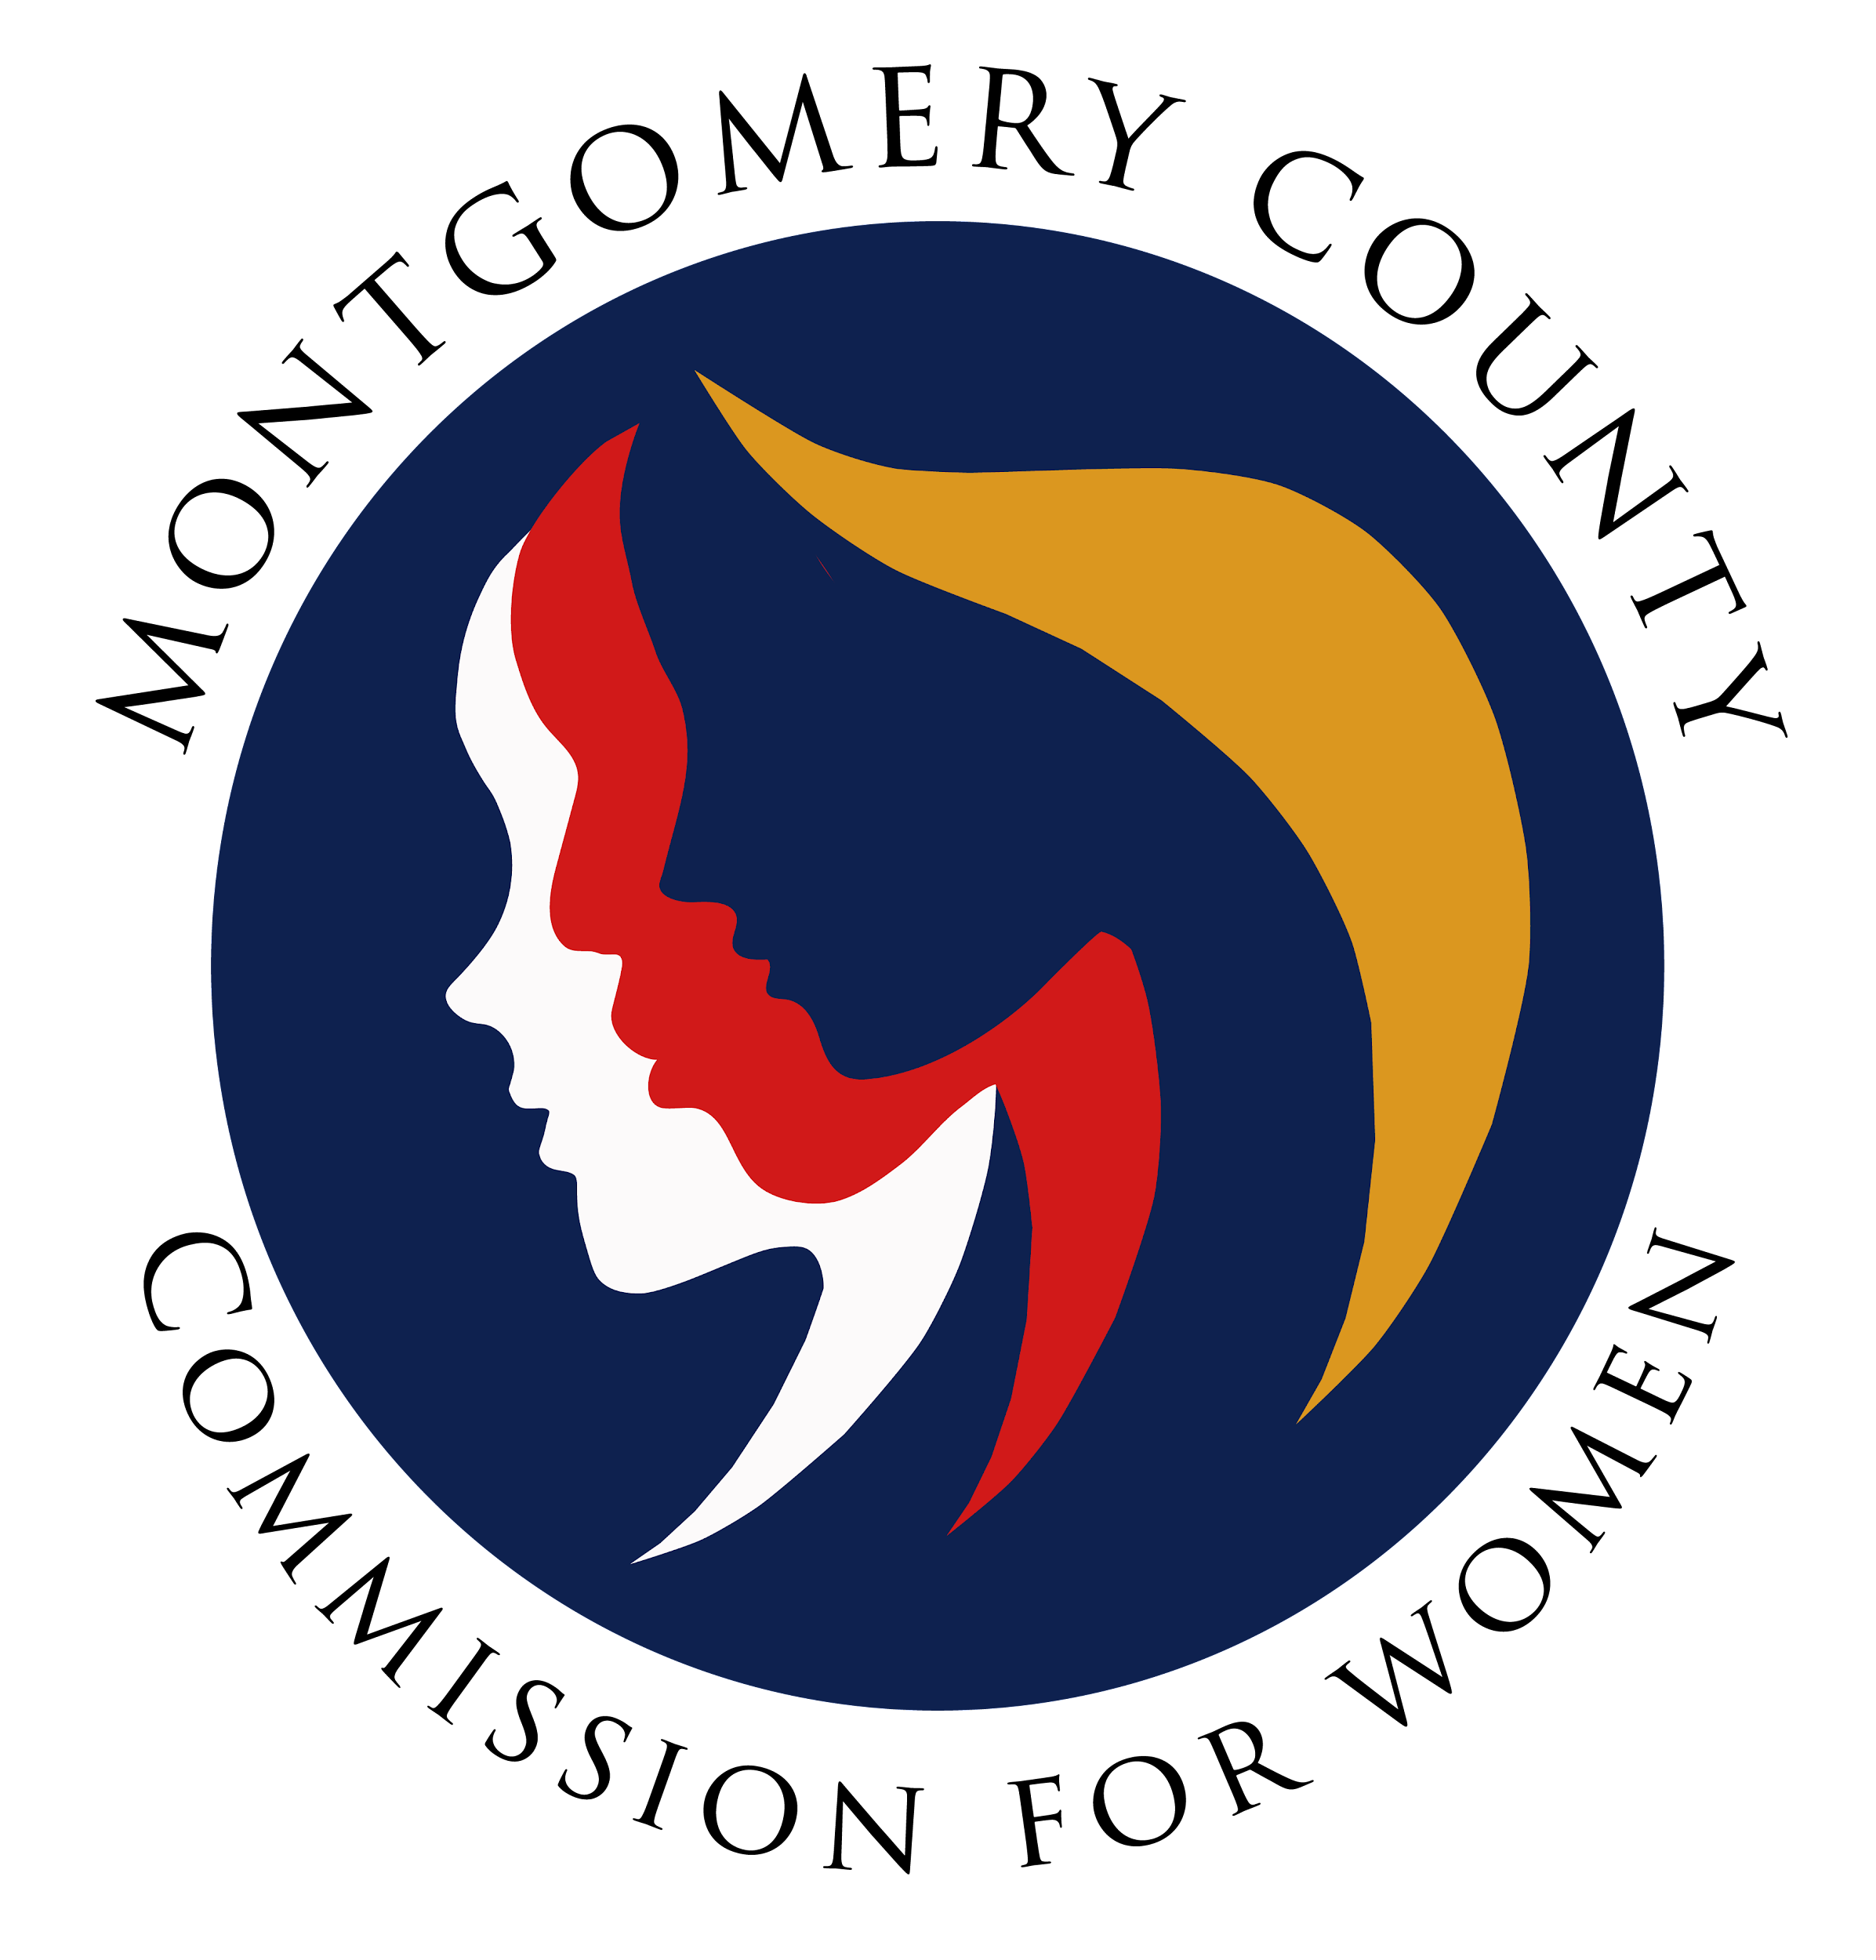
Montgomery County Commission for Women
General Meeting Minutes / In Person
March 9, 2023 / 7:00 – 8:30 p.m.

______________________________________________________________________________
“There is no force more powerful than a woman determined to rise.”
Unknown
______________________________________________________________________________

Attendees
Donna Rojas (Chair)
Arlinda Clark (1st Vice Chair)
Betty Romero (2nd Vice Chair)
Isabel Argoti Jodi Danis Ijeoma Enendu
Helene Meister Kimberly Mouzon Liz Richards
Tondalayo Royster Lindsey Turnbull Leah Wade

CFW Team Members
Jodi Finkelstein (Executive Director)
Absent
LaDonna King
Janet LaValle
Kimberly Mouzon
GENERAL MEETING MINUTES

I. WELCOME AND INTRODUCTIONS / CHAIR ROJAS
- Introduction by Commissioners in attendance and welcome to new Commissioners

II. APPROVAL OF MINUTES AND AGENDA / CHAIR ROJAS

- Approval of March 9, 2023 meeting agenda
Agenda approved by Commissioners
- Approval of February 9, 2023 meeting minutes
Agenda approved by Commissioners
III. EXECUTIVE COMMITTEE REPORT / CHAIR ROJAS
- International Women’s Day
- Councilwoman Laurie-Anne Sayles sponsored a proclamation for International’s Women Day on March 7th
- Commissioner’s Rojas, Argoti, Romero and Meister attended
- CFW Team Members Executive Director, Jodi Finkelstein, Carmen Kaarid and Jennifer
Escobar attended
- Women’s History Month Events
- Governor Wes Moore and first lady will honor the following recipients on March 16th:
- Maryland Women Hall of Fame Winners (2023)
- Maryland Young Women’s Leaders Award (2023)
- Location: Governor’s Mansion in Annapolis

- Women’s Day Reception

- Hosted by Councilwoman Laurie-Anne Sayles on Saturday, March 11, 2023
- Chair Rojas will provide remarks
- Location: AFI in Silver Spring (Registration Required)

IV. EXECUTIVE DIRECTOR REPORT / EXEC DIR., FINKELSTEIN

- CFW Budget/Restricted Budget

- County government budget process is in progress
- CFW submitted the following request to the County Executive:
- Student Stipend / $10K (received preliminary approval)
- Human Trafficking Prevention Committee / $25K (received preliminary approval)
- Requests must complete the budget review process; funds could be approved, denied or reduced. The final determination is completed by the County Council

V. COMMITTEE REPORTS

- Policy and Legislation / Executive Director, Finkelstein

- Executive Director Finkelstein thanked PALS committee and Commissioners who testified for CFW supported bills
- Commissioner Meister is considering the role of MLAW Liaison
- Program Planning / Chair, Commissioner Enendu

- Commissioner Enendu thanked Commissioners who assisted with the review process for the Women Making History Awards
- Thank you to Chair Rojas, Commissioner Turnbull and Executive Directo Finkelstein and Carmen Kaarid who helped with the overall program
- The committee reviewed 40 applications withing a two week turnaround time
- Awards Program held March 16th at Silver Spring Civic Center (RSVP by March 13th)
- One of last year’s award recipients served as a sponsor and contributed 2k to this year’s in person networking awards program

- Budget / Chair Rojas)

- No Report

- Strategic Planning, Research and Evaluation / Chair, Commissioner Romero

- CFW roles and responsibilities are completed and available for Commissioner’s review
- Timeline to complete the strategic plan is forthcoming and will be shared with Commissioner’s soon
- SPRE will complete a narrative of the strategic plan for the annual report

- Emerging Leaders / Commissioners Argoti and Turnbull

- RespectFest / April 16th (Request for Commissioner’s to Attend)
- Career summit / April 15th (Networking Event) One of the goals of the summit is to send every girl home with a blazer

- Public Relations / Chair, Commissioner Argoti

- No report

- Women’s Legislative Briefing / Vice Chair, Clark

- Wrap-up meeting with the WLB Planning Committee
- Gearing up for planning WLB 2024

V. LIAISON REPORTS

- MLAW
- Chair Rojas reported MLAW bills are moving along in the legislative process
- Human Trafficking Prevention (HTP) / Executive Director Finkelstein

- Next meeting March 15th (noon – 1:30 p.m.)
- Several vacancies on the committee in the process of being filled
- Action Items: Revamping Body Works Bill and the Blue Dot Campaign
- Education and Outreach – Updated the Curriculum for MCPS

- Domestic Violence Coordinating Council (DVCC) / Commissioner Royster

- No Report (Commissioner Royster on stand-by to testify)

- RespectFest / Commissioner Mouzon
- Video Contest Submission Date: March 13th (140 entries)
- Virtual Kick-Off Date: April 10th
- Nine Educational Content Booths onsite at Wheaton Recreational Center
- Food Vendors will be on site
- CFW will have an information table
- 2 college student survivors will speak
- IHeart Radio will broadcast
- Ride on Shuttles will transport from the following High Schools:
Einstein, Seneca Valley and Richard Montgomery
- Community Health Initiative / Commissioner LaValle

- No report

- CFW Scholarship / Commissioner Argoti
- No report

- Social Committee / Commissioner Rojas

- Chair Rojas working on an outreach and social event in April

VI. AD HOC COMMITTEE REPORT(S)

- By Laws Committee / Vice Chair Clark and Commissioner LaValle
- Reviewed By-Laws and recommendations will be sent to the Commissioners in April
for review and comment
-Standard Operation Procedures manual with a committee
- Committee Chairs please memorialize your operating procedures

IX. OLD BUSINESS

- N/A
X. NEW BUSINESS/ANNOUNCEMENTS
- Chair Rojas reported interviews are completed to onboard new Commissioner (1 slot
available)
- Name will be submitted to the County Executive to begin the approval process

XI. GOOD NEWS
- Happy Birthday, Commissioner’s Enendu and Wade!

XII. Meeting Adjourned

