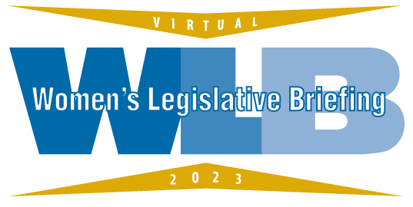
Amanda K. Rodriguez

Amanda K. Rodriguez, Esq. graduated from the University of Maryland at College Park in 2005 as the only candidate to receive the prestigious Arts/Law degree in her class. She received her Juris Doctorate from the University of Baltimore School of Law in 2007. During her legal study, she was the first student attorney in the Immigrants’ Rights Clinic at the University of Baltimore. Subsequently, she wrote numerous articles on the topic of the international implications of human trafficking on the United States’ economy, human trafficking, prosecution, investigation, and domestic minor sex trafficking. Her articles have been published nationally and internationally. She was an Assistant State’s Attorney for Baltimore County where she oversaw all human trafficking investigations in the county. In 2014, Mrs. Rodriguez transitioned to the role of Manager of Domestic Violence and Human Trafficking Policy for the Governor’s Office of Crime Control and Prevention and was appointed a Special Assistant United States Attorney where she oversaw the state-wide implementation of policy and protocol related to human trafficking in Maryland. She subsequently moved to leadership roles at local victim service agencies. She accepted her current position of Executive Director of TurnAround, Baltimore’s rape crisis center, and a comprehensive domestic violence and human trafficking service provider in December of 2019. She is also currently the Co-Chair of the Legislative Subcommittee for the Maryland Human Trafficking Task Force and the Chair of the Legislative Committee of the Board of Directors for the Maryland Network Against Domestic Violence. She has received numerous awards for her work on human trafficking in the state including the Breakthrough Award from the Maryland Human Trafficking Task Force, a special citation from Baltimore County, two citations from the State of Maryland, a special recognition from the Baltimore U.S. Attorney’s Office for her successful prosecution of traffickers involved in child exploitation and her commitment to human trafficking survivors. Additionally, she was recognized in 2014 as a Leading Woman by the Daily Record.

