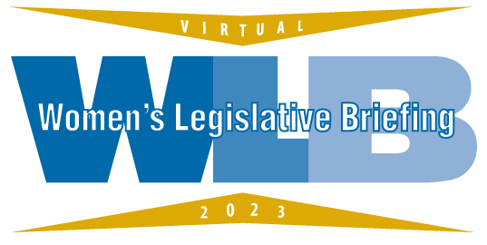

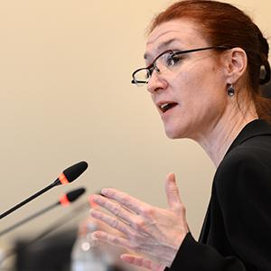

Lisae C. Jordan

Lisae C. Jordan currently serves as Executive Director & Counsel for the Maryland Coalition Against Sexual Assault. MCASA is a membership organization that includes Maryland’s rape crisis center, individuals, and organizations devoted to ending sexual violence. Ms. Jordan has lobbied the Maryland General Assembly for over 25 years and has helped create and pass many statutes to help prevent violence against women and children and bring abusers to justice. Successful advocacy efforts range from reforming Maryland’s sex trafficking law to creating a process to terminate the parental rights of rapists to establishing the Attorney General’s Sexual Assault Evidence Kit Funding and Policy Committee. Ms. Jordan is also the founder and director of the Maryland Coalition Against Sexual Assault’s Sexual Assault Legal Institute (SALI), a nationally recognized project providing legal services to survivors of sexual assault, and legal training and technical assistance for professionals working with survivors. Ms. Jordan honors include a Women’s Law Center of Maryland Award, Maryland Legal Services Corporation’s Cardin Award, and a Justice for Children award from the Maryland Children’s Alliance. She graduated with honors from Harvard Law School and was a law clerk for the Honorable André M. Davis.

