Montgomery County to Induct Six New Honorees into the Human Rights Hall of Fame on Sunday, Dec. 15

**For Immediate Release: Thursday, December 12, 2024**

Montgomery County’s Office of Human Rights (OHR) will honor six individuals for their contributions to advancing human and civil rights in the County at the 13th biennial Human Rights Hall of Fame induction ceremony, set for 7 p.m. on Sunday, Dec. 15, at the BlackRock Center for the Arts in Germantown.

This year’s inductees are Douglas M. Duncan, Catherine S. Leggett, Sherlene Lucas, Constance A. Morella, Rev. Dr. Gareth E. Murray and Carl A. Prather, Sr.

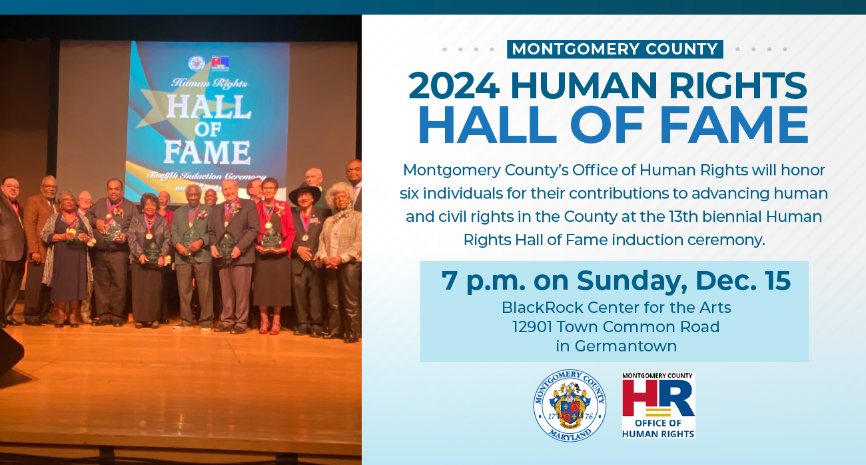

"Montgomery County has long been a place where people come together to build a more just, equitable and inclusive community,” said County Executive Marc Elrich. “The honorees we celebrate this year have made exemplary contributions to advancing human and civil rights in our County. Their work has uplifted the importance of fairness, dignity and opportunity for all. These individuals remind us that the fight for equality continues and that each of us has a role in making our community stronger and more compassionate.”

**Douglas M.  Duncan** served three consecutive terms as Montgomery County Executive starting in 1994, where he led transformative initiatives that improved the lives of residents, particularly those facing economic hardship. Under his leadership, Montgomery County became the first in the nation to implement a local Earned Income Tax Credit, offering targeted tax relief to working families. His administration expanded access to health care, provided a discount prescription drug card to all residents, increased transit subsidies and doubled spending on affordable housing. He also signed a living wage bill into law, demonstrating his deep commitment to economic justice and social equity.

**Catherine S. Leggett**, a distinguished human resources attorney and wife of former Montgomery County Executive Ike Leggett, has made lasting contributions to human rights through her community leadership. She served as campaign chair for the Josiah Henson Museum, raising awareness of his historic role in Montgomery County and American history. Ms. Leggett also co-chaired the Scotland Community’s 2nd Century Project, working to address historical injustices and uplift the church and community, furthering her legacy of equality and historic preservation.

**Sherlene Lucas** is a dedicated leader. She serves as State chair and is an active member of several NAACP committees, including Women in the NAACP, ACT-SO and the Youth Committee. Her tireless work with the Montgomery County NAACP and organizations like Gap Busters, Black Women of Distinction and the Lincoln Park Historical Foundation demonstrates her commitment to advancing civil rights, empowering the community and supporting marginalized voices.

**Constance A. Morella** has dedicated over six decades to public service, including her time as a teacher in Montgomery County Public Schools and Montgomery College. She served eight terms in the U.S. Congress and was a founding member and president of the Montgomery County Commission for Women. She also served as U.S. Ambassador to the Organization for Economic Co-Operation and Development in Paris. She championed civil rights, supported domestic violence victims, advocated for same-sex marriage and played a pivotal role in establishing the Martin Luther King Jr. Memorial. In 2018, Montgomery County honored her by naming the Bethesda Library after her.

**Rev. Dr. Gareth E. Murray** has dedicated his life to advancing human and civil rights through transformative leadership and a commitment to his community. As one of the first African Americans elected to the Maryland General Assembly representing Montgomery County, he championed legislation addressing health disparities, supported minority-owned businesses and promoted cultural competence. He founded the People’s Wellness Clinic and strongly advocated for justice and unity while breaking barriers in the faith and entrepreneurial sectors.

**Carl A. Prather, Sr.**, born in historic Prathertown, a community in the Montgomery Village area founded by enslaved individuals in 1883, has steadfastly advocated for human and civil rights. His efforts to combat food insecurity, promote accessible transportation and support career development and living wages have significantly impacted the community. He served as a commissioner on the Montgomery County Commission on People with Disabilities, advocating for accessibility in local parks. In his community, he leads efforts to provide high-speed internet, free tech support and a private rideshare service to address transportation gaps.

These individuals join the ranks of past honorees who have made extraordinary contributions to advancing civil rights and promoting social justice in Montgomery County.

The Human Rights Hall of Fame was established in 2001 by former OHR Director Odessa Shannon and has since inducted 108 individuals. This year marks the thirteenth class of honorees, whose work has left a positive and lasting impact on Montgomery County.

The selection of this year’s inductees followed a review process by a panel of previous Hall of Fame honorees. The public is invited to attend the ceremony and celebrate the accomplishments of those who have worked to advance civil rights in the County.

The ceremony will be held at [BlackRock Center for the Arts](https://www.blackrockcenter.org/), 12901 Town Common Road, Germantown.

For more information about the Hall of Fame, including details about past inductees, visit the OHR [website](https://www.montgomerycountymd.gov/humanrights/outreach/halloffame.html).

#  #  #

*Release ID: 24-560*  
*Media Contact:*[*Jennifer Garfinkel*](mailto:Jennifer.Garfinkel@montgomerycountymd.gov)*240-962-1506*  
*Categories:*[*Award*](https://www2.montgomerycountymd.gov/mcgportalapps/Press_Filter.aspx?cat=Award&id=23)*,*[*Executive Office*](https://www2.montgomerycountymd.gov/mcgportalapps/Press_Filter.aspx?cat=Executive%20Office&id=23)