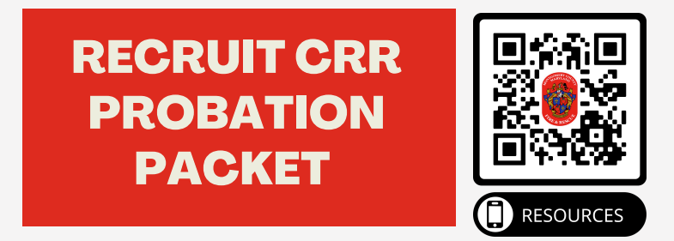
Welcome to the MCFRS Firefighter CRR Recruit Packet. As future firefighters, you will be trained to not only respond to emergencies but also to play a proactive role in preventing disasters before they occur. Community Risk Reduction (CRR) is a critical part of your training, as it focuses on identifying and mitigating risks within the community you serve.
CRR is a data-driven, strategic approach that aims to reduce the frequency and severity of fires, injuries, and other emergencies. It emphasizes working with the community to address hazards, educate the public, and implement programs that promote safety. This includes fire prevention efforts, safety education, community outreach, and collaboration with local organizations to reduce risks that affect the most vulnerable populations.
As a firefighter, your involvement in CRR initiatives will be key to improving the overall safety of your community. By understanding the risks, applying preventive measures, and educating the public, you will not only help save lives and property but also empower the community to be proactive in reducing hazards before they escalate into emergencies.
Throughout your career, CRR will be an ongoing responsibility and an essential component of your role as a first responder. This packet will introduce you to the fundamental principles and practices of CRR, helping you understand how you can make a significant, lasting impact on the safety and well-being of the community. If you have ANY questions or need help at any time on the packet, please reach out to Beth Anne Nesselt (bethanne.nesselt@montgomerycountymd.gov).
I acknowledge that I have read and understood the information provided above about Community Risk Reduction (CRR):
[ ] Yes Your Name: ______________________________________________________
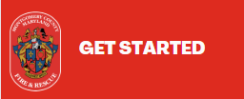
Scan the QR Code above or use the link below to get started. Quicklinks ->Fire Chief ->CRR
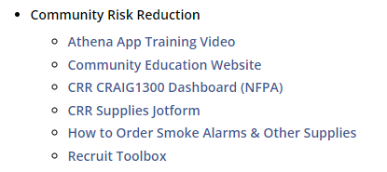

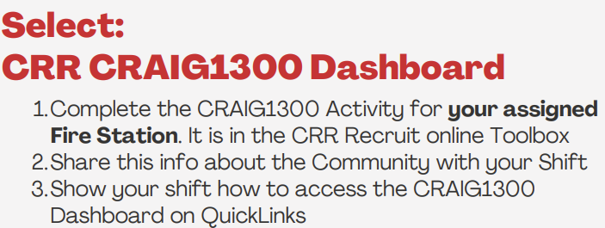
1. What steps did you take to complete this activity?
2. What was the reaction of your shift to the CRAIG1300 Tool? Were they familiar with CRAIG1300?

3. Can you describe the outcome of this activity?

Skill | Signature | Date
Completed


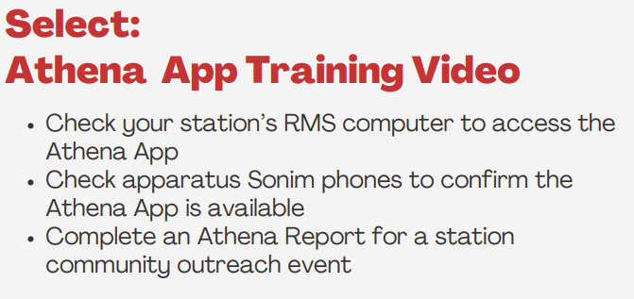
1. Describe your experience using the Athena App. Give specific example(s).
2. What Task did you submit an Athena report on?

3. What features were particularly useful? Any challenging?

Skill | Signature | Date
Completed


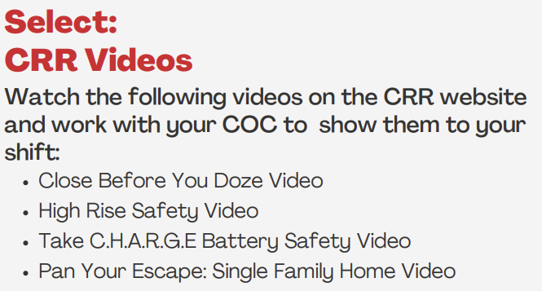
1. What key takeaway from the video do you think will have the most impact on your role as a firefighter in Community Risk Reduction??
2. How can you apply the information from the video to enhance safety and prevent risks within the community you serve?
3. What was your shift’s reaction to the videos? to the CRAIG1300 Tool? Were they familiar with CRAIG1300?

Skill | Signature | Date
Completed


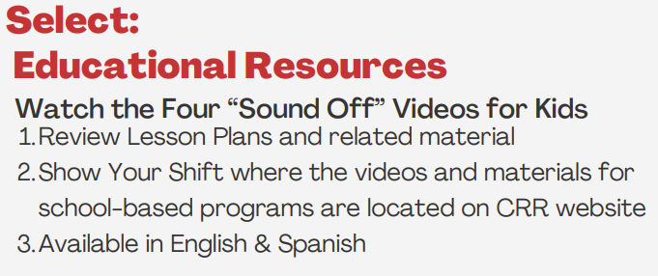
1. What message(s) from the video do you think will resonate most with children and help them understand fire safety or risk prevention?
2. After watching the videos, do you feel more confident in your ability to educate others about fire safety and community risk reduction? Why or why not?

3. What was your shift’s reaction?

Skill | Signature | Date
Completed

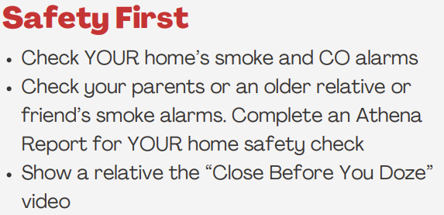

1. After checking your smoke alarms and reviewing the video, what steps did you take to ensure the alarms are functioning properly in your home and a relative's home?
2. How does the information from the Close Before You Doze video impact your understanding of fire safety and prevention? What new insights did you gain?
3. Based on what you learned from the video and your smoke alarm check, what would you recommend to others about fire safety measures in their homes, especially regarding sleeping safety and smoke alarms?

Skill | Signature | Date
Completed


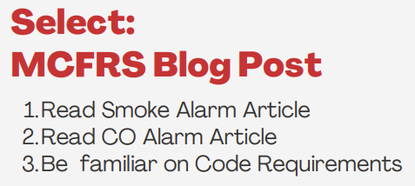
1. List 4 things your learned from reading the Smoke Alarm and CO Alarm articles.

2. How can your use the information to educate others, either within your crew or your community, to improve fire prevention efforts?
3. What was the most important thing you learned?

Skill | Signature | Date
Completed


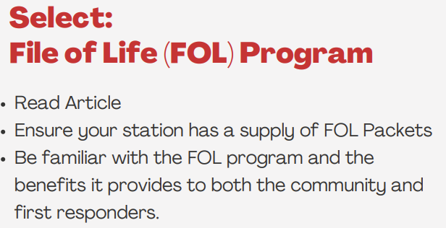
1. How does the File of Life program benefit the community, and why is it important for individuals to have this information readily available in case of an emergency?
2. In what ways can the File of Life program help first responders provide quicker, more effective care during an emergency situation?
3. What steps can you take as a firefighter to encourage community members to participate in the File of Life program and ensure their information is up to date?

Skill | Signature | Date
Completed


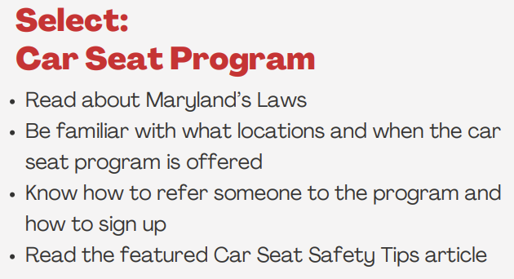
1. How do car seat laws benefit the safety and well-being of children in the community?
2. What are the key age and weight requirements for car seat use in Maryland?
3. As a firefighter, how can you educate parents and caregivers in your community about car seat safety and encourage compliance with Maryland’s car seat laws?

Skill | Signature | Date
Completed

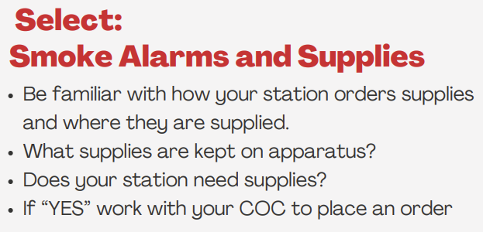

1. Where is your fire station’s inventory of CRR and public education materials kept?
2. What CRR and public education materials (if any) or equipment (smoke alarms) are kept on apparatus at your current station assignment?
3. How does your station ensure that materials are resources are in stock, accessible and up-to-date? Is someone assigned this role?

Skill | Signature | Date
Completed CRAIG1300 Exercise


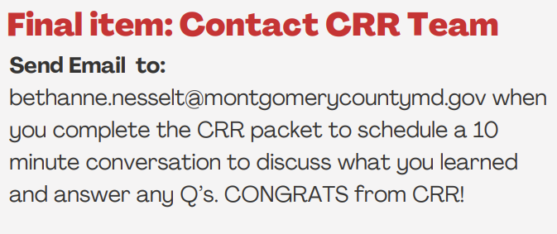

Pro Tip: Please do not wait to the last minute to schedule.

Skill | Signature | Date
Completed

