Create a Google Account

Step 1: Choose a Google Account type
- Go to https://accounts.google.com/signup
- Enter your name.
- In the "Username" field, enter a username.
- Enter and confirm your password.
  - Tip: When you enter your password on mobile, the first letter isn't case sensitive.
- Click Next.
  - Optional: Add and verify a phone number for your account.
- Click Next.
  - Optional: Add and verify a phone number for your account.
- Click Next.

Use an existing email address
- Go to https://accounts.google.com/servicelogin
- Click Use my current email address instead.
- Enter your current email address.
- Click Next.
- Verify your email address with the code sent to your existing email.
- Click Verify.

Step 2: Protect your account with recovery info
If you forget your password or someone is using your account without your permission, updated recovery info makes it much more likely you’ll get your account back.
- Add a recovery phone number
- Add a recovery email address
Set up your Chromebook
To set up your Chromebook or Chromebox, you'll need:
- Your Google Account username and password
- Access to a network

Step 1: Turn on your Chromebook
- If the battery is detached, install the battery.
- Press the power button.

Step 2: Follow the onscreen instructions
- To choose your language and keyboard settings, select the language that appears on the screen.
- Optional: To turn on accessibility features, select Accessibility.
- Choose your network.
- Accept the terms of service.

Step 3: Sign in with your Google Account
To choose your Chromebook owner, enter your Google Account email or phone number and password.
- If you’ve already turned on 2-Step Verification, you’ll be sent a code to your selected device.
- If you don't have a Google Account to add, create one. On some Chromebooks, you can select More options Create new account.
- To use your Chromebook without an account, select Browse as Guest.
- If you're having trouble signing in with your Google Account, use the sign-in troubleshooter.
Once you sign in, your bookmarks, extensions, and apps will appear automatically.
Warranty:
To access the warranty on your Lenovo Chromebook please use the following link below and enter your Service Tag located underneath Chromebook for support:
https://pcsupport.lenovo.com/us/en/warrantylookup#/
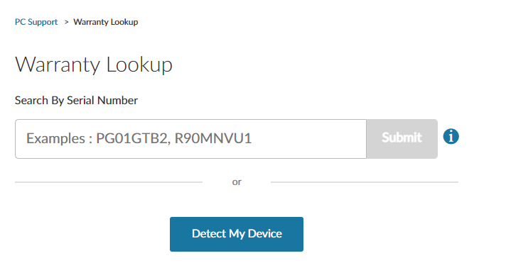
Disclaimer:
If the computer is damaged, lost, or stolen, contact us at montgomeryconnects@montgomerycountymd.gov. The Montgomery County Police Department will be notified if the computer is reported stolen.

